|  |  |
| --- | --- |
|  |  |

Contents

Apache Spark with Scala 4

Introduction 4

Distributed Computing 4

Understanding the Data Lake Landscape 5

Concepts 8

Apache Spark – Intro & Overview 9

Source Code Repository 13

Spark Development Environment 13

Local Mode – Command Line REPL 13

Apache Spark - IntelliJ IDEA 26

Creating a New Project 40

Cloud - Databricks Community & Notebooks 50

Zeppelin Notebooks 55

Spark Execution Model and Architecture 60

Spark Distributed Processing Model - How your program runs? 62

Spark Execution Modes and Cluster Managers 63

Spark Shell – Demo 69

Installing Multi-Node Spark Cluster 74

Working with Notebooks in Cluster – Demo 81

Working with Spark Submit 86

Spark Programming Model & Developer Experience 90

Configuring Spark Application Logs 94

Creating a Spark Session 98

Configuring Spark Session 101

DataFrame Introduction 107

Data Frame Partitions and Executors 113

Spark Transformations and Actions 116

Spark Jobs, Stages and Tasks 126

Understanding your Execution Plan 130

Understanding your Execution Plan 137

Unit Testing Spark Application 154

Debugging Spark Driver and Executor 155

Spark Application Logs in a Cluster 158

Rounding Off Summary 171

Spark Structured API – Foundation 178

Spark RDD API 180

DataSet vs DataFrame 186

Working with Spark Dataset 190

Working with Spark SQL 196

Spark SQL Engine and Catalyst Optimizer 198

Summary 199

Spark Data Sources and Sinks 200

Spark DataFrameReader API 203

Reading CSV, JSON and Parquet files 206

Creating a Parquet File ??? 217

Creating Spark DataFrame Schema 217

Spark DataFrameWriter API 224

Writing Your Data and Managing Layout 229

Spark Databases and Tables 238

Working with Spark SQL Tables 244

Spark Dataframe and DataSet Transformations 253

Data Transformation 253

Working with DataFrame Rows 254

Dataframe Rows and Unit Testing 261

DataFrame Rows and Unstructured Data 267

Working with Dataframe Columns 272

Creating and Using UDF 287

Miscellaneous Transformations 292

Aggregations in Apache Spark 302

Aggregating Dataframes 302

Grouping Aggregations - Solution 307

Windowing Aggregates 311

Spark DataFrame Joins 316

Dataframe Joins and column name ambiguity 316

Outer Joins in Dataframe 323

Internals of Spark Join and shuffle 328

Optimizing your Joins 339

Implementing Bucket Joins 347

# Apache Spark with Scala

## Introduction

### Distributed Computing

Apache Spark is a distributed computing platform. So, before we start the Spark course, lets quickly look at the brief history of large scale distributed computing and its evolution. We created software applications and deployed them on computers. These applications needed to do a lot of things including and not limited to storing and processing data. Over a period of time, the data volume kept growing. Hence, the requirement for storage and computation power was also increasing. However, this need was being fulfilled by the rapid advancement in storage and compute hardware. Our applications automatically started storing more and more data and kept becoming faster and faster by simply upgrading the hardware. However, the advent and rapid adoption of the Internet disrupted this perfect harmony.

The scope and the reach of the software applications started to expand across the geographic boundaries and covered the entire planet. As a result, the data began growing and evolving exponentially. It wasn't possible and practical for hardware technology to catch up with this growth and disruption. But we needed a solution. Google was not only the first to realize this problem, but also the first to develop a viable solution and establish a commercially successful business around it. At a high level, Google had four main problems to solve. They were creating a search engine, and the first thing they wanted to do was to discover and crawl the web pages over the Internet and capture the content and metadata. These types of problems are now categorized a data collections and data ingestion problems. Once the webpage related data is collected, they wanted to store and manage it. However, they knew they are going to collect a massive amount of data on the planet-scale. So the next problem was to store and manage hundreds of petabytes of data. The next problem was to get the computation power for processing those massive volumes. They wanted to apply the PageRank algorithm on the received data and create an index. So, the third problem was to get the required processing power. Finally, the last problem was to organize and store the outcome of the processing. In Google's case, the result was the index. They wanted to keep it in a random-access database that can support high-speed queries by the Google Search Engine application.

Google successfully solved all the above problems, and they were generous enough to reveal their solution to the rest of the world in a series of white papers. The first whitepaper was published by Google in the year 2003, and it talked about solving the Data Storage and Management problem. They termed the solution as Google File System (GFS). The second whitepaper was published by Google in the year 2004 and talked about the Data Processing and Transformation problem. They termed it as MapReduce (MR) programming model. These whitepapers were well appreciated by the open-source community, and they formed the basis for the design and the development of similar open-source implementation – The Hadoop.

The GFS is implemented as a Hadoop Distributed File System – HDFS. Google MR is applied as the Hadoop MapReduce programming framework. The HDFS solved the storage problem by implementing a distributed file system over and above a cluster of computers. It allowed us to combine the storage capacity of hundreds and thousands of computers and use it as a unified storage system. It also allowed to start with a small cluster and expand the size as your data grows. Similarly, MapReduce solved the compute capacity problem by implementing a distributed processing framework over and above the HDFS. It allowed us to break the data processing job into smaller tasks and use the cluster of computers to finish the individual tasks independently. Then it also allowed to combine the outcome of the different tasks and seamlessly produce the consolidated result.

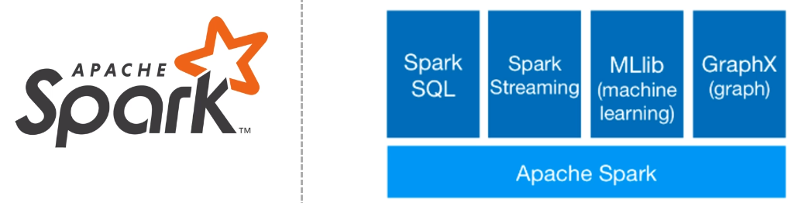

Hadoop grabbed immense attention and popularity among the organizations and professionals. Since then, there are many other solutions developed over the Hadoop platform and open-sourced by various organizations. Some of the most widely adopted systems were Pig, Hive, and finally, the Apache Spark. Apache Spark started at UC Berkeley as an effort to simplify and improve the ideas of the MapReduce Framework. However, it soon gained popularity and took a direction for creating composable APIs in multiple languages and developing a unified programming model for different types of workloads. It is now used by Data Engineers and bigdata practitioners for large scale data crunching. And with the recent integration of Deep Learning Frameworks as a fist-class citizen in Apache Spark, it is expanding adoption in Machine Learning space as well. As per the Apache Foundation 2019 Report, Apache Spark is in the second position by "Most Active Sources: Visits."

### Understanding the Data Lake Landscape

It all started with Google finding a solution for their storage requirements using GFS. The open-source community created a similar solution called HDFS. What exactly we got from HDFS? It allowed us to form a cluster of computers and use the combined capacity for storing our data. And that was a revolutionary technology because it allowed us to collect and store a kind of data volume, which was almost impossible earlier.

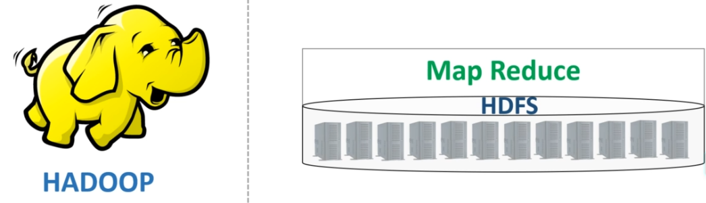

That was not enough. We also got the MapReduce framework. MR allowed us to use the combined computing power of the cluster and use it to process the enormous data volumes that we stored in HDFS. What was there before the HDFS and MR came into existence? Data Warehouses - Like Teradata and Exadata. How we used these Data Warehouses? We created pipelines to collect data from a bunch of OLTP systems and brought them into the Data Warehouse. Then we processed all that data to extract business insights and used it to make the right business decision.

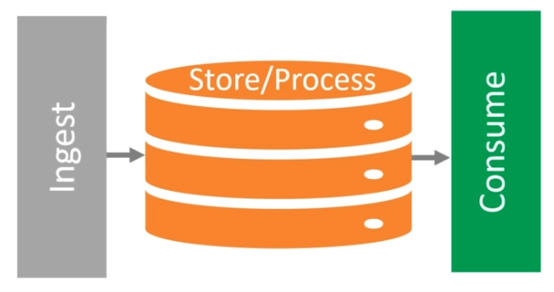

The advent of HDFS and MR started challenging these Data Warehouses in two critical respects. Horizontal Scalability and Capital Cost Increasing the capacity or scaling the HDFS and MR was as simple as adding some more cheap servers to your cluster. It allowed us to start with a low-cost small cluster and add more low priced servers as and when we needed more capacity.

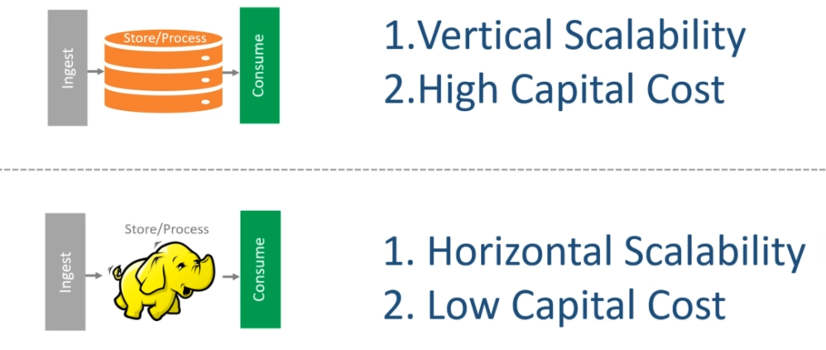

Data Warehouses were challenged, and we needed a new name for this approach. This is precisely when James Dixon, CTO at Pentaho, coined a new term - The Data Lake.

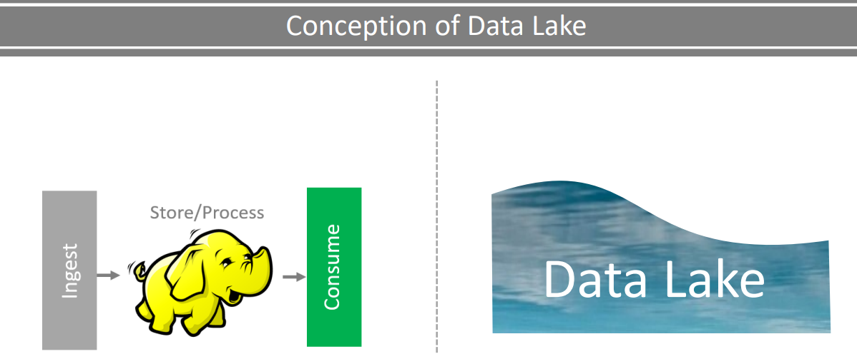

Initially, the Data Lake became synonymous with Hadoop. However, over some time, a lot of things evolved. Hadoop, as a platform, has lost the excitement and hype. Cloud infrastructure became more economical and started seeing wider adoption. And with these developments, the notion of Data Lake also matured as a platform with four key capabilities. Data Collection and Ingestion Data Storage and Management Data Processing and Transformation Data Access and Retrieval.

|  |  |
| --- | --- |
|  |  |

And these four are nothing but the same problems that Google attacked and solved. The core of the data lake platform is the storage infrastructure. In today's data lake, this could be an on-premise HDFS or Cloud Object Stores such as Amazon S3, Azure Blob, Google Cloud Storage, etc. The cloud storage is leading because they offer scalable and high availability access at an extremely low-cost in almost no time to procure. The notion of the data lake recommends that you bring data into the lake in a raw format. What does it mean? That means you should ingest the data into the data lake. And preserve an unmodified immutable copy of the data. The ingest block of the data lake is all about identifying, implementing, and managing the right tools to bring data from the source systems to the data lake. We do not have one ingestion tool that solves the purpose in all use cases. And hence, Â many vendors are competing for a place in this box. The next layer is the processing layer. This is the place where all the computation is going to happen. When I say computation, it means the following kind of work. Initial data quality check.

|  |  |
| --- | --- |
|  |  |

Transforming and preparing your data. Correlating, Aggregating, Analyzing, and extracting some business insights. Applying some machine learning model. All those actions are going to happen in this layer. But you want to do it on a large scale. So the processing layer is further broken into two parts. And this is important for managing things and separate out the responsibilities. Data Processing Framework and Orchestration System The processing framework is the core development framework that allows you to design and develop distributed computing applications.

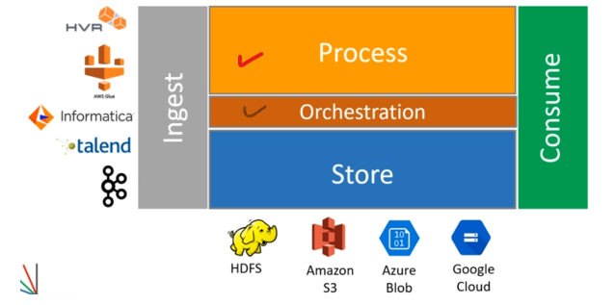

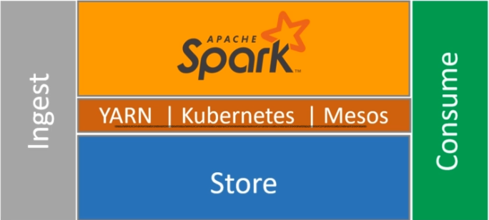

The Apache Spark falls in this place. The orchestration framework is responsible for the formation of the cluster, managing resources, scaling up, scaling down, and many other similar things. And this the place where we have three competitors. Hadoop YARN Kubernetes Apache Mesos The last and most critical capability of the data lake is to allow you to consume the data from the data lake. You can think of your data lake as a repository of raw and processed data. Now the consumption is all about putting that data for real-life usage. But the consumption requirements will be coming in all possible formats. You might have data analysts and data scientists looking to access the data from the lake. You might have some applications and dashboards. Those guys are also interested in aggregated results and insights.

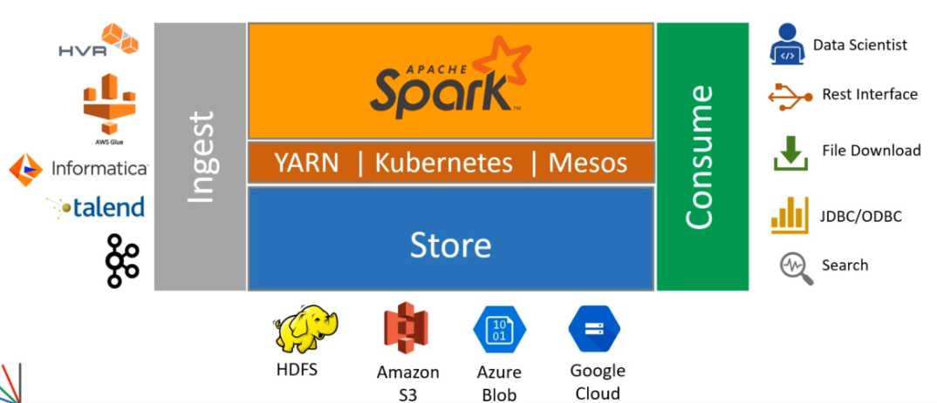

Some of them would ask you to allow JDBC/ODBC connections. Others might ask you for the REST Interface. Experimenting data scientists would be interested in accessing files. The point is straight. Every data lake consumer comes with a different set of requirements and expectations, complicating the consumption layer. And hence, we have a bunch of products competing to find a place in this box as well. At a high level, this is what a data lake is all about. However, the data lake platform is much more complicated as a whole. You are going to need a bunch of other additional capabilities to complete your Data Lake implementation. The most critical ones are listed here. Security and Access Control Scheduling and Workflow Management Data Catalog and Metadata Data Lifecycle and Governance Operations and Monitoring

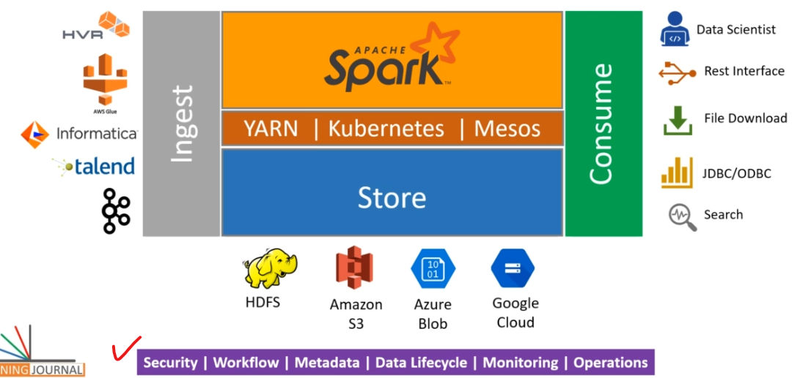

### Concepts

#### What is a Data Warehouse?

#### What is a Data Lake?

#### What is a Operational Data Store?

### Apache Spark – Intro & Overview

By now, you already have some background in distributed computing and seen the data lake as a modern data platform. I also mentioned that Apache Spark is the most popular and the most widely adopted data processing framework in a data lake. So, in this lecture, I am going to take you a little deeper into Apache Spark and help you understand the Spark as a unified data analytics and processing platform. Let's start with a simple question - What is Apache Spark? Let me check the Apache Spark home page. What do you see? This definition doesn't tell much.

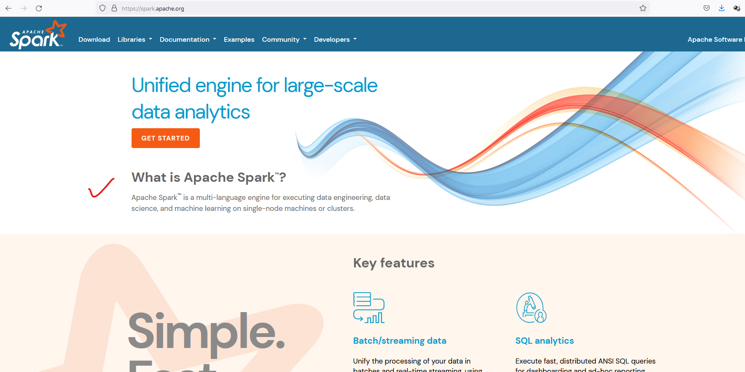

But you will also see this diagram.

|  |  |
| --- | --- |
|  | I will talk about it, but before that, let's look at the Databricks website. They are the main driving force behind the Spark. You will see a similar thing here as well and also a similar diagram.  <https://databricks.com/spark/getting-started-with-apache-spark>  So, let's start with this diagram. Apache Spark is a distributed data processing framework, and this diagram represents the Spark Ecosystem. This figure is going to help us to understand how the whole ecosystem is stitched together. |

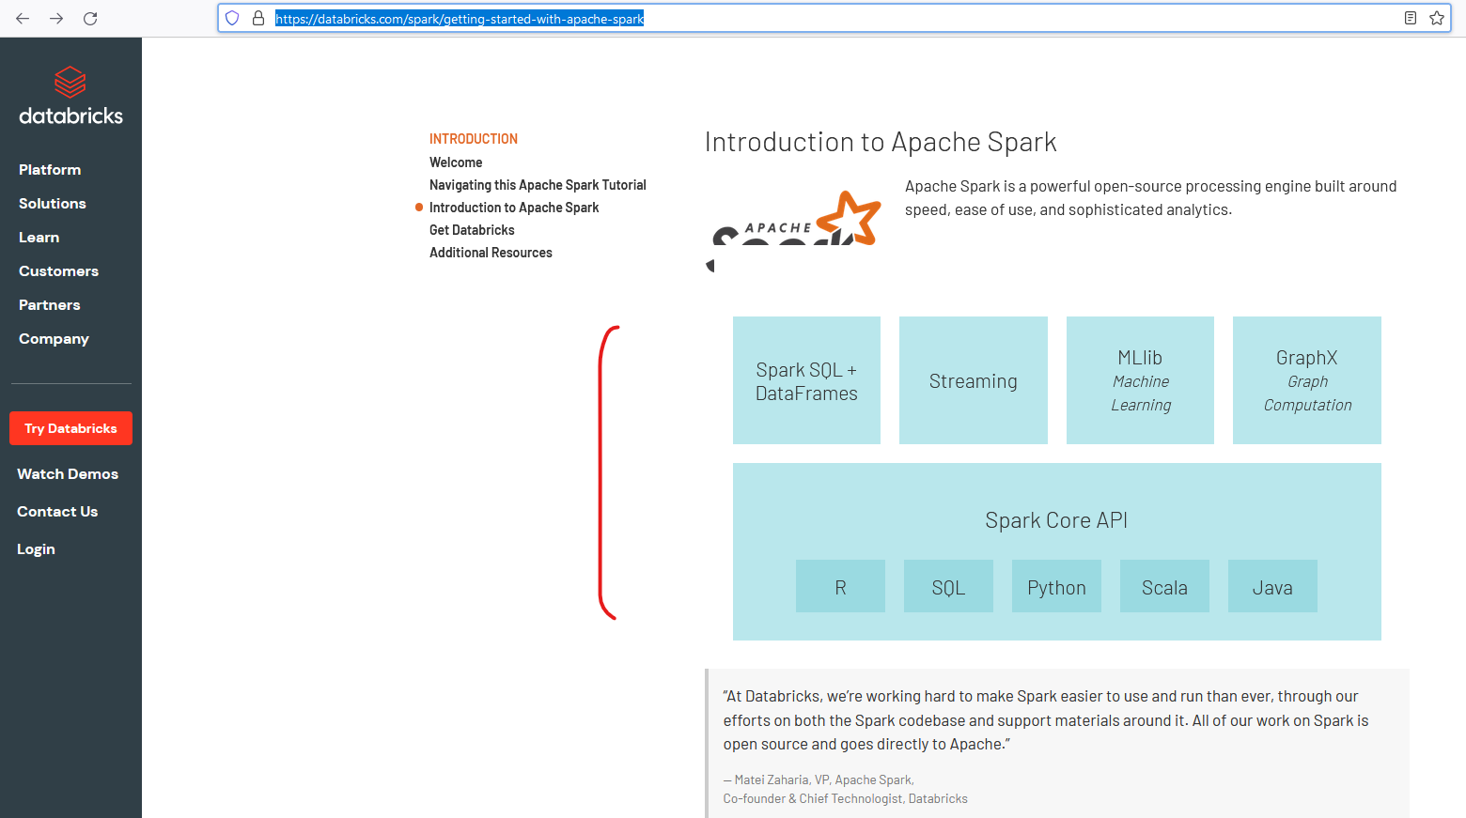

So, the Spark ecosystem is designed in two layers. The bottom layer is the Spark Core Layer Then we have the next layer, which is a set of DSLs, libraries, and APIs. These two things together make the Spark ecosystem. The Spark core layer itself has got two parts. A distributed Computing Engine And a set of core APIs And this whole thing runs on a cluster of computers to offer you distributed data processing. However, Spark does not manage the cluster. It only gives you a data processing framework. So, you are going to need a cluster manager. People use different names for Cluster Manager, such as Resource Manager or the Container Orchestrator.

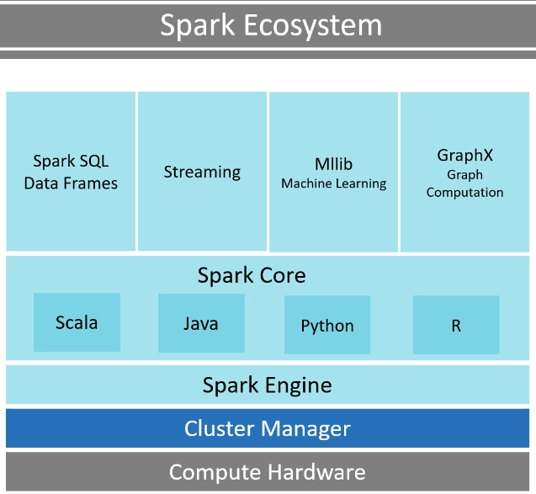 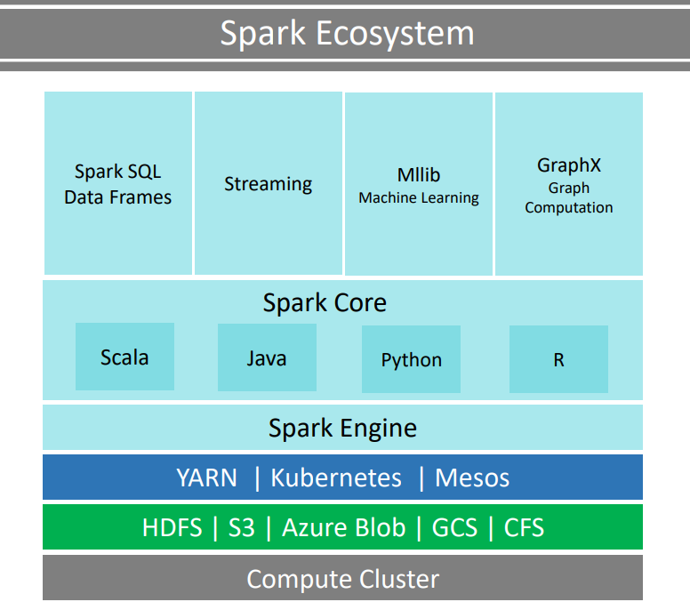

However, they all offer similar services to Spark and Spark is designed to work with both. Spark was initially based on Hadoop MR, and it was adopted in the Hadoop platform. So, the Hadoop YARN resource manager is the most commonly used cluster manager for Spark. However, you have other options such as Mesos, and Spark Standalone Cluster Manager. The newer versions of Spark are also compatible with Kubernetes, which is a Container Orchestrator. Similarly, Spark also doesn't come with an in-built storage system. And it allows you to processes the data which is stored in a variety of storage systems. Some of the most popular and commonly used storage systems are HDFS, Amazon S3, Azure Blob, Google Cloud Storage, and Cassandra file system.

So, one thing is absolutely clear. Apache Spark does not offer Cluster Management and Storage Management. All you can do with Apache Spark is to run your data processing workload. And that part is managed by the Spark Compute Engine. So the compute engine is responsible for a bunch of things. For example, breaking your data processing work into the smaller task, scheduling those tasks on the cluster for parallel execution, providing data to these tasks, managing and monitoring those tasks, provide you fault tolerance when a job fails. And to do all these, the core engine is also responsible for interacting with the cluster manager and the data storage manager. So the Spark compute engine is the core that runs and manages your data processing work and provides you a seamless experience. All you need to do is to submit your data processing jobs to the Spark, and the Spark core is going to take care of everything else.

Now let's move a level up. The second part of the Spark Core - The Core APIs. This layer is the programming interface layer that offers you the core APIs in four major languages. Scala, Java, Python and R programming language. These are the APIs that we used to write data processing logic during the initial days of the Apache Spark. However, these APIs were based on resilient distributed datasets (RDD). And people found them a little tricky to learn and use them for their day to day data processing work. Some people still use them today. However, these APIs are the hardest way to work with Apache Spark. They also lack some performance optimization features. And the Spark creators are now recommending to avoid them as much as possible. However, these APIs can offer you the highest level of flexibility to solve some complex data processing problems.

|  |  |
| --- | --- |
|  | The topmost layer is the prime area of interest for most of the Spark developers and data scientists. This layer is again a set of libraries, packages, APIs and DSL. These are developed by the Spark community over and above the Core APIs. So, you will be using these top-level APIs and DSLs. But internally, all of those will be using Spark Core APIs, and ultimately things will go to the Spark Compute Engine. The topmost API layer is grouped into four categories to support four different types of data processing requirements. However, this is just a logical grouping, and there is no hard boundary. Things are going to overlap in most of the real-life projects. The first group is a set of two things. Spark SQL and then, Spark DataFrame/Dataset APIs The Spark SQL allows you to use SQL queries to process your data. So that part is quite simple for those who already know SQL. Spark DataFrame/DataSet will allow you to use functional programming techniques to solve your data crunching problems. These APIs are available in Java, Scala, and Python. Both of these together can help you resolve most of the structured and semistructured data crunching problems. |

The next one is Spark Streaming libraries, and they allow you to process a continuous and unbounded stream of data. Then you have a set of libraries that are specifically designed to meet your machine learning, deep learning, and AI requirements. The last collection is for Graph Processing libraries, and they allow you to implement Graph Processing Algorithms using Apache Spark. So the topmost layer is nothing but a set of libraries and DSLs to help you solve your data crunching problems. And all these are available in multiple languages such as Java, Scala, Python, and R.

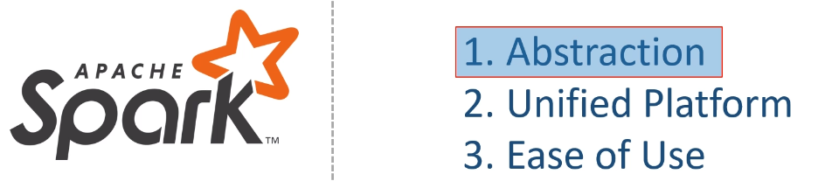

Now the next obvious question is this - What is so great about the Spark Ecosystem? Why is it so popular? At a high level, there are three main reasons. Spark will abstract away the fact that you are coding to execute your program on a cluster of computers. In the best-case scenario, you will be working with tables and using SQL queries. You will feel like working with a database. In the worst-case scenario, you will be working with RDDs or data frames. You will feel like working with Java/Scala collections, or a python data frame. That's it. Everything else, all the complexities of distributed storage, computation, and parallel programming is abstracted away by the Spark core. Spark combines the capability of SQL queries, Batch Processing, Stream Processing, Structured and semistructured data handling, Graph processing, machine learning, and deep learning. All of this in a single framework using your favorite programming language. You can mix and match them to solve many sophisticated requirements. If you compare it with old Hadoop and MapReduce code, Spark code is much shorter, simple, easy to read, and understand. You also have a growing and evolving ecosystem to offer ready to use libraries, algorithms, and integration with a wide variety of other systems. And these three things make Spark a super popular distributed computing platform for data processing. That's all.

### Source Code Repository

<https://github.com/LearningJournal/SparkProgrammingInScala>

Compressed Code Download Link: <https://github.com/LearningJournal/SparkProgrammingInScala/archive/refs/heads/master.zip>

## Spark Development Environment

The first step in learning Apache Spark is to get access to the Spark System. There are many ways you can get Spark, and here are some standard methods for a learner. The easiest method to get Spark is to download the Spark binaries and run them in local-mode on your laptop. This is the super simple method, but you will have access to the Spark from the command-line only.

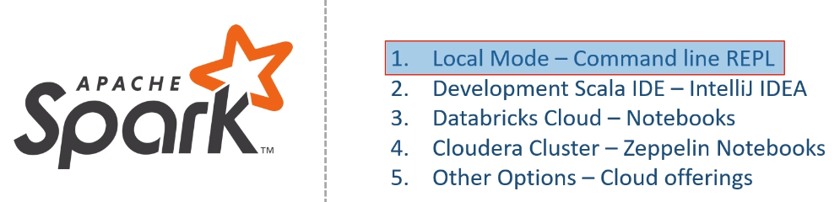

We will be using this approach in some of the examples, and I have a separate video to help you set up local mode Spark on your laptop or desktop. The next and the most common method is to run Spark in your IDE, such as IntelliJ Idea. This approach is the most effective method for Spark Developers. And most of the lectures in this course will be using this approach. The third approach of using Spark is to get access to the Databricks Cloud environment. This approach is also one of the most common methods, and you will be using Spark from Databricks Notebook. Databricks Cloud is the most popular commercial Spark offering, which runs only in cloud platforms. I will also demonstrate this approach and help you familiarize yourself with the Databricks Cloud. The next standard method for using Spark is via Zeppelin Notebooks. This approach is commonly used by developers when they are working with Cloudera Spark distribution. I will also cover this method.

There are many different options and Spark offerings. Such as Amazon EMR, Google DataProc, Azure HDInsight, and maybe a few more. However, these offerings are all commercial and have a tiny presence in real-life projects. So I am not going to include these in this course. However, I might be referring and using some of these here and there to cover the main objective of learning Spark. All the four options which I talked about are going to run Spark on a single machine or on a single virtual machine. However, Spark is a distributed processing system, and the real-life projects would be running it on a multi-node cluster environment. While Spark development and unit testing activity happen on a single machine, but a learner must have some exposure to the Spark cluster environment. So, I will be using Cloudera Cluster and Google cloud platform to expose you to the clustered environment. Great! That's all for this lecture. Let's start setting up the Spark environment in the next video.

### Local Mode – Command Line REPL

We will be setting up single node Spark and running it in local mode from the command line. So, let's start. The first thing is to get the Spark Binaries. You can download the Spark binaries from spark.apache.org. Click the download link, and it will take you to the download page. Select your preferred version, choose a package type, and download the compressed file. I am interested in the Spark 3.0, so I am going to download the Spark 3 binaries. You can download this binary from the Spark Apache website as I am showing it here. However, I have included a copy of the same in your course library. This is to make sure that you are using the same version as I am using in this training, and we can avoid unnecessary confusion.

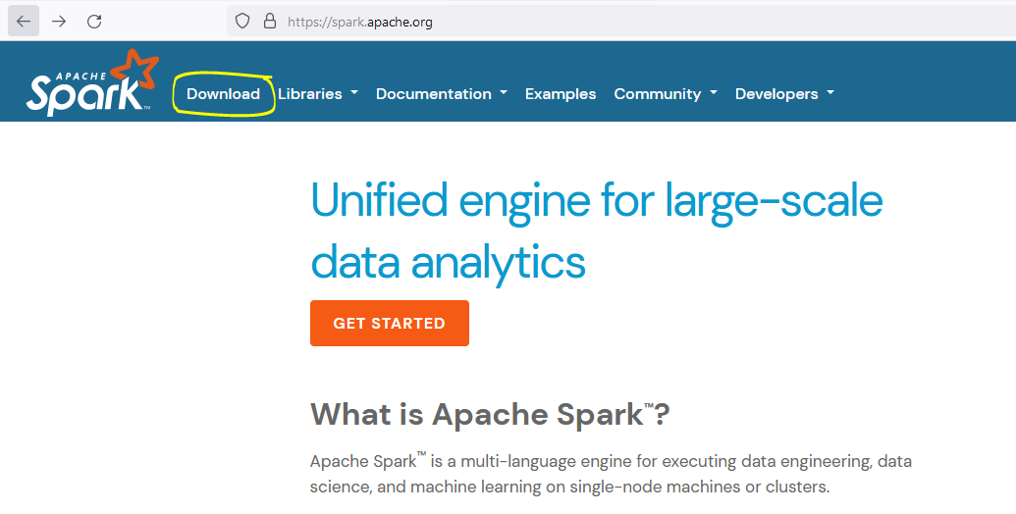

I also changed the log levels, so you get a clean screen while using command-line tools. So, I recommend that you download the Spark binaries from your included course material. Un-compress the downloaded file, and you should get a tar file. You need to extract the tar file, and you should get a Spark 3.0 directory. Let me rename it as Spark3.

<https://www.apache.org/dyn/closer.lua/spark/spark-3.2.0/spark-3.2.0-bin-hadoop3.2.tgz>

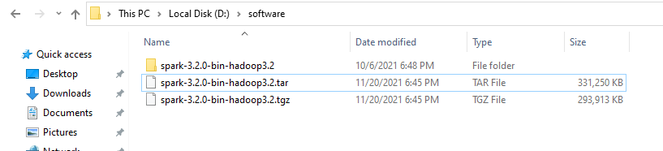

This renaming is not necessary, but I feel convenient with small directory names. If you downloaded it from your course material, then it should directly extract as the spark3 directory. Now let's look into the content of the directory.

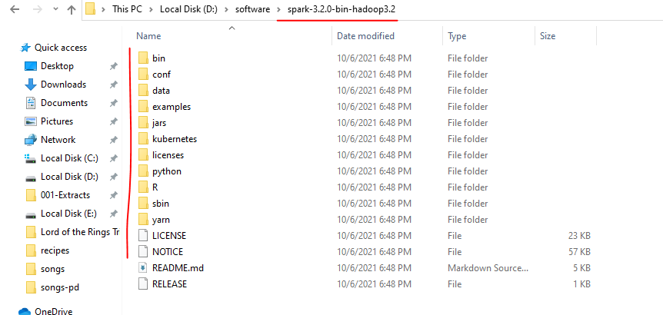

The bin folder is the place where all your Spark command-line tools are included. You will see two versions of every command. The first one is a shell script,  and the other one is a CMD file. I will be using windows laptop, so the cmd files are more important for me. However, you can use shell scripts on Linux and Mac machines in the same manner. There are other directories as well.

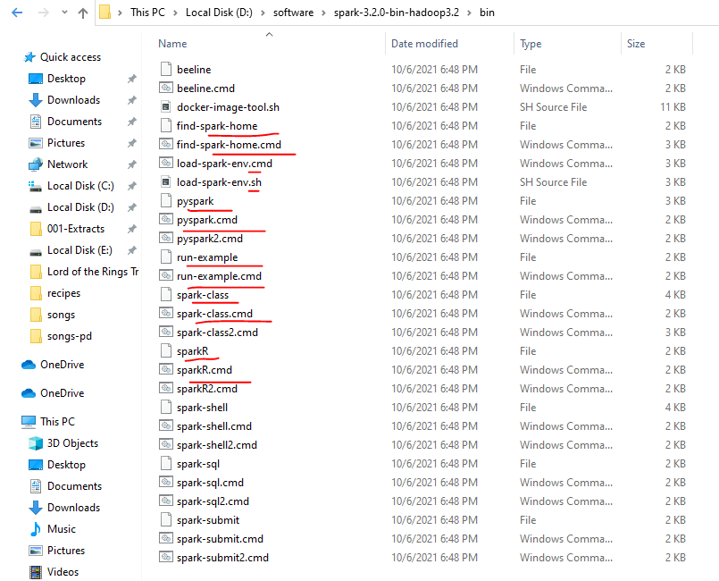

But let's not worry about them at this stage. Great! The first step is over. The next step is to start the spark-shell command-line tool and test your installation. Let me try it. Oops! I got an error. What does it say? Could not locate winutils.exe in the Hadoop binaries.

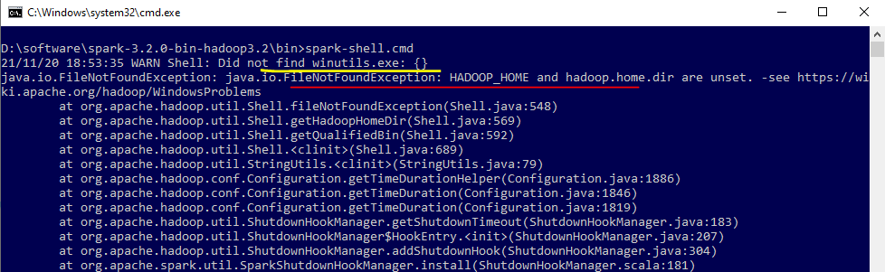

You will not see this problem on a Linux or Mac machine. And the spark-shell should be starting without any errors. However, you will need to download and install winutils to run Spark on a windows machine. I am on windows 10, so I need the winutils. You can download it from the GitHub. However, I have included a truncated tiny version in your course material. So, you can get it from your course material resources folder of this lecture.

<https://github.com/cdarlint/winutils>

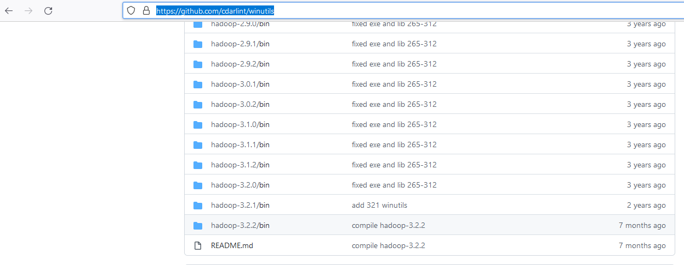

<https://github.com/cdarlint/winutils/tree/master/hadoop-3.2.2/bin>

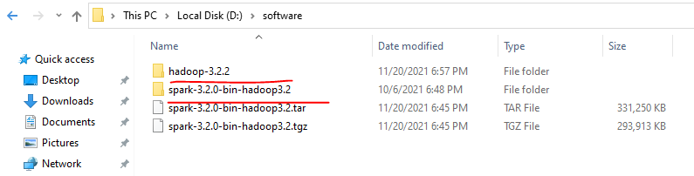

Place the hdp directory somewhere on your machine. I am keeping it in the C:\, but you can keep it wherever you want. The next step is to set up the HADOOP_HOME, and it should point to the winutils home directory. Let me do it. You can check it once. Looks good. Now you can start the spark-shell, and it should run without any errors. Great!

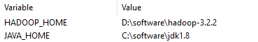

C:\Users\Lalit>echo %HADOOP_HOME%

D:\software\hadoop-3.2.2

C:\Users\Lalit>echo %SPARK_HOME%

D:\software\spark-3.2.0-bin-hadoop3.2

C:\Users\Lalit>echo %PATH%

C:\Windows\system32;C:\Windows;C:\Windows\System32\Wbem;C:\Windows\System32\WindowsPowerShell\v1.0\;C:\Windows\System32\OpenSSH\;C:\Users\Lalit\AppData\Local\Programs\Python\Python310\Scripts;C:\Users\Lalit\AppData\Local\Programs\Python\Python310\;C:\Users\Lalit\AppData\Local\Microsoft\WindowsApps;C:\software\Microsoft VS Code\bin;C:\software\jdk1.8\bin;C:\software\apache-maven-3.8.3\bin;D:\software\spark-3.2.0-bin-hadoop3.2\bin;D:\002-workspaces\scala;C:\software\sbt\bin;.;

C:\Users\Lalit>echo %JAVA_HOME%

C:\software\jdk1.8

So I got another error since I chose Spark 3.2 with hadoop 3.2

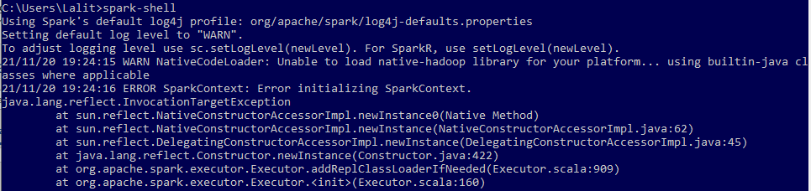

Cause

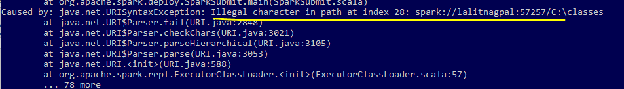

And the work around solution was to start the cluster manually and then the spark shell after that

<https://stackoverflow.com/questions/69669524/spark-illegal-character-in-path>

Open a spark cluster manually using the command:

1. **spark-class org.apache.spark.deploy.master.Master**

Your output should be something like the image below :

[**https://i.stack.imgur.com/7lOKO.png**](https://i.stack.imgur.com/7lOKO.png)

This means that your UI is set at localhost:4040 and you have opened the master at 192.168.2.4:7077.

So now the only thing thats left to do is open a **2nd** cmd and execute the command :

1. **spark-shell --master spark://192.168.2.4:7077**

and you are pretty much ready to go. I dont say that this is the best solution so i hope you elight me with a better one. I hope i helped.

|  |  |
| --- | --- |
|  |  |

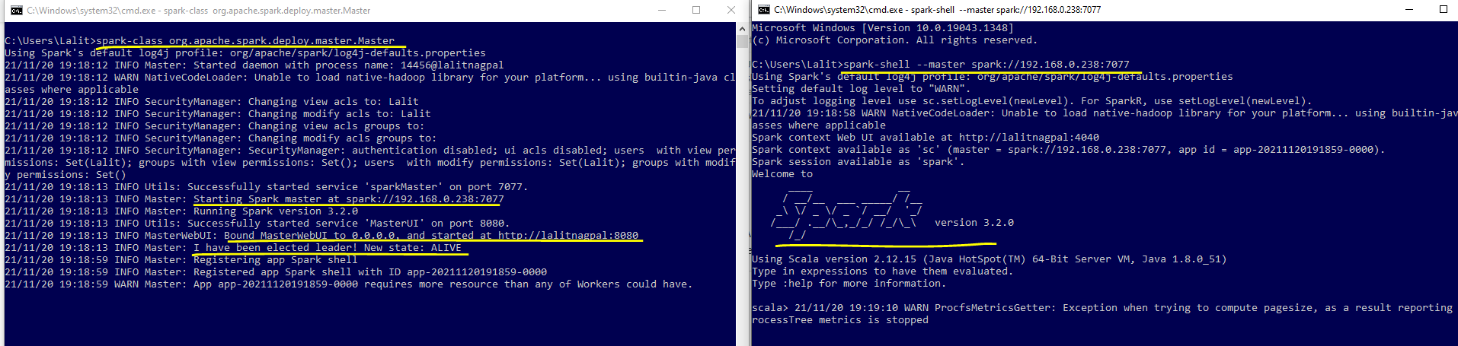

That is all. However, if you have a Docker setup on your local machine, then you can also get a Spark Container. All you need to do is to visit the learning journal spark repository at the docker hub and get the docker run command from the repository description. Run it from your command window, and it will give you a Linux shell. Now you can start the same spark-shell from here. Simple.  Isn't it? This one is a little more convenient because it runs Spark in a CentOS 8 container, and you get to work with Spark on a Linux platform.

<https://hub.docker.com/r/learningjournal/spark>

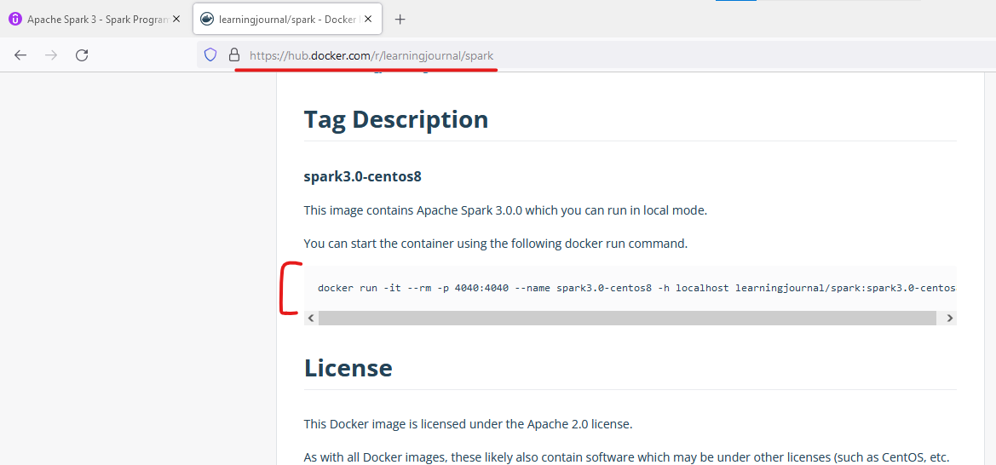

**Install Docker 4.2.0**

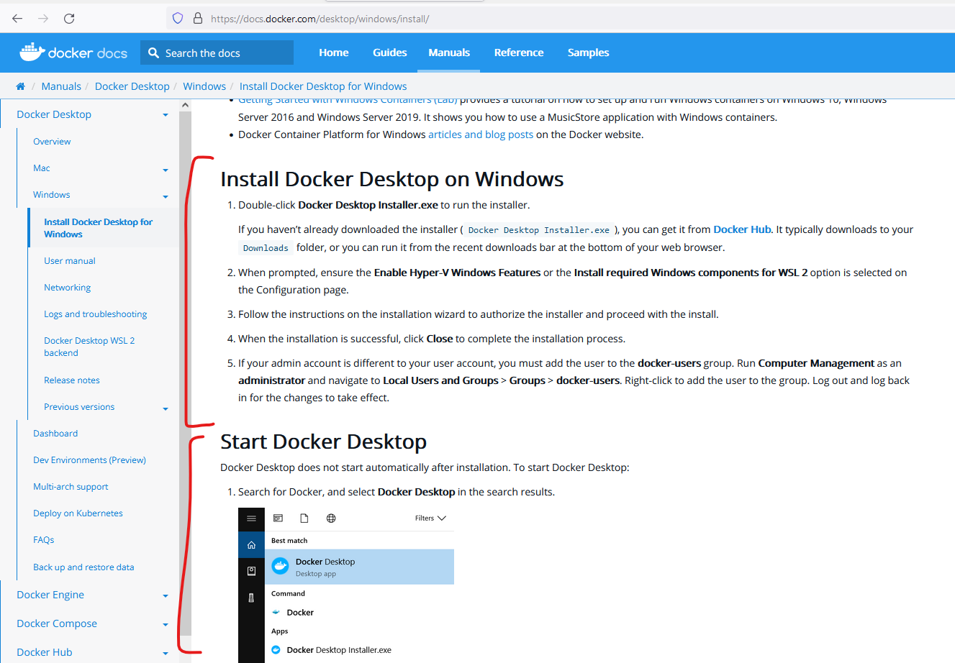

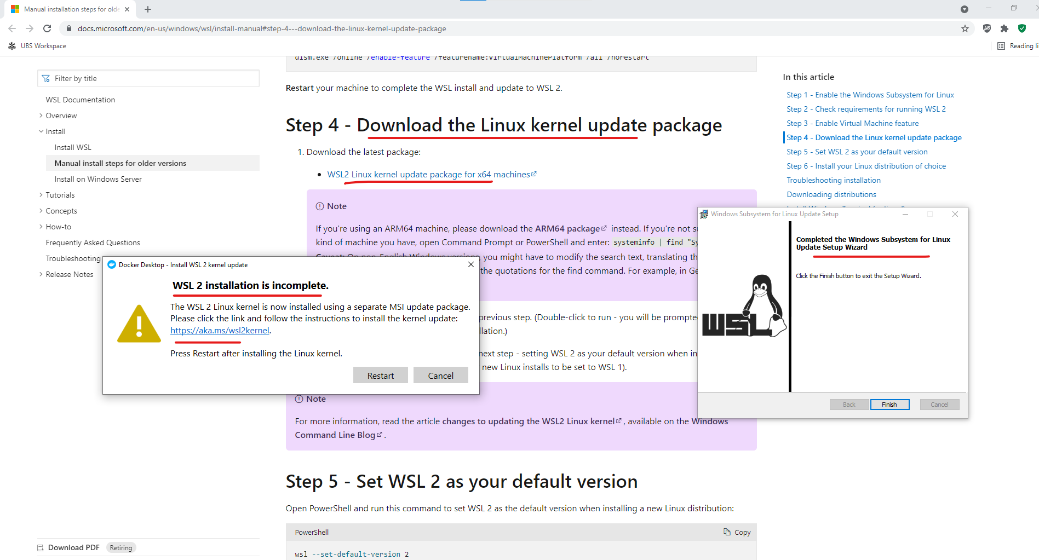

<https://docs.microsoft.com/en-us/windows/wsl/install-manual#step-4---download-the-linux-kernel-update-package>

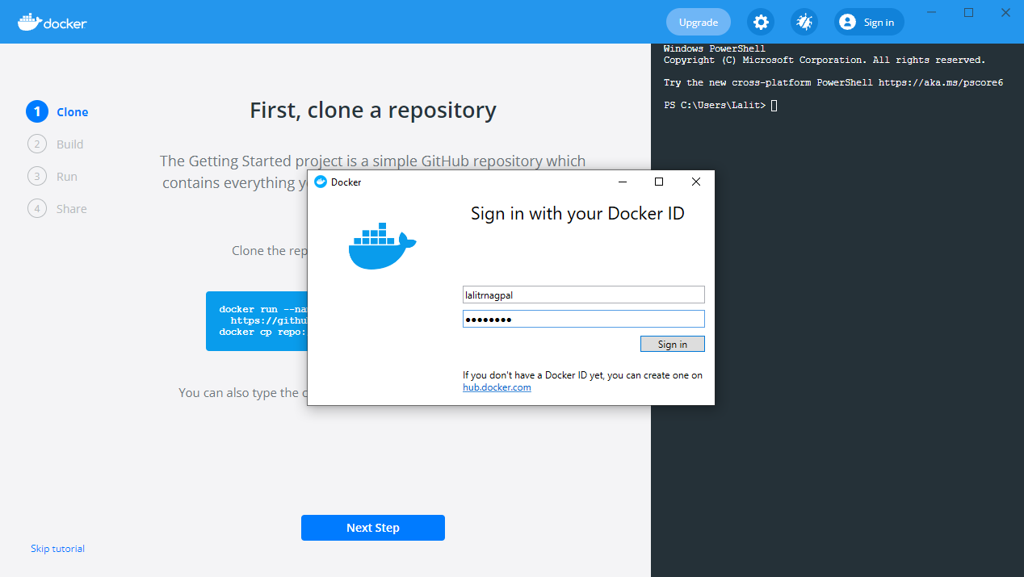

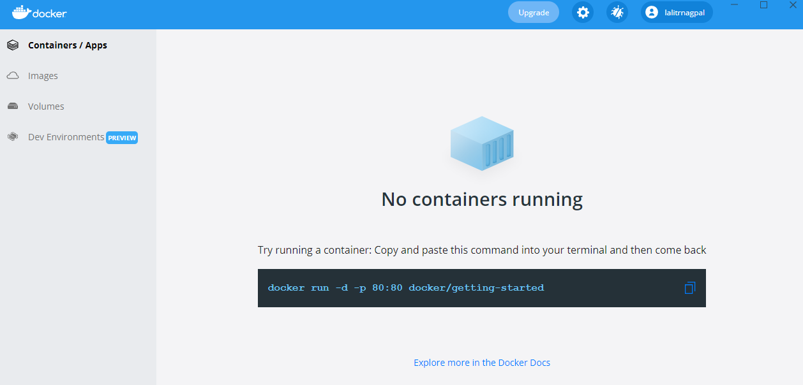

<https://hub.docker.com/r/learningjournal/spark>

**spark3.0-centos8**

This image contains Apache Spark 3.0.0 which you can run in local mode.

You can start the container using the following docker run command.

docker run -it --rm -p 4040:4040 --name spark3.0-centos8 -h localhost learningjournal/spark:spark3.0-centos8

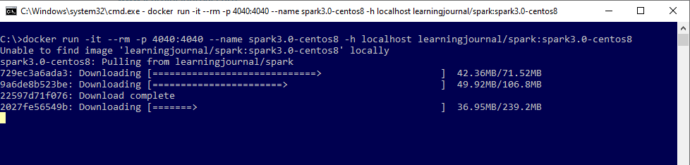

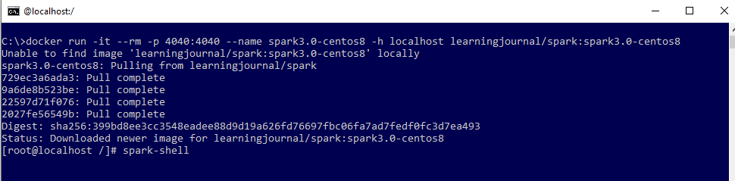

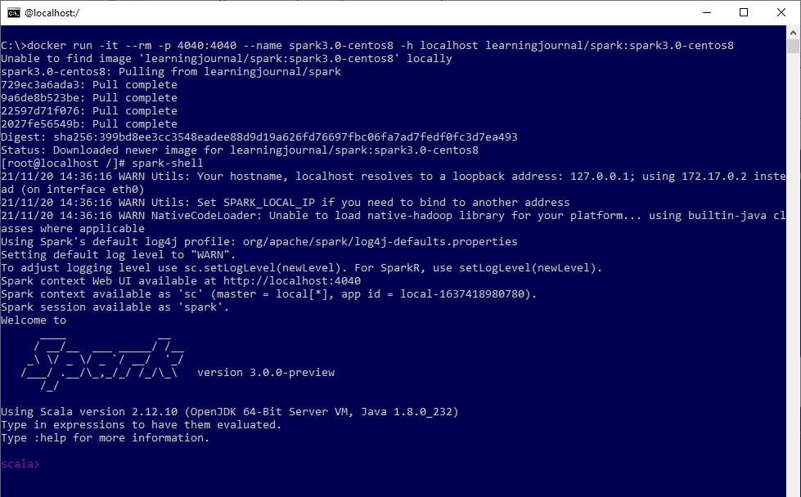

Container stops when we exit the spark scala shell with ctrl + D and the exit out of the linux shell

Below is the image we used, available to us locally now.

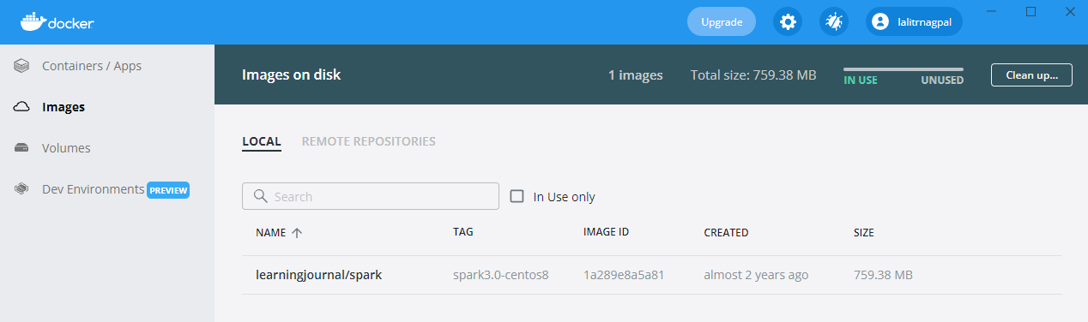

### Apache Spark - IntelliJ IDEA

I am going to use IntelliJ Community edition and also assuming that you already have IntelliJ Idea installed on your machine. We will be using Scala as our Spark programming language and SBT as the build tool. So, the first thing is to get the Scala plugin installed. Start your IntelliJ Idea, and go to settings. Click on the plugins and select the marketplace in the right side box. Search for Scala. If the Scala plugin is not installed, then click the install button. And that's all. IntelliJ will pull this plugin and install it. You may have to restart your IDE. That's it. You are now ready to create Spark programs using Scala and SBT.

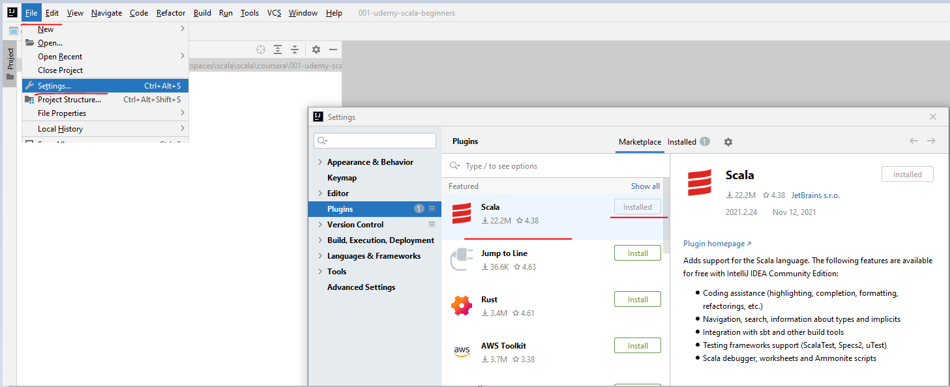

We will learn to create new programs. But for now, let's use an example and test it. We want to make sure that we can run and test Spark Programs using IntelliJ. All the examples used in this course are available in a public GitHub repository. You can access the GitHub repository using the following URL. I have included this URL link in your lecture resources. You can get the link in the attached PDF document in your lecture resources.

<https://github.com/LearningJournal/SparkProgrammingInScala>

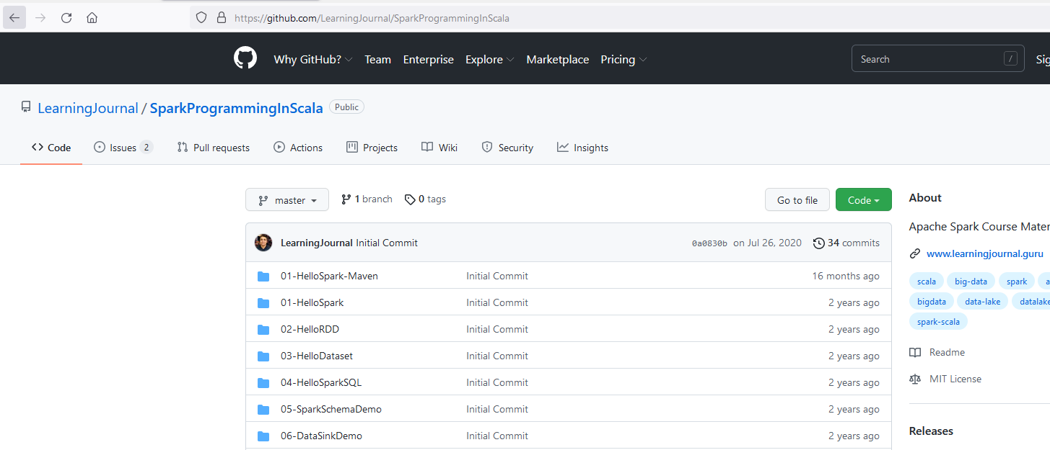

So, go to the GitHub repository and download the examples. I am keeping it in a separate directory. Let's say, spark-examples. Once your examples are downloaded. Extract them to the spark-examples directory. Okay. Here it is. However, I don't like these long directory names. Sometimes, they give problems in windows 10. So I am moving them here in the spark-examples directory. Short and sweet. Now I can delete these two guys. Great! Come back to IntelliJ, open, and select the HelloSpark directory. Your IDE should ask you to enable auto-import. Do it. Wait for a minute. If you are running a Scala project for the first time, it might take a few minutes to download and configure Scala and SBT packages. This Project is using Scala 2.12.10 version. Why? Because we downloaded Spark 3.0, which is built on Scala 2.12.10. Great! The first Spark example is loaded in your IDE.

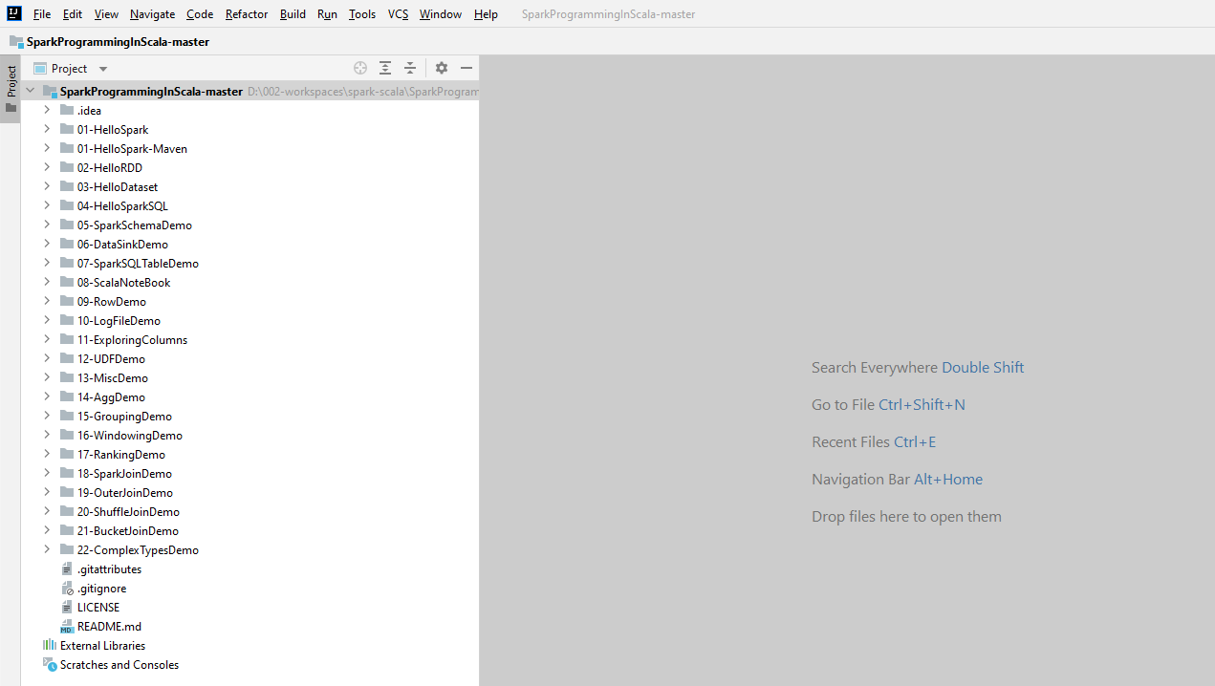

Now it's time to run it. Go to the source file and try running it. You might get an error message.

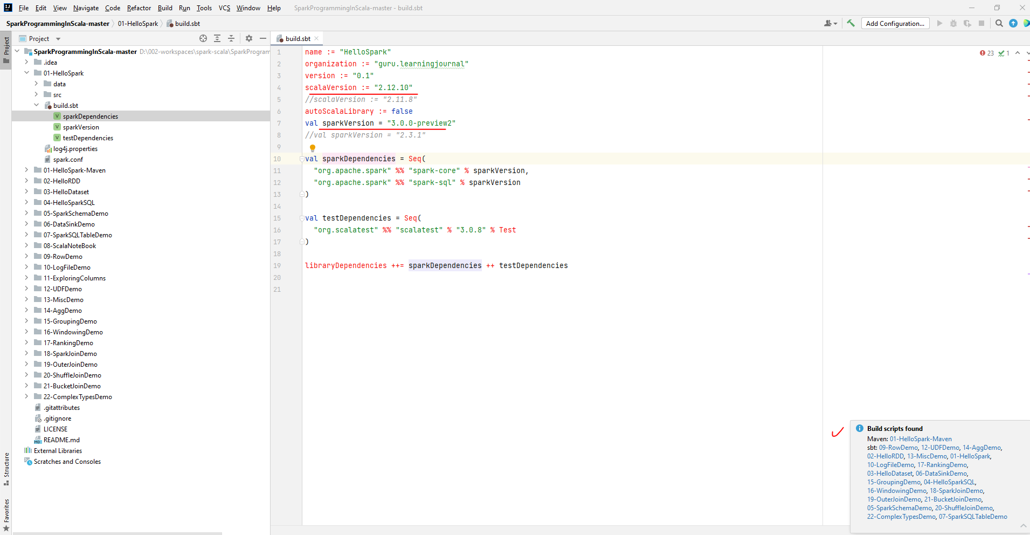

But that's perfectly fine. We ran it once to get a run configuration. Go to the Run menu and select the edit configurations.

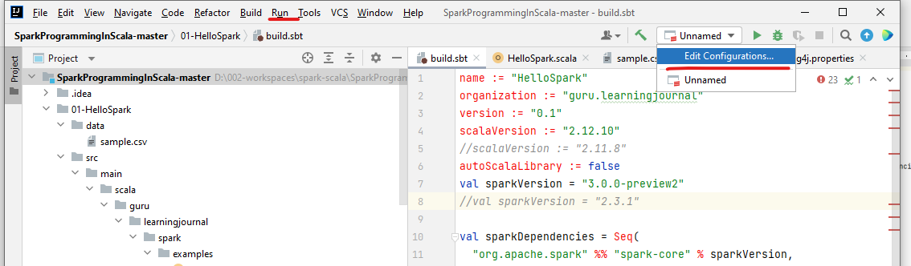

We have a few settings here, which are critical. The first one is the main class. Make sure your example's main class is selected here.

We have only one main class in this example, and that one is already selected. So we are good at this. The next one is VM options. And these are JVM configuration options. All examples in this course are going to use some JVM options. I have included them in the attached PDF. Make sure you copy them and paste it here. This is mandatory for all examples in this course. I have explained these options in the course. So, nothing to worry about now. Simply paste them here.

Press F12 to open console in IntelliJ

Run a sbt update in the Console

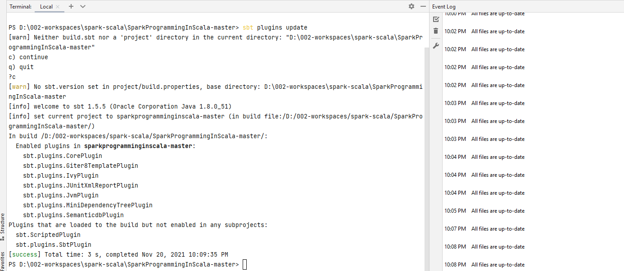

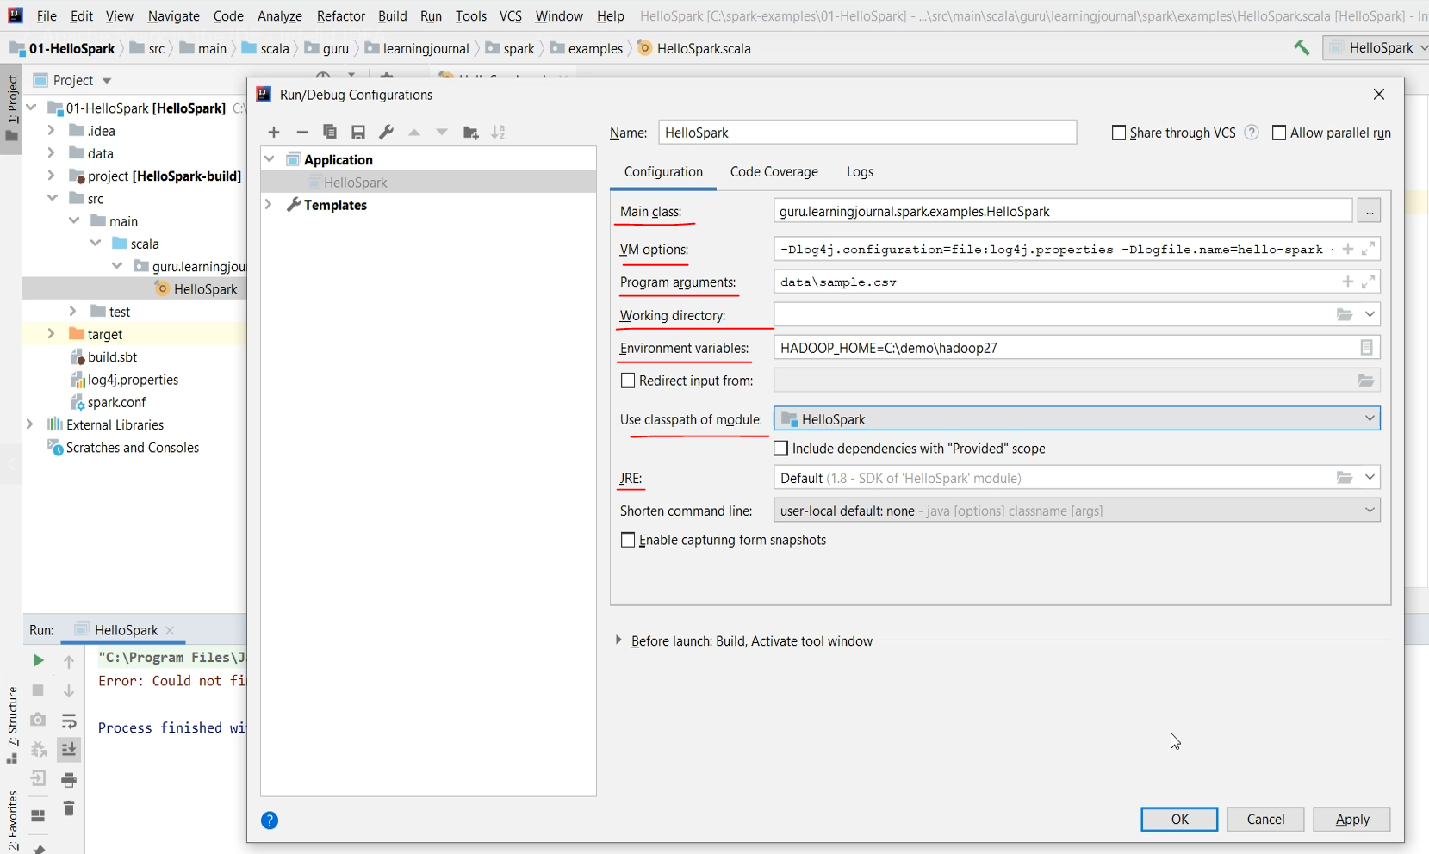

The third one is the program arguments. Some examples of this course are going to take the data source file name as a program argument. This example expects the following. The next one is the working directory. Make sure your current project directory is selected here. You can even have a blank. However, you should not have an incorrect directory that does not exist on your machine. Rest all other settings are straight. We are not going to use any environment variable from the IntelliJ. However, make sure you have set the HADOOP_HOME environment variable on your computer. If you are working on your office machine and do not have permission to set environment variables, you can give them to IntelliJ. Like this. Also, make sure that you are using the classpath of your current example. This setting should not be blank like no_module. And also, you should be using JDK 1.8. That's all about the run configuration. But remember. You have to do it for each example. Even if you are creating a new project from scratch, these settings are critical for every IntelliJ project. Save it and try running your Project once again.

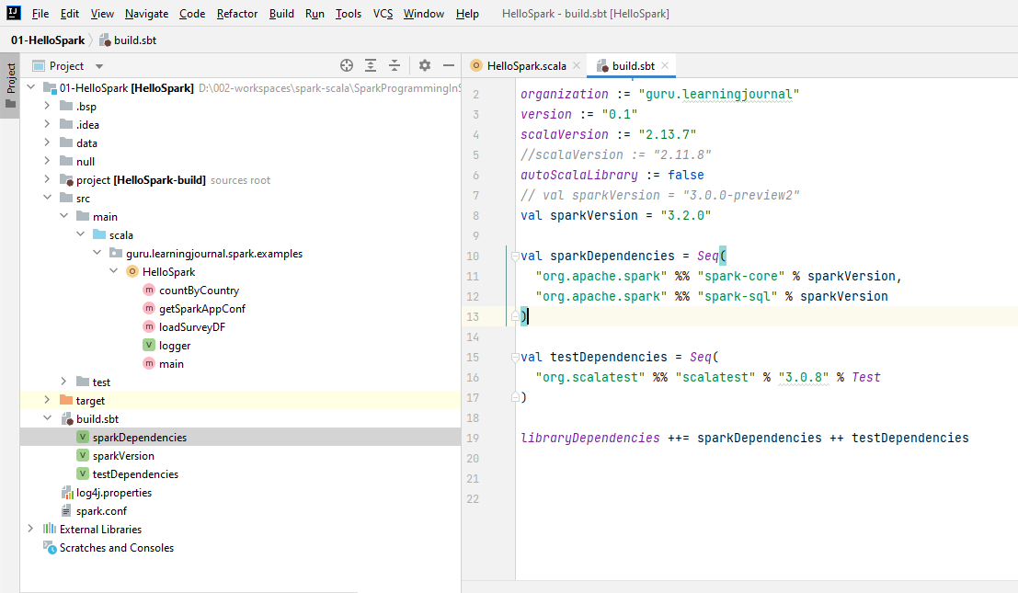

For this to build – open the project directory in IntelliJ and not like above showing all projects

It should work. Great! Some examples will also have test cases.

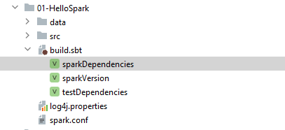

D:\002-workspaces\spark-scala\SparkProgrammingInScala-master\**01-HelloSpark**

It compiles directly.

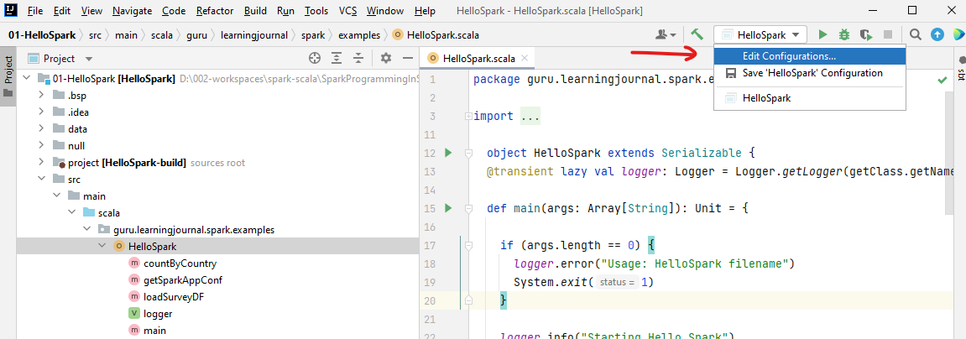

Provide the command line argument of the data file name

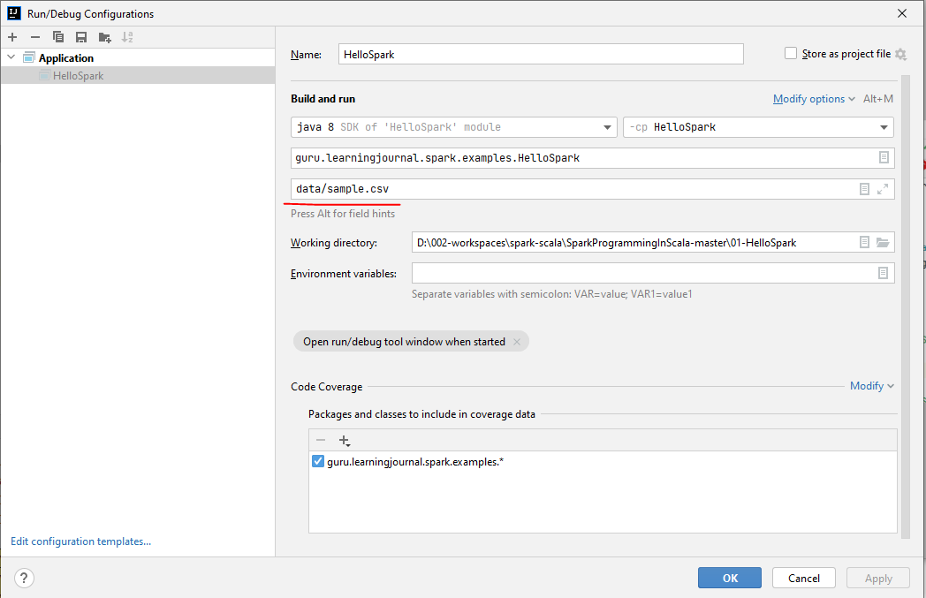

And run the file

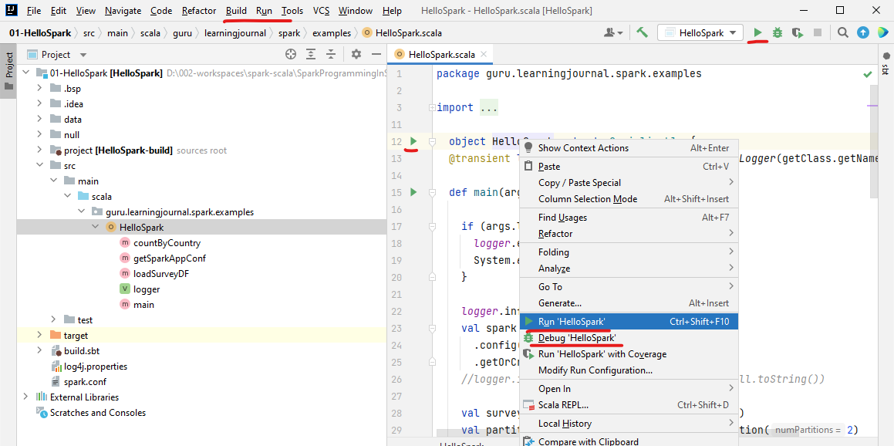

**build.sbt**

name := "HelloSpark"

organization := "guru.learningjournal"

version := "0.1"

scalaVersion := "2.12.10"

*//scalaVersion := "2.11.8"*

autoScalaLibrary := false

val sparkVersion = "3.0.0-preview2"

*//val sparkVersion = "2.3.1"*

val sparkDependencies = Seq(

"org.apache.spark" %% "spark-core" % sparkVersion,

"org.apache.spark" %% "spark-sql" % sparkVersion

)

val testDependencies = Seq(

"org.scalatest" %% "scalatest" % "3.0.8" % Test

)

libraryDependencies **++=** sparkDependencies **++** testDependencies

**log4j.properties**

*# Set everything to be logged to the console*

log4j.rootCategory=WARN, console

*# define console appender*

log4j.appender.console=org.apache.log4j.ConsoleAppender

log4j.appender.console.target=System.out

log4j.appender.console.layout=org.apache.log4j.PatternLayout

log4j.appender.console.layout.ConversionPattern=%d{yy/MM/dd HH:mm:ss} %p %c{1}: %m%n

*#application log*

log4j.logger.guru.learningjournal.spark.examples=INFO, console, file

log4j.additivity.guru.learningjournal.spark.examples=false

*#define rolling file appender*

log4j.appender.file=org.apache.log4j.RollingFileAppender

log4j.appender.file.File=${spark.yarn.app.container.log.dir}/${logfile.name}.log

*#define following in Java System*

*# -Dlog4j.configuration=file:log4j.properties*

*# -Dlogfile.name=hello-spark*

*# -Dspark.yarn.app.container.log.dir=app-logs*

log4j.appender.file.ImmediateFlush=true

log4j.appender.file.Append=false

log4j.appender.file.MaxFileSize=500MB

log4j.appender.file.MaxBackupIndex=2

log4j.appender.file.layout=org.apache.log4j.PatternLayout

log4j.appender.file.layout.conversionPattern=%d{yy/MM/dd HH:mm:ss} %p %c{1}: %m%n

*# Recommendations from Spark template*

log4j.logger.org.apache.spark.repl.Main=WARN

log4j.logger.org.spark_project.jetty=WARN

log4j.logger.org.spark_project.jetty.util.component.AbstractLifeCycle=ERROR

log4j.logger.org.apache.spark.repl.SparkIMain$exprTyper=INFO

log4j.logger.org.apache.spark.repl.SparkILoop$SparkILoopInterpreter=INFO

log4j.logger.org.apache.parquet=ERROR

log4j.logger.parquet=ERROR

log4j.logger.org.apache.hadoop.hive.metastore.RetryingHMSHandler=FATAL

log4j.logger.org.apache.hadoop.hive.ql.exec.FunctionRegistry=ERROR

**HelloSpark.scala**

package guru.learningjournal.spark.examples

import java.util.Properties

import scala.language.implicitConversions

import org.apache.log4j.Logger

import org.apache.spark.SparkConf

import org.apache.spark.sql.{DataFrame, SparkSession}

import scala.io.Source

object HelloSpark extends Serializable {

@transient lazy val logger: Logger = Logger.getLogger(getClass.getName)

def main(args: Array[String]): Unit = {

if (args.length == 0) {

logger.error("Usage: HelloSpark filename")

System.exit(1)

}

logger.info("Starting Hello Spark")

val spark = SparkSession.builder()

.config(getSparkAppConf)

.getOrCreate()

logger.info("spark.conf=" + spark.conf.getAll.toString())

val surveyRawDF = **loadSurveyDF(**spark, args(0)**)**

val partitionedSurveyDF = surveyRawDF.repartition(2)

val countDF = **countByCountry(**partitionedSurveyDF**)**

countDF.foreach(row => {

logger.info("Country: " + row.getString(0) + " Count: " + row.getLong(1))

})

logger.info(countDF.collect().mkString("->"))

logger.info("Finished Hello Spark")

*//scala.io.StdIn.readLine()*

spark.stop()

}

def countByCountry(surveyDF: DataFrame): DataFrame = {

surveyDF.where("Age < 40")

.select("Age", "Gender", "Country", "state")

.groupBy("Country")

.count()

}

def loadSurveyDF(spark: SparkSession, dataFile: String): DataFrame = {

spark.read

.option("header", "true")

.option("inferSchema", "true")

.csv(dataFile)

}

def getSparkAppConf: SparkConf = {

val **sparkAppConf** = new SparkConf

*//Set all Spark Configs*

val props = new Properties

props.load(Source.fromFile("spark.conf").bufferedReader())

props.forEach((k, v) => sparkAppConf.set(k.toString, v.toString))

*//This is a fix for Scala 2.11*

*//import scala.collection.JavaConverters._*

*//props.asScala.foreach(kv => sparkAppConf.set(kv._1, kv._2))*

**sparkAppConf**

}

}

**sample.csv**

"Timestamp","Age","Gender","Country","state","self_employed","family_history","treatment","work_interfere","no_employees","remote_work","tech_company","benefits","care_options","wellness_program","seek_help","anonymity","leave","mental_health_consequence","phys_health_consequence","coworkers","supervisor","mental_health_interview","phys_health_interview","mental_vs_physical","obs_consequence","comments"

2014-08-27 11:29:31,37,"Female","United States","IL",NA,"No","Yes","Often","6-25","No","Yes","Yes","Not sure","No","Yes","Yes","Somewhat easy","No","No","Some of them","Yes","No","Maybe","Yes","No",NA

2014-08-27 11:29:37,44,"M","United States","IN",NA,"No","No","Rarely","More than 1000","No","No","Don't know","No","Don't know","Don't know","Don't know","Don't know","Maybe","No","No","No","No","No","Don't know","No",NA

**spark.conf**

spark.app.name = Hello Spark

spark.master = local[3]

spark.sql.shuffle.partitions = 2

*Output:*

***Logs when its run***

*21/11/21 08:52:50 INFO HelloSpark$: Country: United Kingdom Count: 1*

*21/11/21 08:52:50 INFO HelloSpark$: Country: Canada Count: 2*

*21/11/21 08:52:50 INFO HelloSpark$: Country: United States Count: 4*

**Running the Test Case**

HelloSparkTest.scala

package guru.learningjournal.spark.examples

import org.apache.spark.sql.SparkSession

import org.scalatest.{BeforeAndAfterAll, FunSuite}

import guru.learningjournal.spark.examples.HelloSpark.{countByCountry, loadSurveyDF}

import scala.collection.mutable

class HelloSparkTest extends FunSuite with BeforeAndAfterAll {

@transient var *spark*: SparkSession = _

override def beforeAll(): Unit = {

*spark* = SparkSession.builder()

.appName("HelloSparkTest")

.master("local[3]")

.getOrCreate()

}

override def afterAll(): Unit = {

spark.stop()

}

test("Data File Loading") {

val sampleDF = loadSurveyDF(*spark*,"data/sample.csv")

val rCount = sampleDF.count()

assert(rCount==9, " record count should be 9")

}

test("Count by Country"){

val sampleDF = *loadSurveyDF*(*spark*,"data/sample.csv" )

val countDF = *countByCountry*(sampleDF)

val countryMap = new mutable.HashMap[String, Long]

countDF.collect().foreach(r => countryMap.put(r.getString(0), r.getLong(1)))

assert(countryMap("United States") == 4, ":- Count for Unites States should be 6")

assert(countryMap("Canada") == 2, ":- Count for Canada should be 2")

assert(countryMap("United Kingdom") == 1, ":- Count for Unites Kingdom should be 1")

}

}

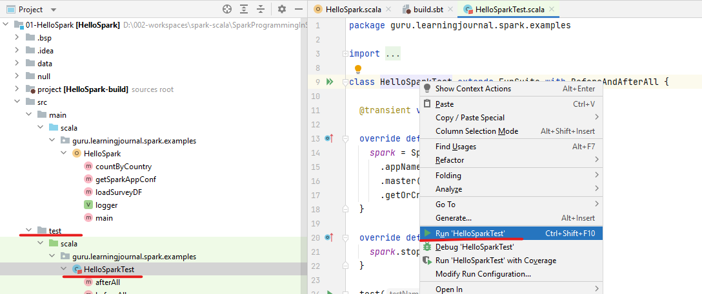

**FunSuite documentation**

org.scalatest

@Finders(Array("org.scalatest.finders.FunSuiteFinder"))

class FunSuite

extends FunSuiteLike

A suite of tests in which each test is represented as a function value. The “Fun” in FunSuite stands for “function.”

Recommended Usage: For teams coming from xUnit, FunSuite feels comfortable and familiar while still giving some benefits of BDD: FunSuite makes it easy to write descriptive test names, natural to write focused tests, and generates specification-like output that can facilitate communication among stakeholders.

Here's an example FunSuite:

package org.scalatest.examples.funsuite

import org.scalatest.FunSuite

class SetSuite extends FunSuite {

test("An empty Set should have size 0") {

assert(Set.empty.size === 0)

}

test("Invoking head on an empty Set should produce NoSuchElementException") {

assertThrows[NoSuchElementException] {

Set.empty.head

}

}

org.scalatest

@Finders(Array("org.scalatest.finders.FunSuiteFinder"))

trait FunSuiteLike

extends TestSuite

with TestRegistration with Informing with Notifying with Alerting with Documenting

Implementation trait for class FunSuite, which represents a suite of tests in which each test is represented as a function value.

FunSuite is a class, not a trait, to minimize compile time given there is a slight compiler overhead to mixing in traits compared to extending classes. If you need to mix the behavior of FunSuite into some other class, you can use this trait instead, because class FunSuite does nothing more than extend this trait and add a nice toString implementation.

See the documentation of the class for a detailed overview of FunSuite.

sbt: org.scalatest:scalatest_2.13:3.0.8:jar

This example also comes with some unit test cases. Right-click the test class and try running it. It worked. I passed 2 of 2 tests.

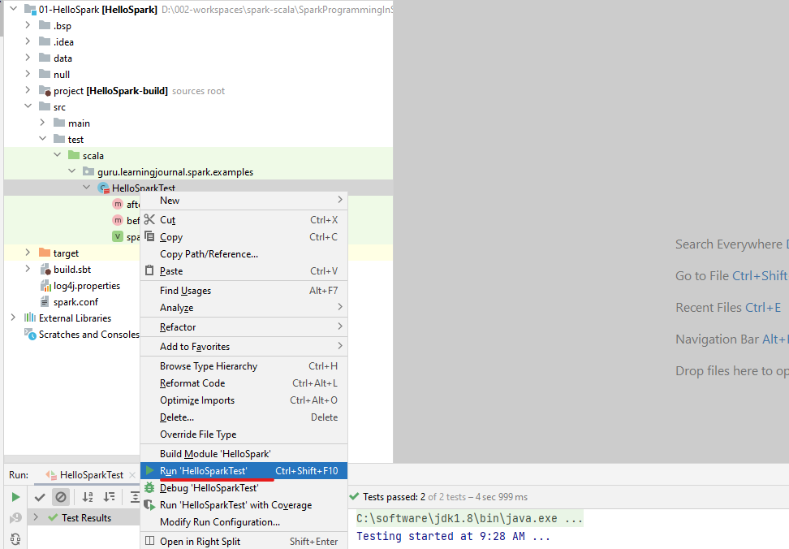

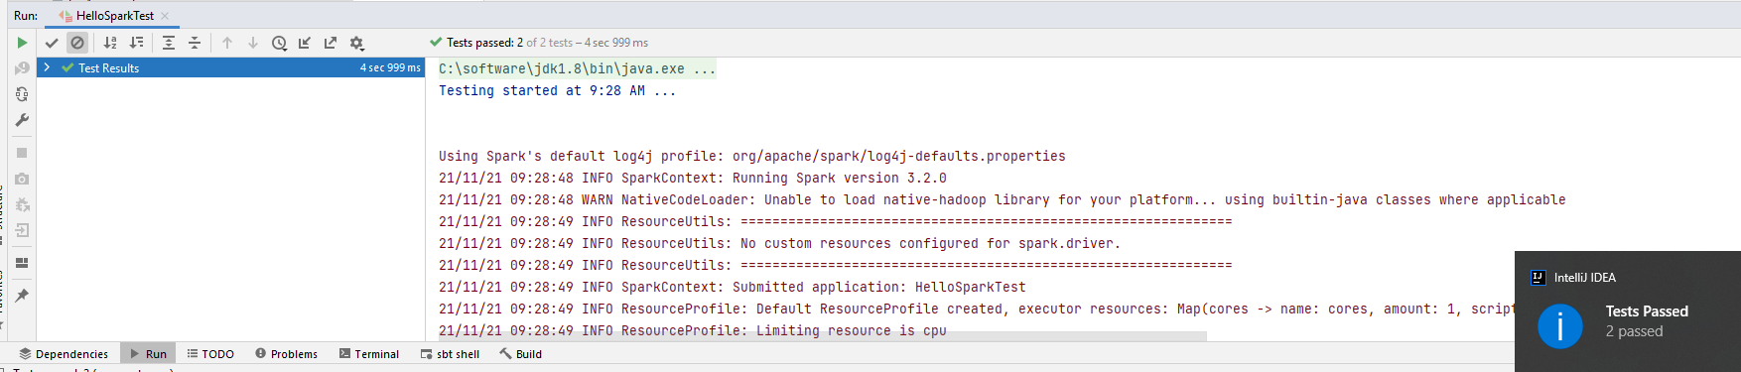

If you are facing some problems while running the test cases, it could be again due to run configurations. Let me show you. So, you have a separate run configuration for your test class. So, this one was for the application class. And the other one is for the Scala Test class. Things are the same here also. Which Test class do you want to run? The name should match your test class. VM parameters, the environment variable, working directory, classpath of the module, and the Java version.

Testing started at 9:26 AM ...

Using Spark's default log4j profile: org/apache/spark/log4j-defaults.properties

21/11/21 09:26:28 INFO SparkContext: Running Spark version 3.2.0

Edit Configurations for the Test Case

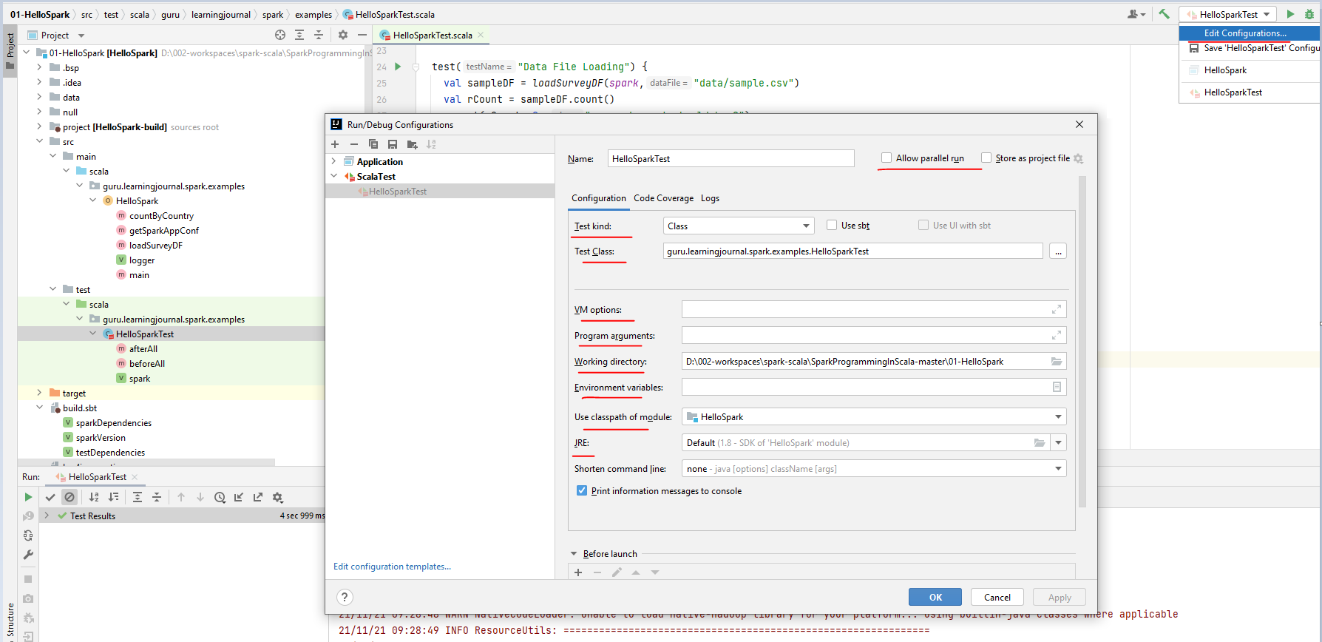

We talked about all of this. If you are not setting HADOOP_HOME on your machine, then you must provide it here also. Great! So now, you are ready to use your IDE to develop some Spark programs, debug it, run unit test cases, and finally package and deploy them on your Spark Cluster. We will cover all that in other lectures.

### Creating a New Project

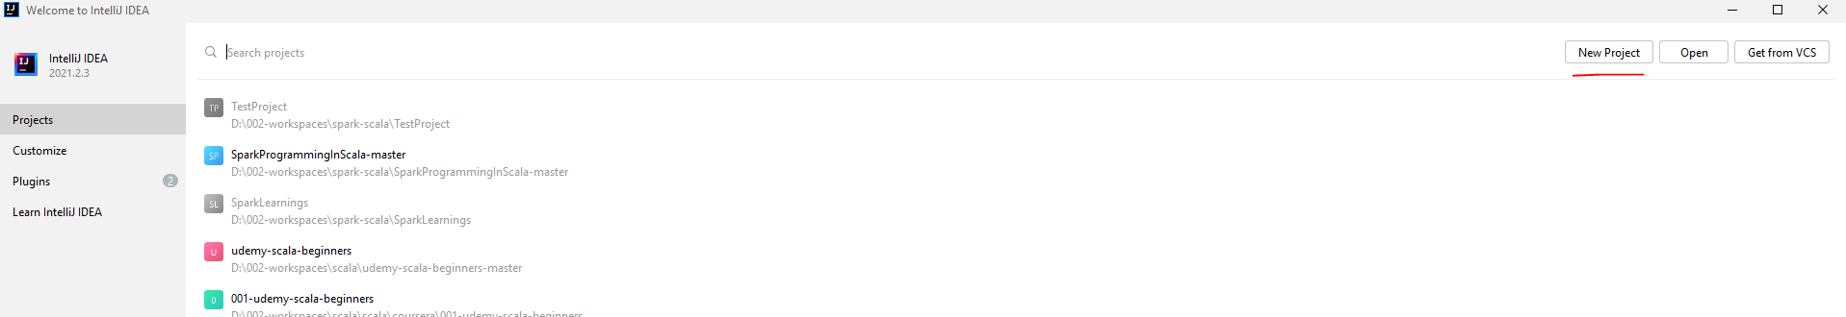

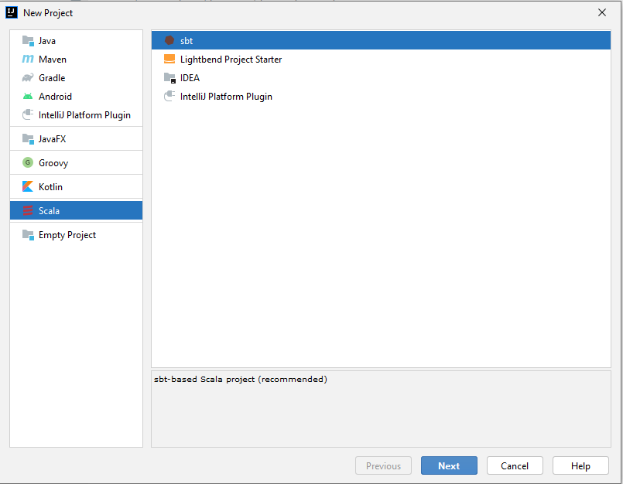

Fetches sbt and Scala versions available

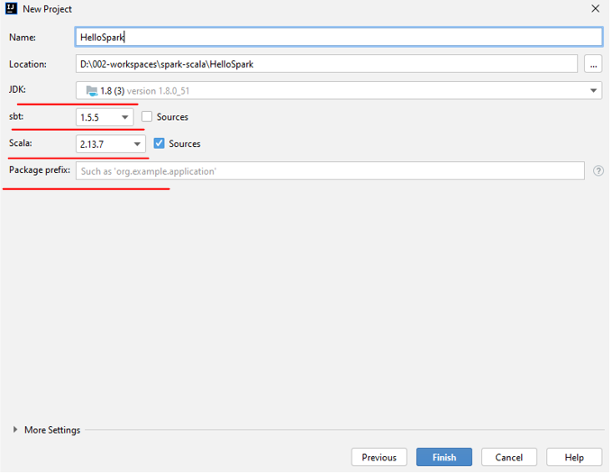

Let it sync

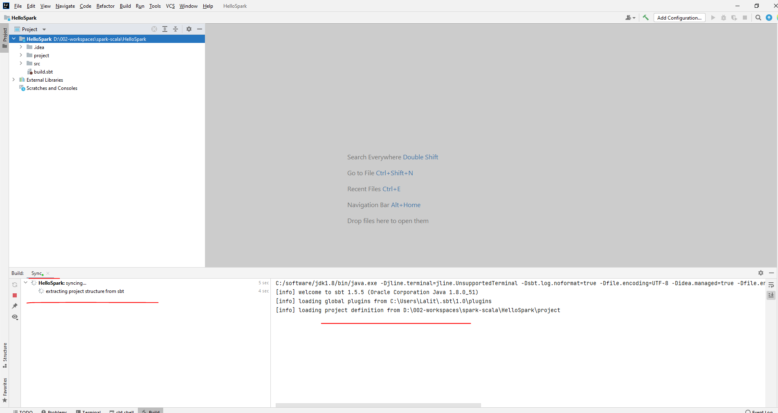

Add dependencies

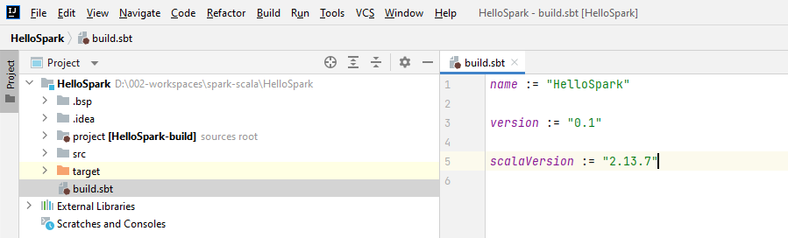

Search for Maven repository Log4j and pickup from the sbt tab

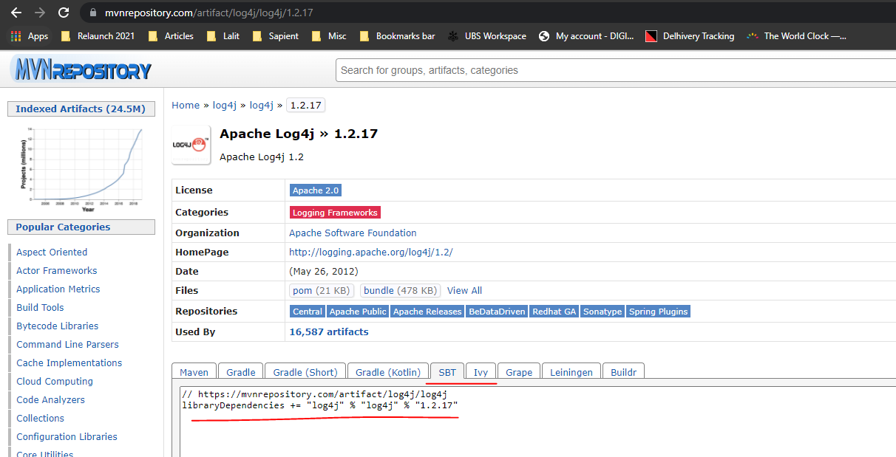

Search for Maven Spark Repository, pickup from sbt

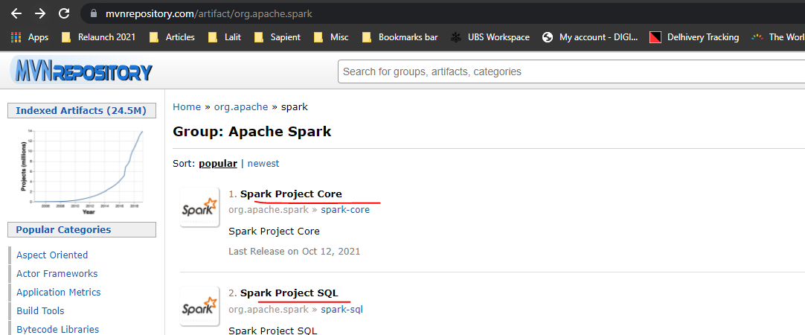

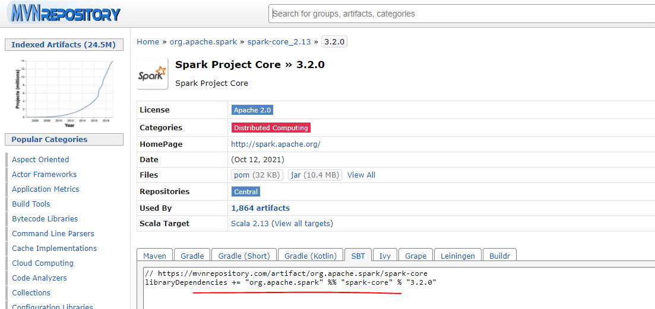

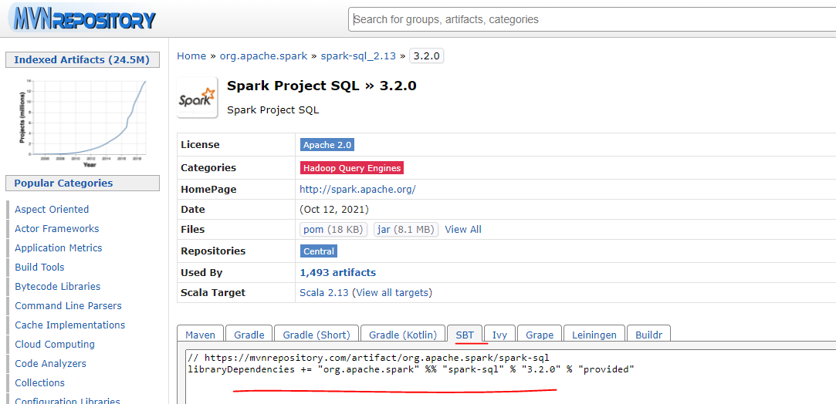

After all dependencies are specified, load the sbt changes by clicking on this icon

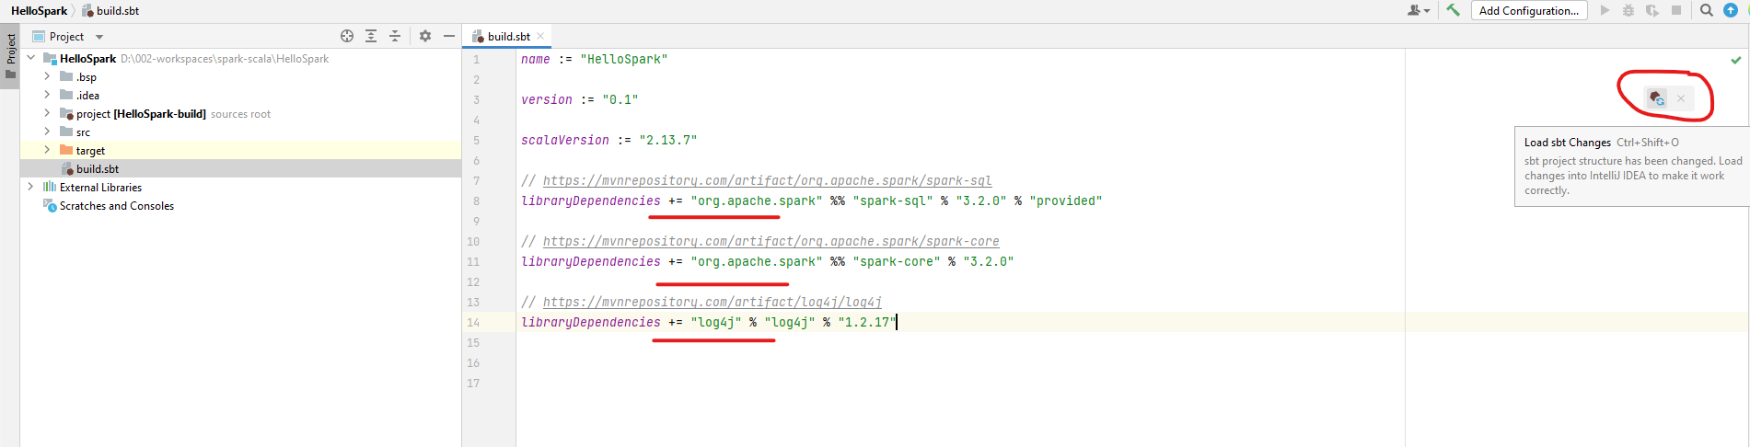

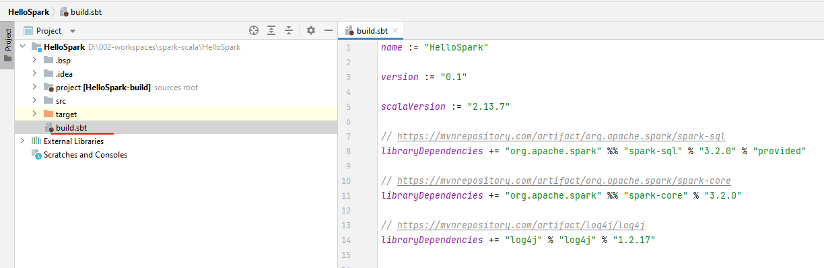

**build.sbt**

name := "HelloSpark"

version := "0.1"

scalaVersion := "2.13.7"

// https://mvnrepository.com/artifact/org.apache.spark/spark-sql

libraryDependencies **+=** "org.apache.spark" %% "spark-sql" % "3.2.0" % "provided"

// https://mvnrepository.com/artifact/org.apache.spark/spark-core

libraryDependencies **+=** "org.apache.spark" %% "spark-core" % "3.2.0"

// https://mvnrepository.com/artifact/log4j/log4j

libraryDependencies **+=** "log4j" % "log4j" % "1.2.17"

Modified this file to

**build.sbt**

name:= "HelloSpark"

version:= "0.1"

scalaVersion:= "2.13.7"

val sparkVersion = "3.2.0"

val sparkDependencies = Seq(

"org.apache.spark" %% "spark-core" % sparkVersion,

"org.apache.spark" %% "spark-sql" % sparkVersion

)

val testDependencies = Seq(

"org.scalatest" %% "scalatest" % "3.0.8" % Test

)

libraryDependencies**++=** sparkDependencies **++** testDependencies

**HelloSpark.sql**

package org.learning.scala

import org.apache.log4j.Logger

import org.apache.spark.SparkConf

import org.apache.spark.sql.SparkSession

import java.util.Properties

import scala.language.implicitConversions

import scala.io.Source

object HelloSpark extends Serializable {

@transient lazy val *logger*: Logger = Logger.getLogger(getClass.getName)

def main(args: Array[String]): Unit = {

*// if (*args*.*length *== 0) {*

*//* logger*.*error*("Usage: HelloSpark filename")*

*//* println*("Hello There!")*

*//* System*.*exit*(1)*

*// }*

logger.info("Starting Hello Spark")

*println*("Starting Hello Spark")

val spark = SparkSession.builder()

.config(getSparkAppConf)

.getOrCreate()

*logger.info("spark.conf=" +* spark*.*conf*.*getAll*.*toString()*)*

*logger*.info("Finished Hello Spark")

*//scala.io.StdIn.readLine()*

spark.stop()

}

def getSparkAppConf: SparkConf = {

val sparkAppConf = new SparkConf

*//Set all Spark Configs*

val props = new Properties

props.load(Source.fromFile("spark.conf").bufferedReader())

props.forEach((k, v) => sparkAppConf.set(k.toString, v.toString))

*//This is a fix for Scala 2.11*

*//import scala.collection.JavaConverters._*

*//props.asScala.foreach(kv => sparkAppConf.set(kv._1, kv._2))*

sparkAppConf

}

}

**spark.conf**

spark.app.name = Hello Spark

spark.master = local[3]

spark.sql.shuffle.partitions = 2

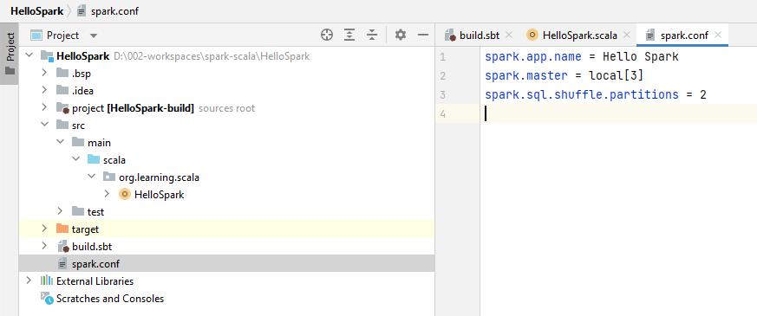

On Running the Scala file now

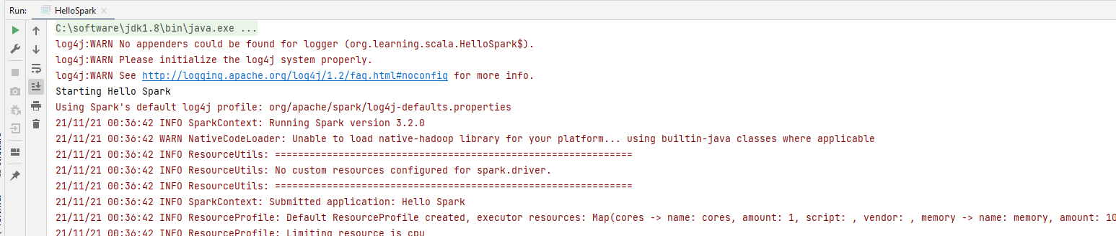

### Cloud - Databricks Community & Notebooks

Lets see the steps for getting access to the Databricks Cloud Community Edition. The Databricks Cloud is the most popular solution for running Spark in the Cloud environment. It comes with almost everything that you need to develop, test, and deploy a Spark application in the Cloud. And they are generous enough to offer a Community Edition for the learners. However, the Community Edition is going to give you a 6GB single-node Spark Cluster. You will be running your Spark code using Databricks Notebook in your browser. And a bunch of Databricks commercial features will not be available in the Community Edition. But it is a good place for learners. So, let's get the access.

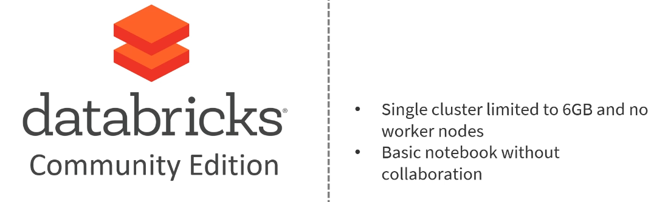

Go to https://databricks.com/ and click the try Databricks link. We are going to register for the Community Edition. Provide your details and create a new account. They will send you a verification email. Follow the email link, and you should be able to land into the Databricks Cloud. The welcome screen looks like this. Let's quickly explore it. For doing anything here, you must have a Spark Cluster. So, let's go ahead and create a new Databricks Community Cluster.

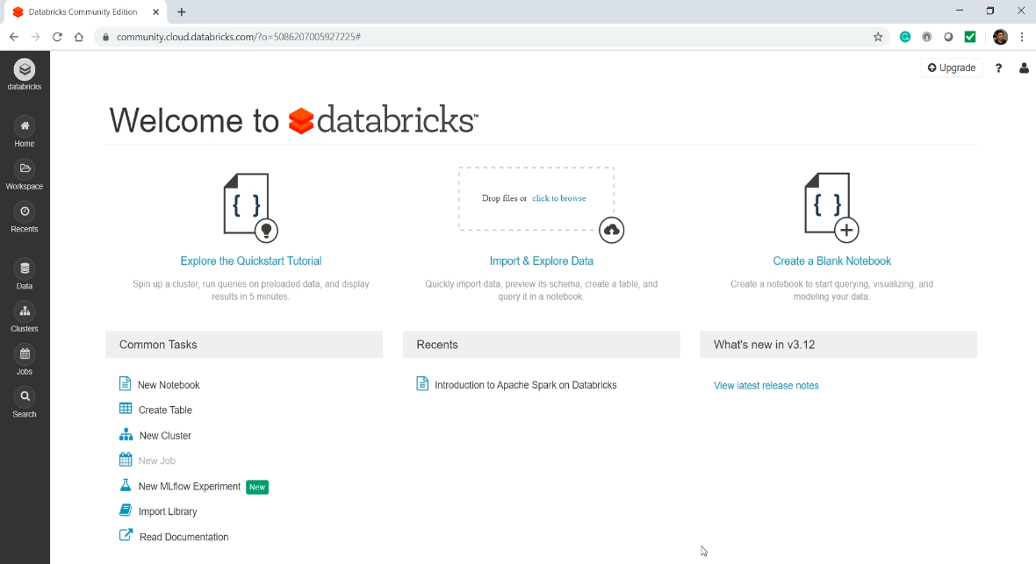

Give a name to your Cluster and select a Spark Version. Hit the Create Cluster button and wait for few minutes while Databricks is setting up your Cluster. So, what is a Databricks Cluster? Well, the Cluster is obviously your Spark Cluster - In case of the Community Edition, it is a single and tiny VM with 6 GB memory.

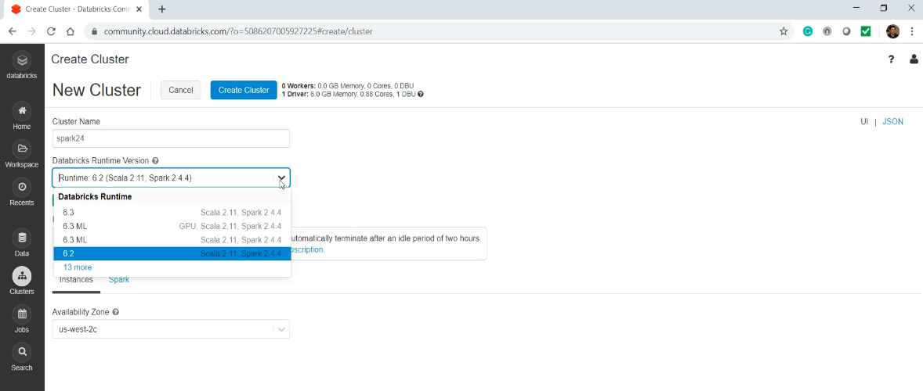

You can create only one active Cluster in the community edition. And Databricks will automatically remove your Community Edition cluster if you are not using it for 2 hours.

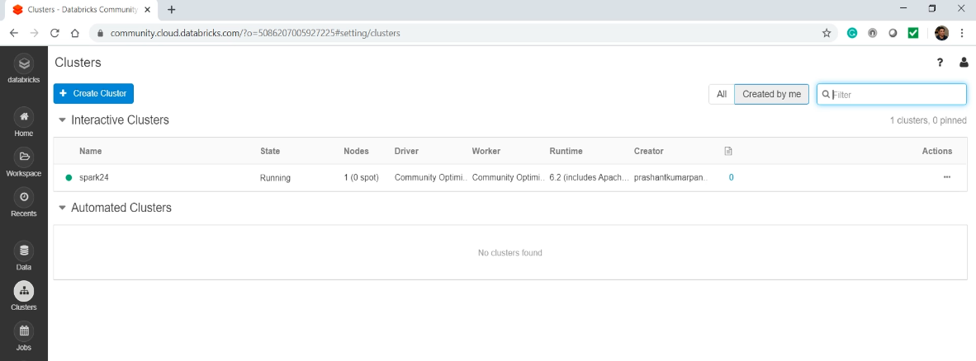

However, you can create a new one later. Now let's create a new Notebook. Give a name to your Notebook, select your default language (SQL), and attach it to a cluster. Good! So what is a Notebook?

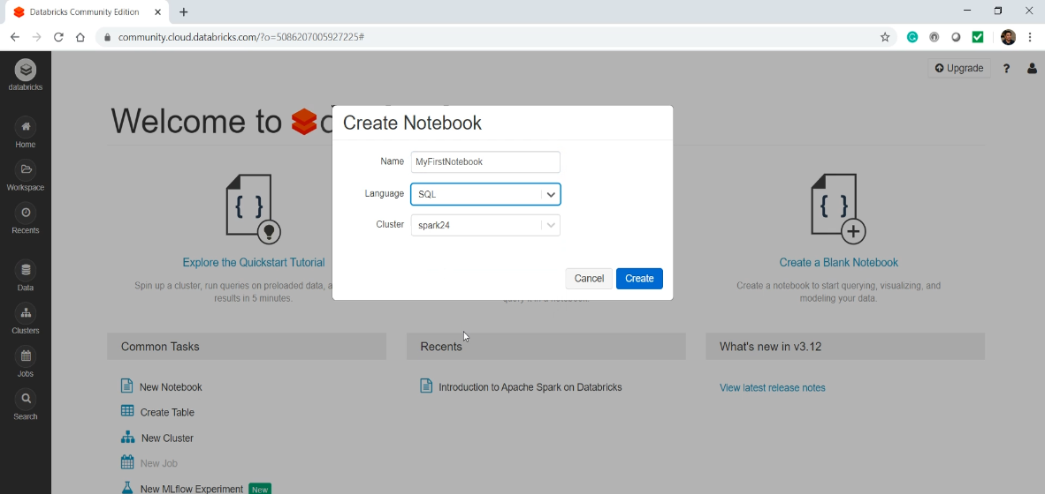

The Notebook is like a project file. You can write your Spark code in the Notebook, run it on your Databricks cluster and also see the results in the Notebook itself. It doesn't offer you IDE-like features, but the Notebooks are a pretty powerful interface for Spark Developers.

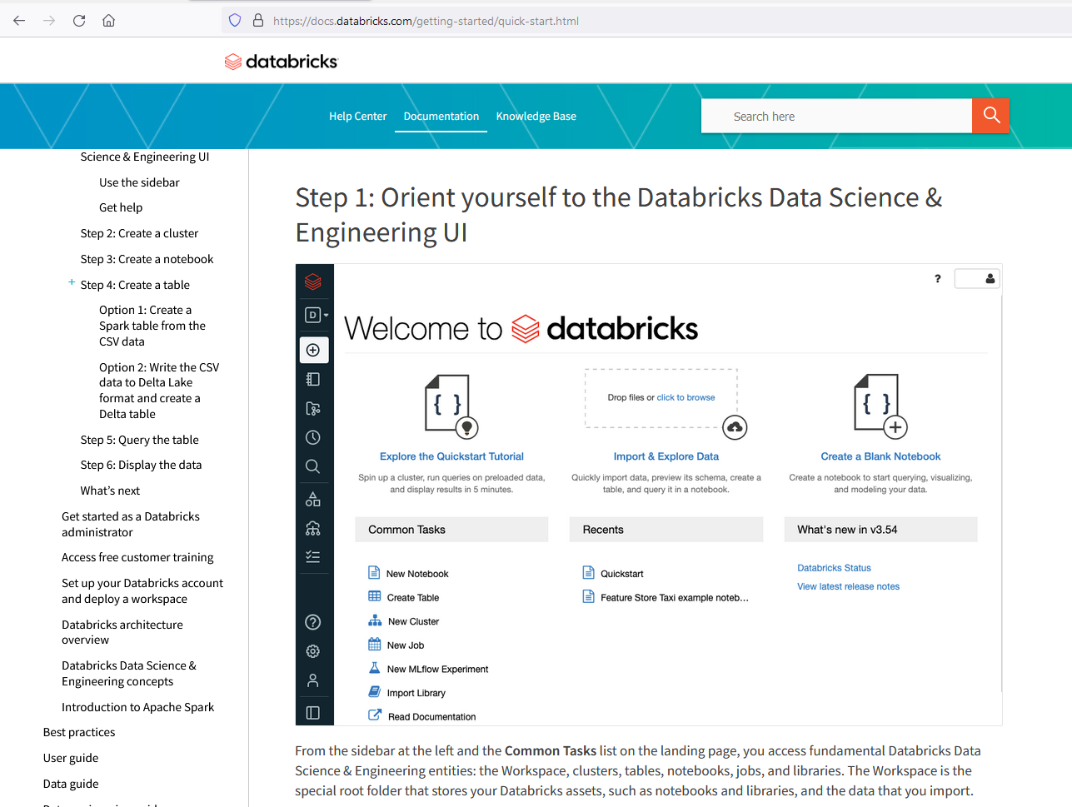

We are going to follow some steps which I borrowed from the Databricks documentation. You can get it here I have also included these steps and the commands in your course material. See screenshot above.

<https://docs.databricks.com/getting-started/quick-start.html>

Just in case the documentation page is changed or moved. So, copy this command and paste it in your Notebook.

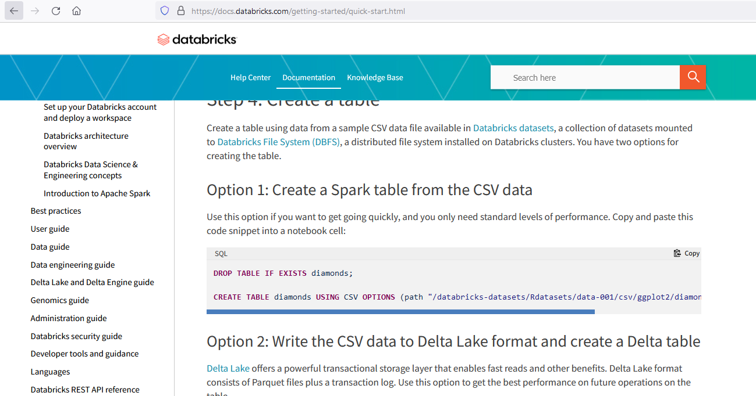

DROP TABLE IF EXISTS diamonds;

CREATE TABLE diamonds USING CSV OPTIONS (path "/databricks-datasets/Rdatasets/data-001/csv/ggplot2/diamonds.csv", header "true")

You can run it using Shift+Enter, or you can also click this run button. So what are we doing here? We are creating a Spark Table using a CSV file. The data file is already available in the Databricks file system, which is also known as DBFS.

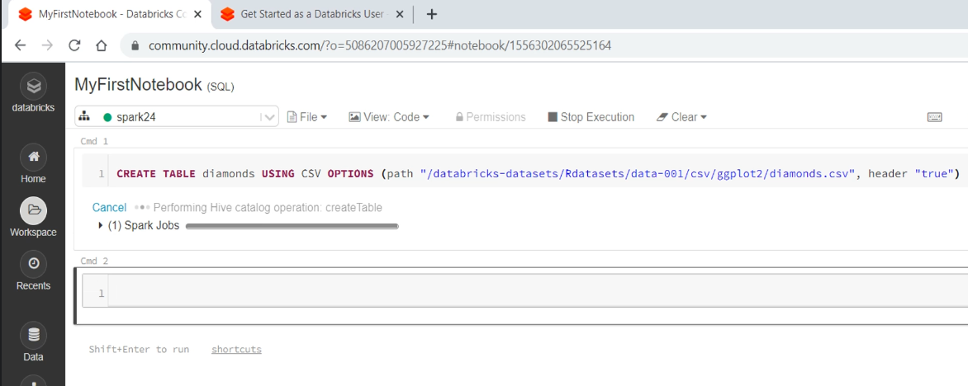

You can access the DBFS like you access your local Linux directories. Now you can scroll down the documentation and copy this select statement. Run it. Wait for a few seconds, and you can see the results.

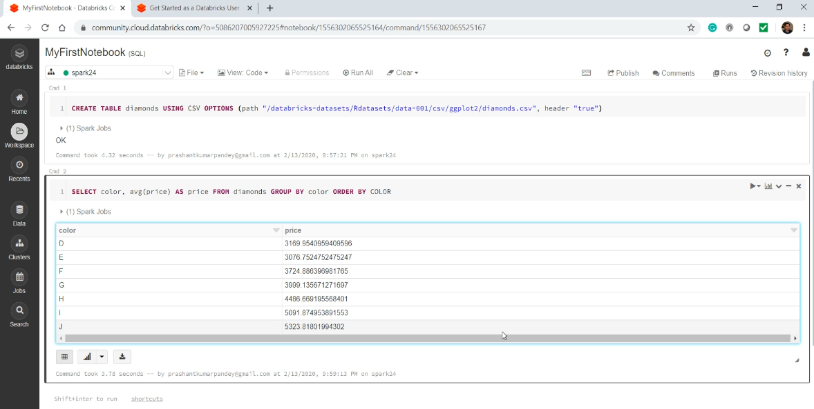

The Notebook can also help you with some basic visualizations. Click this chart button, and it shows you a graphical representation of your output. You can look at the Plot Options and customize it. When you are done. Come back to the clusters list and terminate your Cluster.

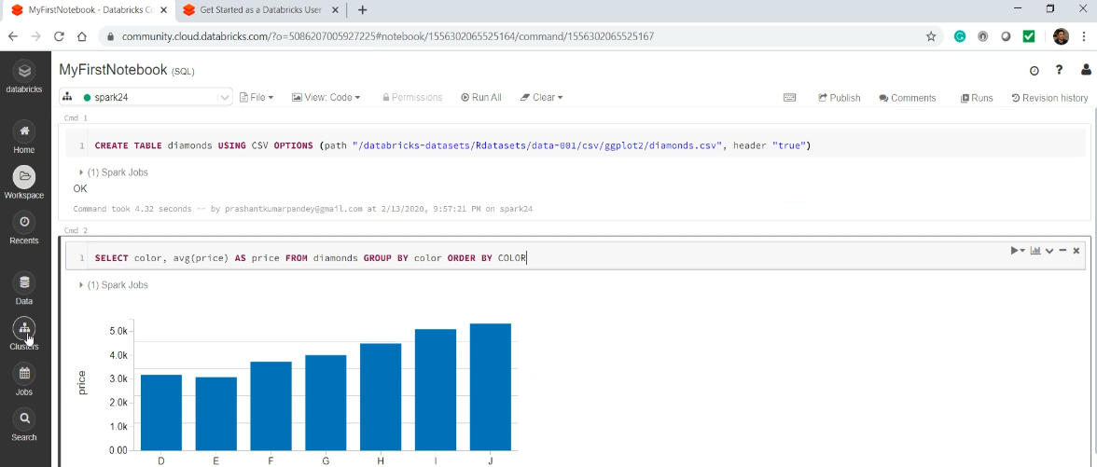

You can completely delete it. It doesn't matter because we can create a new one later.

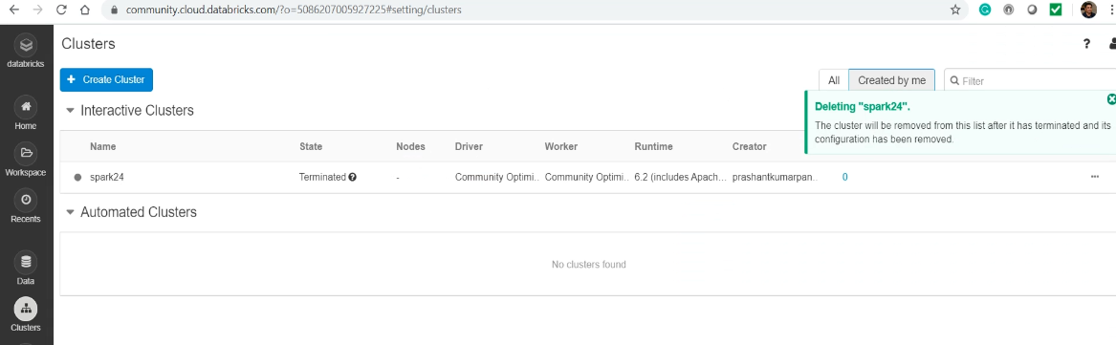

And surprisingly, your data is never lost because the Cluster is purely a compute resource. It doesn't store your data, but it is only used for executing your code and processing the data. If you want to go back to your Notebook, you can find it in your workspace. Try running your SELECT statement once again. It works. Because your database table remains intact even if you delete your Databricks Compute Cluster.

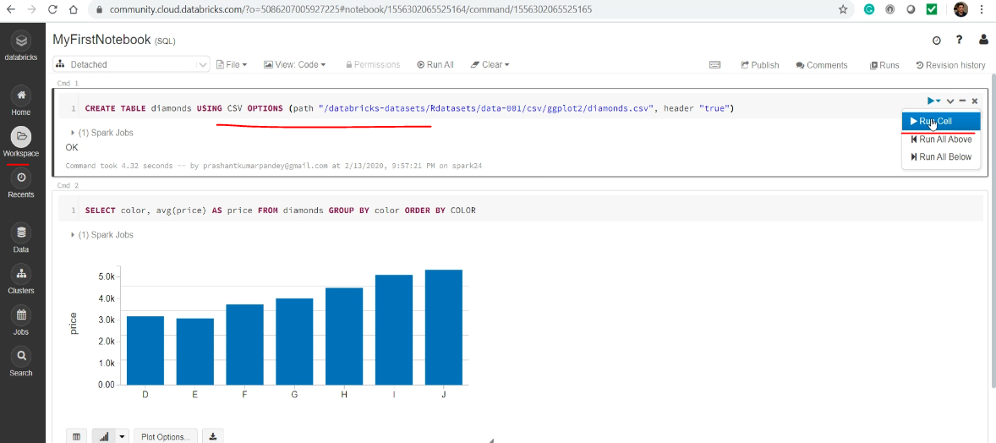

### Zeppelin Notebooks

The steps for getting access to the Zeppelin Notebook Environment. This approach is commonly used by developers and data scientists when they are working with Cloudera or Hortonworks Distribution. You can download a Hortonworks or Cloudera QuickStart VM and use them on your local machine for learning. You can also get it as a docker container. However, those VMs or the Containers are high resource-consuming options and might be an overkill. All you need is to access Apache Spark from the Zeppelin notebook. And this option is available with Zeppelin only because it comes with an embedded Spark.

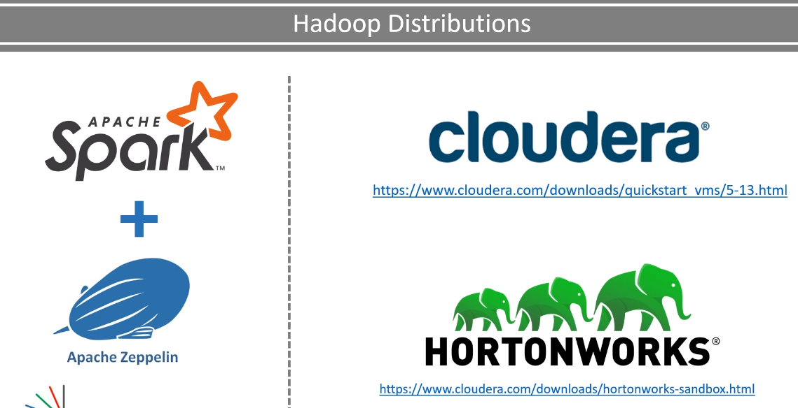

You do not need a full Cloudera or Hortonworks VM. End of the day, your experience of using Spark from Zeppelin notebook is going to remain the same. So, let's download and use Spark from the Zeppelin Notebook. Go to https://zeppelin.apache.org/ and download Zeppelin. I am going to download this smaller package.

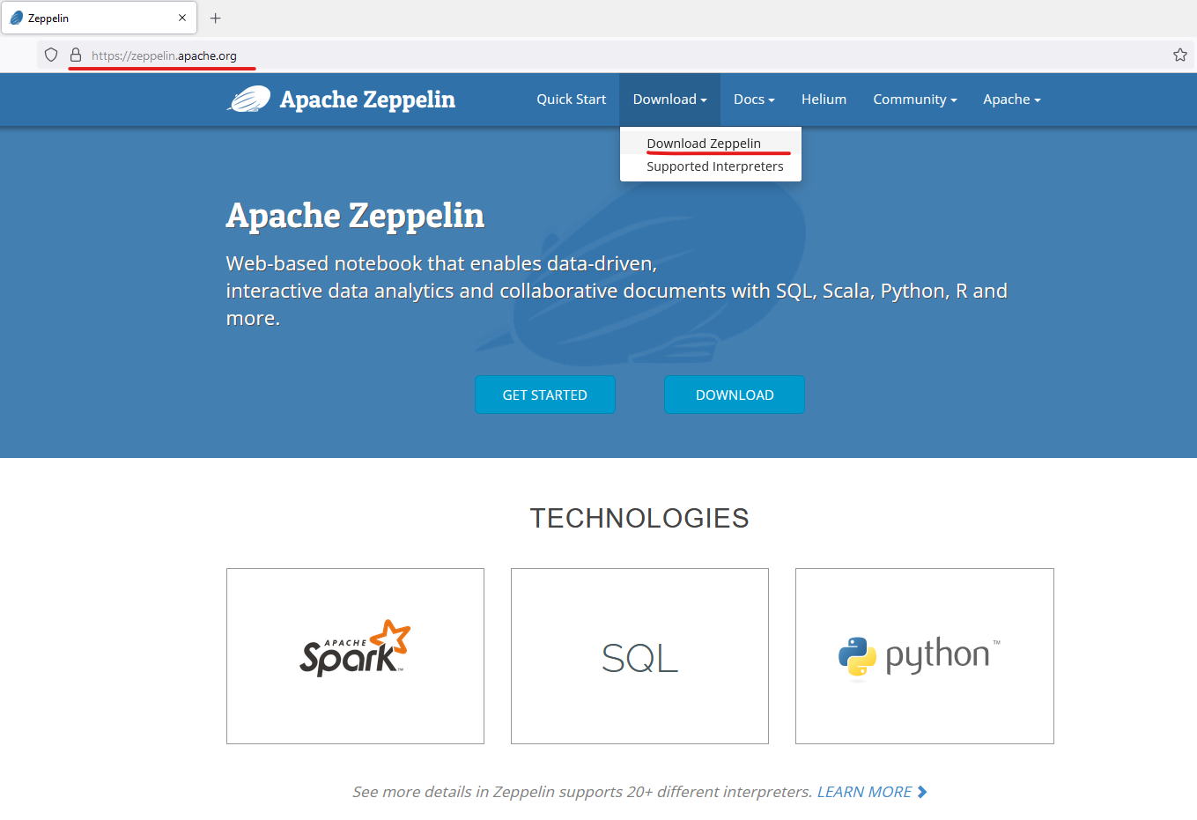

Okay, so here is the file. Uncompress it, and you will get a tar file. Extract the tar, and you should have a zeppelin directory, which looks like this.

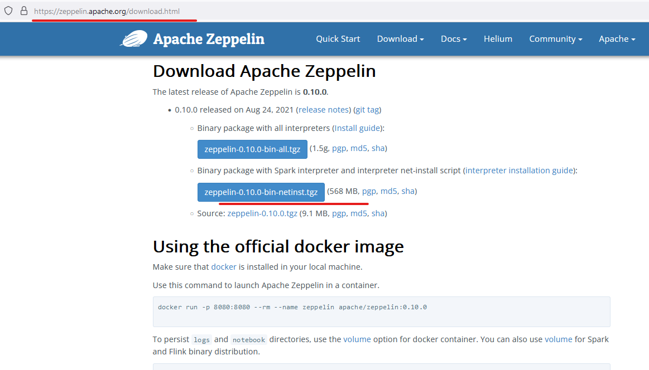

I have also included a compressed zeppelin file in your course material so you can download the same version as I am using in this video. However, you can get it from the apache website as well. Check out the bin directory, and you should see a zeppelin.cmd file and also a zeppelin.sh file. I am on a windows machine, so I am going to use the zeppelin.cmd. Execute the command file, and it will start the Zeppelin server.

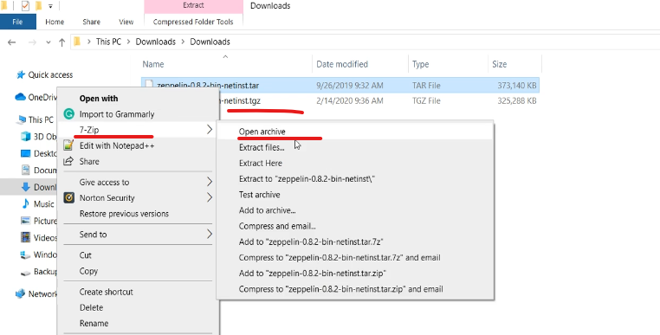

If you are on Linux or Mac, you will be using the zeppelin.sh. Zeppelin server will start and bind to the port 8080. So, make sure you are not running anything else on this port. Wait for some time. It often takes a few minutes to start. So, wait until you see this message. Done! Zeppelin server started.

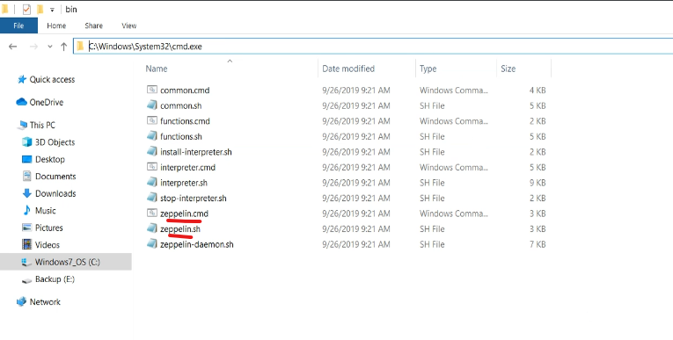

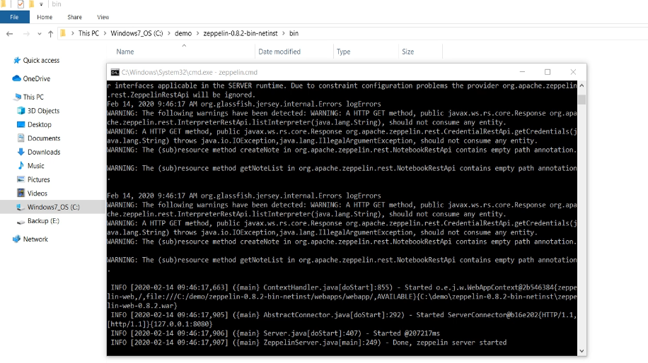

Great! Now you can start your browser and access zeppelin at localhost:8080

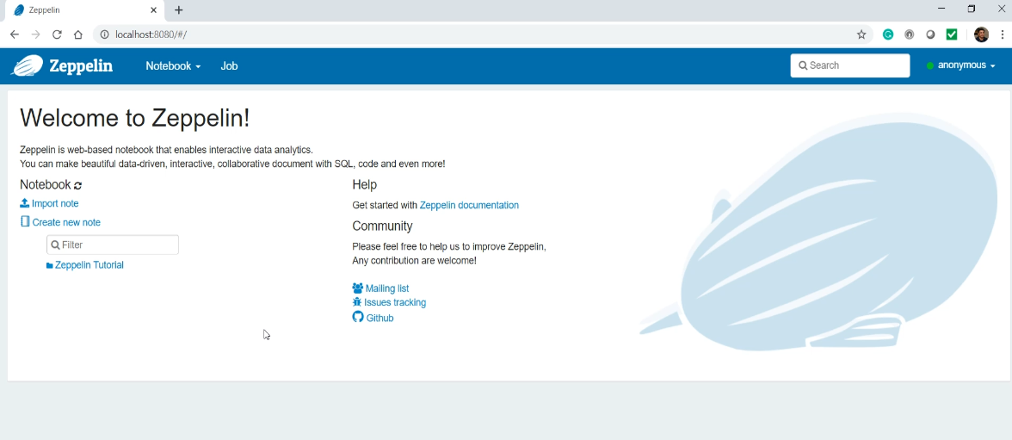

Zeppelin is somewhat similar to the Data Bricks Notebook, which we explored in the earlier lecture. So, the first thing is to create a new Notebook. Name it. That's all. You have these notebook cells where you can type your Spark code and run it. Let's check the Spark version. You can execute the content of the cell using Shift+Enter or use this run button. Good. So, this the embedded Spark version that came with your Zeppelin.

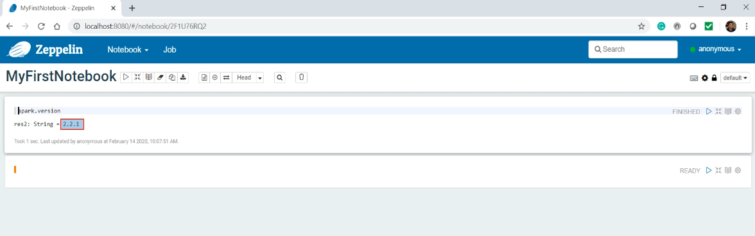

It might be a little older version, but that should be fine. Now let's do a little more. But before you start doing anything, download the sample data file named people.json from your course material and place it in some local directory location. Then copy-paste this code. The code is also included in the code material.

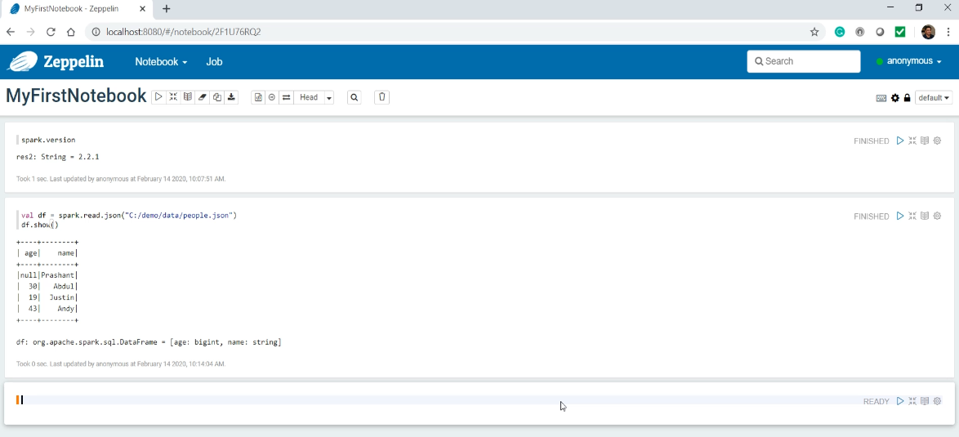

What are we doing? Simple test. Reading data from this file and printing the content. Press Shift+Enter to execute it. Simple! Isn't it?

## Spark Execution Model and Architecture

What is Apache Spark? Simple! A distributed computing platform. What do we do with Apache Spark? Again a simple question. We create programs and execute them on a Spark Cluster. The answer to the second question brings two more questions. How do we create Spark Programs? And How do we execute Spark programs on a Spark Cluster? This entire course is all about the first question. You will learn that as we progress with the training. But before we start creating Spark programs, I want to answer the second question. Executing Spark program is not so simple and straightforward. You must have some good sense of Spark Architecure and execution model. So, this entire section is dedicated for understanding Spark Execution Model and the Architecture. Let's start with the straight question. How to execute Spark Programs? We have two methods to run spark programs. Interactive Clients and Submit a Job I already showed you Spark installations. You learned about command-line Spark Shell and web-based Notebooks. Both of these are interactive clients.

And they offer you an easy method to run your spark programs. Both of these will allow you to run your Spark code line-by-line and get the output back on your console. Most of the people will use them for learning or during the development phase. Interactive clients are best suitable for exploration purposes. But ultimately, all your exploration will end up into a full-fledged Spark application. Isn't it? You may want to develop a stream processing application or a batch processing job, Spark supports both. For example, you might want to read a news feed as a continuous stream. Then you want to apply a machine-learning algorithm to figure out the type of users that might be interested in each news and redirect the story to those users.

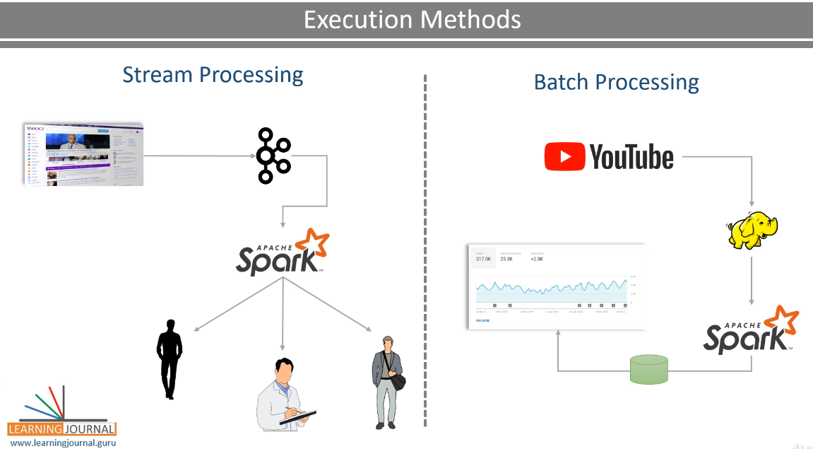

You may also want to create a batch job. For example, my YouTube statistics. In this case, we collect the data for 24 hours and start a scheduled spark job to compute the watch-time minutes for the last 24 hours. Finally, the outcome goes to a table and also appears on the dashboard. In both the scenarios, a stream processing Job or a periodic batch job, you must package your application and submit it to the Spark cluster for execution. And that's the second method for executing your programs on a Spark Cluster.

|  |  |
| --- | --- |
|  |  |

For a production use case, you will be using this technique. Apache Spark comes with a spark-submit utility to allow you to submit your Spark jobs to the cluster. We will learn more about it in a separate video, and I will show you how to use spark-submit and various options offered by the tool. Great! So you got your answer to the main question. How to execute Spark Programs? You can run your Spark applications using one of the following methods. Spark shell and Notebooks are the main interactive tools. Whereas the Spark Submit is the primary tool for submitting a Spark program to the cluster. We use interactive clients for learning, development, and exploration. Â Still, a real-life production implementation is all about packaging your Spark application and submitting it to the cluster for execution. Spark-submit is the most commonly used tool for this purpose. However, most of the Spark vendors are going to offer you some other alternatives. For example, Databricks Cloud will allow you to submit the Notebook itself, and you do not need to package your application and use the spark-submit tool. Most of the cloud-based Spark vendors will also allow you to use Rest APIs or a web-based interface to submit your packaged Spark application. And they internally take care of running the job on the Spark cluster. All those methods are vendor-specific, but spark-submit is a universally accepted method and works in almost all cases.

### Spark Distributed Processing Model - How your program runs?

You already learned that we develop Spark applications and submit them to the Spark Cluster for execution. However, we still don't know how Spark is going to execute our application on a distributed cluster. Spark is a distributed processing engine. So, So, how is the Spark distributed processing model works? And that's the topic for this video. Spark applies a master-slave architecture to every application. So, when we submit our application to the Spark, it is going to create a master process for your application. This master process is then going to create a bunch of slaves to distribute the work and complete your job. You can think of these as runtime containers with some dedicated CPU and memory.

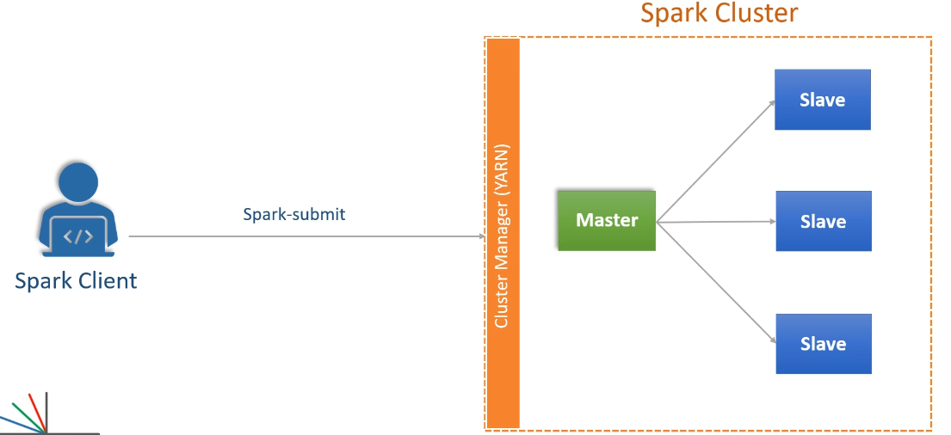

In Spark terminology, the master is a driver, and the slaves are the executors.

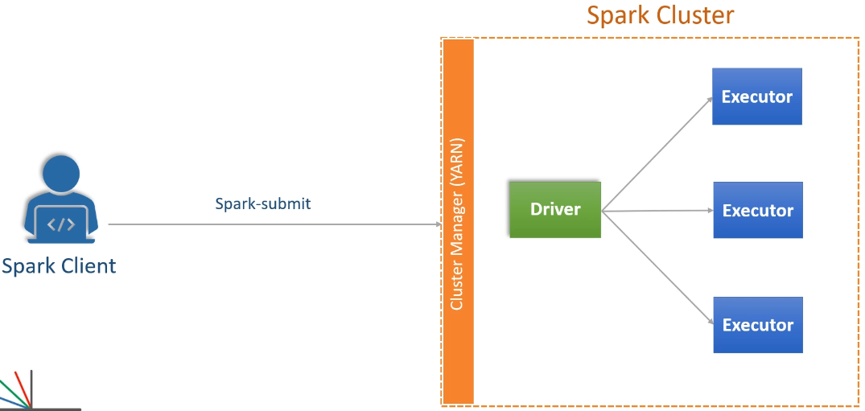

But remember, I am not talking about the cluster. The cluster itself might have a master-node and a bunch of slave nodes. But those things are part of the cluster and are managed by the cluster manager. I am talking about your application and the containers. So, the Spark engine is going to ask for a container from the underlying cluster manager to start the driver process. Once started, the driver is again going to ask for some more containers to start the executor process. And this happens for each application. Let me explain with a simple example. Suppose you are using the spark-submit utility, and you submitted an application A1. Now Spark engine will request the cluster manager to give a container and start a driver process for A1. Once started, the driver will ask for some more containers from the cluster manager and start slave executors. And that's all. Now your driver and executors are responsible for running your application code and doing the job that you wanted.

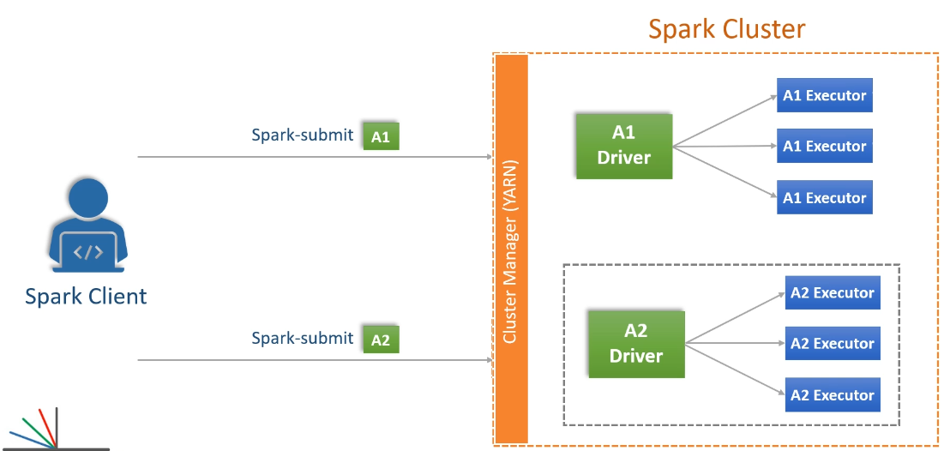

Let's assume you submitted one more application, A2. Now the A2 is going to repeat the same. That means the spark engine will request a container and start the A2 driver. Then the A2 driver is going to ask some more containers and start the A2 executors. And in all this, A1 and A2 are two independent applications. Both of them are following a master-salve architecture and have their own dedicated driver and executors. The point is straight. Every spark application applies a master-slave architecture and runs independently on the cluster. And that is how Spark is a distributed computing platform. Make sense?

### Spark Execution Modes and Cluster Managers

In the earlier lecture, I talked about what happens when you submit your application to the Spark cluster. And you learned about the driver and the executors running in containers on the cluster. However, most of the Spark development happens on a local machine or using an interactive tool such as spark-shell or notebooks. So we still have two open questions. How Spark runs your application on a local machine when we do not have a cluster and a cluster manager. And the next question is about how Spark runs our application when we use interactive tools. Because in that case, we do not submit the application to the Spark cluster. This lecture is going to answer both of these questions.

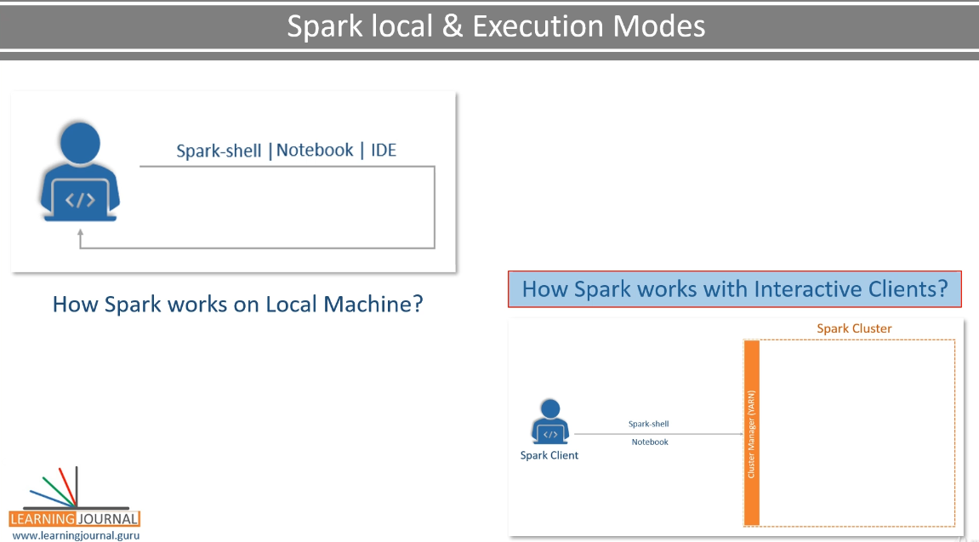

Let's start with the first question. How does Spark run on a local machine? You can execute a Spark application on your local machine without even having a real cluster. And we have already done that in an earlier video. Do you remember the IntelliJ IDEA setup? We executed a Hello Spark program from the IDE. So what happened to the notion of the driver and the executors? Well, you can configure your application to run on a variety of clusters, and the Spark engine is compatible with the following cluster managers. When I executed the Spark from the IntelliJ IDEA, I used the local cluster manager.

Let me show you. So here is a configuration that tells about the target cluster manager. I used local[3].

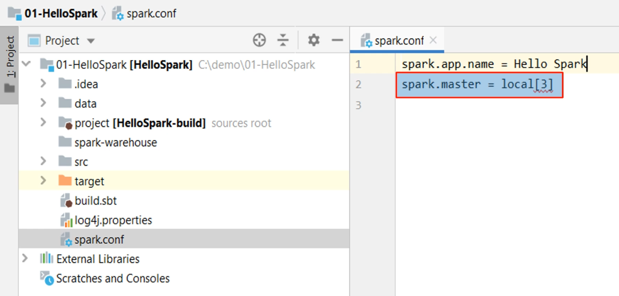

In this case, Spark runs locally as a multi-threaded application. In the case of my example, I configured it to start three threads, and that's what the three means. You can have 2, 3, 5, or whatever number you want. If you simply say local and do not give any number, then it becomes a single-threaded application. So, when you configure your application to run with a single local thread, then you will have a driver only and no executors. And in that case, your driver is forced to do everything itself.

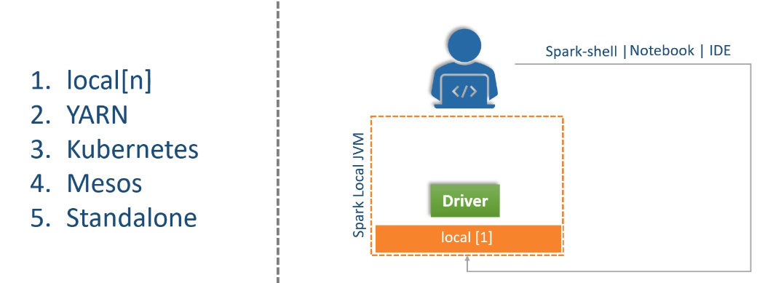

Nothing happens in parallel. However, when you run your application with three local threads, then your application will have one dedicated thread for the driver and two executor threads. And this local cluster manager is designed for running, testing, and debugging your spark application locally. This technique is nothing but a simulation of distributed client-server architecture using multiple threads so we can test our application locally. Make sense?

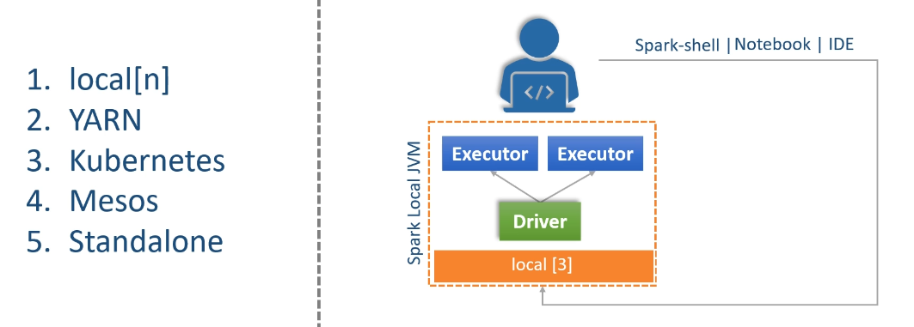

Great! We will learn more about these other cluster managers in a later video. Now let's move to the next question. How Does Spark run with an interactive tool? Spark gives you a choice to run your application in one of the following modes.

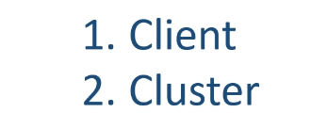

The Client mode is designed for interactive clients, such as spark-shell and the notebooks. In this mode, the Spark driver process runs locally at your client machine. However, the driver still connects to the cluster manager and starts all the executors on the cluster. And this is a powerful feature for submitting interactive queries and receiving results back to your client. And that is how your spark-shell and the Notebooks are working.

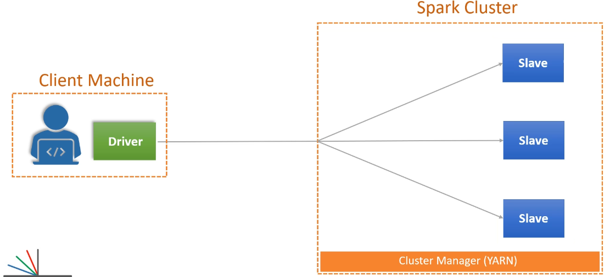

However, if you are quitting your client or you log off from your client machine, then your driver dies, and hence the executors will also die in the absence of the driver.

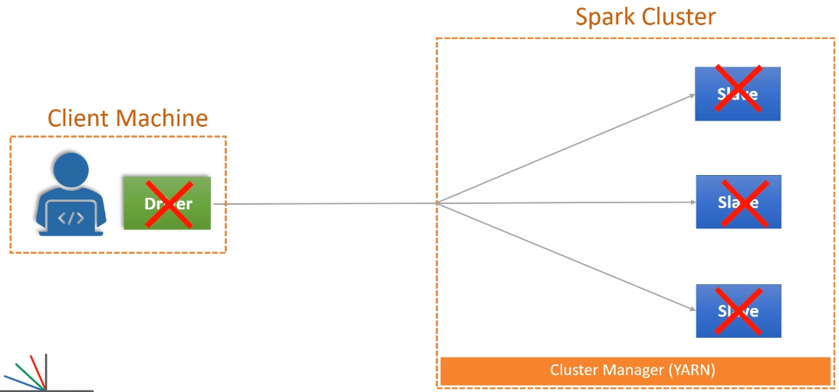

So, client mode is suitable for interactive work but not for long-running jobs. The cluster mode is designed to submit your application to the cluster and let it run. In this mode, everything runs on the cluster. Your driver, as well as the executors. Once you submit your application to run in cluster mode, you can log off from the client machine, and your driver is not impacted because it is running on the cluster. So, the cluster mode is meant for submitting long-running jobs to the cluster.

Spark supports the following type of cluster - YARN Mesos, Kubernetes, Local and Standalone

Which configuration is used to specify the Spark Cluster manager? spark.master

The following are spark.master value – local[*], local[3], local[50]

Spark supports the following mode of execution – Client mode and Cluster mode

Following is true for local[3] spark.master – Your application runs in single JVM with three threads

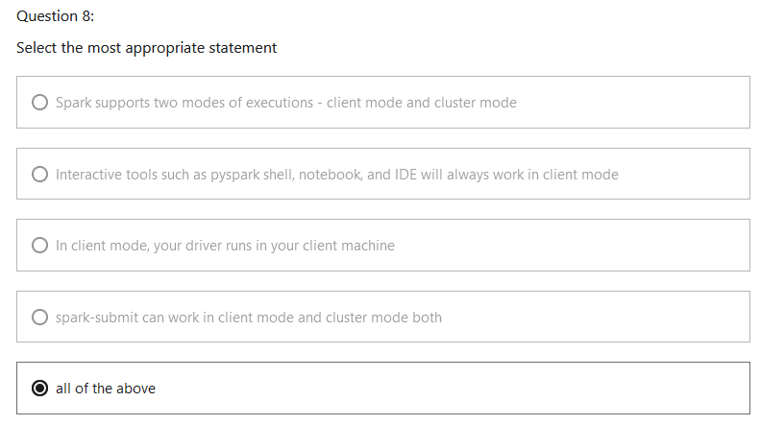

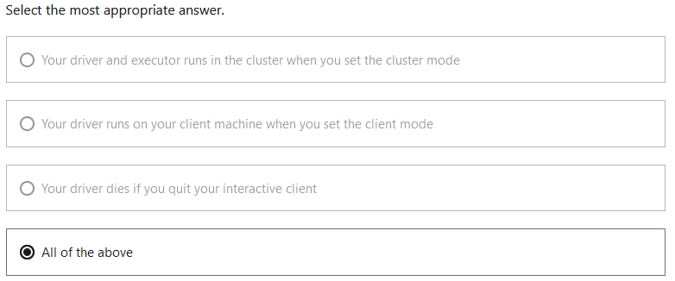

Summarizing Spark Execution Models - When to use What?

So far, in this section, you learned about the Spark client-server execution model. I talked about a bunch of things, such as cluster managers and execution modes. Let's try to summarize all those concepts. So, the cluster manager is at the top. When you are going to run your Spark application, the first thing is to make a decision on which cluster manager you are going to use.

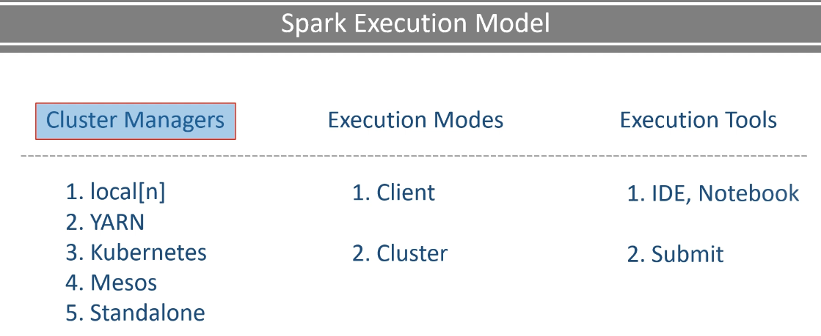

There are many options, but in most of the cases, you will be working with two cluster managers. Local and YARN You will be using Local when you are working in your IDE or in a Notebook on your local machine. And you will be using YARN when you are running your Spark application on a real cluster. You have two kinds of the cluster setup. The on-premise cluster which is mostly Cloudera distribution. On-Cloud cluster, which might be Databricks, Google Dataproc, or other similar offerings. Most of them are also using the YARN manager under the hood. Once you know your cluster manager, then you decide on the execution mode.

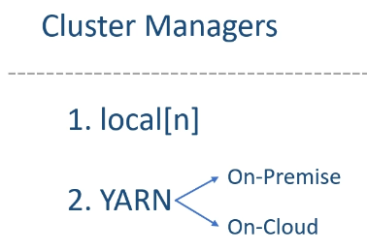

You already learned that Spark supports two modes. Client Mode and the Cluster Mode You will be using client mode on your local machine with the local cluster manager. Cluster mode doesn't make any sense here because you do not have a real cluster. You can also use the client mode on the YARN cluster when you are working in a YARN cluster but using a notebook or a spark-shell. Finally, you will be using the cluster mode when you are submitting your Spark application to run on a real cluster. So, we have the three most widely used execution models.

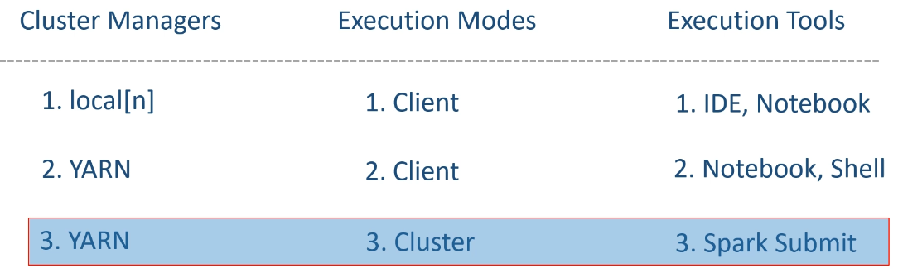

However, all this was a theory. Now you need to see them in action. So, I will give a demo for the three execution modes and show you the driver and the executors.

### Spark Shell – Demo

Lets first see the demo for the local client mode. And you are going to see how the driver and the executors are getting created in this mode. You will also learn details of using spark-shell. This mode of operation is mostly used by developer community for local Spark development activity. So, let's start with the first demo. You already installed spark binaries on your local machine. I am going to start a command window and run spark-shell in local-client-mode. That's what we wanted to do. But before that, let's look at the spark-shell help. So, spark-shell gives you a lot of options.

C:\Users\Lalit>spark-shell --help

Usage: .\bin\spark-shell.cmd [options]

Scala REPL options:

-I <file> preload <file>, enforcing line-by-line interpretation

Options:

--master MASTER_URL spark://host:port, mesos://host:port, yarn,

k8s://https://host:port, or local (Default: local[*]).

--deploy-mode DEPLOY_MODE Whether to launch the driver program locally ("client") or

on one of the worker machines inside the cluster ("cluster")

(Default: client).

--class CLASS_NAME Your application's main class (for Java / Scala apps).

--name NAME A name of your application.

--jars JARS Comma-separated list of jars to include on the driver

and executor classpaths.

--packages Comma-separated list of maven coordinates of jars to include

on the driver and executor classpaths. Will search the local

maven repo, then maven central and any additional remote

repositories given by --repositories. The format for the

coordinates should be groupId:artifactId:version.

--exclude-packages Comma-separated list of groupId:artifactId, to exclude while

resolving the dependencies provided in --packages to avoid

dependency conflicts.

--repositories Comma-separated list of additional remote repositories to

search for the maven coordinates given with --packages.

--py-files PY_FILES Comma-separated list of .zip, .egg, or .py files to place

on the PYTHONPATH for Python apps.

--files FILES Comma-separated list of files to be placed in the working

directory of each executor. File paths of these files

in executors can be accessed via SparkFiles.get(fileName).

--archives ARCHIVES Comma-separated list of archives to be extracted into the

working directory of each executor.

--conf, -c PROP=VALUE Arbitrary Spark configuration property.

--properties-file FILE Path to a file from which to load extra properties. If not

specified, this will look for conf/spark-defaults.conf.

--driver-memory MEM Memory for driver (e.g. 1000M, 2G) (Default: 1024M).

--driver-java-options Extra Java options to pass to the driver.

--driver-library-path Extra library path entries to pass to the driver.

--driver-class-path Extra class path entries to pass to the driver. Note that

jars added with --jars are automatically included in the

classpath.

--executor-memory MEM Memory per executor (e.g. 1000M, 2G) (Default: 1G).

--proxy-user NAME User to impersonate when submitting the application.

This argument does not work with --principal / --keytab.

--help, -h Show this help message and exit.

--verbose, -v Print additional debug output.

--version, Print the version of current Spark.

Cluster deploy mode only:

--driver-cores NUM Number of cores used by the driver, only in cluster mode

(Default: 1).

Spark standalone or Mesos with cluster deploy mode only:

--supervise If given, restarts the driver on failure.

Spark standalone, Mesos or K8s with cluster deploy mode only:

--kill SUBMISSION_ID If given, kills the driver specified.

--status SUBMISSION_ID If given, requests the status of the driver specified.

Spark standalone, Mesos and Kubernetes only:

--total-executor-cores NUM Total cores for all executors.

Spark standalone, YARN and Kubernetes only:

--executor-cores NUM Number of cores used by each executor. (Default: 1 in

YARN and K8S modes, or all available cores on the worker

in standalone mode).

Spark on YARN and Kubernetes only:

--num-executors NUM Number of executors to launch (Default: 2).

If dynamic allocation is enabled, the initial number of

executors will be at least NUM.

--principal PRINCIPAL Principal to be used to login to KDC.

--keytab KEYTAB The full path to the file that contains the keytab for the

principal specified above.

Spark on YARN only:

--queue QUEUE_NAME The YARN queue to submit to (Default: "default").

The --master option is to tell the spark-shell about the cluster manager. We want to use the local, and that's the default. However, I am going to use 3 threads. The default star will allow spark-shell to create n number of threads depending upon the resource availability. However, I want to fix it to 3. The deploy mode defaults to the client, and that's what we want. So, we are going to leave that option. You have many other options, but I want to leave them for now and use the --driver-memory. The default JVM heap size is approximately 1GB in most of the cases. And that's what the spark-shell is going to get. For this example, even a 1GB should be more than enough. But if you want to increase the memory for your driver program, then you can use this option. I am going to give it a sum of 2GB. Spark shell gives you many other configuration options. Some are generic, and some are only applicable to the specific cluster managers. For example, you can specify the number of executors, and it is only relevant to the YARN manager. We will use it in the next demo. Great! So we are ready with our spark-shell command.

C:\> spark-class org.apache.spark.deploy.master.Master

Using Spark's default log4j profile: org/apache/spark/log4j-defaults.properties

21/11/21 14:55:11 INFO Master: Started daemon with process name: 22692@lalitnagpal

21/11/21 14:55:11 WARN NativeCodeLoader: Unable to load native-hadoop library for your platform... using builtin-java classes where applicable

21/11/21 14:55:11 INFO SecurityManager: Changing view acls to: Lalit

21/11/21 14:55:11 INFO SecurityManager: Changing modify acls to: Lalit

21/11/21 14:55:11 INFO SecurityManager: Changing view acls groups to:

21/11/21 14:55:11 INFO SecurityManager: Changing modify acls groups to:

21/11/21 14:55:11 INFO SecurityManager: SecurityManager: authentication disabled; ui acls disabled; users with view permissions: Set(Lalit); groups with view permissions: Set(); users with modify permissions: Set(Lalit); groups with modify permissions: Set()

21/11/21 14:55:12 INFO Utils: Successfully started service 'sparkMaster' on port 7077.

21/11/21 14:55:12 INFO Master: Starting Spark master at spark://172.17.224.1:7077

21/11/21 14:55:12 INFO Master: Running Spark version 3.2.0

21/11/21 14:55:12 INFO Utils: Successfully started service 'MasterUI' on port 8080.

21/11/21 14:55:12 INFO MasterWebUI: Bound MasterWebUI to 0.0.0.0, and started at http://lalitnagpal.mshome.net:8080

21/11/21 14:55:12 INFO Master: I have been elected leader! New state: ALIVE

21/11/21 14:55:55 INFO Master: Registering app Spark shell

21/11/21 14:55:55 INFO Master: Registered app Spark shell with ID app-20211121145555-0000

21/11/21 14:55:55 WARN Master: App app-20211121145555-0000 requires more resource than any of Workers could have.

C:\> spark-shell --master spark://172.17.224.1:7077

Using Spark's default log4j profile: org/apache/spark/log4j-defaults.properties

Setting default log level to "WARN".

To adjust logging level use sc.setLogLevel(newLevel). For SparkR, use setLogLevel(newLevel).

21/11/21 14:55:54 WARN NativeCodeLoader: Unable to load native-hadoop library for your platform... using builtin-java classes where applicable

Spark context Web UI available at http://lalitnagpal.mshome.net:4040

Spark context available as 'sc' (master = spark://172.17.224.1:7077, app id = app-20211121145555-0000).

Spark session available as 'spark'.

Welcome to

____ __

/ __/__ ___ _____/ /__

_\ \/ _ \/ _ `/ __/ '_/

/___/ .__/\_,_/_/ /_/\_\ version 3.2.0

/_/

Using Scala version 2.12.15 (Java HotSpot(TM) 64-Bit Server VM, Java 1.8.0_51)

Type in expressions to have them evaluated.

Type :help for more information.

scala>

We are going to ask for three threads and a sum of 2GB memory. Let's start. Great! The shell is up. Let me do something simple. So I am reading a JSON file and showing the content of the file. Simple. We will learn more coding later. Apache Spark is a well-designed system, and it generates a lot of metrics, logs, and other information to monitor and investigate things about your application. A bunch of information is available to you via Spark Context web UI. And here is the URL.

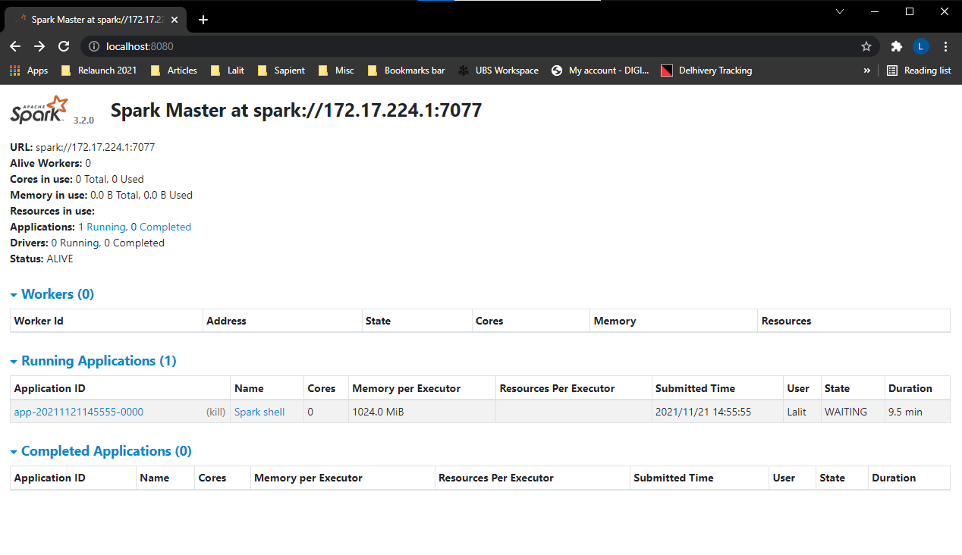

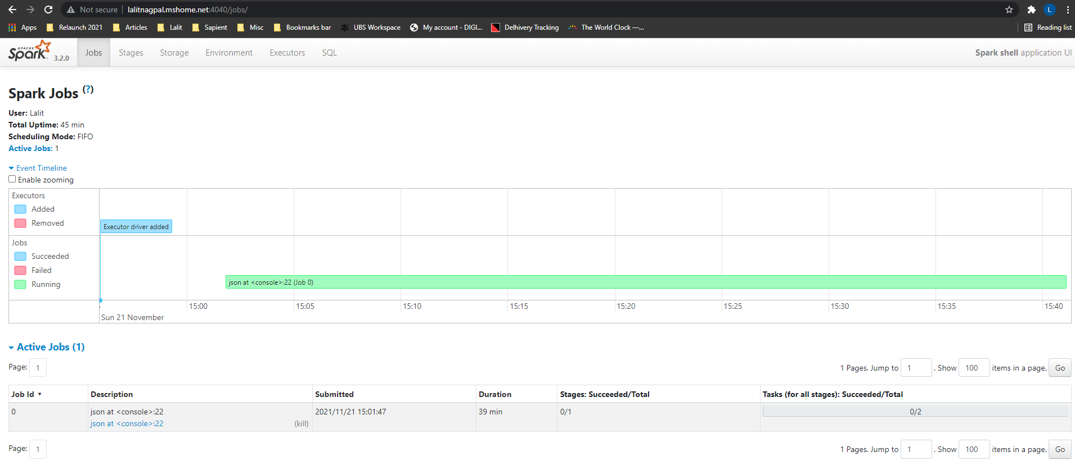

Let's try it and see what we have there. So you can see the event timeline. Spark started an executor driver process. We do not see the separate driver and executor processes. Why? Because we are in a local cluster, and everything is running inside a single JVM. And the JVM is a combination of driver and executors.

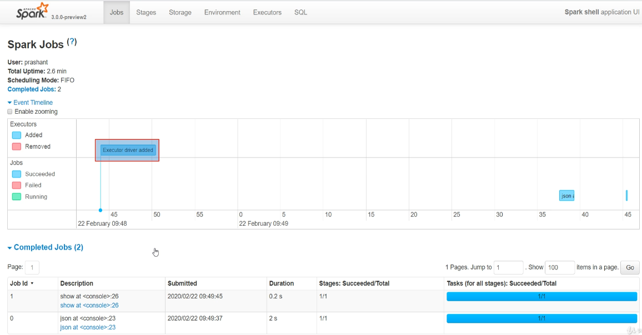

And that's what we see here. Just one process which icludes driver as well as the executors. We asked for three threads, and you can see it here in the executors' tab. So all we have is one driver with three cores. And that's the number of threads. And we got roughly 900MB memory for the driver. We asked 2GB, but that's the sum of the overall JVM.

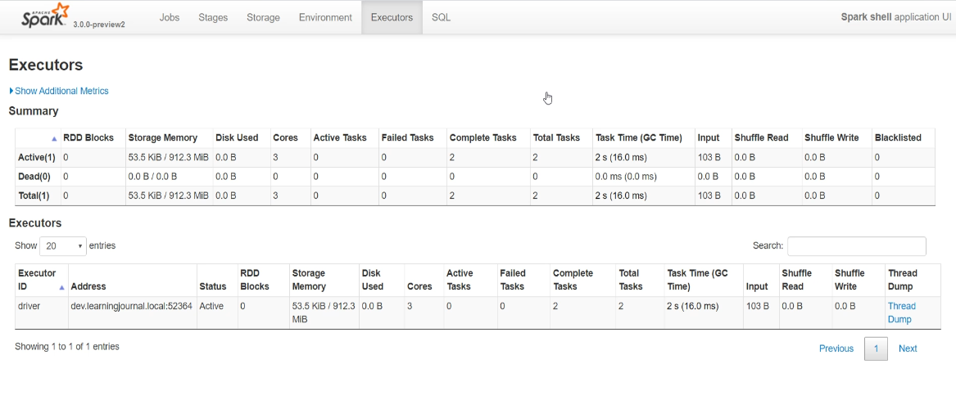

Great! So you learned about spark-shell and got some sense of the local cluster, driver, executors, and also saw the Spark Context Web UI. The UI is available only when the spark application is running. You cannot access the Context UI after quitting from the spark-shell.

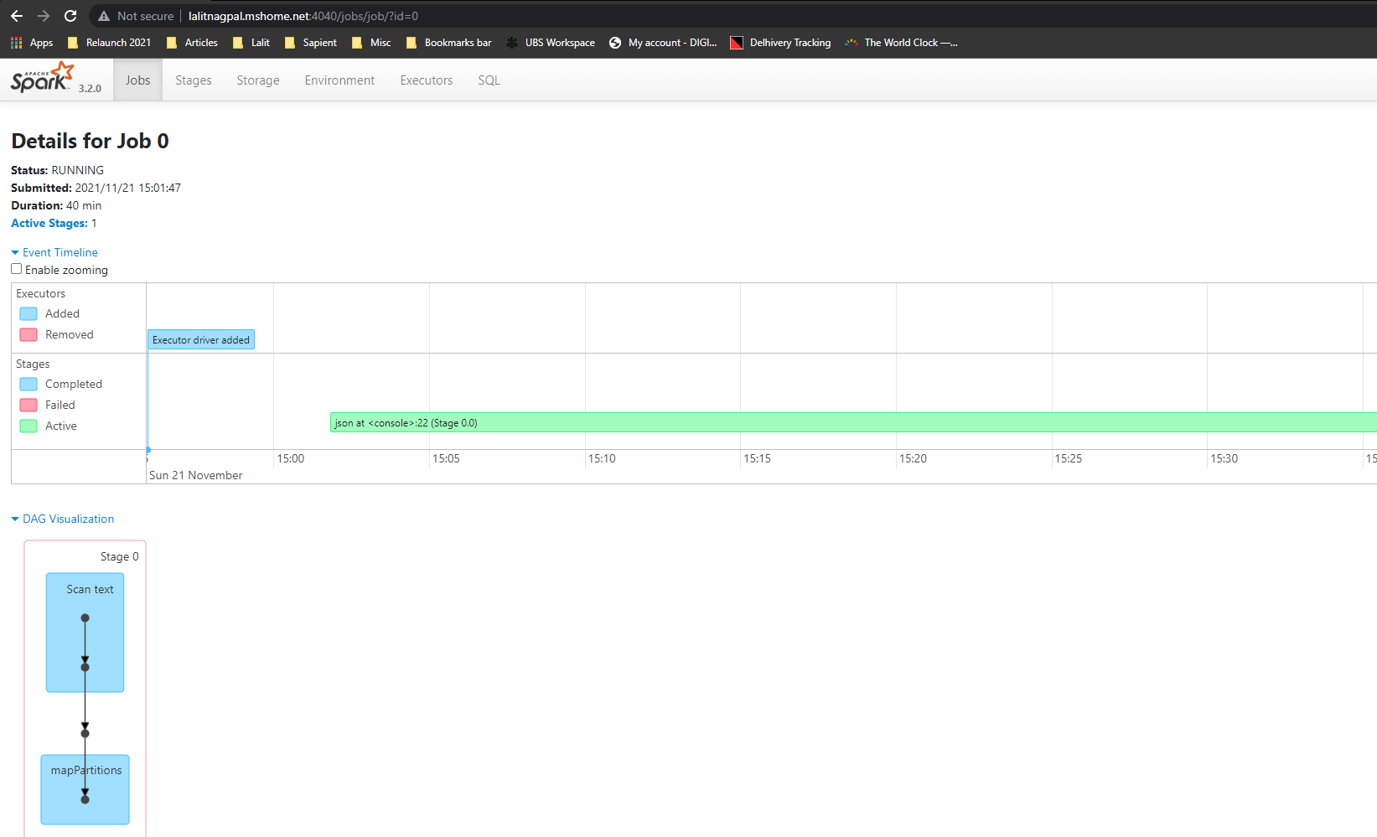

### Installing Multi-Node Spark Cluster

We have seen a few things on our local machines. However, Spark is a distributed cluster. So, you may want to get access to a real distributed cluster for exploring how things are going to work on a real distributed cluster. I often use Google Cloud environment to set up a multi-node cluster for exploring Spark in a realistically distributed environment. So, In this lecture, we will set up a multi-node Spark cluster in Google Cloud. I will be using this cluster setup in some of the lectures to give you a demo on how things are going to work in a distributed cluster. So, Let's start. I will be using Google Cloud to set up a Spark cluster. If you want to do it yourself, then you should have a Google Cloud account. It is a paid service, and you will be charged for this. However, Google may offer some free credits for the first time users. You can check the details on the Google Cloud Website. Once you have a GCP account, go to your Console Home page. And you should see a dashboard similar to this.

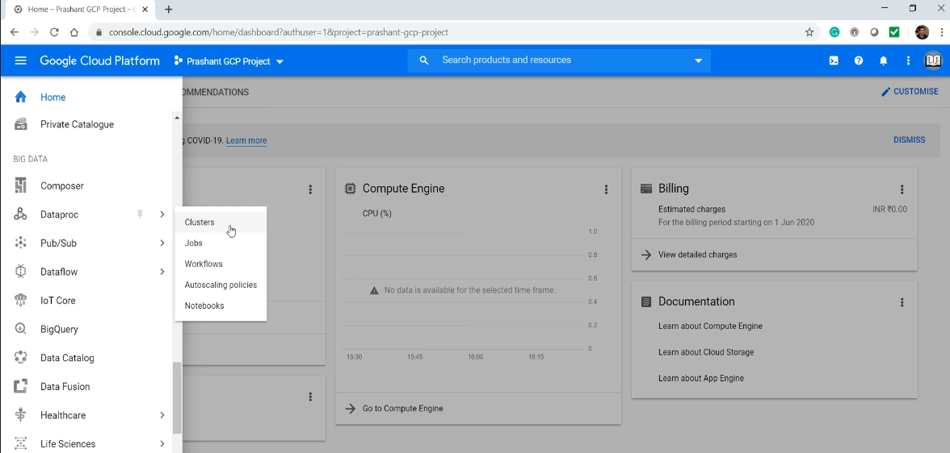

Click the GCP menu and look for the Dataproc. I am going to create a Dataproc cluster. Google Dataproc is an on-demand YARN Cluster which comes with the Spark setup. Give a name to your cluster. Then we select the machine type for our master node. I am taking a machine with 2 CPU and 7.5 GB memory. I don't need a lot of disc space. Now I need to select a machine type for the executor nodes. A single CPU core is good enough for the workers. Reduce the space and create three workers. So, I am going to have a 4 node YARN Cluster having One Master and 3 data nodes.

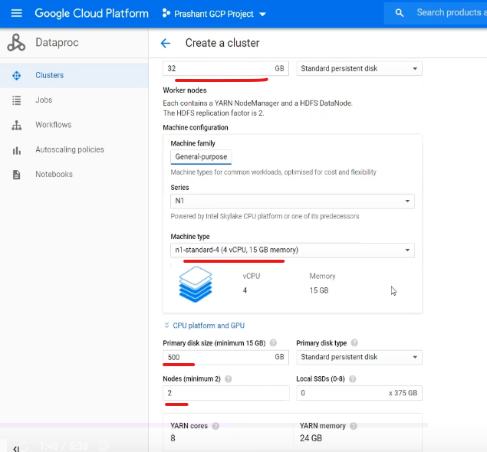

The next important thing is to enable access to web interfaces. This will allow you to access the Spark UI and History server. I will show you that in a minute.

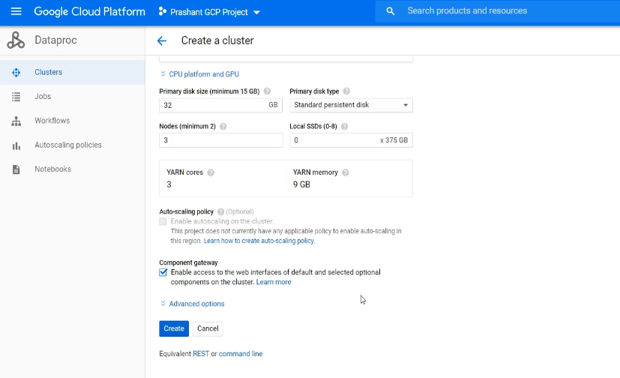

We will also get into the advance options and change the Spark Version. So the latest available version is Spark 2.4. Let's take this one.

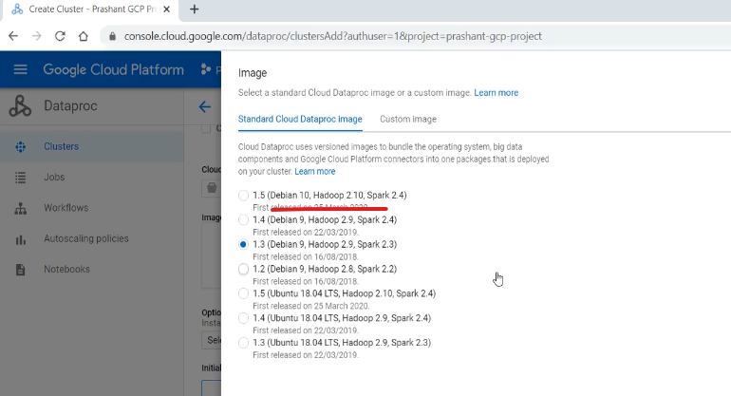

Now we also need some optional components. If you want to use PySpark, then you should also take Anaconda. You can also get Jypyter Notebook environment. However, let me take Zeepelin notebook. The Zeppelin notebook is similar to the Databricks Cloud notebook.

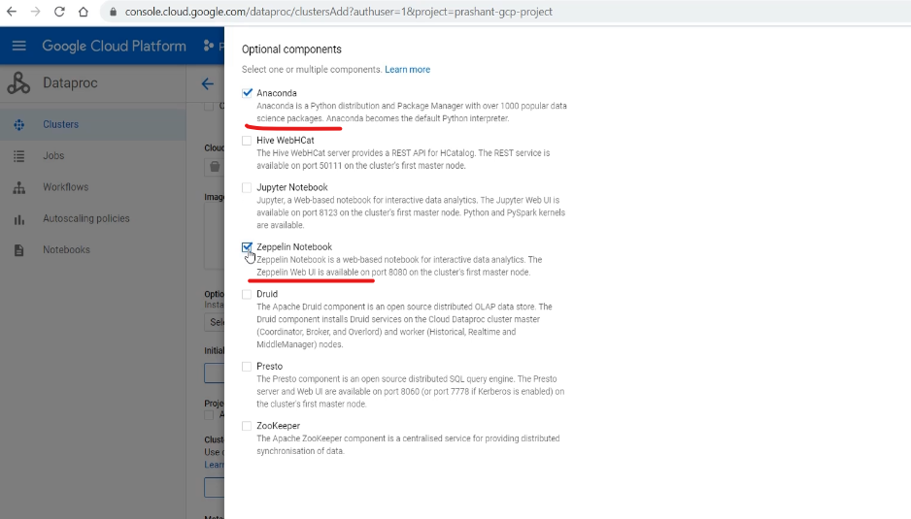

If you want, you can schedule the deletion of the cluster. So, the GCP will automatically delete this cluster. Let's create it.

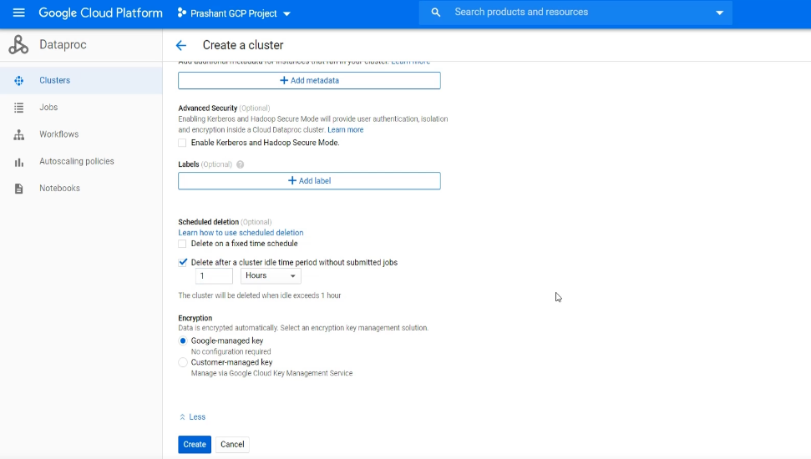

Oops! It looks like it is expecting a storage bucket. That's fine. Let me come back and create one storage bucket. Give a name to your bucket. We don't want a multi-region bucket. We want everything to be in the same data center. So, let me select the location. This is the same data center location that I chose for my cluster. I want the storage bucket also to be in the same data center. The rest all is fine.

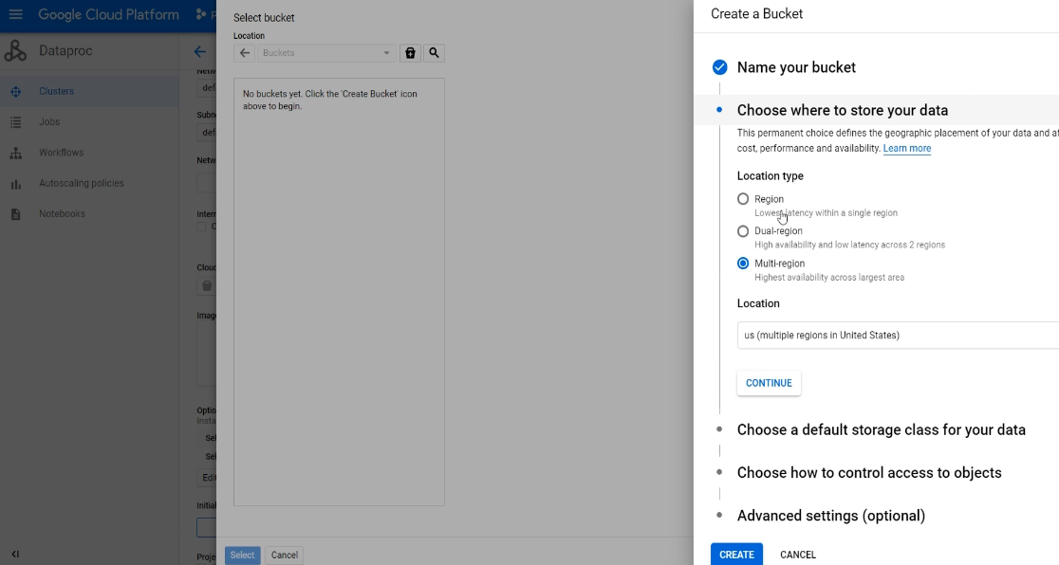

No, we don't want to get into the fine-grained access control. Create the bucket. Come back to the cluster and then create the cluster.

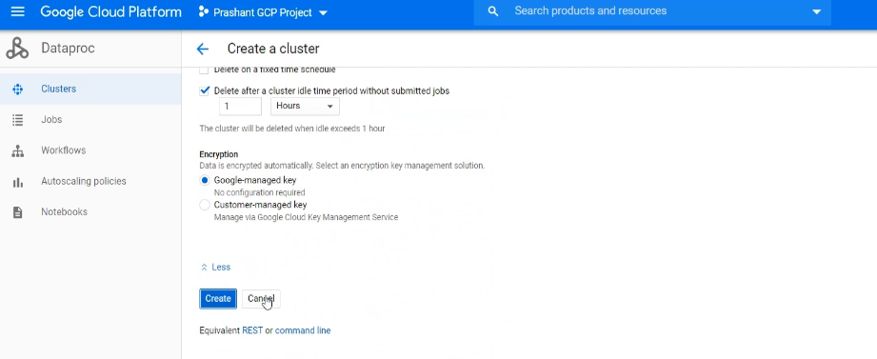

Wait for a few minutes, and your cluster is ready. Let me check. So, this one is the dashboard. Here are my 4 VMs, and I can ssh to the master node. I will show you the SSH in a minute.

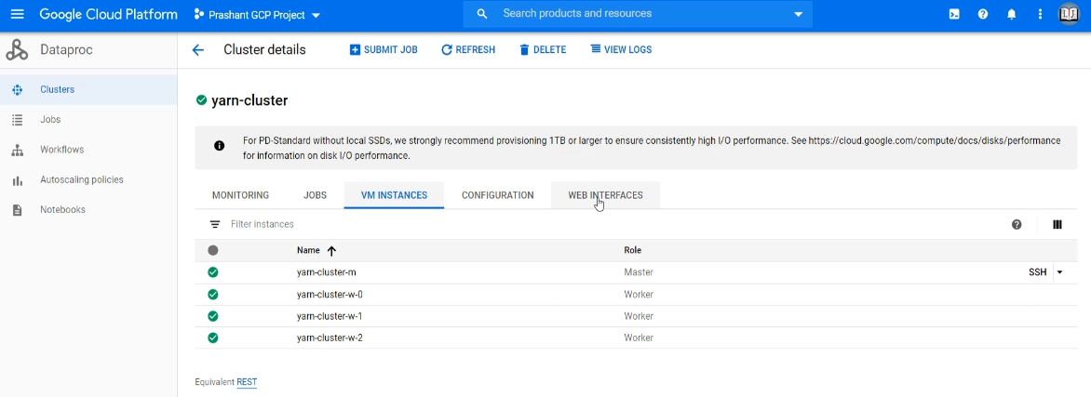

Let's check the web interface. So, you can access the Zeppelin, Spark history server, the YARN resource manager, and a few other things. These are all web-based interfaces, and they are just a click away. I will talk about these when we start using this cluster.

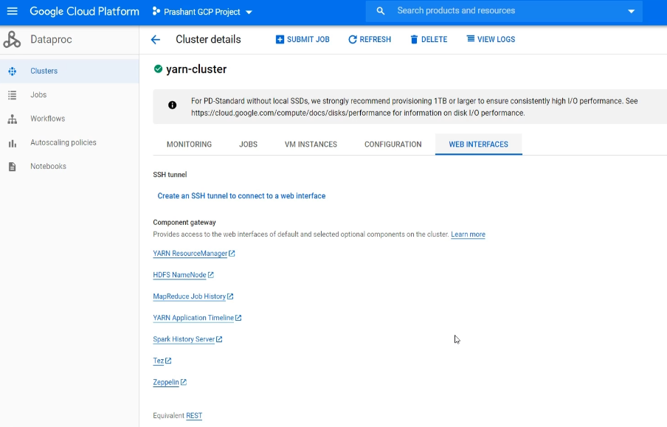

Great! So you have a 4 node Spark Cluster. You can use it to explore and learn. When you are done for the day, delete it. Creating and deleting a Spark Cluster in Google cloud is quick and straightforward. So, we create it and use it for 1-2 hours and delete it. If you want to use it again the next day, create a new one, use it, and delete it. That's how you can manage your cost.

We also created a storage bucket. Let me go to the home page and check what else I have. So I also have two storage buckets. They are cheaper than the cluster machines, but I don't have a lot of data there, which I want to preserve. So, let me delete them as well. Good. Refresh the page to confirm. Great! So we learned to get access to a distributed spark cluster. I will be using it for the demos, and you can use them for your practice. However, most of the Spark learning happens on your local machine.

### Working with Notebooks in Cluster – Demo

In this lecture, I am going to give you a demo for the YARN client mode using spark-shell as well as the Zeppelin Notebook. This mode of operation is mostly used by data scientists and data analysts for interactive exploration directly in your production cluster.

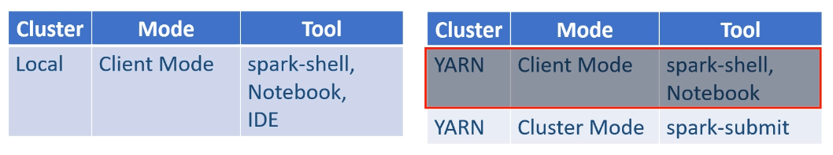

In most cases, you are going to prefer using a notebook for its web-based interface and graph capabilities. However, I will also give you a demo using a spark-shell. So, let's start. I have this 4 node YARN managed cluster. I got one master node, three data nodes, and I have done this setup in the google cloud platform for this demo.

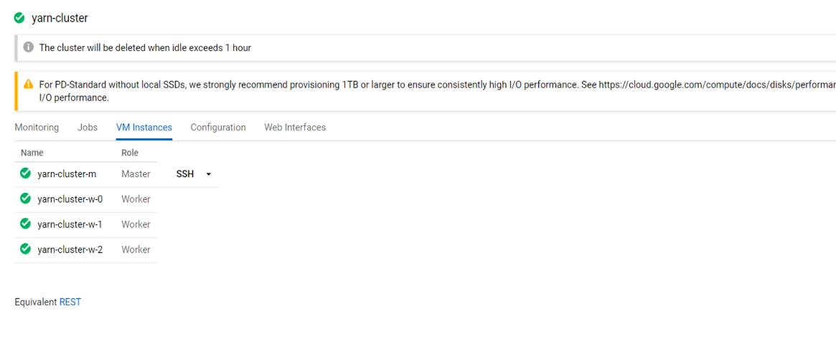

This cluster comes with Spark 2.4 because Spark 3.0 is not yet released for production usage. Let me give show you the spark-shell. You already learned to use the spark-shell, right? I am going to ssh to one of these nodes and start the spark-shell.

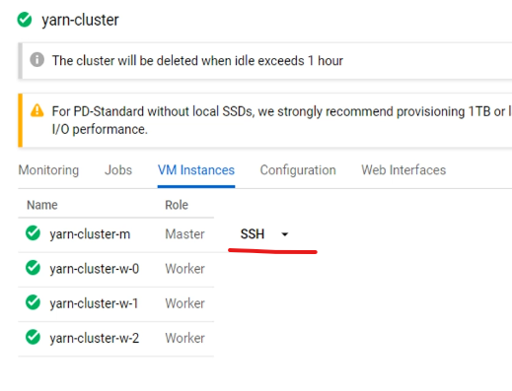 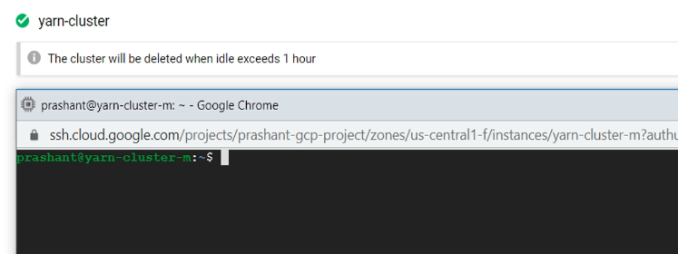

Here is the spark-shell command that we used in the earlier lecture. I am going to change the master to YARN. Reduce the driver's memory to 1GB   and ask for the 500 MB executor memory. I am also adding one more configuration to get two executors. You can also add a few more things. Such as how many CPU cores do you need for each executor. Most of the values which I am using here are the default values. So I do not need to tell all these things, and merely running spark-shell will start in client mode with these values. However, I am doing this to help you learn these options. Good. Let's hit the enter key.

$ spark-shell --master yarn

--driver-memory 1G

--executor-memory 500M

--num-executors 2

--executor-cores 1

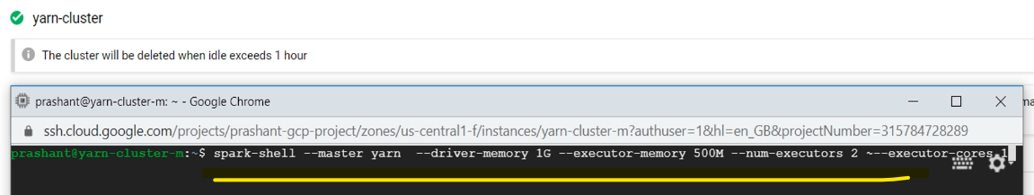

Great! My spark-shell is now running.

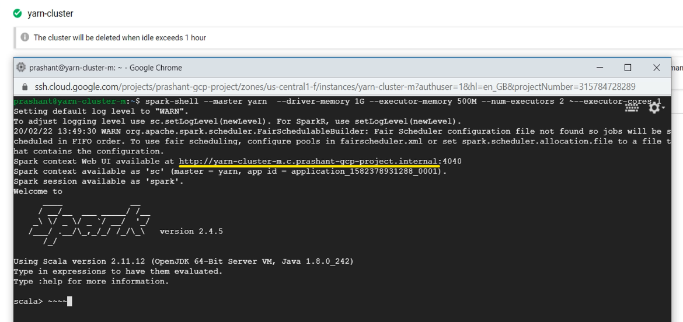

My driver and the executors should have already been created, and they will be waiting for me to submit some spark commands. You can access the Spark Context UI using this URL and look at the event timeline. However, this URL is only valid while my spark-shell is running. So, in a real production cluster, we often ignore this Spark Context UI and use the Spark History Server or the YARN resource manager UI. Let me open the Spark History Server. In a secure enterprise setup, you need to ask your operations team to get you access to the Spark History server and also provide the URL link. However, for me, I already know it. Great!

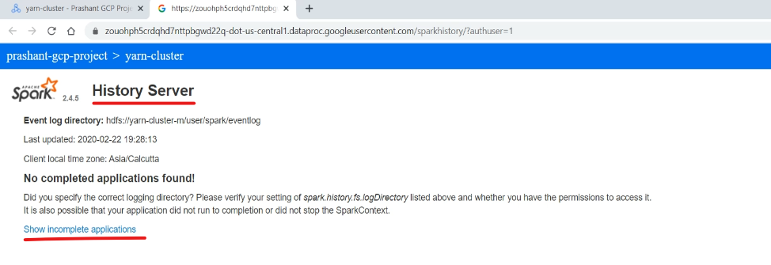

So the Spark history server will show you the list of applications that you executed in the past. That's why it is called a history server, right? But you can also get a list of currently running applications. So, here is my application. And the application name is the Spark Shell. Click the application ID, and it will take you to the Spark Context UI. Let's look at the event timeline. So, we have got one driver and two executors.

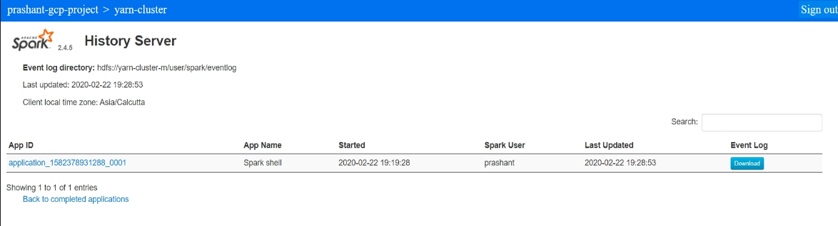

That's what we asked for. Let's look at the executor tab. So, we now have one driver and two executors.

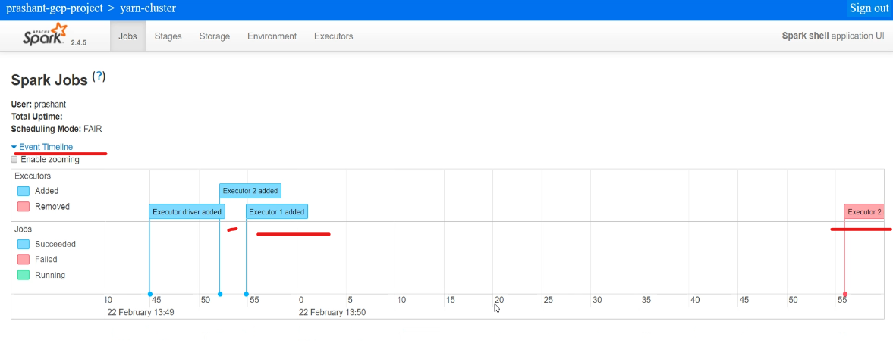

One executor is dead, and that's caused by the YARN dynamic allocation policy. We are not doing anything, and in that case, the YARN dynamic allocation policy is to release the resources. Great! We are done with the spark-shell on a real multi-node YARN cluster. You are not much likely to use this approach. Instead, you would always prefer to use the notebook for your interactive exploration.

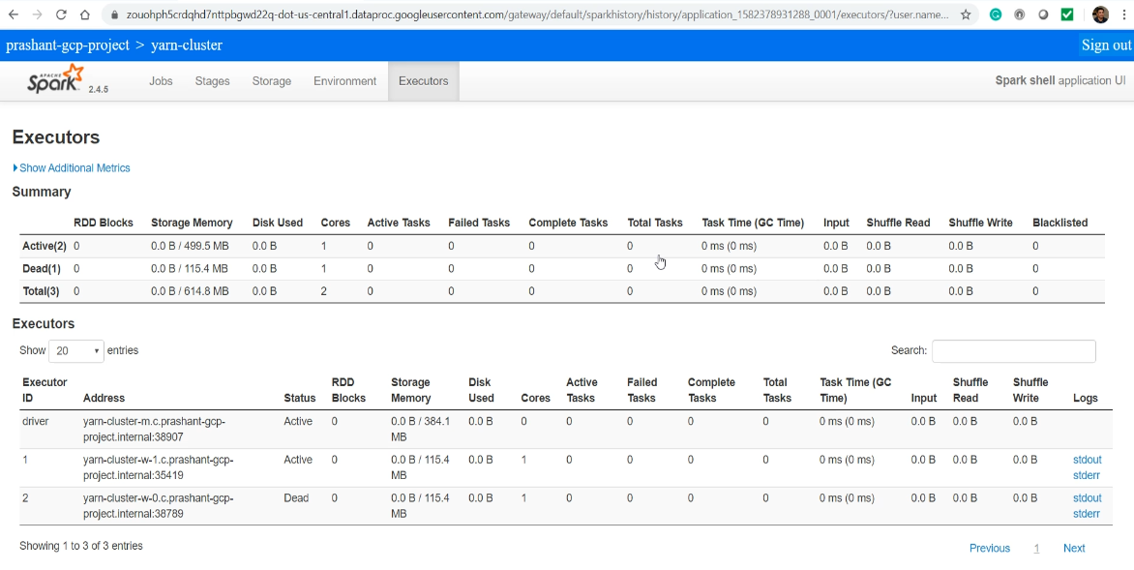

So, let me show you the same thing with a zeppelin notebook. Let me visit the zeppelin UI. In your secure enterprise setup, you must ask your cluster operations team to provide you the zeppelin URL and also grant you access for the same. I am going to create a notebook. The notebook is not like a shell, which immediately establishes the driver and executors.

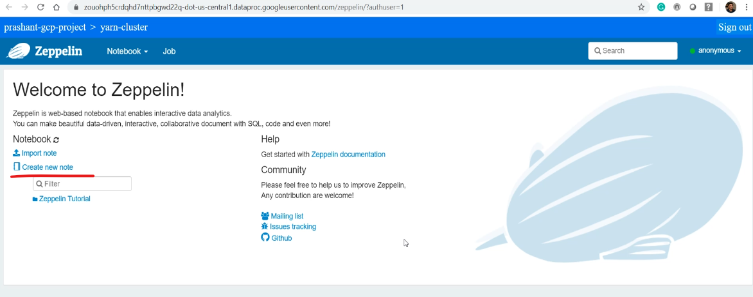

It is just a web interface which is not yet connected to the cluster. You must run some spark command to initiate the connection. And it could be as simple as checking the spark version. Let me wait until it completes.

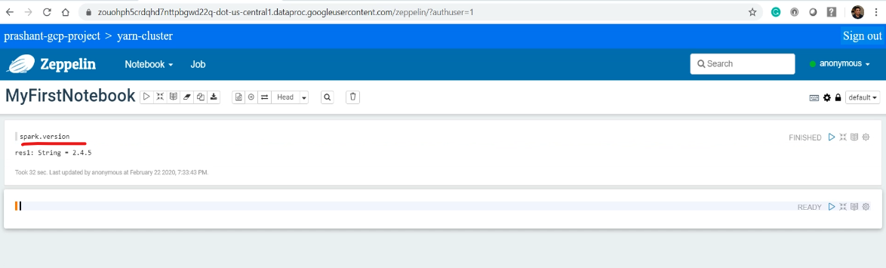

Now you can go to the spark history server. Great! So the old spark-shell is now showing in the completed application history. Let me check the incomplete applications.

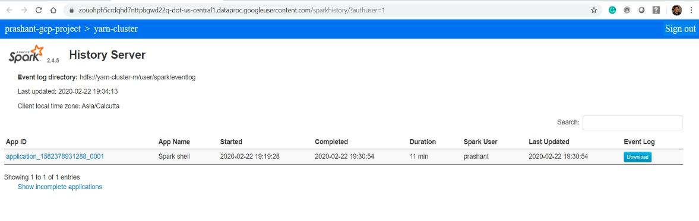

Click on the application ID. Let me check the event timeline. Great! So we got one driver and two executors.

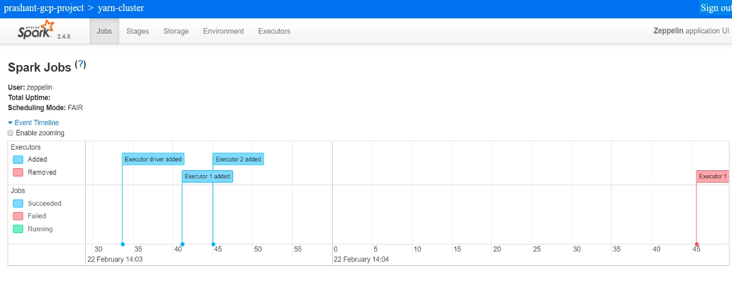

However, one executor is already released by the YARN dynamic resource allocation policy. You can look at the executor's tab, and you will see similar information. One driver, two executors. However, one executor is already dead. Spark is a highly configurable system. And you can look at the various configuration in the environment tab.

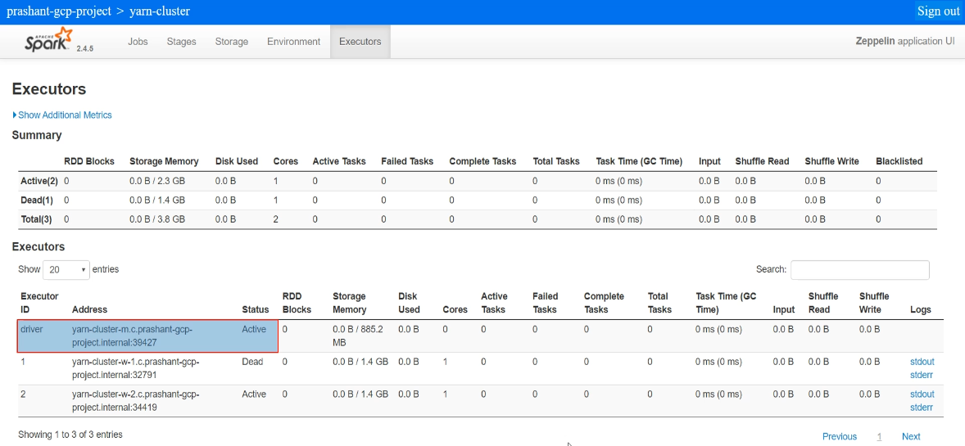

So the default zepplin client started with following configurations. spark.executor.instances 2 spark.submit.deployMode client spark.master yarn spark.executor.memory spark.executor.cores 1

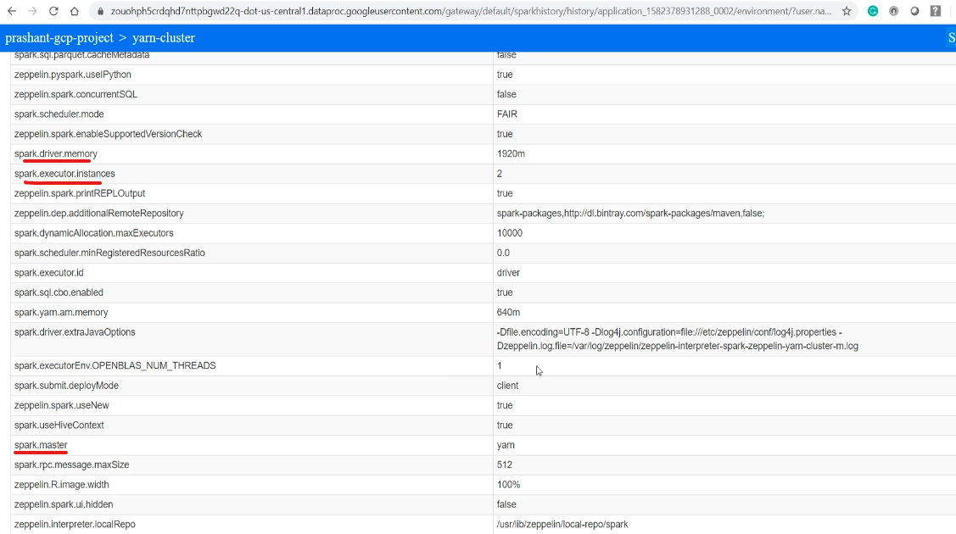

### Working with Spark Submit

Lets see a demo for the spark-submit, and we will be using the YARN cluster mode for this demo. This mode of operation is mostly used for executing your packaged Spark application on your production cluster. So, let's start with the spark-submit help and look at some available options. Great! So most of the options listed here are the same as offered by the spark-shell.

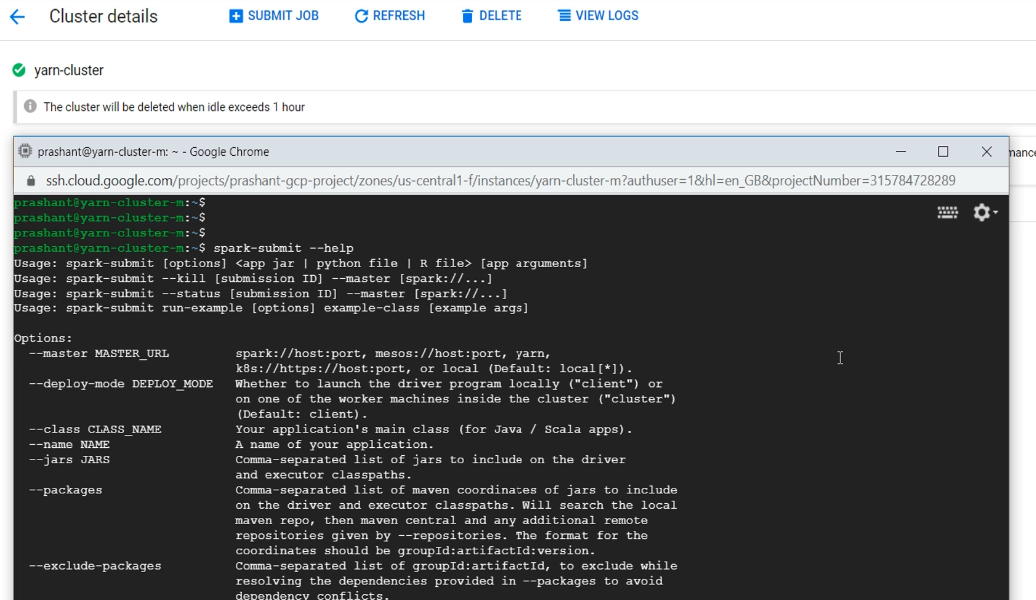

We already learned about the master, deploy-mode, driver-memory, executor-memory, driver-cores, executor-cores, and num-executors. We will learn about some more options as we progress with the course. However, at this stage, you already learned some basic options, and you are ready to start submitting your Spark application. Great!

So you cannot submit your application unless you have finished creating it and packaged it. We are going to learn to create Spark applications using the Scala programming language. And a scala application is packaged in a JAR file that you can submit to the cluster. So, first thing first. We need an application JAR. I haven't created anything yet, so let's use a spark example application.

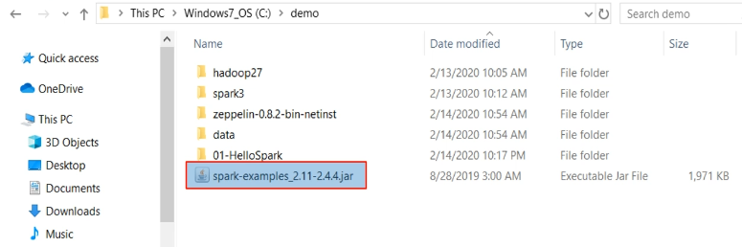

I have got this spark examples jar file for spark 2.4.4. And that's the spark version of my YARN Cluster. I need to upload this jar to one of my cluster machines. So, upload the jar file. Good. So I have the packaged application in my current directory. Now, let's use the spark-submit. I am going to use the YARN master. Deploy mode is a cluster. And I ignore other options and accept the defaults.

The jar was uploaded to the GCP shell and is available in the directory of the shell now ( see yellow highlighted jar )

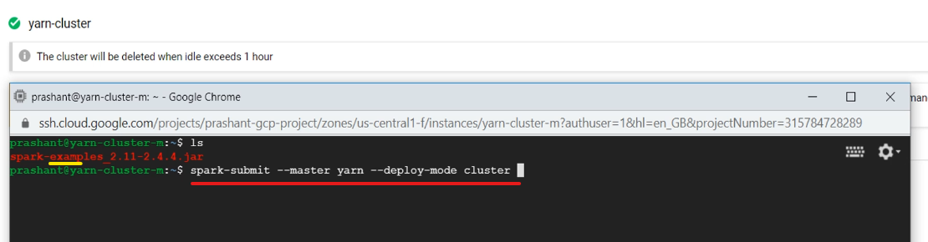

Once you are done with your options, the next thing is to specify the executable class in your JAR file. I am going to use the SparkPi example from this package. This is an example that uses the Spark cluster to compute the approximation of the value of Pi. Well, it is just a demo application, but it serves our purpose to learn how to submit your spark applications. The next thing is to give the application jar. Finally, command-line arguments for your application. This example expects a numeric value. I am giving 100. Great! We are ready to submit this application. Let's hit the enter. Done. We submitted an application to the cluster and got the application id.

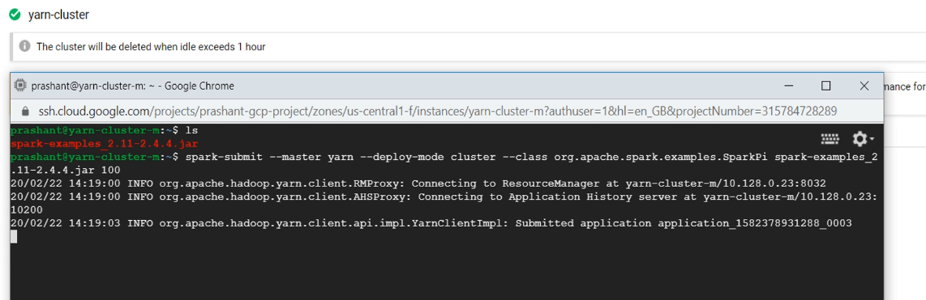

Now you can go to the spark history server and look at the application status. Here it is. The Application name is the Spark Pi,

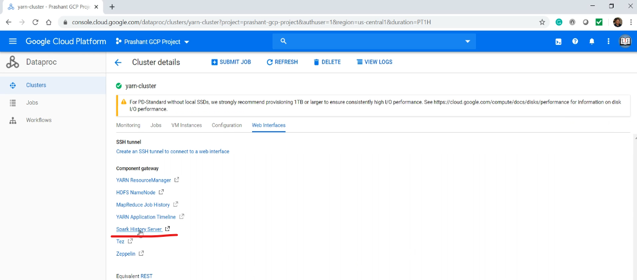

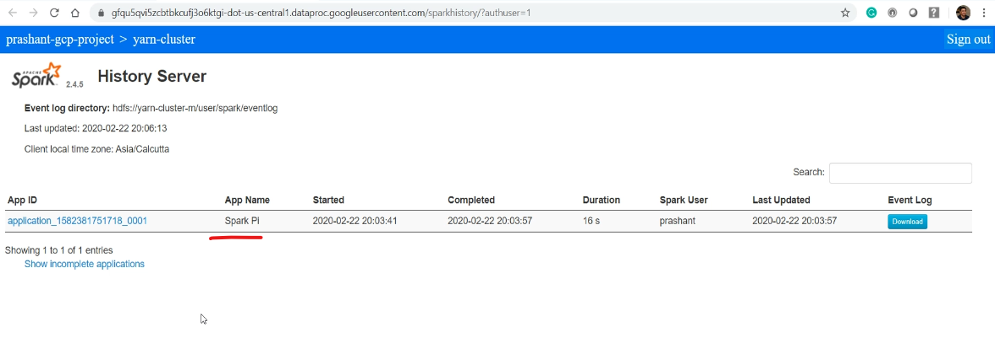

Let's look at the event timeline. You already know all this and what it means.

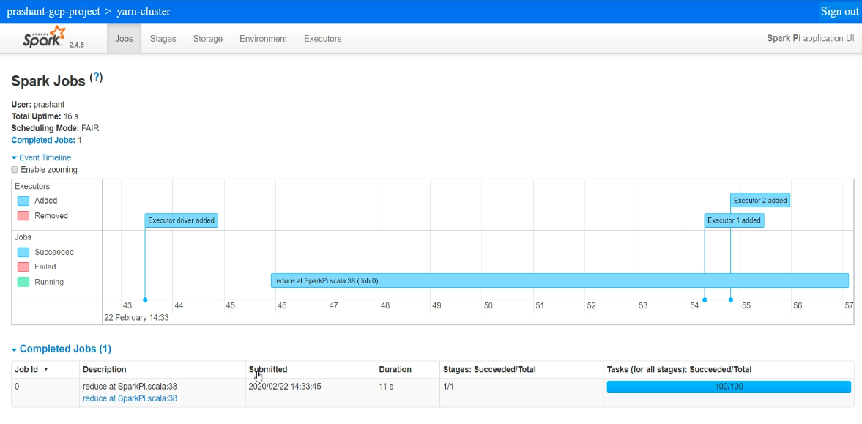

Summary

We learned about some Spark concepts and got an answer to the following two questions. How to execute your Spark programs? And How your program runs? To answer the first question, you learned about a bunch of concepts, including interactive clients and spark-submit. Then I talked about client mode and cluster mode. I also gave you a demo for all of these. To answer the second question, you learned about the driver and executors. I showed you the Spark Context UI and the Spark History Server. And you have seen a visual representation of driver and executors in the Spark application timeline. Now its time to start getting into the details of the next obvious question. How to create Spark programs? You might be wondering why I am delaying the answer to this central question. I have a valid reason for the delay. Creating an efficient and correct Spark program is not that straightforward. You must have some good sense of a bunch of Spark concepts to understand the Spark programming model However, with no further delay, I am going to help you create your first Spark Application in the next section. And you will also learn some more Spark concepts while we build our first Spark program.

Following spark-submit option is used to run your spark application on a YARN cluster.

--master yarn

Following option is used to start spark-shell in client mode.

--deploy-mode client

You can set the driver's memory using the following option.

--driver-memory

Which spark-submit option is used to set the executor memory requirement?

--executor-memory

How can you assign 2 CPU cores to each executor

--executor-cores 2

How can you assign 5 GB memory for your driver?

--driver-memory 5G

How can you ask for 10 executors?

--num-executors 10

You can track your currently running application using the following method. ( Note, not through history server )

YARN Resource Manager > Your Application Id > Application Master in Tracking UI column

## Spark Programming Model & Developer Experience

We are going to create and run our first Spark program. And in this first lecture, we are going to create a Spark Project and define our project Build Configuration. So, let's start. We are going to use IntelliJ IDEA as our development IDE. So, start IntelliJ IDEA and create a new project. I am going to be using Scala and SBT. Why? Because most of the serious Spark development work is being done in Scala. And SBT is the preferred build tool for Scala projects.

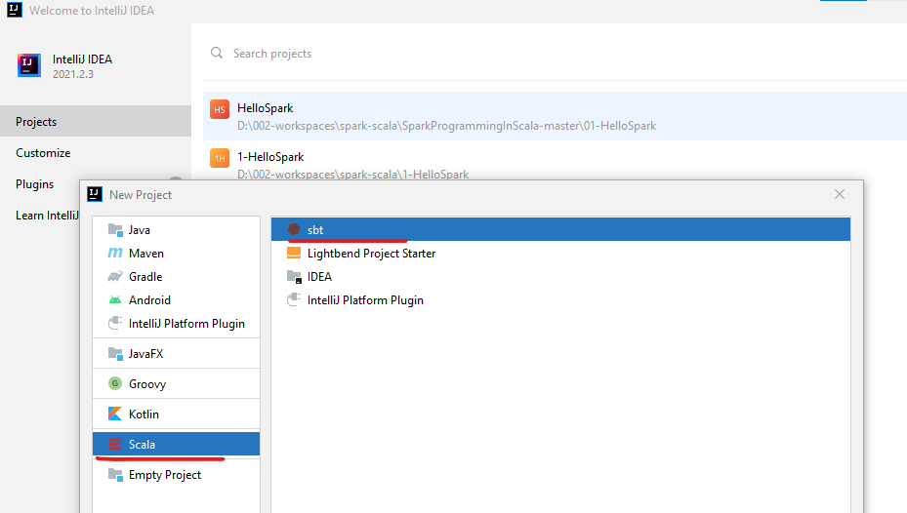

However, you can also use the apache maven if you prefer Maven builds. I am going to name it as HelloSpark. We will leave the SBT version to its default value, but we are going to change the Scala version. Why? Because I want to match the Scala version of my project with the Scala version of my Spark Cluster.

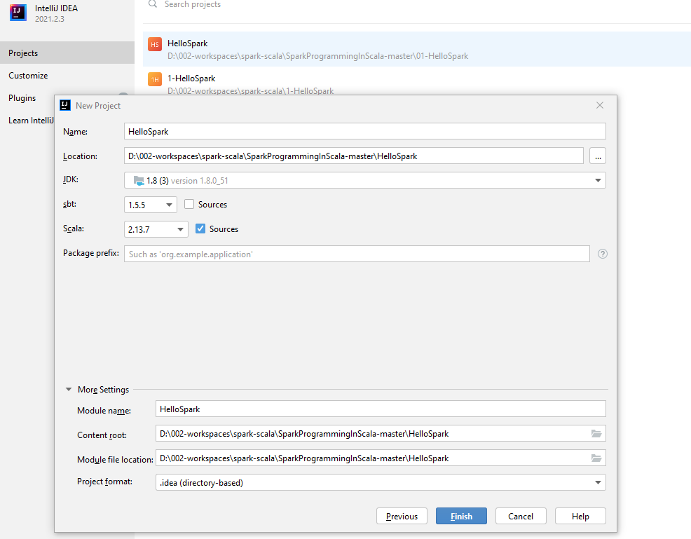

This course is created with Spark 3.0, and we intend to deploy our examples on Spark 3.0 cluster, which is pre-built with Scala 2.12.10. Let me show you.

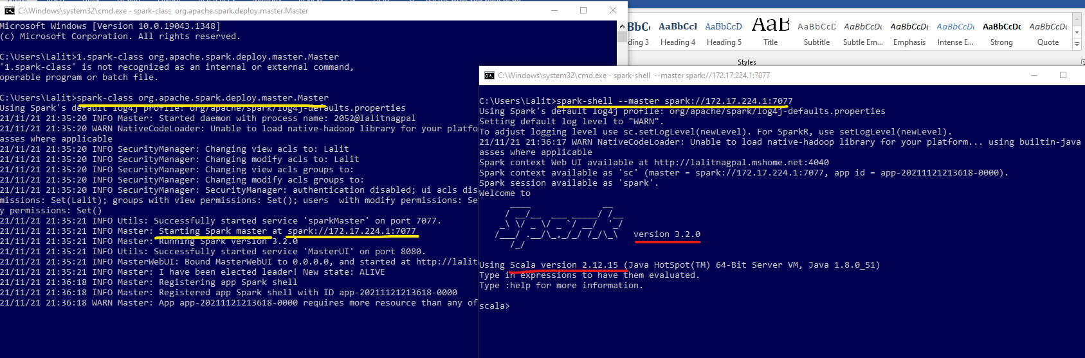

Start your Spark shell, and it will show you the Spark and Scala versions. And this is an important thing to note and remember that you must match your Scala version to avoid unnecessary conflicts. Let's finish the project creation. If you are creating your first Scala project, your IDE is going to take some time to download the Scala and SBT packages. So here is your empty SBT project. Double click on this build.sbt file and it should open.

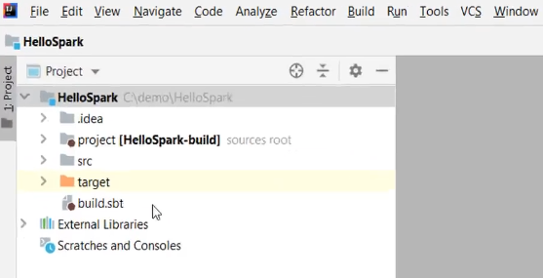 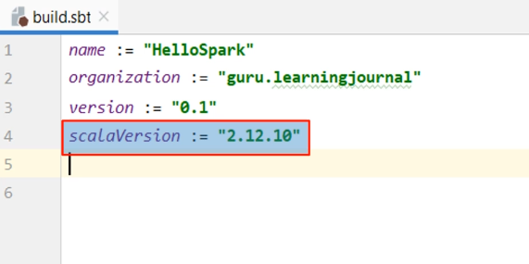

So this is your build file, and we are going to define some basic things. Few things are already there, such as name and version. These two are the project metadata. You can also add an organization which is used as a namespace for the project. We also have the Scala Compiler version, and that's already defined here. Where does it come? Well, we selected this in the previous step. If you are working on an existing project and want to change the Scala version of your project, you can change it here, and your project starts using the new Scala version. However, defining the Scala compiler version will also add Scala library as a dependency in your project. If you don't want it, then you can set autoScalaLibrary to false. You can also define variables in your build.sbt file and use them later. Let me define some variables. The first variable is the Spark version. So, we are going to use Spark 3.0 preview 2. Why? Because that's the most recent Spark version as on date.

**build.sbt**

*name* := "HelloSpark"

*organization* := "guru.learningjournal"

*version* := "0.1"

*scalaVersion* := "2.13.7"

*//scalaVersion := "2.11.8"*

*autoScalaLibrary* := false

*// val sparkVersion = "3.0.0-preview2"*

val sparkVersion = "3.2.0"

val sparkDependencies = *Seq*(

"org.apache.spark" %% "spark-core" % sparkVersion,

"org.apache.spark" %% "spark-sql" % sparkVersion

)

val testDependencies = *Seq*(

"org.scalatest" %% "scalatest" % "3.0.8" % *Test*

)

*libraryDependencies* ++= sparkDependencies ++ testDependencies

The second variable is a sequence of Spark dependencies. So, we are going to need Spark Core and Spark SQL. Well, you might need a few more things at a later stage. However, these two are enough to start with this first project. What else? Well, no program is complete without uint testing. So, we need some test dependencies. I am going to use scala test for creating unit test cases. So, let's add the Scala test dependency. Great! We are done with the dependencies. So, let me add both of these to an existing default library dependencies sequence. Great! We are done with the project build configuration. Now it's time to create a simple Spark program. Let's do it. I am assuming you already know some basics of Scala programming. If not, you might want to check out the learningjournal.guru courses and join my Scala programming course. Great! So assuming that you know Scala programming, let's create a Scala object and the main() method. Create a new package. I am going to create all my Scala classes and Objects under this package. Now, create a Scala class, select an object, and give a name to your Scala Object. Great! So this is going to become my main executable Scala Object.

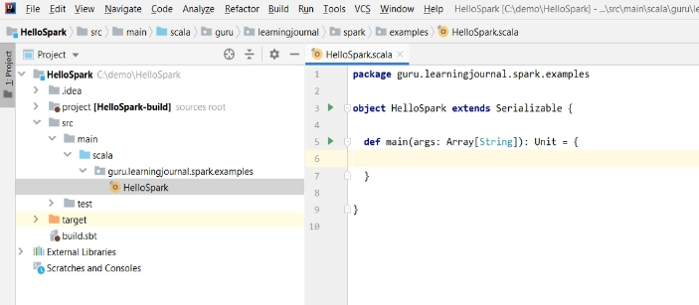

We are going to create a Spark program, right? Spark is a distributed application, so my object should be serializable. So, let me extend the Serializable interface. This is a standard thing for a Spark program because the Spark framework must serialize your classes over the network. Now let me add a main() method. Great! So we are now ready with a basic project template with an executable entry point - the main() method and also a build configuration. That's all for this video. In the next video, we are going to extend it further.

### Configuring Spark Application Logs

We already created a basic Spark project and also defined the build configuration. However, a proper application must have some kind of application logging. So, in this video, we are going to configure the Spark application log. Let's start. Spark project is using Log4J, and we also want to use the same for our Spark applications.

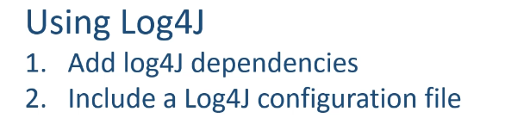

Configuring Log4J for your project is a two-step process. Add required dependencies to your build file And include a Log4J configuration file in your project. In our case, we do not need to provide an additional dependency for log4j because it comes as a transient dependency with spark-core. However, we need to add a log4j configuration file. Let me add it. I am going to create the log4j.properties file in the project root. We often include this file in the project resources. Still, I am creating it in the project root because we do not want to package this file in the application jar. We want to keep it outside the application Jar and supply it separately while submitting my application to the cluster. I will explain this again in a later video of this section. But for now, let us create the log4j properties in the root folder.

The content of this file is pretty much standard. Let me paste the content, and I will explain it.

**log4j.properties**

*# Set everything to be logged to the console*

log4j.rootCategory=WARN, console

*# define console appender*

log4j.appender.console=org.apache.log4j.**ConsoleAppender**

log4j.appender.console.target=System.out

log4j.appender.console.layout=org.apache.log4j.PatternLayout

log4j.appender.console.layout.ConversionPattern=%d{yy/MM/dd HH:mm:ss} %p %c{1}: %m%n

*#application log*

log4j.logger.guru.learningjournal.spark.examples=INFO, console, file

log4j.additivity.guru.learningjournal.spark.examples=false

*#define rolling file appender*

log4j.appender.file=org.apache.log4j.RollingFileAppender

log4j.appender.file.File=${spark.yarn.app.container.log.dir}/${logfile.name}.log

*#define following in Java System*

*# -Dlog4j.configuration=file:log4j.properties*

*# -Dlogfile.name=hello-spark*

*# -Dspark.yarn.app.container.log.dir=app-logs*

log4j.appender.file.ImmediateFlush=true

log4j.appender.file.Append=false

log4j.appender.file.MaxFileSize=500MB

log4j.appender.file.MaxBackupIndex=2

log4j.appender.file.layout=org.apache.log4j.PatternLayout

log4j.appender.file.layout.conversionPattern=%d{yy/MM/dd HH:mm:ss} %p %c{1}: %m%n

*# Recommendations from Spark template*

log4j.logger.org.apache.spark.repl.Main=WARN

log4j.logger.org.spark_project.jetty=WARN

log4j.logger.org.spark_project.jetty.util.component.AbstractLifeCycle=ERROR

log4j.logger.org.apache.spark.repl.SparkIMain$exprTyper=INFO

log4j.logger.org.apache.spark.repl.SparkILoop$SparkILoopInterpreter=INFO

log4j.logger.org.apache.parquet=ERROR

log4j.logger.parquet=ERROR

log4j.logger.org.apache.hadoop.hive.metastore.RetryingHMSHandler=FATAL

log4j.logger.org.apache.hadoop.hive.ql.exec.FunctionRegistry=ERROR

I am assuming you already know some log4j configuration basics. However, let me quickly explain a few things. We are doing two things here. The first thing is to stop all unnecessary log messages and restrict it to show only errors and warnings. Why? Because we do not want Spark and other libraries to show info and debug messages. Then the second thing is to set up our application classes to show info and debug messages. This arrangement will give us a clean and meaningful application logs coming up from your code and avoid things to showup from the Spark code. So, the first few lines are standard things. We are setting the root level to warning and default appender to console. Then we are defining the console appender configurations. Up to this level, we make sure that all the warnings and error messages will be sent to the console, and the logger will ignore the debug and the info messages. So, we defined the default logger behavior. If errors or warnings are coming from Spark or any other Hadoop components, you will see them on your console. Still, you will not see any INFO or DEBUG messages. However, we want to see the INFO and DEBUG messages that are coming from our classes. So, the next thing is to configure our application classes to override this default behavior. So, I am defining a logger for my package and set the log level to INFO. Then I am sending it to the console and also to a file.

I am also setting the additivity to false. Why? Because we want to make sure that the same log entry is not repeated multiple times. This logger configuration is going to work for me because I will be creating all my code under this package hierarchy. However, you might be creating a different package, and hence you may have to change this logger definition. This is the only place where you may have to change the package name with your application package name. Otherwise, the rest of the configurations are standard, and they should be working for your projects also.

Now the next thing is to define our file appender. I am going to use a rolling file appender, and all of these lines are standard configurations for a rolling file appender. The rest of the settings below this level are some recommendations by the Spark Log4J configuration template. So, I am keeping them in my configuration file as well. Great! So at a high level, we are done. However, what is this variable? All these log4j configurations are standard for any Scala or Java project. The only tweak is the log file location and the log file name. And this thing is supercritical. If you mess up with this configuration, then you may have to struggle a lot to get your application logs.

You may not face a problem on your local machine. But when you deploy your application to a real cluster, things start messing up, and you may find it challenging to locate your application logs. If you get this configuration right, your life is going to be a lot easier. Let me explain the main problem and how to deal with it.

We already learned that the Spark follows a master-slave architecture, and your application is going to run as one driver and multiple executor processes. And all these executors are individual JVMs running on different machines in your cluster. What does it mean? Your driver is running on one machine, and all your executors are running at different computers. But you do not have any control over it. In fact, you do not know what is going to execute where? All of that is managed by the cluster manager.

Now think about the driver are executers all creating application log files on their local machines. So your log file is also distributed. How are you going to collect it? Well, you can not do it. So, you are going to rely on your cluster manager for managing the log. Now let's assume we are using YARN. So, YARN is going to collect all these log files and keep it at one predefined location so you can read them and investigate them quickly.

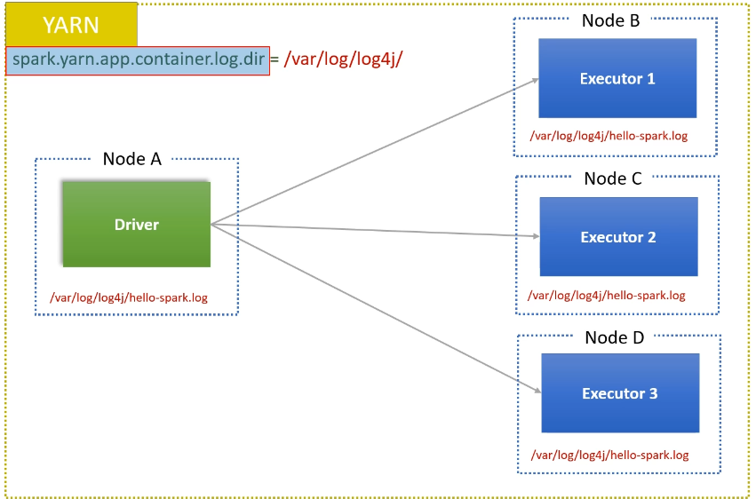

But for YARN to find these log files, you should make sure that your application JVM is creating logs at a well defined fixed location on each machine. And that's what we define here. If you want your YARN manager to collect your application logs, then you must ensure to create log files in 'spark.yarn.app.container.log.dirctory.' This is a variable that YARN is going to use for log collection.

*#define rolling file appender*

log4j.appender.file=org.apache.log4j.RollingFileAppender

log4j.appender.file.File=${spark.yarn.app.container.log.dir}/${logfile.name}.log

And this configuration should be defined appropriately by your cluster admin. If your application is creating log files at some other location, YARN is not going to collect it. Or, if your cluster admin forgot to define a value for this variable, YARN is not going to manage the logs. And you are going to struggle for receiving and reading your log files. The next variable is the log file name. We are using a variable name for the log file name because we want to control the log file name and do not wish log4j to use a default and random name.

We will come back to these variables once again in a later video when we are submitting our first Spark application to a real distributed cluster. But for now, we are going to run and test our application in a local machine. So, these variables should have a valid value on your local setup as well. How to configure a local Spark log directory? You can define your log4J variables in your IDE. Let's do it quickly.

Go to the Run menu and click on the Edit Configurations. Make sure your main class is selected here. My main() class name is HelloSpark. Now we define three JVM configurations. The first one is the log4j configuration file name and location. My log4j configuration file name is log4j.properties, and it is present in the project root folder. Now my JVM should locate the log4j properties file and load it at runtime. The next configuration is the spark .yarn.app.container.log.dirrectory. This variable should have already been set in your cluster. But for the local machine, we do not have a YARN manager. So, we are going to mock this variable for running it locally. Let me set it as app-logs. Finally, the last configuration is the log file name. Let me set it as hello-spark.

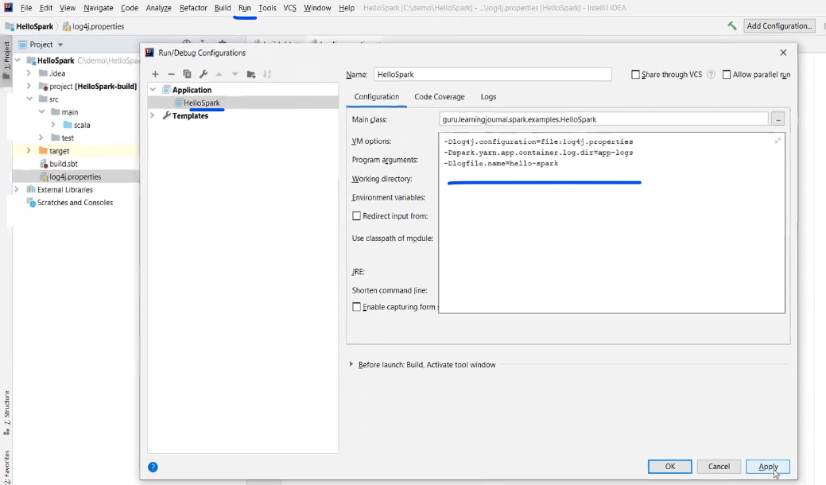

Apply the changes and close your run configuration. Great! Now you are ready with your Spark project template. We defined a build definition, log4j configuration, configured JVM variables, and you also have a main() method. See you in the next video, and we will start creating Spark Code.

Which configuration is used to pass values to Spark driver JVM?

spark.driver.extraJavaOptions

You can inform spark that log4j.properties file is present in the current directory using the following configuration?

-Dlog4j.configuration=file:log4j.properties

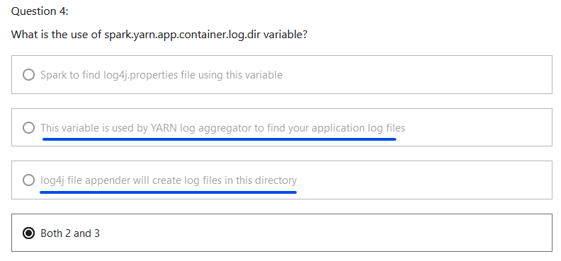

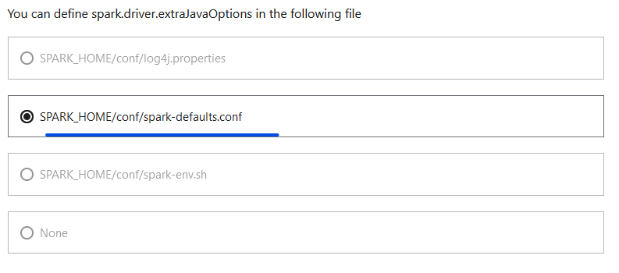

### Creating a Spark Session

Now its time to start writing our first Spark Program. Let's start. We already learned that every Spark program will start a driver. And then, the driver is going to start the executors for doing most of the work. So, the first thing in a Spark program is to create a SparkSession object, which is your Spark Driver. Well, it is an overwhelming statement, and one can debate if the Spark Session is the driver or the main() method itself is the driver. However, things are going to make a good sense if you start looking at your Spark Session as your driver. So, I am going to follow this notion. SparkSession is your driver. And I will explain it many times.

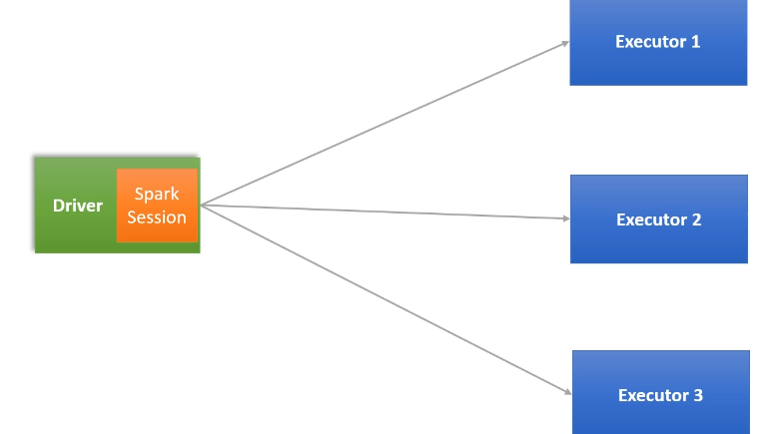

When you start the spark-shell or the notebook, they create a Spark Session for you and make it available as a variable named spark. You have already seen and used it in the earlier videos. However, when you are writing a spark program, then you must create a SparkSession because it is not already provided. Creating a SparkSession is straightforward. You will declare a Scala val and use SparkSession.builder().getOrCreate(). That's all. You got your SparkSession object, and we often name it as the spark.

import java.util.Properties

import scala.language.*implicitConversions*

import org.apache.log4j.Logger

import org.apache.spark.SparkConf

import org.apache.spark.sql.{DataFrame, SparkSession}

import scala.io.Source

object HelloSpark extends Serializable {

def main(args: Array[String]): Unit = {

val spark = SparkSession.*builder*()

.getOrCreate()

SparkSession is a Singleton object, so each Spark application can have one and only one active spark session. And that makes a perfect sense because the SparkSession is your driver, and you cannot have more than one driver in a spark application. Great! Spark is a highly configurable system, and hence your SparkSession is also highly configurable. However, I haven't used any configurations yet. Let's add some configs. The builder method returns a Builder object, which allows you to configure your SparkSession and finally use the getOrCreate(). Some configurations, such as AppName, and Master are the most commonly used configs by almost every application. So, we have direct methods to specify them. However, we also have some overloaded config () methods for all other configurations. Let me define the application name. We also want to set the cluster manager, and we already learn that the cluster manager config is defined as a spark master. I am going to use local multithreaded JVM with three threads. Great! So we created a Spark session, and that means we created our spark driver. We will be using this driver to do some data processing, and once we are done with it, we should stop the driver. That's how a typical spark program is structured. In the earlier lecture, we configured log4j for this project. So let me add some log entries. I am going to declare a transient lazy logger and instantiate it. Once you have the logger, you can use it wherever you want. I am going to push one info message in the beginning. And one more at the end. That's all. This program is doing only one thing. Creating a Spark driver that starts, does nothing, and stops. Let me run it.

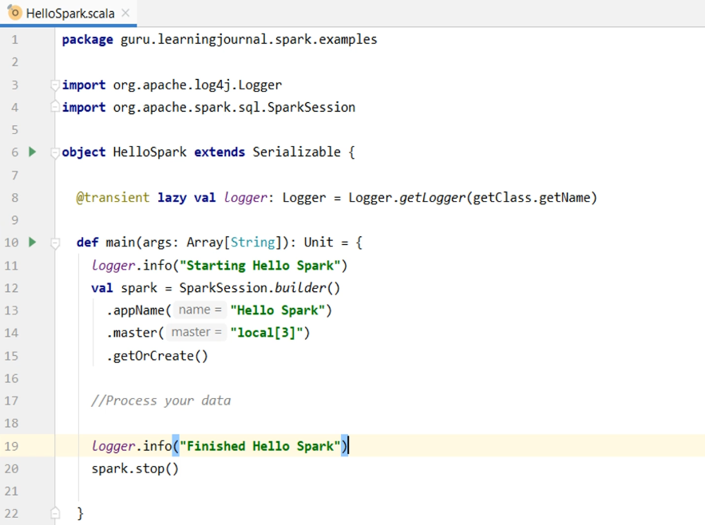

We got these log messages to the console. Starting Spark and Finished Spark. I also got this warning, but that's fine, you can ignore it. If you look at your project explorer, you will also notice this app-logs directory. Do you remember this directory name? We configured our log4j file appender to create log files in this directory, right? And here is the log file. If you compare this log file with the console log, you are going to notice a visible difference. The log file is configured to show log entries coming from my package only. It is clean and gives me only those things that I want to see. It does not contain cluster level or noisy entries coming from other spark and Hadoop packages. These logs are super valuable when you want to investigate problems while running your application on a real distributed cluster.

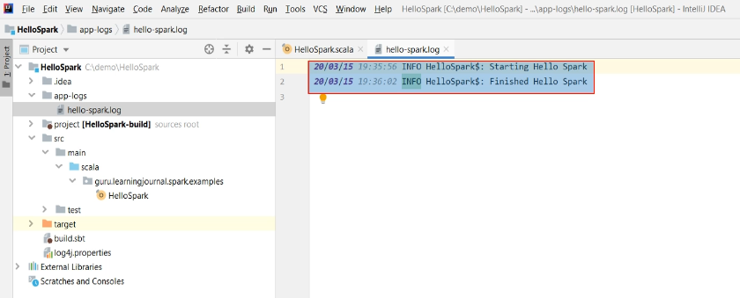

I will give you a demo for the same in a later video. So, in this video, we learned to create and stop the Spark session, or you can say, we learned to create and stop the spark driver.

### Configuring Spark Session

Apache Spark is a highly configurable system, and Spark allows you to set those configurations using four different methods. We have already used the first two methods. Let me explain all these. Spark Session builder gives you a config method which takes a SparkConf object.

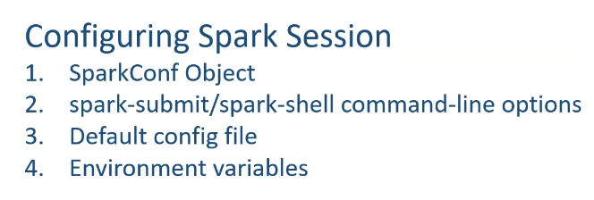

And that's the first method for configuring your Spark Application. SparkConf allows you to configure most of the common properties, including the application name and the spark master. So, instead of using appName() and master() methods, you can use SparkConf. Let me show you. Create a SparkConf object. Now, you can use the set() method to set the application name config. You can set as many configs as you want. However, you must know the actual config property name string. For example, the spark application name config string is "spark.app.name." Similarly, "spark.master" is the string config name for the spark master. You can refer to the following documentation link for a list of all available spark configs.

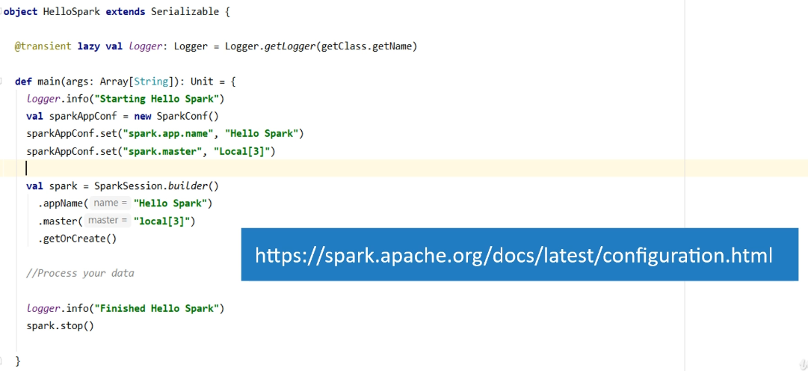

Once you have your SparkConf ready with all the desired configs, you can pass it to the session builder. Now, these two lines are not needed. Great! So you learned the first and most commonly used approach to configure your Spark Application. However, we still have one problem. All these configurations are hardcoded in my application. In some cases, you may want to avoid hard-coding specific configs and keep it outside your application code. For example, hardcoding the master is a big problem. While developing and debugging my application, I want to use the local master. However, once my application is ready, I want to deploy it in a cluster environment.

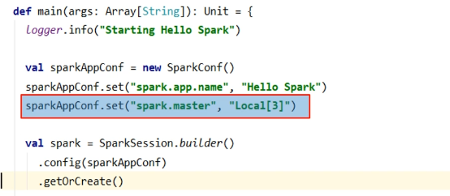

And I don't know yet if I am going to use it on YARN or on a Kubernetes cluster. So, I do not want to hardcode this config. How do you deal with this requirement? We have a couple of approaches to handle it. The first approach is to keep these configurations in a separate file and load it from the file at runtime. Let me show you. I am creating a plain text file named spark.conf. You can use whatever filename you want, but I just prefer using spark.conf. You should also notice that I am keeping this file in the project root, just like we created log4j.properties. Now, I can place my configurations in this file. Let's keep only two configs for now. I am keeping these configs as a key-value pair separated by the '=' symbol. If you have some experience with Java properties files, you already know this format, right?

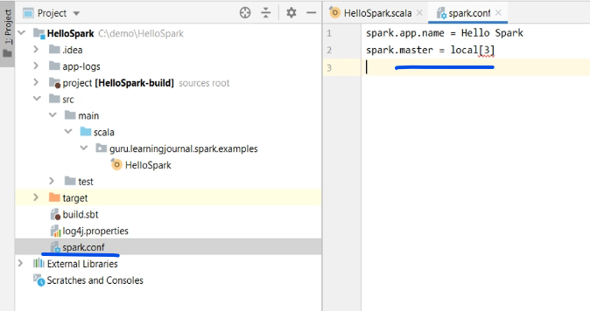

Great! Now come back to your code and create a Scala function - getSparkAppConf. This function is going to return the SparkConf object. Let's finish the function body. We will create a new SparkConf object. Read the configs from the file and set it to the SparkConf. Finally, return the SparkConf object. How do you read the config file? Well, that's straightforward. Create a java properties object. Load the properties from the file. Now, for each property, we get the key/value pair and use it in the SparkConf.set() method. That's all. Done.

def getSparkAppConf: SparkConf = {

val sparkAppConf = new SparkConf

*//Set all Spark Configs*

val props = new Properties

props.load(Source.*fromFile*("spark.conf").bufferedReader())

props.forEach((k, v) => sparkAppConf.set(k.toString, v.toString))

*//This is a fix for Scala 2.11*

*//import scala.collection.JavaConverters._*

*//props.asScala.foreach(kv => sparkAppConf.set(kv._1, kv._2))*

sparkAppConf

}

**HelloSpark.scala**

import java.util.Properties

import scala.language.*implicitConversions*

import org.apache.log4j.Logger

import org.apache.spark.SparkConf

import org.apache.spark.sql.{DataFrame, SparkSession}

import scala.io.Source

object HelloSpark extends Serializable {

@transient lazy val *logger*: Logger = Logger.*getLogger*(getClass.getName)

def main(args: Array[String]): Unit = {

*logger*.info("Starting Hello Spark")

val spark = SparkSession.*builder*()

.config(*getSparkAppConf*)

.getOrCreate()

*logger*.info("spark.conf=" + spark.*conf*.getAll.toString())

This code perfectly works with Scala 2.12. However, if you are using Scala 2.11, then you may have to tweak it a little. Here is the code for Scala 2.11. Well, this is needed because before Scala 2.12, we had some problems dealing with Java Lambdas, and we needed some complicated code to deal with them. I am going to run some examples using Scala 2.11, and hence we keep this code here but comment it for now. Great! So we have a function now. This function reads all the configs from the "spark.conf" file, set them to the SparkConf object, and return the ready to use SparkConf. Now, all we need to do is to come back to the main() method and use it in the spark builder dot config method. Done. We fixed the hardcoding problem. Now you can add more and more configs in this spark.conf file, and your application will load it at runtime and use them to configure your SparkSession. Let me put a dummy value. Just for fun. Do you want to run it once and see the outcome? You can read all your spark configs using the SparkSession.conf method. Let me run it. Great! You can see the outcome.

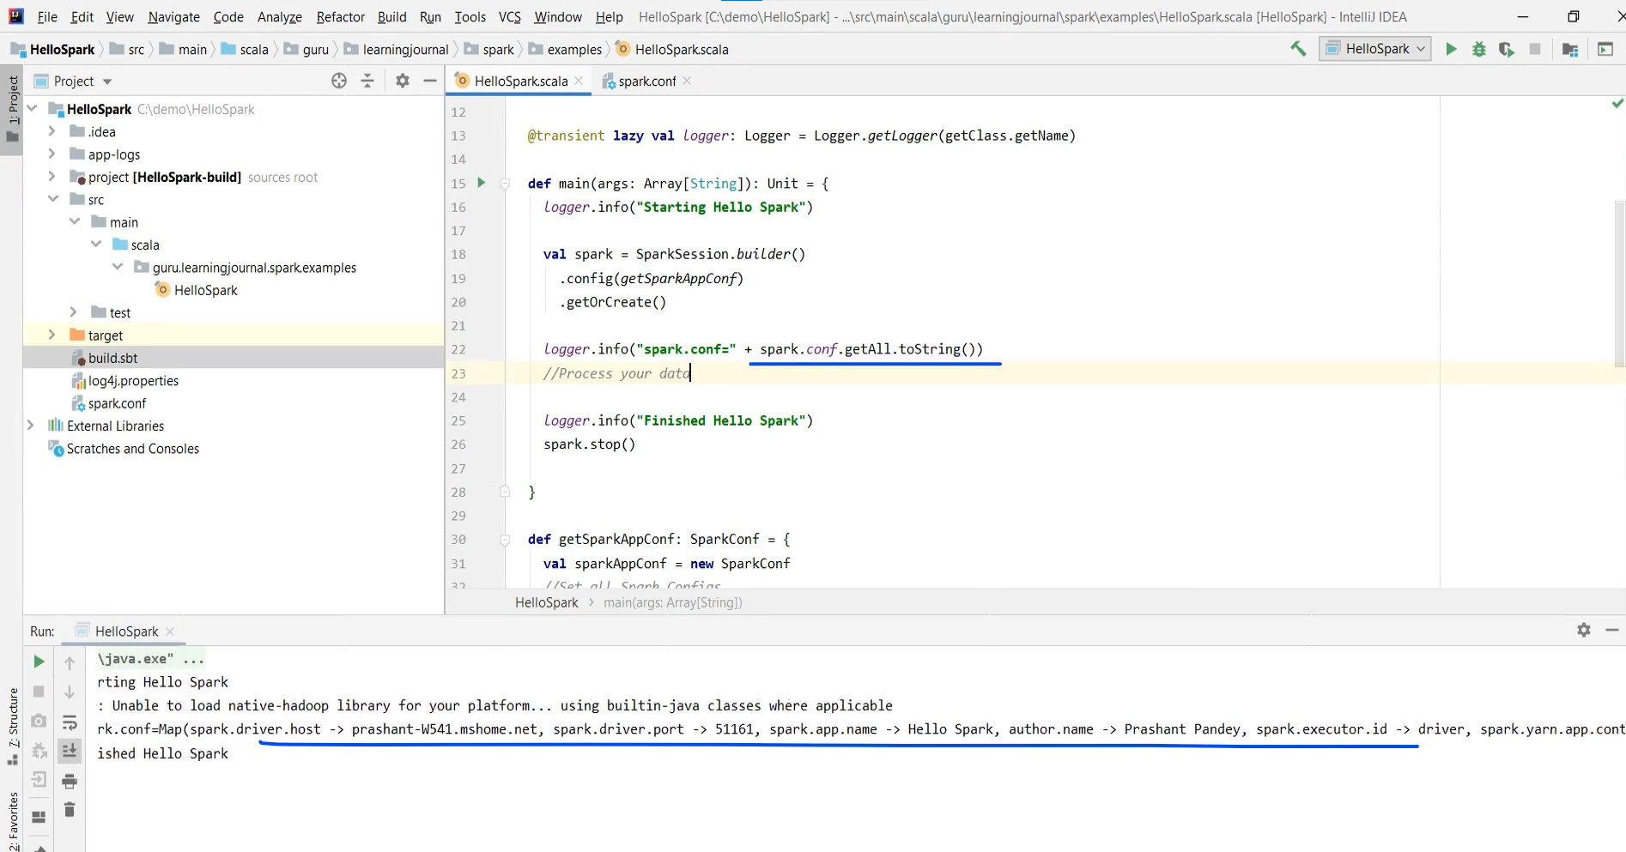

We loaded everything from the config file. Good. So you learned the first method of configuring your Spark application. Now let me talk about the second method. We have already used spark-submit in an earlier video. Spark-submit allows you to configure your application using command-line options such as --master. You have already seen that in action.

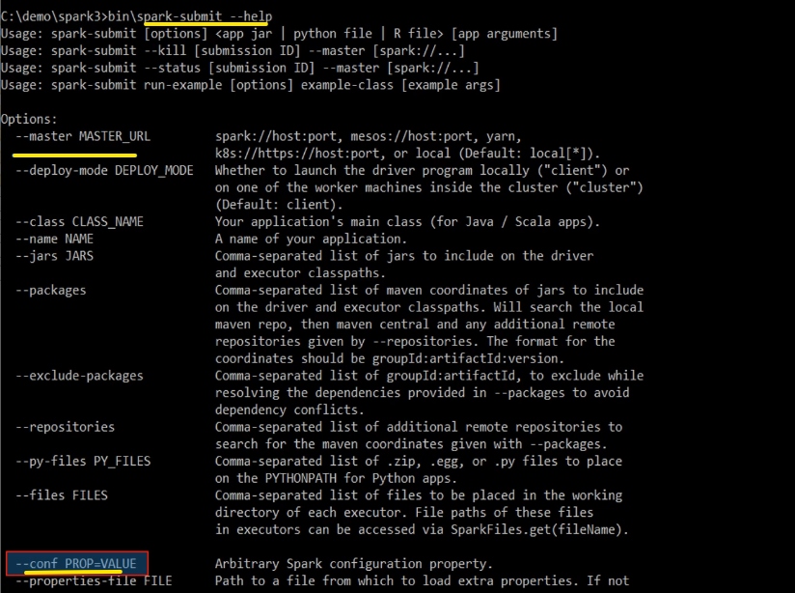

Similarly, spark-submit can also accept any Spark config using the --conf flag. Here is an example. If you have a space in your config, then you must enclose it in double-quotes. Otherwise, the double quote is not necessary.



So how is this spark-submit method different from the SparkConf method? You have two things to learn here. The first point is this. All these config values specified as flags will be passed on to the application driver and merged with those specified through SparkConf.

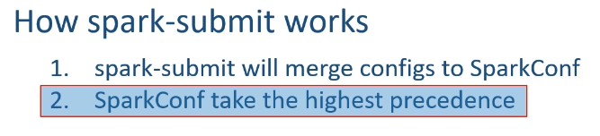

So, ultimately, both methods are the same but two different approaches. However, configs that are set directly on the SparkConf take the highest precedence. So, if you are setting the same config from both the places, SparkConf will be effective, and spark-submit config is ignored. Great! Now the next point is this. Spark properties can be grouped into two categories. The first category is for deployment-related configs such as spark.driver.memory, and spark.executor.instances.

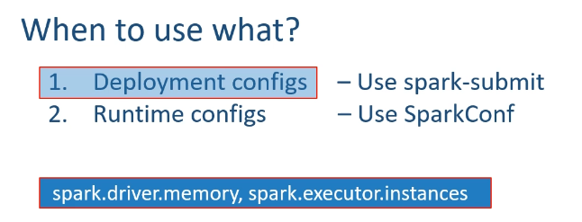 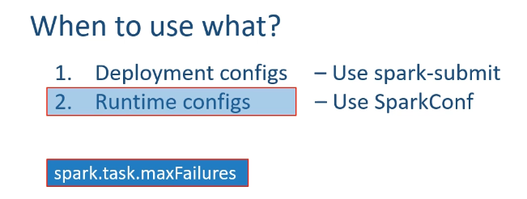

This kind of config is going to depend on which cluster manager and deploy mode you choose and may not affect the SparkConf. So, we often set them through the spark-submit command line and avoid keeping them in the spark.conf. The other category of configs is to control the Spark Application runtime behavior such as spark.task.maxFailures. So, we often set them through SparkConf. There is no clear boundary between these two categories, but I follow a simple thumb rule. Look at the Spark submit help. Wherever you see specially named flags, such as --master, --driver-memory, --num-executors, etc. You should be using them with the spark-submit, and rest all configs are the right candidate for SparkConf.

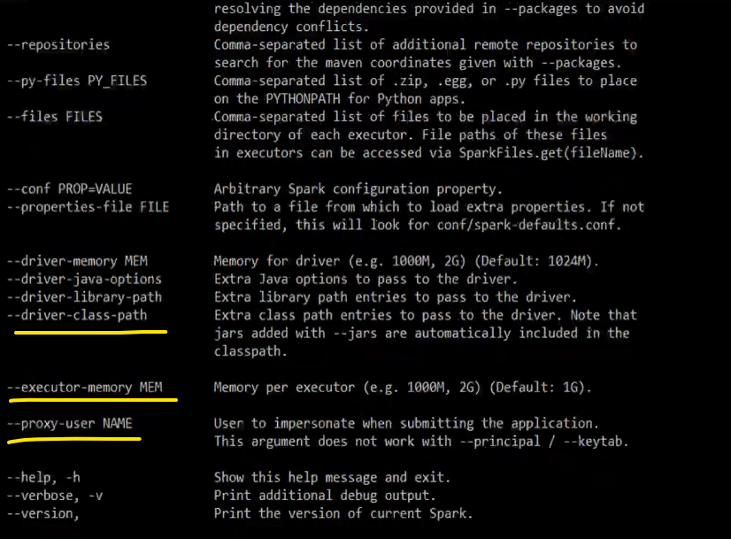

However, different architects may have their own rules and choices. Now the next method is to use the default config file. This one is mostly used by your cluster admins and often ignored by the Spark developers.

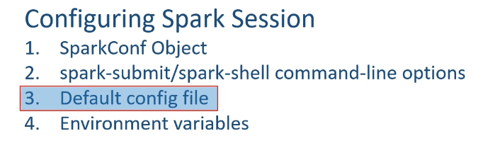

Let me explain. The spark-submit tool is designed to look for the spark-defaults.conf file in the conf directory of your SPARK_HOME. The spark-submit and even spark-shell will read this file and load all the configs defined in this file.

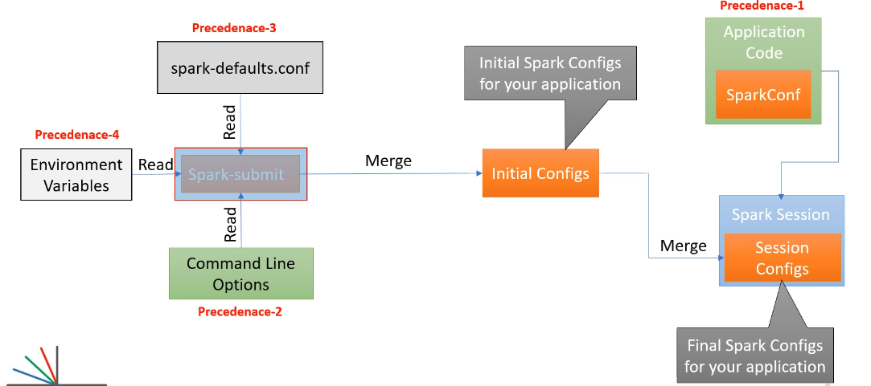

Those configs are also passed to your application and automatically merged with the SparkConf in your SparkSession. However, configs in this are given the lowest precedence. And this file is used by your cluster admins as default configs for all the applications. But as an application developer, you are going to override the defaults using spark-submit or using your SparkConf. Finally, the last option is to use environment variables. This one is also a special category and mostly used by your cluster admins. Your admins and cluster architect will be using environment variables to set things like JAVA_HOME, SPARK_HOME, PYSPARK_PYTHON version, etc. Setting these environment variables varies across different cluster managers, operating systems, and the infrastructure environment. Great! That's all about configuring the Spark application and your runtime environment. You learned four methods. However, you will be using the first two methods most of the time - SparkConf and spark-submit. The other two ways are for cluster admins and infrastructure teams.

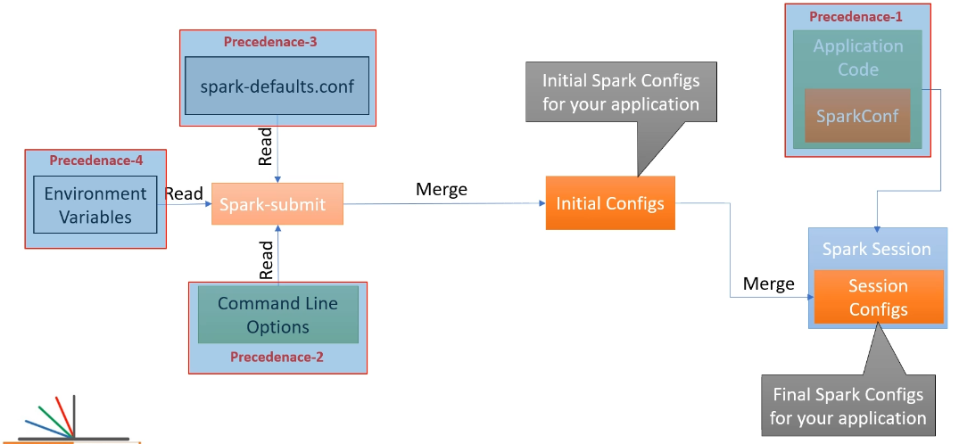

**Quiz**

SparkSession is an entry point to Programming Spark

SparkSession can be created using SparkSession.builder()

A SparkContext represents the connection to Spark Cluster

A SparkContext can be used to get SparkConf object

A SparkContext was a entry point to Programming Spark in the older versions

SparkConf is used to get/ set various Spark parameters as Key Value pairs

SparkConf can be retrieved from your spark session using spark.sparkContext.getConf()

You can create a SparkConf that loads defaults from system properties and the classpath

Setting values to SparkConf directly takes precedence over System Properties

You can set the configuration to your Spark application using the spark-submit command line option

You can set the configuration to your Spark application setting environment variable on the machine where you run spark-submit

You can set the configuration to your Spark application using the SPARK_HOME/conf/spark-defaults.conf on the machine where you run the spark-submit

You can set the configuration to your Spark application setting key/ value pair to SparkConf object in your application code.

Following Spark application configuration precedence is correct

Environment variable -> spark-defaults.conf -> spark-submit command line -> SparkConf

### DataFrame Introduction

In the earlier lecture, We created and configured our Spark Session. In this lecture, we are going to take our next step in Spark Programming. So, let's start. Spark is a distributed data processing framework. And typical data processing is a three-step process.

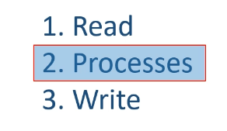

Read the data Processes it according to your business requirement And finally, write the outcome of your processing You can debate it for machine learning, model training, and many other things. However, at a high level, we do these three things, and I am going to start the discussion using these three steps. So, let's implement the first step in our Spark application. Reading the data. I have a data file named sample.csv.

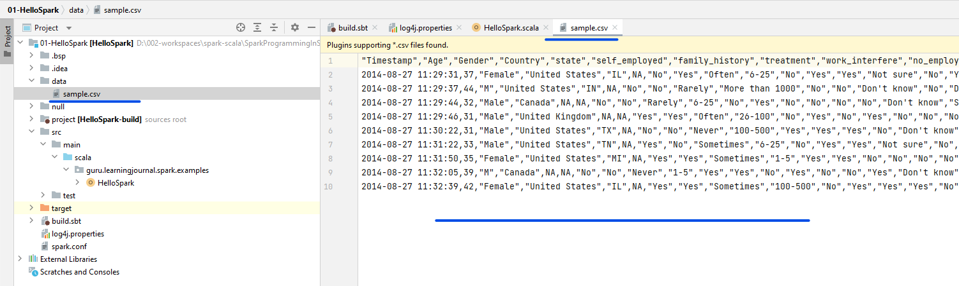

It is a small file with less than ten records, and I am going to use it for local development, debugging, and testing. I am keeping this file in a separate directory named data. I want to read this file using Spark. So, the first thing that I want to do is to pass the file name and location as a command-line argument to my application.

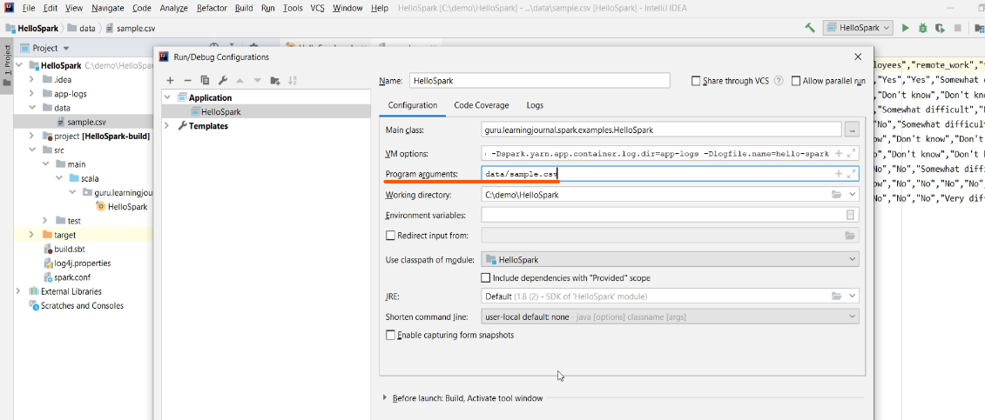

Why? Because I do not want to hardcode the data file name and location in my application. Then we check for the command line argument. If not provided, we log an error and exit the program. Great! So now, we are ready to read the data file, and the file name is given in the command line argument. Let's do it. We start with the Spark Session and call the read() method, which returns a DataFrameReader object. And the DataFrameReader is your gateway to read the data in Apache Spark. It allows you to read the data from a variety of sources, and you can see all these functions here. You can read a CSV, JDBC, JSON, ORC, Parquet, and Text File.

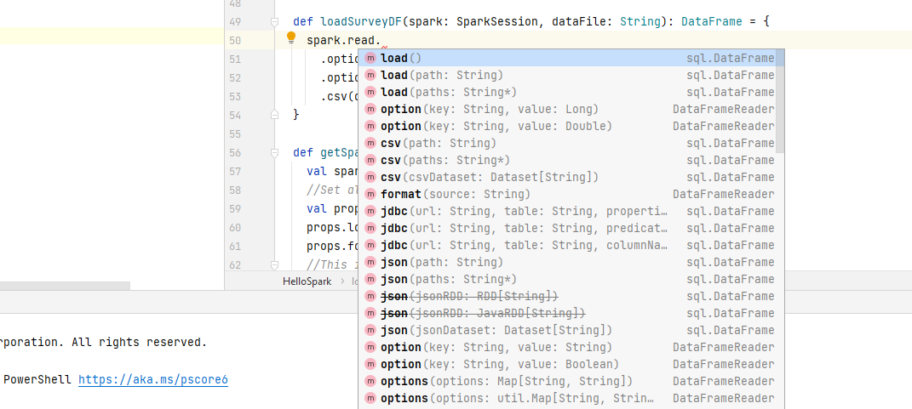

Well, the list doesn't end here, and I will cover it in more detail at a later stage. However, we want to read a CSV file, so let's use the CSV() method. You have three variants, and I am going to use the first one, which takes a single file path. All you need to do is to pass the file path. That's all.

Spark will load the data into a Spark DataFrame. CSV data files are plain text data files. They offer a lot of flexibility, and hence they are complex to read correctly. Let me explain what I mean by CSV being a flexible but complex file format. Look at my data file. The first row is a header row, and the rest of the rows are data rows. The DataFrameReader doesn't know these details. So, we must tell this information to the DataFrameReader so it can read the file correctly.

def loadSurveyDF(spark: SparkSession, dataFile: String): DataFrame = {

spark.read

.option("header", "true")

.option("inferSchema", "true")

.csv(dataFile)

}

You can do it using the DataFrameReader option() method. The option method takes a key-value pair, and you can get a list of all available CSV options from Spark Documentation. Go to the Spark Home page. Select Documentation. Then choose API docs and Scala. Now you can search for dataframe reader. Checkout the CSV method, and you should get the list of all available options. My data file comes with a header row, so I want to set the header option.

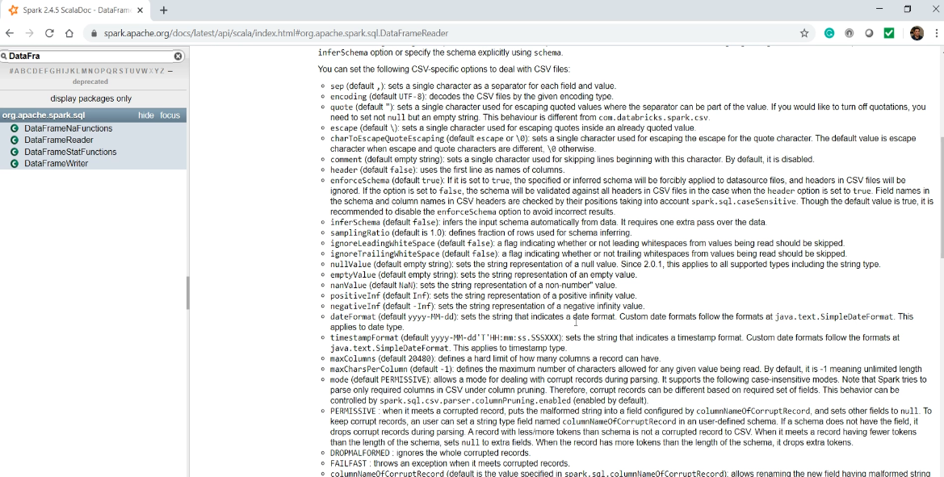

The default value is false, and I am going to set it to true. Let's do it. Now the DataFrameReader will skip the first row but use it to infer the column names and create a Spark DataFrame. So far, so good. But What is a DataFrame? Spark offers you three data structures to load data from your data source. DataFrame DataSet and RDD.

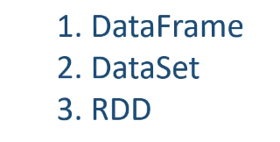

I will formally introduce you to all these three structures in the next section. However, we are going to use DataFrame in this section, so let me give you a quick introduction to the DataFrame. Spark DataFrame is a two-dimensional table-like data structure that is inspired by Pandas DataFrame. They are a distributed table with named columns and well-defined schema. That means each column has a specific data type such as integer, float, string, timestamp, etc. You can visualize your DataFrame as a database table.

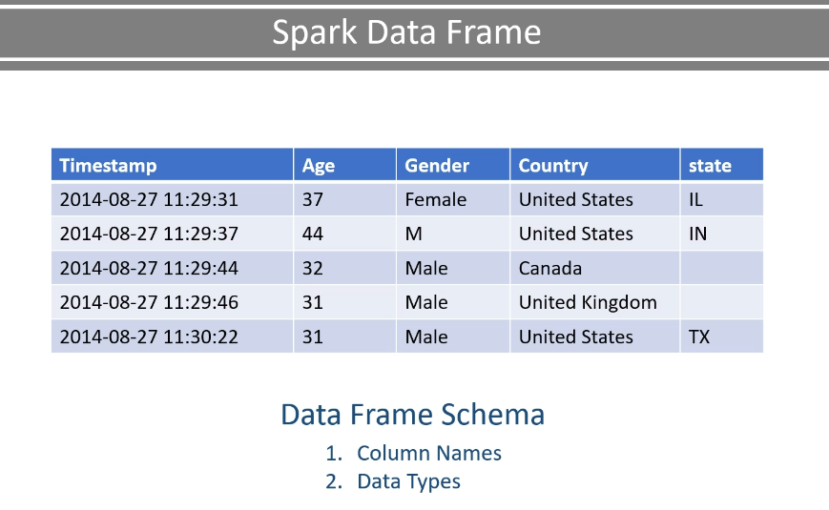

And most of the operations that you are going to perform on these DataFrames s are also similar to database table operation using rows and columns. So, if you have already worked with databases and SQL, you are going to feel at home with Spark DataFrames. Great! So now you know that a DataFrame must have two things. Column Names And Schema - I mean, data types for each column. Now let's come back to our program. We are reading a CSV file using a DataFrameReader. We are also using the header option. So, the DataFrameReader is going to use the header row and infer the column names. But what about the schema? I mean, the data types for the columns. Let's look at the CSV options. You can use the inferSchema option.

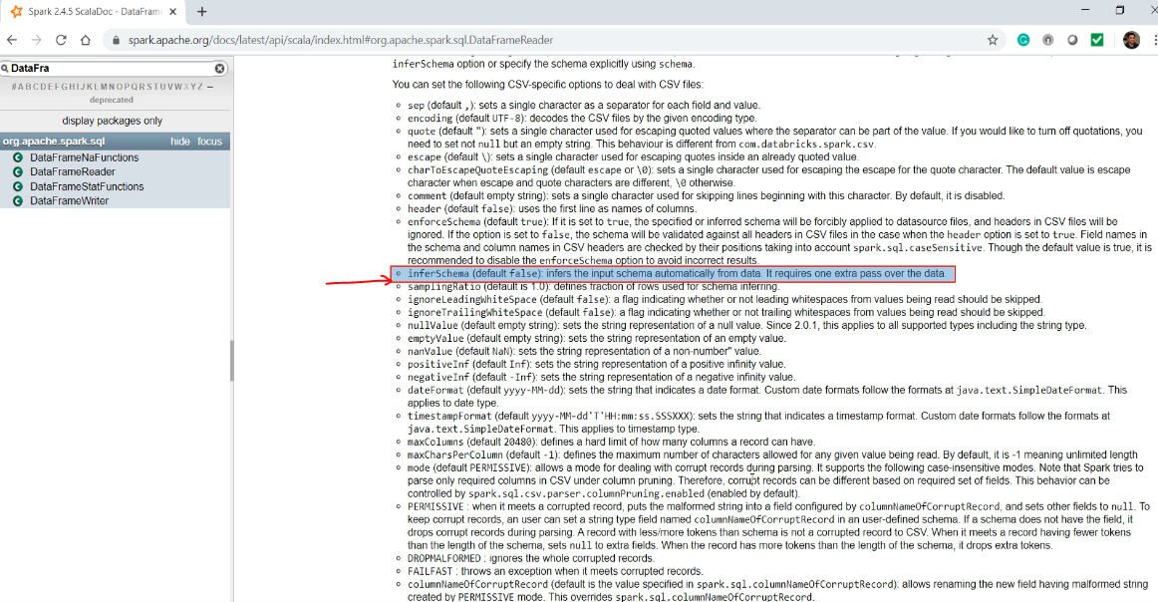

This option will allow the DataFrameReader to read a portion of the file and make an intelligent guess about the data types for all the columns. This option works well in some cases, but it fails to infer the correct data types in most of the cases. However, at this stage, we are good to go with the infer schema option. And I will explain a more appropriate method in a later video. Great! So let me add the inferSchema option. Done. This code is going to read a CSV data file, use the first row to infer the column names, make an intelligent guess for the column data types, and finally return a DataFrame.

However, I do not want to keep this code in my main() method. I recommend that you create a function and move this code to the function. Why? Well, we are going to reuse this code at least twice, if not more. The first place is your main() method, and the second place is your unit testing. The point is straight. Break your code into smaller functions that you can reuse and apply unit testing. Do not dump everything in your main method. So, let me create a function. I am going to name it as loadSurveyDF. This function will take two arguments. SparkSession and the file location. And the function is going to return a DataFrame. Paste the code. That's it. Now you can call this function from your main() method. If you want to quickly run it and verify your code, use the DataFrame show() method and run it.

def **loadSurveyDF**(spark: SparkSession, dataFile: String): DataFrame = {

spark.read

.option("header", "true")

.option("inferSchema", "true")

.csv(dataFile)

}

**HelloSpark.scala**

package guru.learningjournal.spark.examples

import java.util.Properties

import scala.language.*implicitConversions*

import org.apache.log4j.Logger

import org.apache.spark.SparkConf

import org.apache.spark.sql.{DataFrame, SparkSession}

import scala.io.Source

object HelloSpark extends Serializable {

@transient lazy val *logger*: Logger = Logger.*getLogger*(getClass.getName)

def main(args: Array[String]): Unit = {

if (args.length == 0) {

*logger*.error("Usage: HelloSpark filename")

System.*exit*(1)

}

*logger*.info("Starting Hello Spark")

val spark = SparkSession.*builder*()

.config(*getSparkAppConf*)

.getOrCreate()

*logger*.info("spark.conf=" + spark.*conf*.getAll.toString())

val surveyRawDF = ***loadSurveyDF*(**spark, **args(0))**

surveyRawDF.show()

. . .

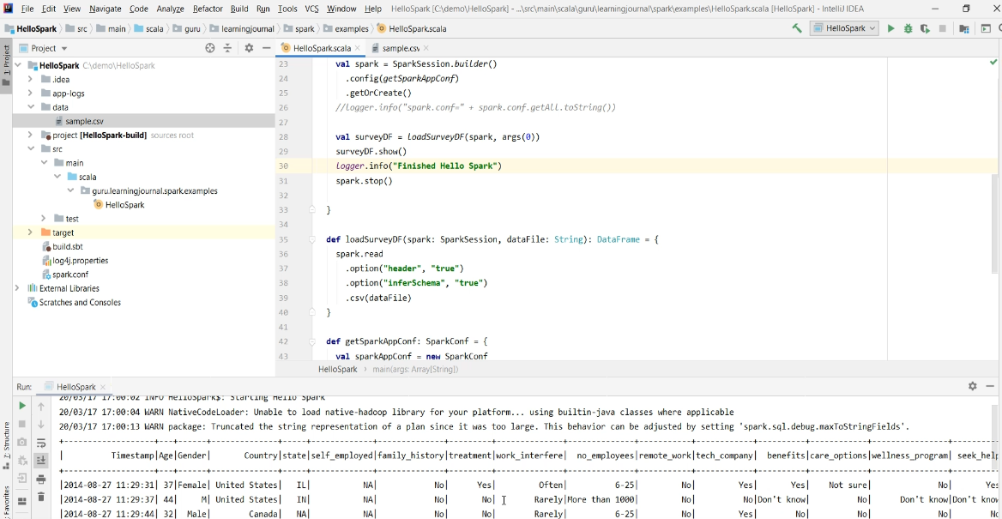

### Data Frame Partitions and Executors

In the earlier lecture, we created a Spark DataFrame. And I mentioned that the DataFrame is a distributed data structure. In this lecture, I am going to elaborate on how DataFrame is a distributed data structure, and how does it help Spark to implement distributed processing. So, let's start. We already learned that the SparkSession offers you a read() method to read data from a data file such as a CSV file. In a real-life scenario, your CSV file is going to be stored in a distributed storage such as HDFS or cloud storage such as Amazon S3. All these distributed storage systems are designed to partition your data file and store those partitions across the distributed storage nodes. So let's assume that you have these 10 node storage cluster. When you save your file on this cluster, your file might be broken into 100 smaller partitions, and those partitions are stored on these ten nodes.

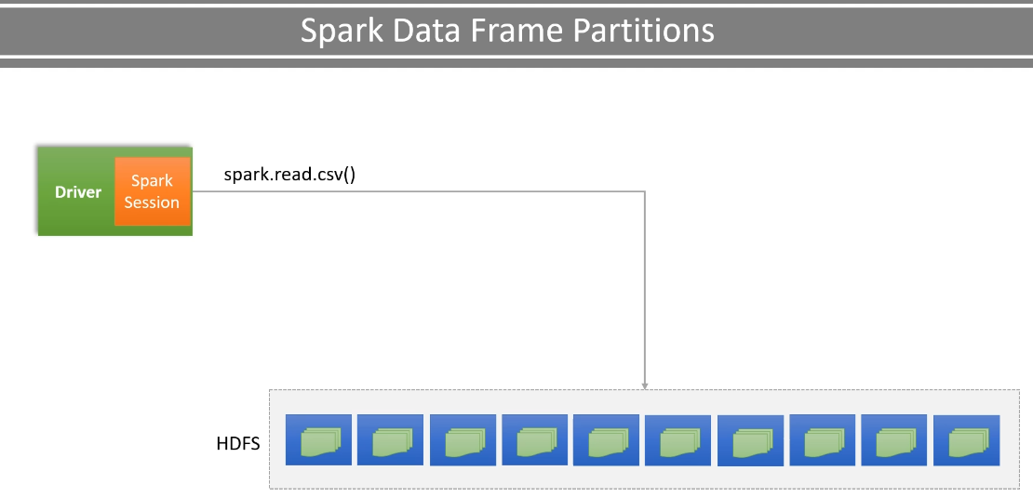

Some storage systems will allow you to control the number of file partitions, but some others may not allow you to control it, and they manage it internally. However, one thing is clear that your data file is stored as smaller partitions, and each storage node may have one or more partitions of your file. Now you are going to read this file using a Spark DataFrameReader. Since the data is already partitioned, so the DataFrameReader is also going to read them as a bunch of in-memory partitions. So you can think of your DataFrame as a bunch of smaller DataFrames, each logically representing a partition.

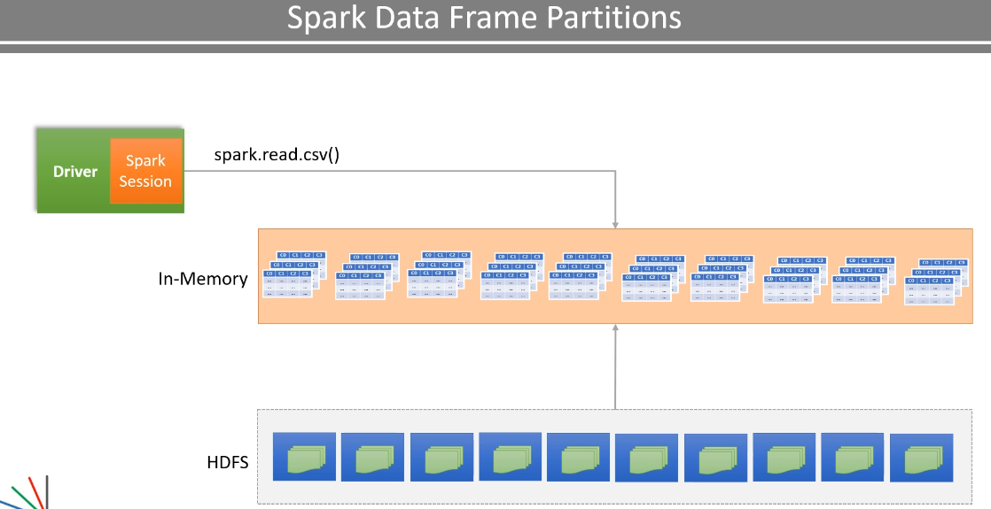

Now let me shift your attention to the Spark driver. I already mentioned that you can think of your Spark session as your Spark driver. So, you told your driver to read the data file. That is why we have this method like spark dot read, and the variable SparkSpark is your driver. So basically, we are telling the driver that we want to read this data file. And the driver is going to reach out to the cluster manager and the storage manager to get the details about the data file partitions. So at runtime, your driver knows how to read the data file and how many partitions are there. Hence, it can create a logical in-memory data structure, which we see as a DataFrame. However, nothing is loaded in the memory yet. Its all a logical structure with enough information to actually load it. So you can think of your DataFrame as a bunch of smaller DataFrames, each logically representing a partition.

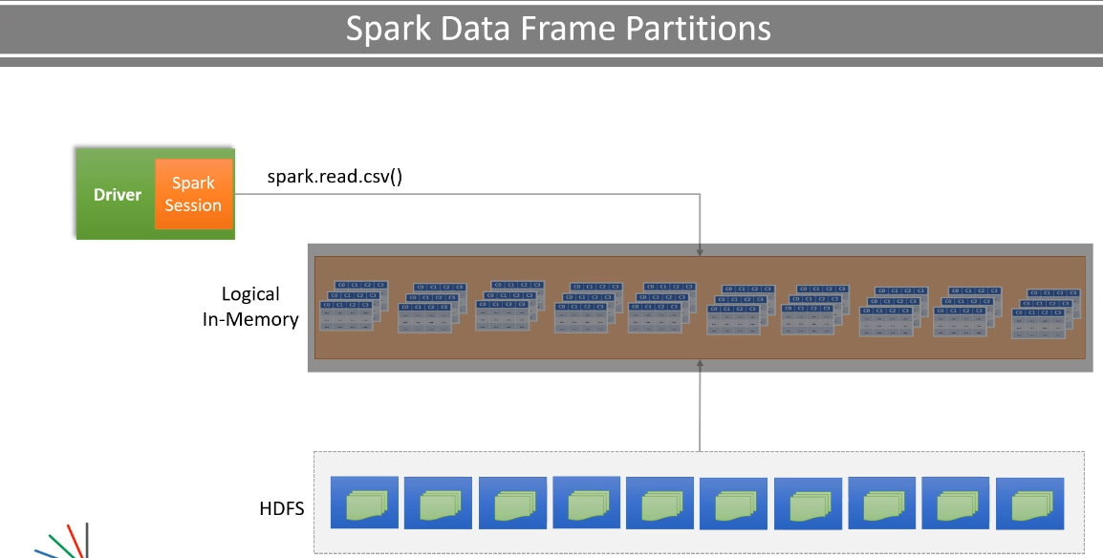

Now let me shift your attention to the Spark executors. We already learned that you can configure your SparkSession to start N number of executors. I previously covered it in the earlier lecture, and you can also decide on how much memory and CPU do you want to allocate to your executors. All those configurations are available to your driver. Let's assume that you configured to start five executors, each with 10 GB of memory and 5 CPU cores. Now the driver is again going to reach out to the cluster manager and ask for the containers. Once those containers are allocated, the driver is going to start the executors within those containers. We already know that each executor is nothing but a JVM process with some assigned CPU cores and memory.

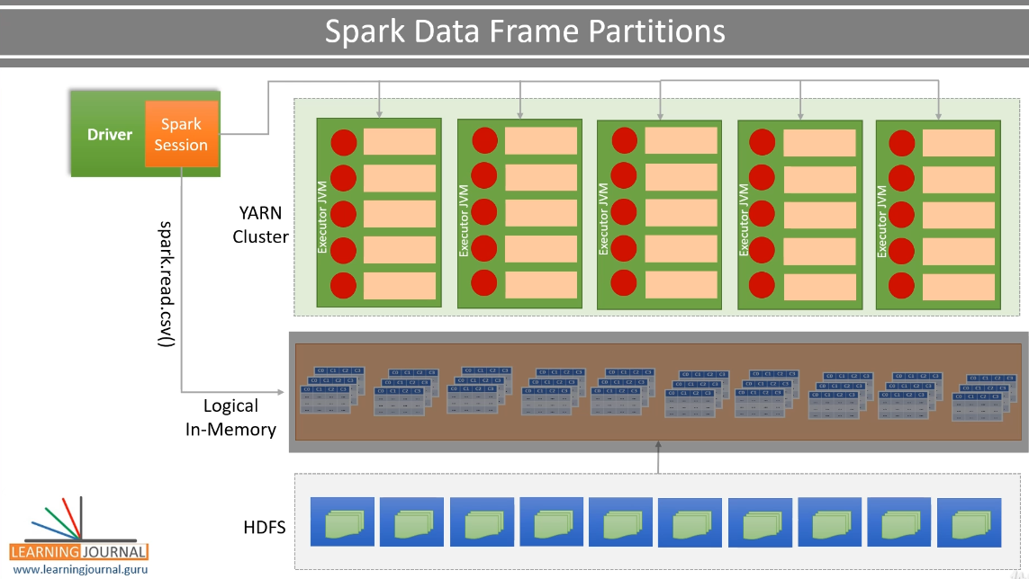

In this case, each executor JVM is started with 5 CPU cores and 10 GB memory. Now the driver is ready to distribute the work to these executors. So, the driver is going to assign some DataFrame partitions to each JVM core. And these executor cores will load their respective partitions in the memory.

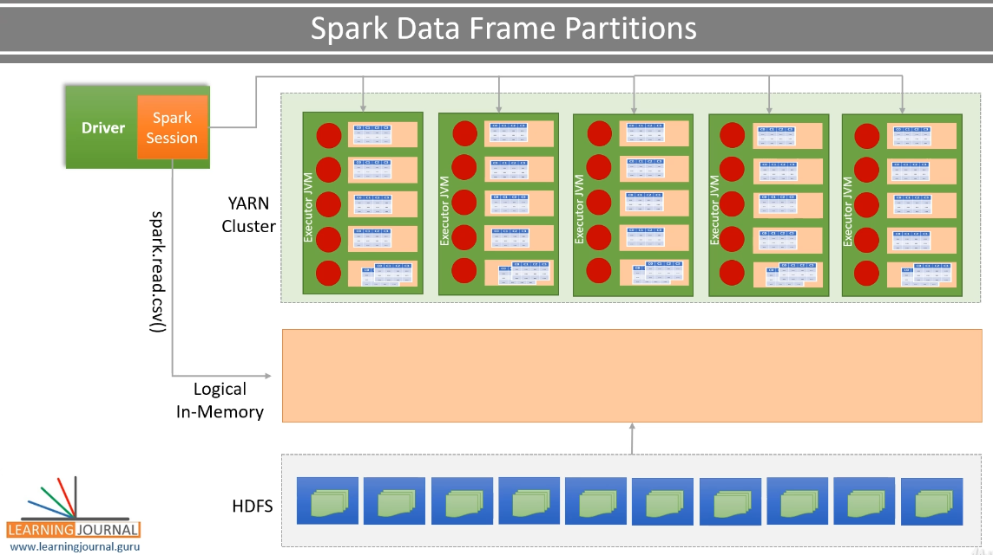

And this is how the final state looks like. Now you are ready with a distributed DataFrame setup where each executor core is assigned its own data partition to work on. Isn't it amazing? Yes, it is. And in all this, SparkSpark will also try to minimize the network bandwidth for loading data from the physical storage to the JVM memory. How? Well, that's an internal Spark optimization. While assigning partitions to these executors, SparkSpark will try its best to allocate the partitions which are closest to the executors in the network. However, such data locality is not always possible. And Spark, as well as your cluster manager, is going to work together to achieve the best possible localization.

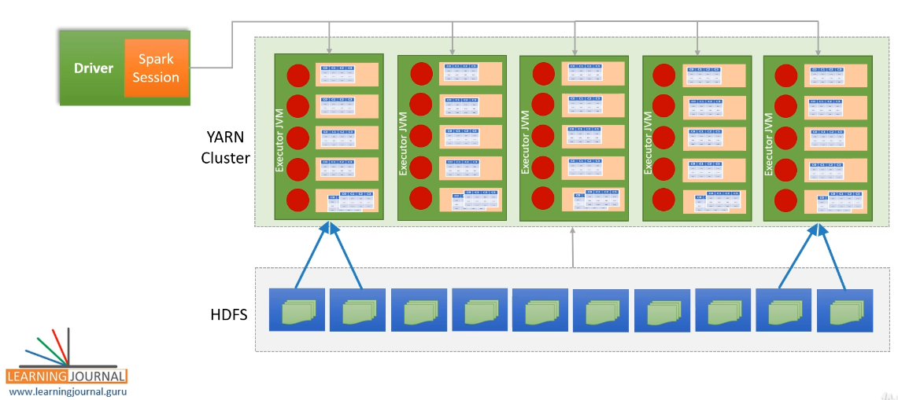

### Spark Transformations and Actions

In the earlier lecture, I talked about the DataFrame partitions and how they are assigned to executors to distribute the work. In this lecture, I am going to talk about some basics of Spark data processing and some more internal details. So, let's start. We already learned to read our data file into a Spark DataFrame. The DataFrame is internally a distributed data structure, and it is composed of a bunch of partitions.

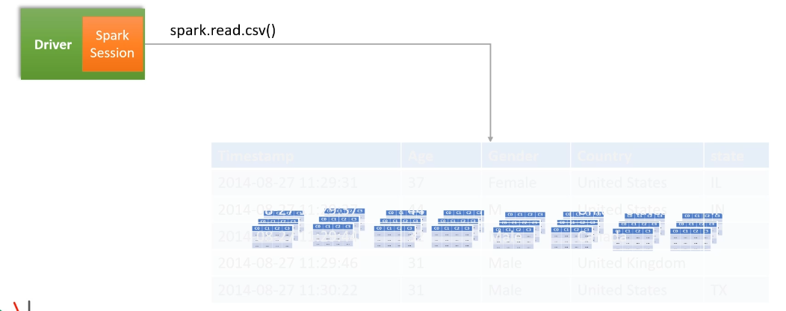

However, a Spark programmer can visualize it as a plain DataFrame structure. And that's what Spark brings to us - hiding out all the complexities of distributed processing, and we can simply work with a DataFrame as we work with a plain non-distributed data structure. After reading our data, we are now ready to process it. However, Spark DataFrame is an immutable data structure. That means you cannot change it. Strange, right? If you cannot change them, then how are you going to process them? Spark DataFrames are immutable. However, you can give instructions to your driver about what do you want to do. And let the driver decide how to achieve it with the help of the executors.

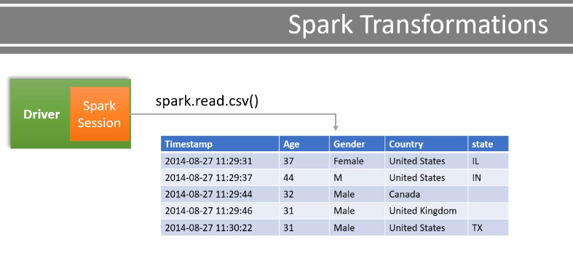

These instructions to the driver are called transformations. And these transformations could be as simple as some SQL like operations such as select(), filter(), and groupBy(). Let's come back to our example and add some transformations.

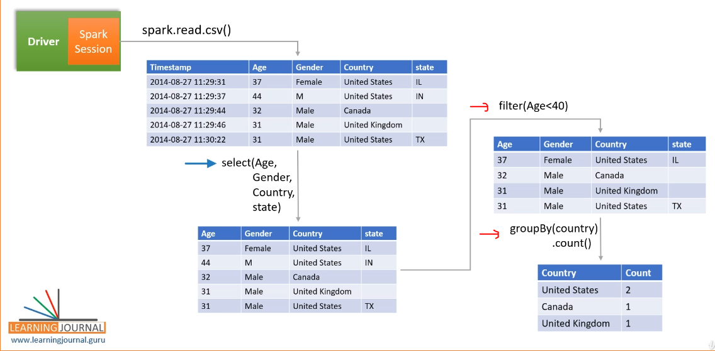

So we start with the DataFrame and apply a filter using the where() method. I am going to add a simple condition where Age is less than 40. You might be wondering if I am changing the DataFrame, or I am giving instructions to the driver to change it. Let me explain. We are simply using a builder pattern. We started with the SparkSession, which is your driver Then we added a DataFrame to the same SparkSession. Now we added a where method to the same DataFrame. Ultimately everything goes into the SparkSession. You can do it in two steps as I have done it, or you can chain these transformations like this. Both are the same. You can add another transformation. Let me do it. I am selecting only four columns. You can chain more. Let me add a groupBy().

package guru.learningjournal.spark.examples

import java.util.Properties

import scala.language.*implicitConversions*

import org.apache.log4j.Logger

import org.apache.spark.SparkConf

import org.apache.spark.sql.{DataFrame, SparkSession}

import scala.io.Source

object HelloSpark extends Serializable {

@transient lazy val *logger*: Logger = Logger.*getLogger*(getClass.getName)

def main(args: Array[String]): Unit = {

if (args.length == 0) {

*logger*.error("Usage: HelloSpark filename")

System.*exit*(1)

}

*logger*.info("Starting Hello Spark")

val spark = SparkSession.*builder*()

.config(*getSparkAppConf*)

.getOrCreate()

*logger*.info("spark.conf=" + spark.*conf*.getAll.toString())

val surveyRawDF = *loadSurveyDF*(spark, args(0))

*logger*.info("Finished Hello Spark")

*//scala.io.StdIn.readLine()*

spark.stop()

}

def countByCountry(surveyDF: DataFrame): DataFrame = {

surveyDF.where("Age < 40")

.select("Age", "Gender", "Country", "state")

.groupBy("Country")

.count()

}

def loadSurveyDF(spark: SparkSession, dataFile: String): DataFrame = {

spark.read

.option("header", "true")

.option("inferSchema", "true")

.csv(dataFile)

}

def getSparkAppConf: SparkConf = {

val sparkAppConf = new SparkConf

*//Set all Spark Configs*

val props = new Properties

props.load(Source.fromFile("spark.conf").bufferedReader())

props.forEach((k, v) => sparkAppConf.set(k.toString, v.toString))

*//This is a fix for Scala 2.11*

*//import scala.collection.JavaConverters._*

*//props.asScala.foreach(kv => sparkAppConf.set(kv._1, kv._2))*

sparkAppConf

}

}

All this goes into the Same SparkSession object. In fact, we are using a builder pattern to create our SparkSession step by step. Make Sense? Instead of chaining everything one after another, you can break it into smaller steps using intermediate variables. For example, you can hold your raw data frame in surveyRawDF. Then you can keep the filtered records in a separate intermediate variable filteredSurveyDF. Similarly, you can hold the groupedSurveyDF in a different variable. No matter you chain these transformations or break them in smaller steps, all of these transformations are going to your SparkSession. And each intermediate step is another DataFrame that you can think of as an outcome of the applied transformation.

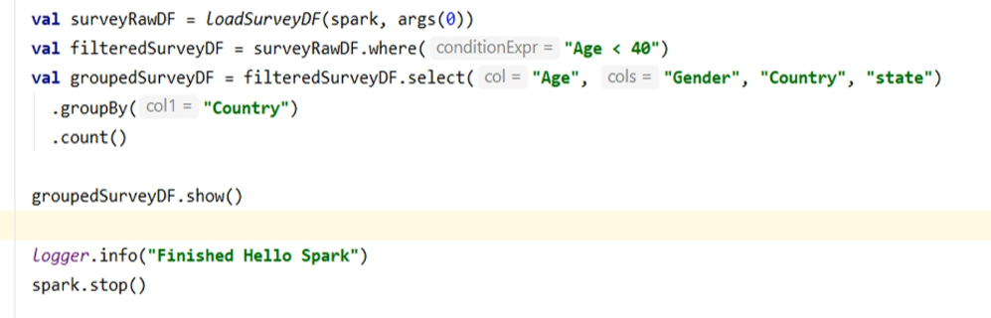

For example, surveyRawDF is an outcome of this transformation. Similarly, groupedSurveyDF is an outcome of the groupBy() transformation. Now let me shift your attention to a bigger picture. If you look at all these transformations carefully, you will realize that we are creating a graph of the operations. So this simple graph might look like this. So the point is straightforward.

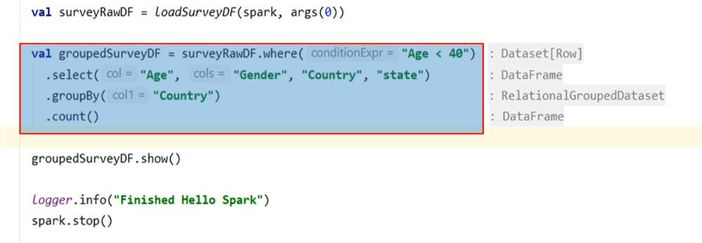

Spark data processing is all about creating a DAG of operations. So all that we are going to do in Spark programming is to create a DAG of activities And these operations are of two types. Transformations and Actions. Transformations are used to transform one DataFrame into another DataFrame without modifying the original DataFrame. For example, the where() clause transformation. It works on the input DataFrame and produces an output DataFrame.

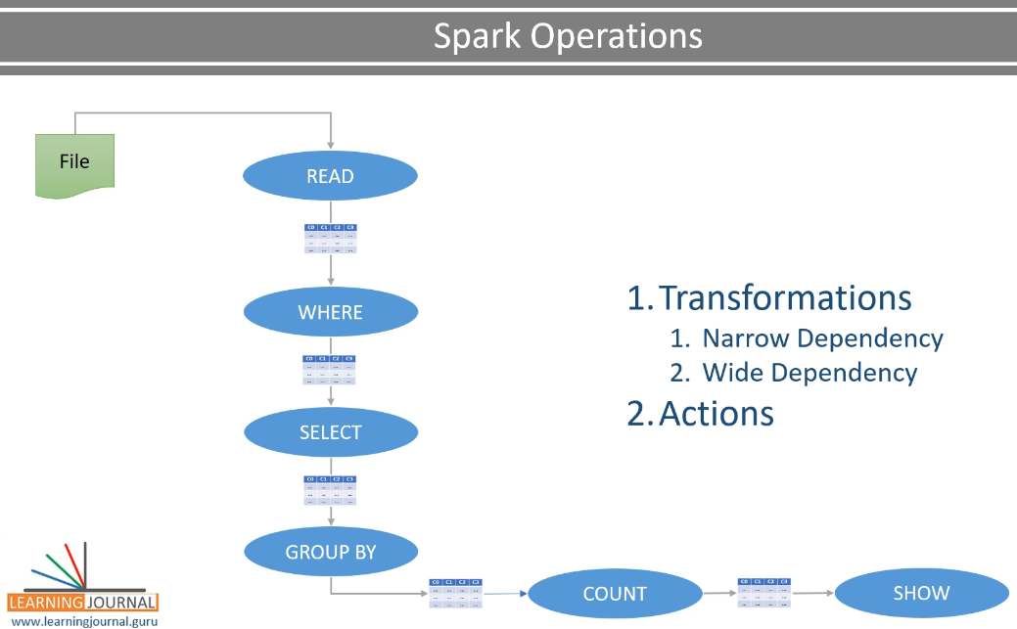

The initial input DataFrame remains immutable. And that's how the Spark DataFrame is an immutable data structure. Spark Transformation is further classified into two types. Narrow Dependency Transformation and Wide Dependency Transformations A transformation that can be performed on a single partition and still produce an overall valid result is a Narrow Dependency. For example, the where() clause transformation is a narrow dependency.

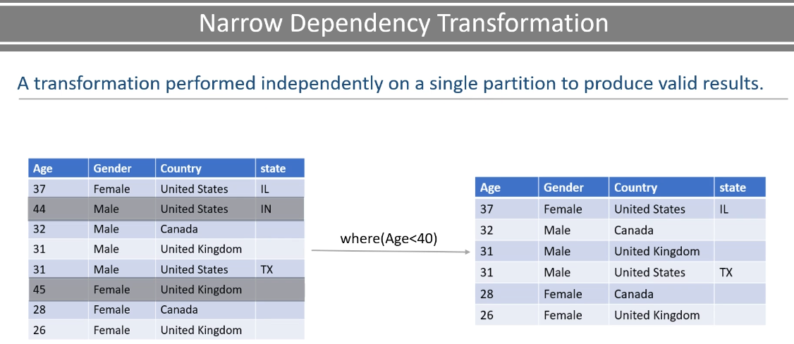

Let's assume you have two partitions of a data frame. If you apply a where() clause transformation on this data frame, Spark executor should be able to perform this filtering on each partition. They do not depend on any other partition. And we still get a valid overall result on combining these filtered partitions. That's what we mean by narrow dependency transformation.

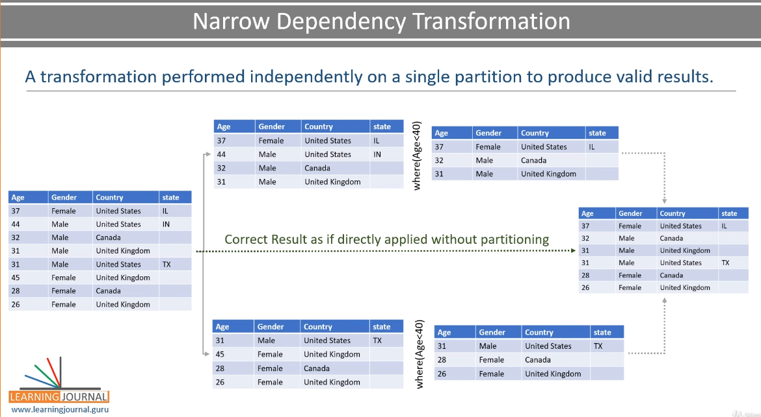

Such transformations are not dependent on other things, and it can be easily accomplished by each executor on their partitions. So, what is the wide dependency transformation? A transformation that requires data from other partitions to produce correct results. For example a groupBy() transformation.

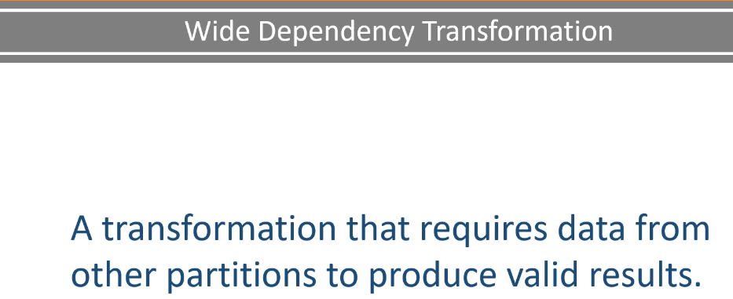

Now, look at these two DataFrame partitions. We want to apply a groupBy transformation and then count the number of records in each group. The Spark executor can perform a groupBy on each individual partition and create a new DataFrame partition. Now we want to count the rows in each group. Here is the result of the count. However, we do not get an overall correct result on combining these two outputs.

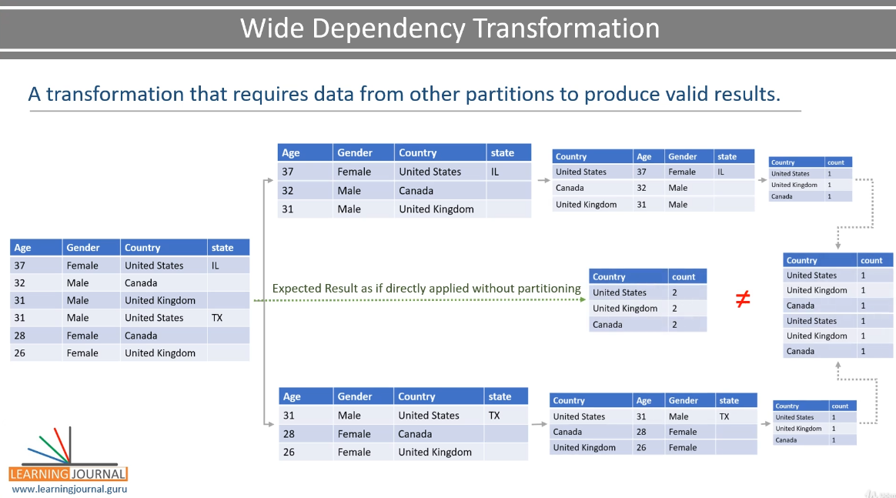

So, the GroupBy brakes the independence of a partition. Hence, Any aggregation after the GroupBy will produce incorrect results. And this kind of transformations, such as groupBy is classified as the, wide dependency transformation. But how can we fix it? We can do that using the repartitioning of the grouped data. What does it mean? Simple! Combine all the partitions and then create some new partitions to make sure that all the records of the same group. are collected into the same partition

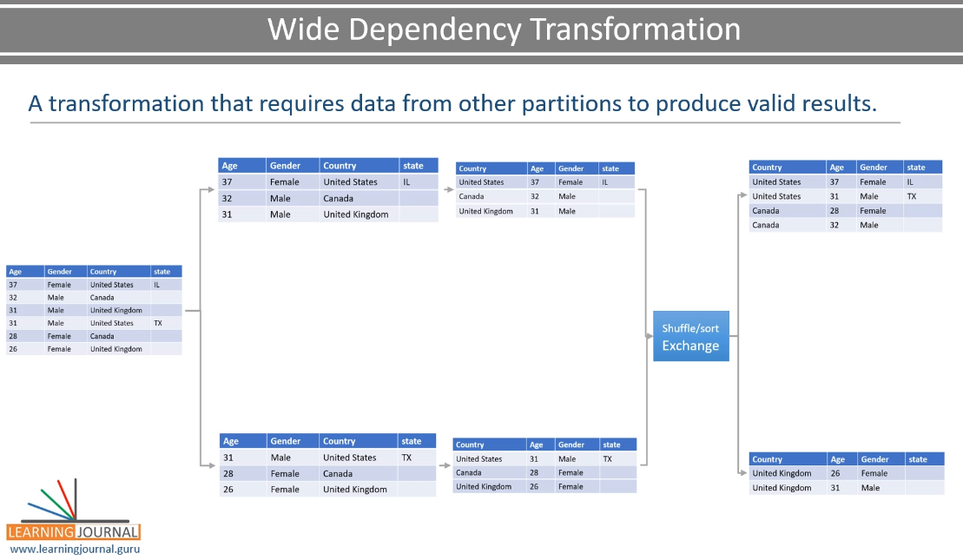

Here is the result of the repartitioning. This operation of combining and repartitions of data is caused by the wide dependency transformation and known as shuffle and sort operation. Now you can apply the count() aggregation on these new partitions. The count() aggregation remains a narrow dependency. Why? Combine the outcome of the count() operation, and you still have a valid result. Isn't it? So the point is straightforward. Some Spark DataFrame transformations such as GroupBy(), OrderBy(), Join, distinct, and many others are wide dependency transformations.

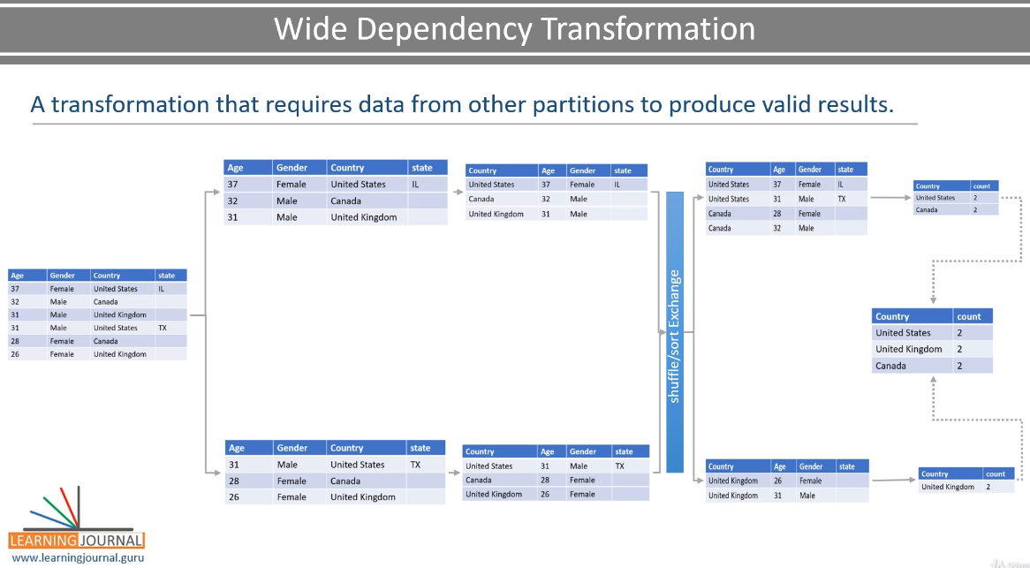

All these will result in an internally managed shuffle/sort operation. We do not have to do anything for shuffle/sort. Spark will internally manage it, and we always get the correct result. Great! So you learned about the transformations except for one last thing. Lazy Evaluations. Lazy evaluation is a functional programming technique. What does it mean for a Spark program? Simple! Look at these transformations. A typical programmer is going to look at these transformations as individual statements that are executed and evaluated line by line. So you might think of it as read the data, then perform this transformation, then move to the next operation and execute it, and move on line by line.

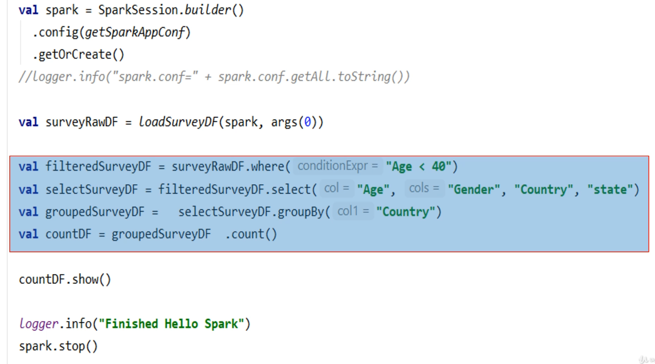

That's how a typical program runs. However Spark programs are not going to behave the same. Why? Because we are using a builder pattern to create a DAG of transformations. All of this goes to the Spark Driver. The driver is going to look at these operations, rearrange them to optimize certain activities, and finally create an execution plan which will be executed by the executors. So these statements are not executed as individual operations, but they are converted into an optimized execution plan which is terminated and triggered by an Action. But what is an Action?

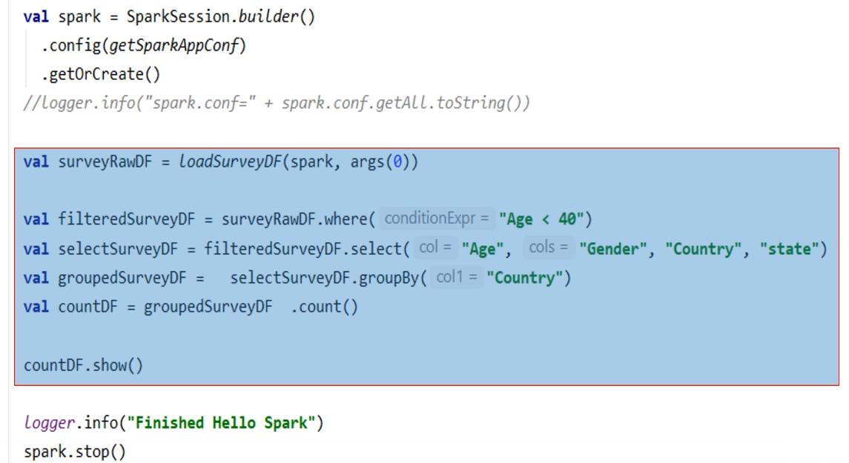

Read, Write, Collect, and Show. Look at the code. All of these are transformations because we are transforming one DataFrame into another DataFrame. Once we are done, we want to see the result. And you cannot see the result until we execute and finish all of this. So, we need to take action, compute the result, and show it to the console. And that's why show() is an Action. Similarly, all of these are actions.

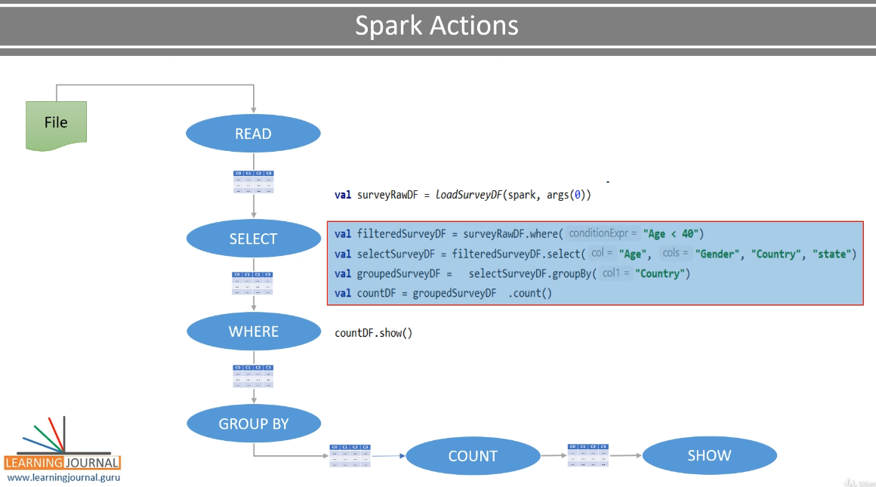

You want to write the result to a data file Collect the result from the executors to the driver Read a data file to infer the column names and schema. So, Spark Actions will terminate the Transformation DAG and trigger the execution. That is why we say that the transformations are lazy, but actions are evaluated immediately. Anything which takes one DataFrame and converts into another DataFrame is a Transformation. But Operations that require you to read, write, collect to show the data is an Action.

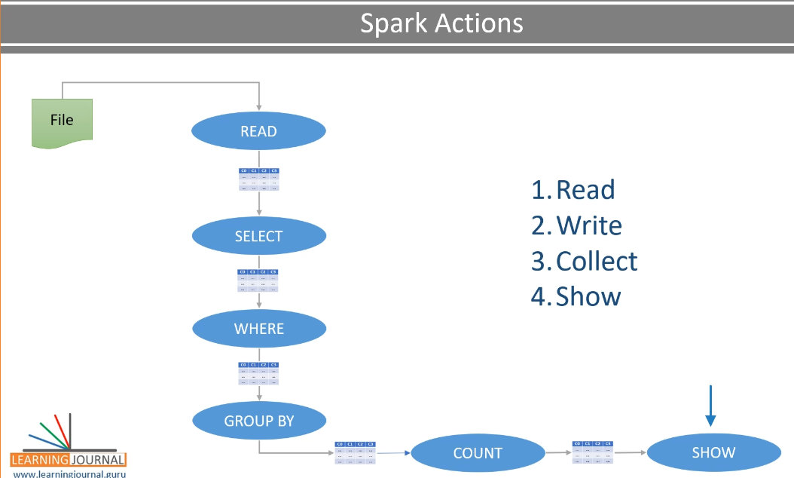

### Spark Jobs, Stages and Tasks

We learned about Spark Transformations and Actions. We also learned that the Spark Transformations and Actions are going to result in an Execution Plan. And this execution plan is finally executed by the executors. In this lecture, I am going to elaborate on the execution plan. So, let's start. Let's come back to our example code. So what are we doing here? We are doing three things. I am reading a data file and also inferring the schema. The result is a DataFrame. Then I am applying a chain of transformations. The result is another DataFrame.

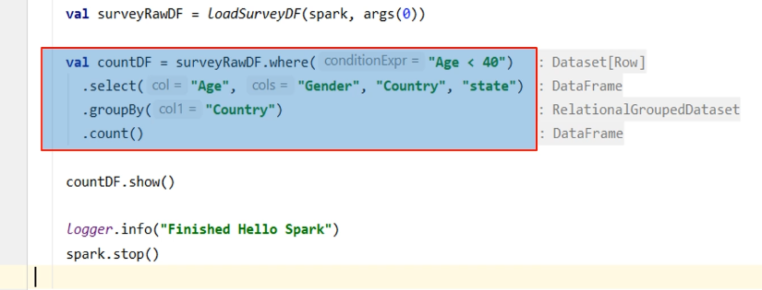

Finally, we are using the action.

countDF.show()

Now, based on this example, we want to understand the internal execution plan. How are these things executed internally? Right? That's not an easy goal. Why? Because Spark is similar to a compiler. It takes your straightforward code and compiles it to generate low-level Spark code and also creates an execution plan. All those things are too complicated, and understanding what is internally happening is difficult. But let me try giving you some good sense about it. We are going to make some changes to this code and prepare ourselves to learn a tough topic. The first thing is to move these transformations to a separate function. Let me create a function. Now I am going to move this code to the function. Then I am going to call the function here. Great! Now it looks clean, and we can also write unit test cases for this function in the next lecture.

The next thing is to replace this show() action with the collect() action and manually print the outcome to the application log. Why is this needed? Well, I have two reasons. The collect action returns the DataFrame as Scala Array. However, the show() method is a utility function to print the DataFrame. So, you are more likely to use the collect() action, whereas the show() is useful for debugging purposes. The second reason The show() method compiles down to complex internal code. It might create unnecessary confusion when we are trying to learn a complex topic. Great! Now let's come to the next change. I am reading a small data file having nine records. It is stored on my local machine. So, I already know that I do not have multiple file partitions. So when I load this file, I am going to get a DataFrame of a single partition. And that's not good for learning real internal behavior or unit testing my code locally. I want to simulate multiple partitions. So, I am going to take my initial DataFrame and repartition it. The repartition() is a transformation. So it takes a DataFrame as input and produces another DataFrame.

package guru.learningjournal.spark.examples

import java.util.Properties

import scala.language.*implicitConversions*

import org.apache.log4j.Logger

import org.apache.spark.SparkConf

import org.apache.spark.sql.{DataFrame, SparkSession}

import scala.io.Source

object HelloSpark extends Serializable {

@transient lazy val *logger*: Logger = Logger.*getLogger*(getClass.getName)

def **main**(args: Array[String]): Unit = {

if (args.length == 0) {

*logger*.error("Usage: HelloSpark filename")

System.*exit*(1)

}

*logger*.info("Starting Hello Spark")

val spark = SparkSession.*builder*()

.config(*getSparkAppConf*)

.getOrCreate()

*logger*.info("spark.conf=" + spark.*conf*.getAll.toString())

val surveyRawDF = *loadSurveyDF*(spark, args(0))

val partitionedSurveyDF = surveyRawDF.repartition(2)

val countDF = *countByCountry*(partitionedSurveyDF)

countDF.foreach(row => {

*logger*.info("Country: " + row.getString(0) + " Count: " + row.getLong(1))

})

*logger*.info( countDF.collect().mkString("->") )

*logger*.info("Finished Hello Spark")

*//scala.io.StdIn.readLine()*

spark.stop()

}

def **countByCountry**(surveyDF: DataFrame): DataFrame = {

surveyDF.where("Age < 40")

.select("Age", "Gender", "Country", "state")

.groupBy("Country")

.count()

}

def **loadSurveyDF**(spark: SparkSession, dataFile: String): DataFrame = {

spark.read

.option("header", "true")

.option("inferSchema", "true")

.csv(dataFile)

}

def **getSparkAppConf**: SparkConf = {

val sparkAppConf = new SparkConf

*//Set all Spark Configs*

val props = new Properties

props.load(Source.*fromFile*("spark.conf").bufferedReader())

props.forEach((k, v) => sparkAppConf.set(k.toString, v.toString))

*//This is a fix for Scala 2.11*

*//import scala.collection.JavaConverters._*

*//props.asScala.foreach(kv => sparkAppConf.set(kv._1, kv._2))*

sparkAppConf

}

}

Now, this new DataFrame should have two partitions, and we are going to use this partitioned DataFrame for the rest of the transformations. Great! What is next? We already know that we are applying a wide dependency transformation groupBy. So, the groupBy is going to result in an internal repartitioning caused by the shuffle/sort. We started our transformation chain on a DataFrame, which we forcefully repartitioned to make sure that we get two partitions. However, we do not know how many partitions will result after the shuffle/sort. But we want to control this behavior, so we understand what we are doing and don't get confused by the default behavior. How to do this? Well, we can control it using a configuration. Let me add it.

**spark.conf**

spark.app.name = Hello Spark

spark.master = local[3]

spark.sql.shuffle.partitions = 2

So, the spark.sql.shuffle.partitions is going to set the number of shuffle/sort partitions. What does it mean? Simple. The shuffle/sort caused by the groupBy will result in only two partitions. So, we made sure that the whole transformation flow is accomplished with two partitions. Neither more nor less at any stage. Now the last thing. We are going to execute this example locally and look at the execution plan using the Spark UI. I already introduced you to the Spark UI in our earlier videos. And you learned that the Spark UI is only available during the life of the Application. So, I am going to ask for the user input here. this line will make sure that our program does not finish. and we can look at the Spark UI, right? But don't forget to remove this line later. This line is for local debugging and not for production.

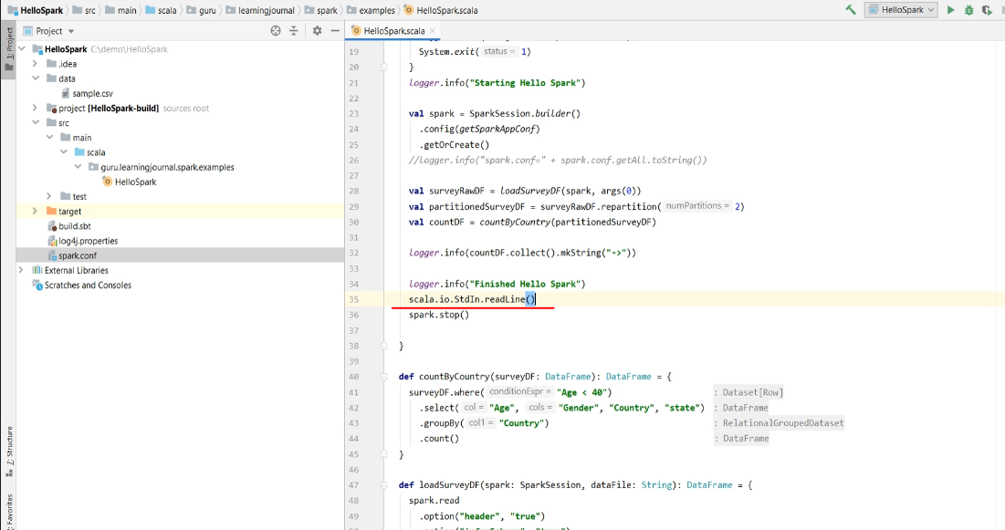

We are done and now ready to understand the execution plan. Let me execute it once and show you the Spark UI. Great! So we got the output. Let's jump to the Spark UI. It should be available at localhost:4040 Here it is. The Spark UI comes with multiple tabs. The first tab shows you the list of Spark Jobs. For our simple example, we got three jobs. Starting from zero, one, and two. Now each job is broken down into stages. The first and second job has got only one stage each. But the third one is a three-stage job. So we have a total of 5 stages altogether. One plus one plus three. Total five. You can see the list of all five stages in this next tab. These stages are again broken down into tasks. So, stage 0-2 has got one task each. However, stage-three and four are broken down into two tasks each.

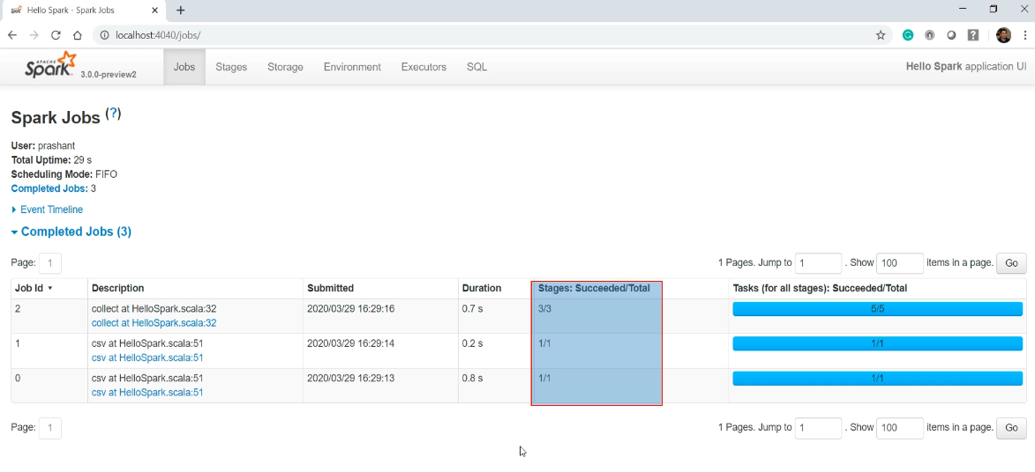

Here is the overall pictorial representation of my Spark Application. My application code is compiled down into three jobs. These jobs are again broken into five stages.

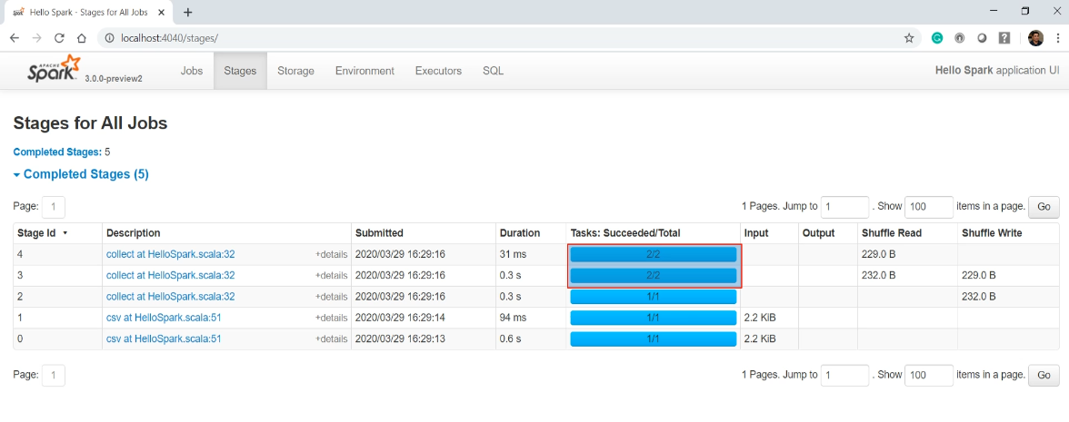

And then, these stages are further split into seven tasks. So the point is straightforward. Your Spark Application will internally generate a bunch of Jobs, Stages, and tasks. And these tasks are the unit of work that is finally assigned to executors. However, you might be wondering how this all happened? I mean, Can we map our code with this diagram. Can we understand how my code translates into these tasks?

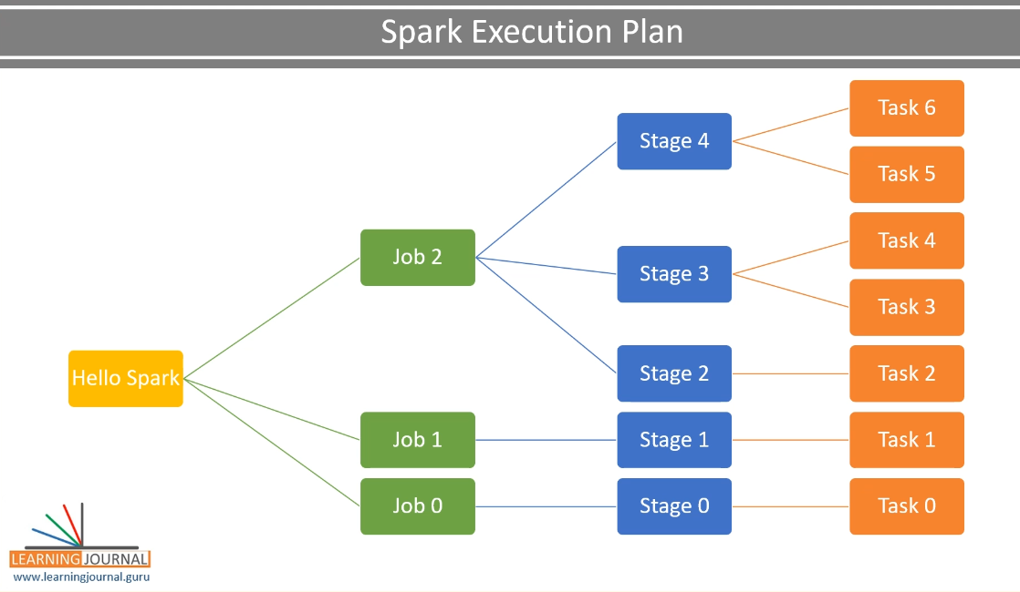

And that's the topic for the next video. So in this video, we learned the following things. How to structure our code How to control the number of partitions How to hold your program so you can investigate the Spark UI And finally, I introduced you to Spark Jobs, Stages, and Tasks. In the next lecture, We are going to dig further into these jobs, stages, and tasks.

### Understanding your Execution Plan

In the previous video, I talked about the Spark Jobs, Stages, and Tasks. In this video, We are going to understand how the application code translates to these jobs, stages, and tasks. So, let's start. Let me start with the example code and see how things are build-up, taking a step by step approach. I am going to comment-out these three lines of code and also comment-out these options. Good. So now we are doing just one thing. Load a data file. We are not inferring the schema. Just a plain data load. Loading data into a DataFrame is an action, and every Spark action is translated into a Spark job. Let me execute this example and show you. Great! So we have only one action in our code, and hence we have one Spark Job.

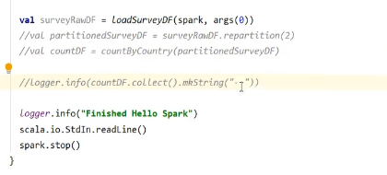

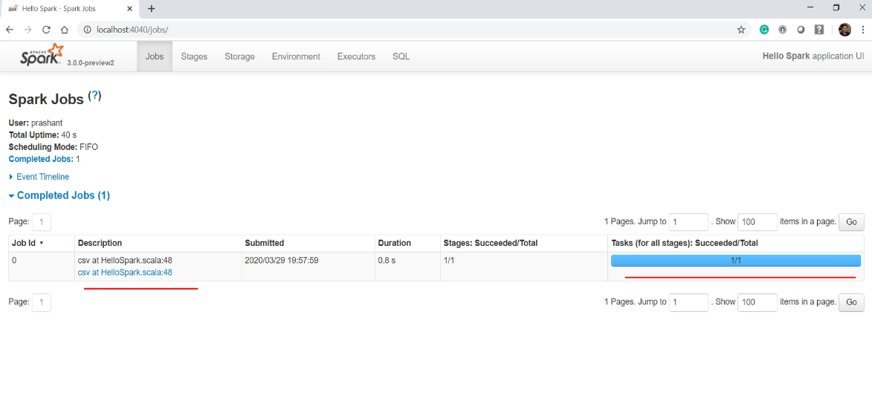

This job is caused by CSV action, and you can see it here. Now every job must have at least one stage, and each stage must have at least one task. And that's what we see here. You can see the same in the stages tab. Each stage comes with its own DAG of internal operations. You can get the DAG by clicking the stage in the Spark UI. Here it is.

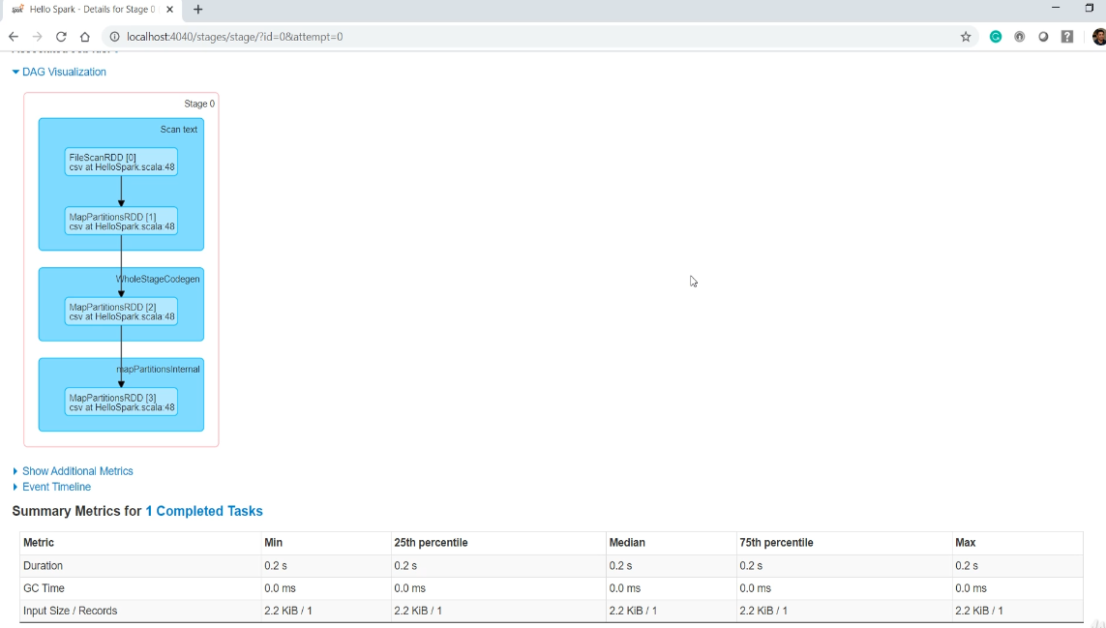

So the DAG shows the sequence of internal processes. This sequence is the compiled code generated by the Spark. Remember, I told you that Spark is a kind of compiler that compiles your code to some internal low-level Spark code. And that's what you see here in this DAG. You might not know the exact meaning of these low-level operations unless you understand the lowest level of spark core APIs. And you don't even need to know them. However, you can make some good sense by reading it. So all we are doing here is to scan the file details and map the partitions.

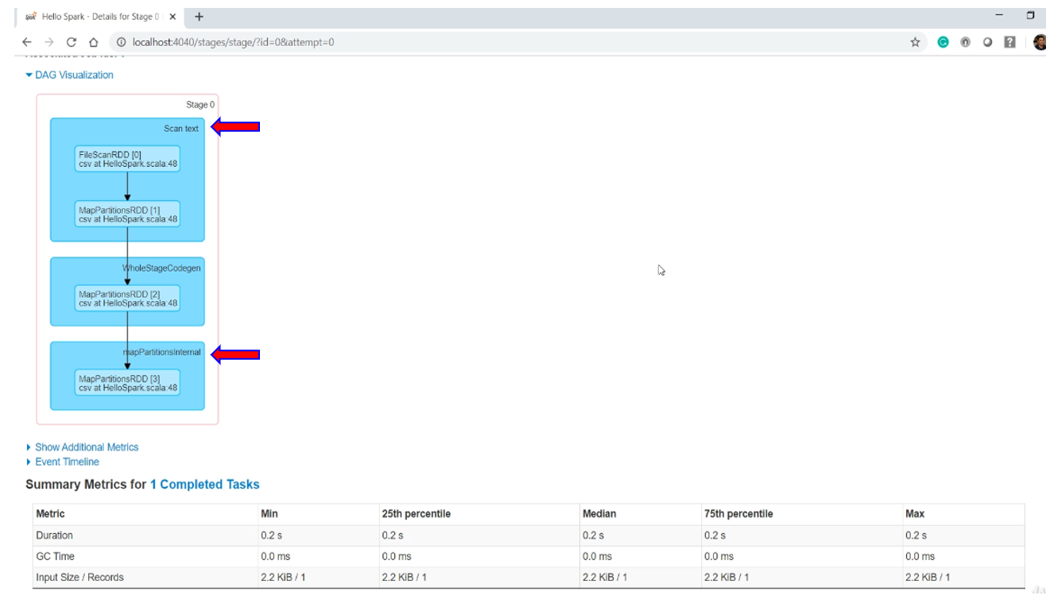

So at this stage, we know which file we want to read and how many partitions are there in this file. And that's what this high-level code is all about. That's what we wanted to do. Now let's stop this application and move to the next step. Let me uncomment these options. What do you expect?

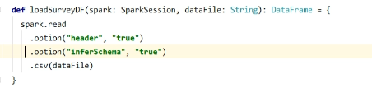

These options are to make sure that we actually read a portion of the file and infer the column names and data types for each column. Since we are reading the physical data, you can expect one more action. One more action should result in one more job. Why? Because each action translates to a Spark Job. Let's run it and recheck our Spark UI. Good. So now we have two Spark Jobs. As expected, right? Both jobs are triggered by the CSV method.

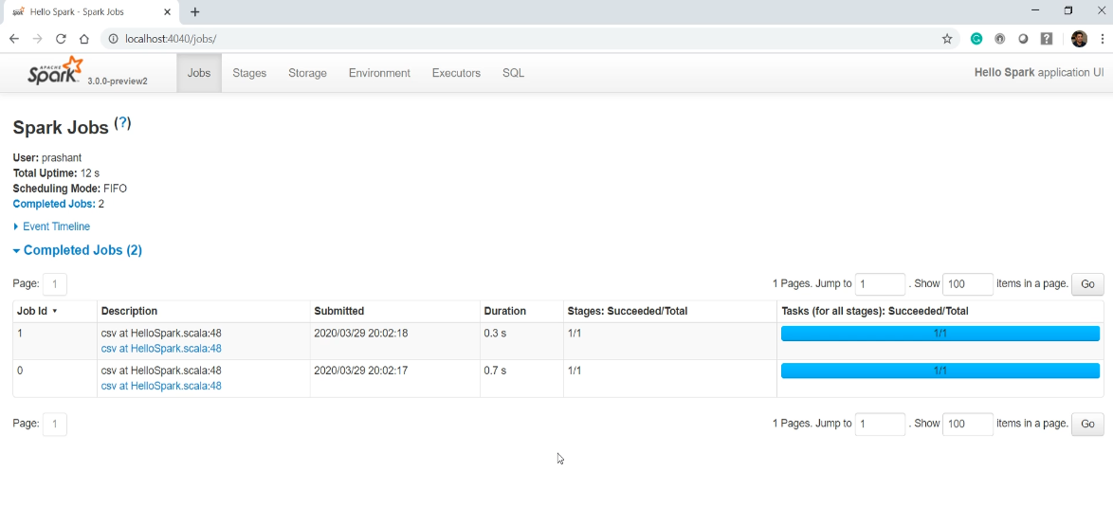

Because the high-level code is the CSV method, which internally causes two actions. The first action is to learn about the file and the partitions. The second action is to infer the file schema. Each job should have at least one stage and one task. So we have two stages with one task each. Make sense? Let me check out the DAG for stage-1. Here it is. It looks like a complicated sequence. But I can easily make out that we are deserializing the content after scanning the text file. So, we are inferring the schema while we deserialize it. Great!

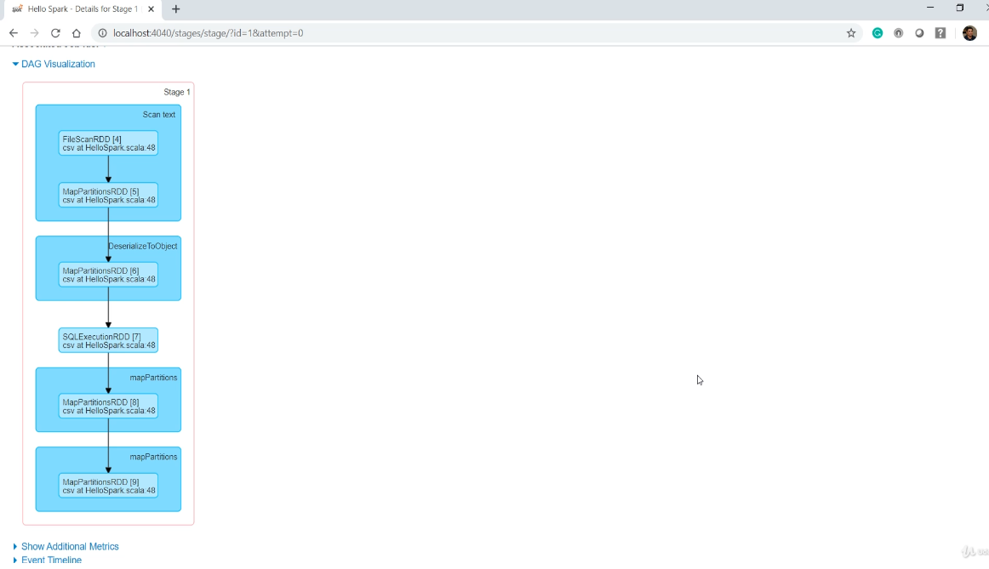

So now you understand these two jobs. Both are caused by the spark dot read and the CSV method with these two options. Make Sense? Now I am going to uncomment everything else. Great! Now before we jump over the Spark UI, let me explain a few things. So, the spark is going to look at your code and break it into smaller sections separated by an action. I have two actions. Reading a file and collecting the results.

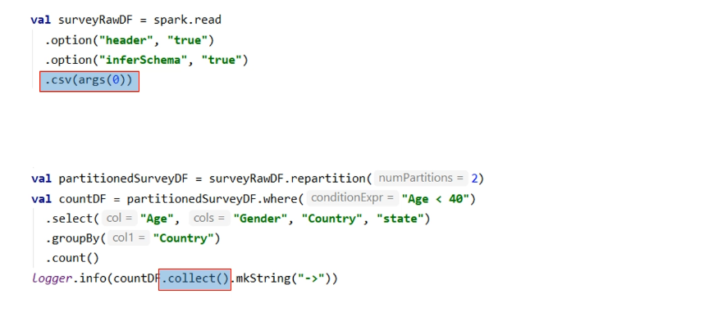

Now each section becomes at least one Spark Job. Reading a file and inferring schema are two internal actions. So, we saw two jobs for this part of the code. However, collecting the results is a simple action, so I am going to get one job for this section of the code. And this job should cover everything from here to the collect().

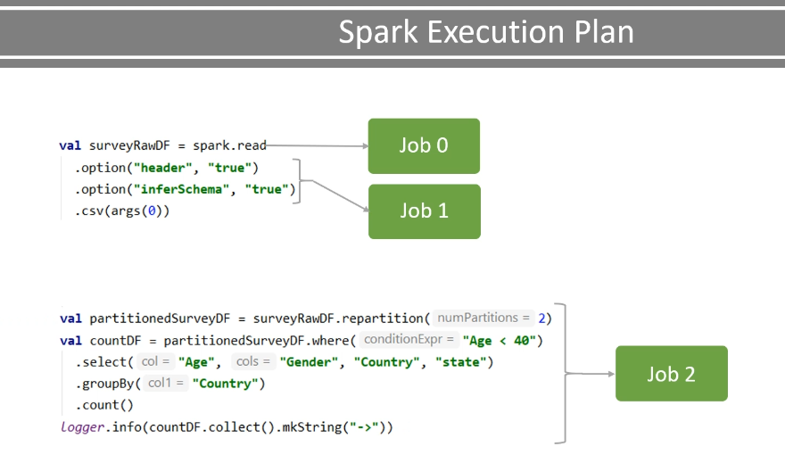

So all these transformations, including repartition, select, where, groupBy, and count. All of this are planned as a single job. triggered by the collect action.

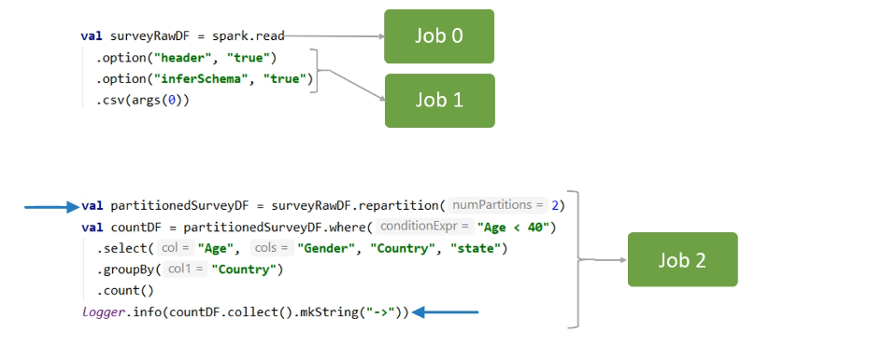

Now let's drill down to the Spark Job. Spark will create a DAG for each job and break it into stages separated by a shuffle operation. So, here is my DAG for the collect() job. We start from reading the previous DataFrame, then repartition it, filter, select, groupBy, and finally count it. Do you know which of these will cause a shuffle? Repartition and groupBy. So Spark is going to break this job into three stages. This first stage will read the earlier DataFrame, make two partitions, and write them to an internal buffer called the exchange.

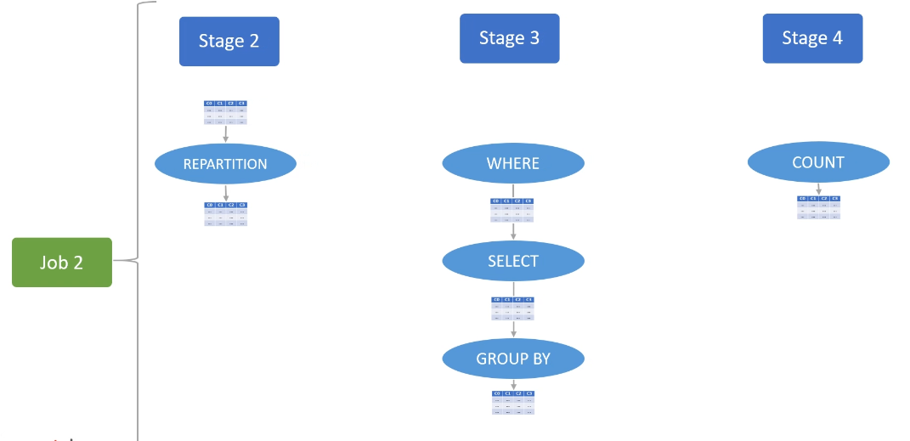

The next stage is going to execute in parallel. Why? Because now we have two partitions. Each parallel stage task is going to read one partition from the exchange and perform these narrow transformations. That's what we call Tasks. Now the second stage finishes at the groupBy writing the result to exchange. Why? Because we must shuffle/sort the groupBy results. The third stage will again start to read the result from the exchange. And this stage is also going to have two parallel tasks because we configured our session to have only two partitions for an internal shuffle.

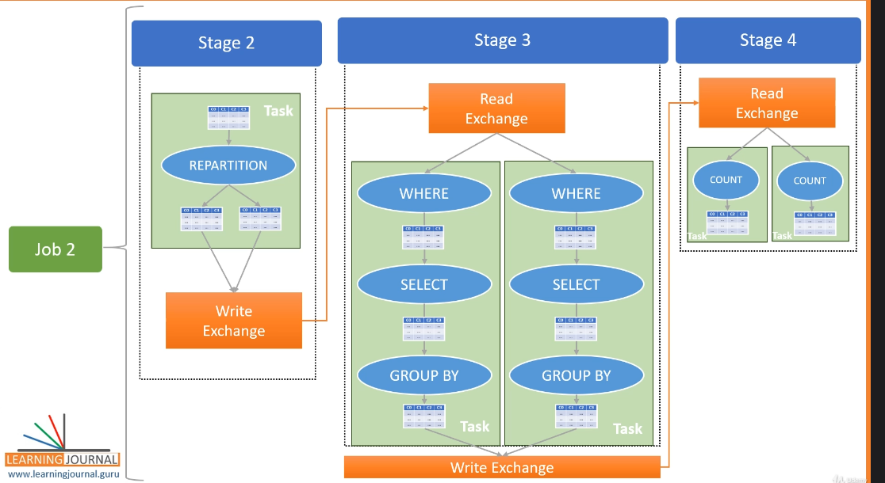

Finally, the collect runs at the driver to collect outcomes from both these tasks. So, in summary, each action will result in a Job. Each wide-transformation will result in a separate stage. And every stage executes in parallel depending upon the number of DataFrame partitions. The first stage operated on a single partition DataFrame, so we do not have any parallel processing here. The next two stages worked on two partitions, so we have two parallel tasks. You can see all this in your Spark UI. Here it is. We have three jobs. The first two jobs are for CSV action. The last job is collect-action. If you look at the DAG for the whole job, you will see three stages. The first stage starts reading a DataFrame. And finishes writing data to exchange caused by repartition. You can see it here. One task and a shuffle-write operation. The next stage starts reading the data from the exchange. You can see it here again. Shuffle read and two tasks. So, this stage runs in parallel because we have two partitions for this stage. The stage finishes writing data to exchange caused by the groupBy. You can see the write here.

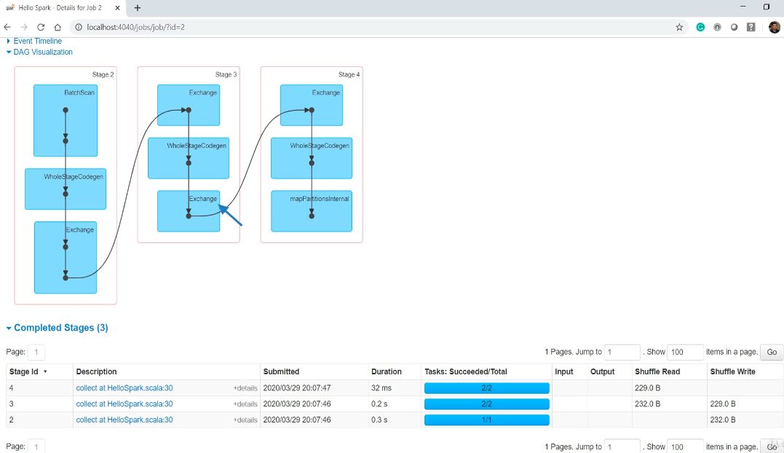

The last stage again reads from the exchange and executes two parallel tasks. This DAG is for the whole job. If you want to drill down further into any of the stages, you can go to the stages tab or just click any of the stages here. Both methods will take you to the same page.

### Understanding your Execution Plan

We spoke about the Spark Jobs, Stages, and Tasks. We are now going to understand how the application code translates to these jobs, stages, and tasks. So, let's start.

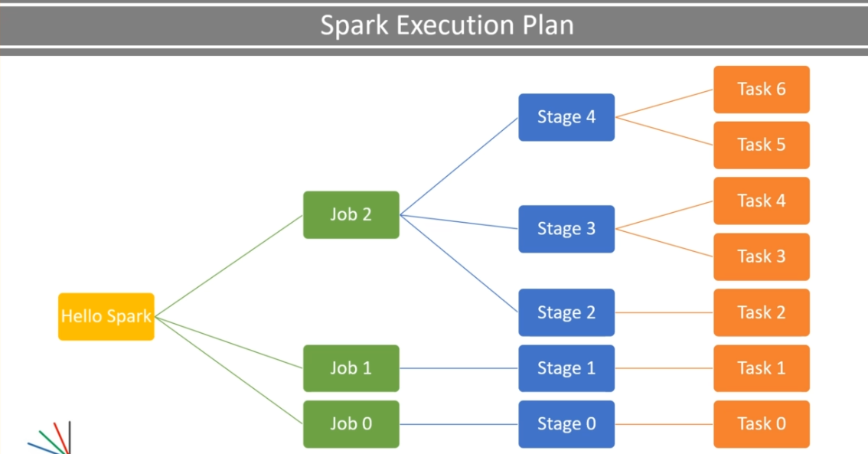

Let me start with the example code and see how things are build-up, taking a step by step approach. I am going to comment-out these three lines of code and also comment-out these options.

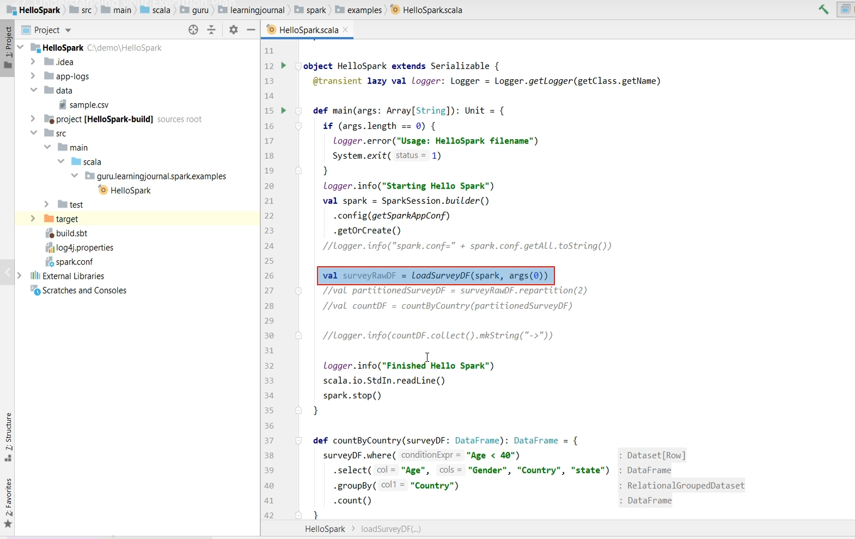

So now we are doing just one thing. Load a data file. We are not inferring the schema. Just a plain data load. Loading data into a DataFrame is an action, and every Spark action is translated into a Spark job. Let me execute this example and show you. Great! So we have only one action in our code, and hence we have one Spark Job. This job is caused by CSV action, and you can see it here.

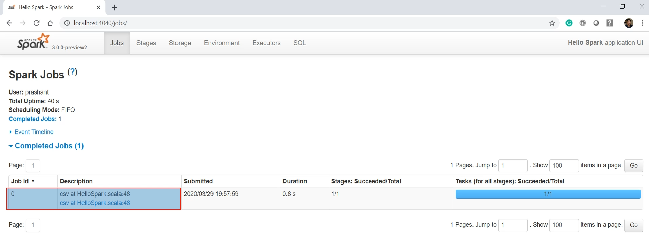

Now every job must have at least one stage, and each stage must have at least one task. And that's what we see here. You can see the same in the stages tab. Each stage comes with its own DAG of internal operations. You can get the DAG by clicking the stage in the Spark UI. Here it is. So the DAG shows the sequence of internal processes. This sequence is the compiled code generated by the Spark. Remember, I told you that Spark is a kind of compiler that compiles your code to some internal low-level Spark code. And that's what you see here in this DAG.

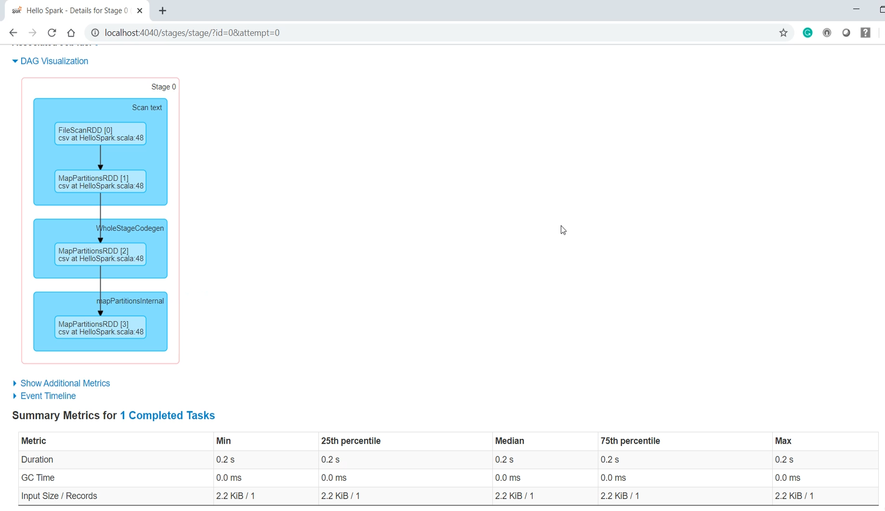

You might not know the exact meaning of these low-level operations unless you understand the lowest level of spark core APIs. And you don't even need to know them. However, you can make some good sense by reading it. So all we are doing here is to scan the file details and map the partitions. So at this stage, we know which file we want to read and how many partitions are there in this file. And that's what this high-level code is all about. That's what we wanted to do.

Now let's stop this application and move to the next step. Let me uncomment these options. What do you expect? These options are to make sure that we actually read a portion of the file and infer the column names and data types for each column. Since we are reading the physical data, you can expect one more action. One more action should result in one more job. Why?

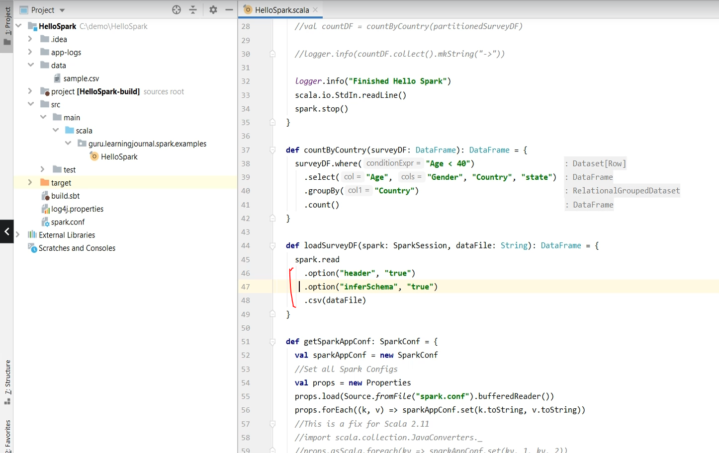

Because each action translates to a Spark Job. Let's run it and recheck our Spark UI.

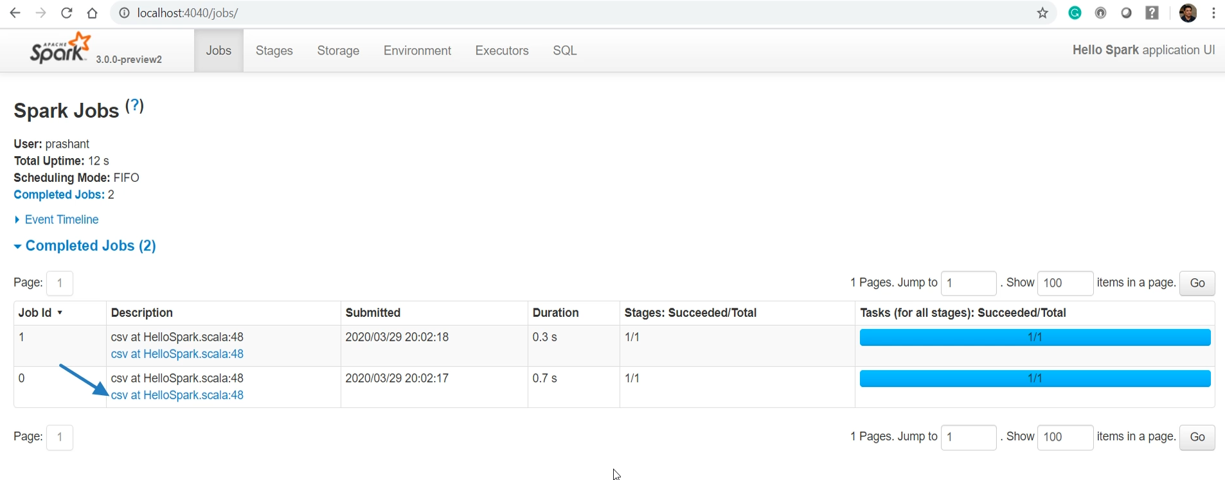

So now we have two Spark Jobs. As expected, right? Both jobs are triggered by the CSV method. Because the high-level code is the CSV method, which internally causes two actions. The first action is to learn about the file and the partitions. The second action is to infer the file schema. Each job should have at least one stage and one task. So we have two stages with one task each.

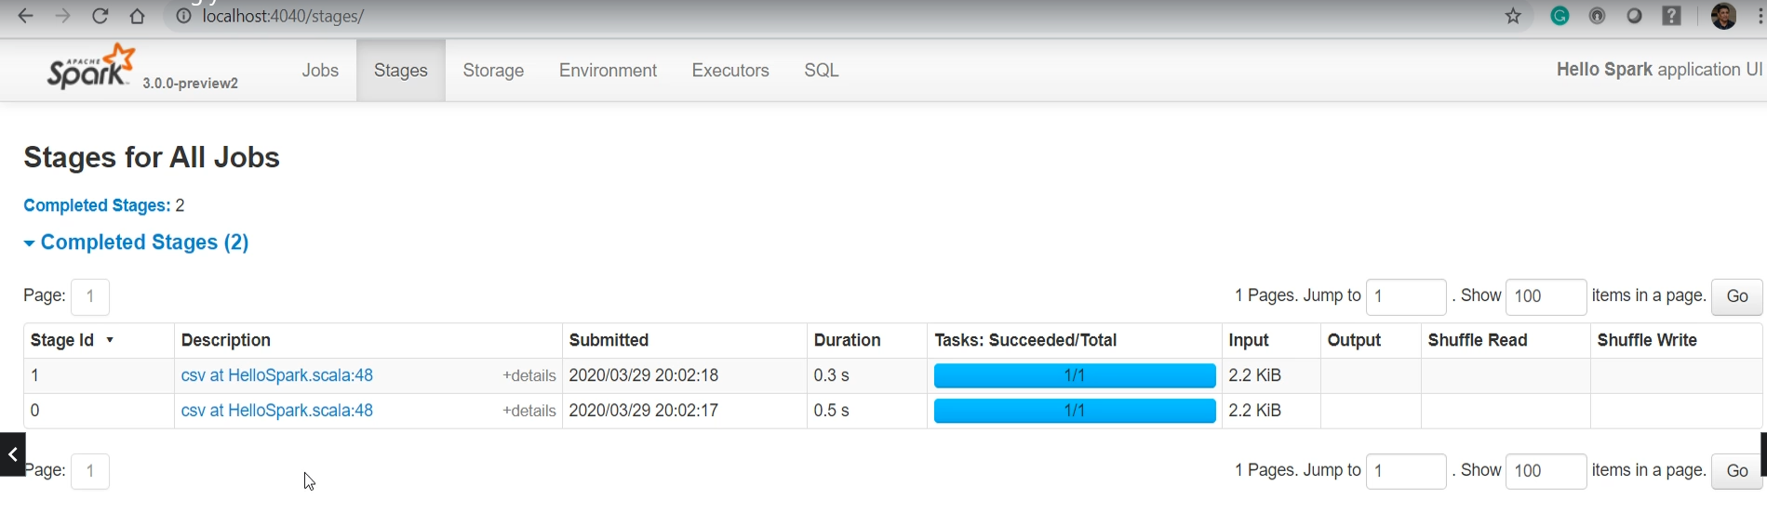

Make sense? Let me check out the DAG for stage-1. Here it is. It looks like a complicated sequence. But I can easily make out that we are deserializing the content after scanning the text file. So, we are inferring the schema while we deserialize it. Great! So now you understand these two jobs.

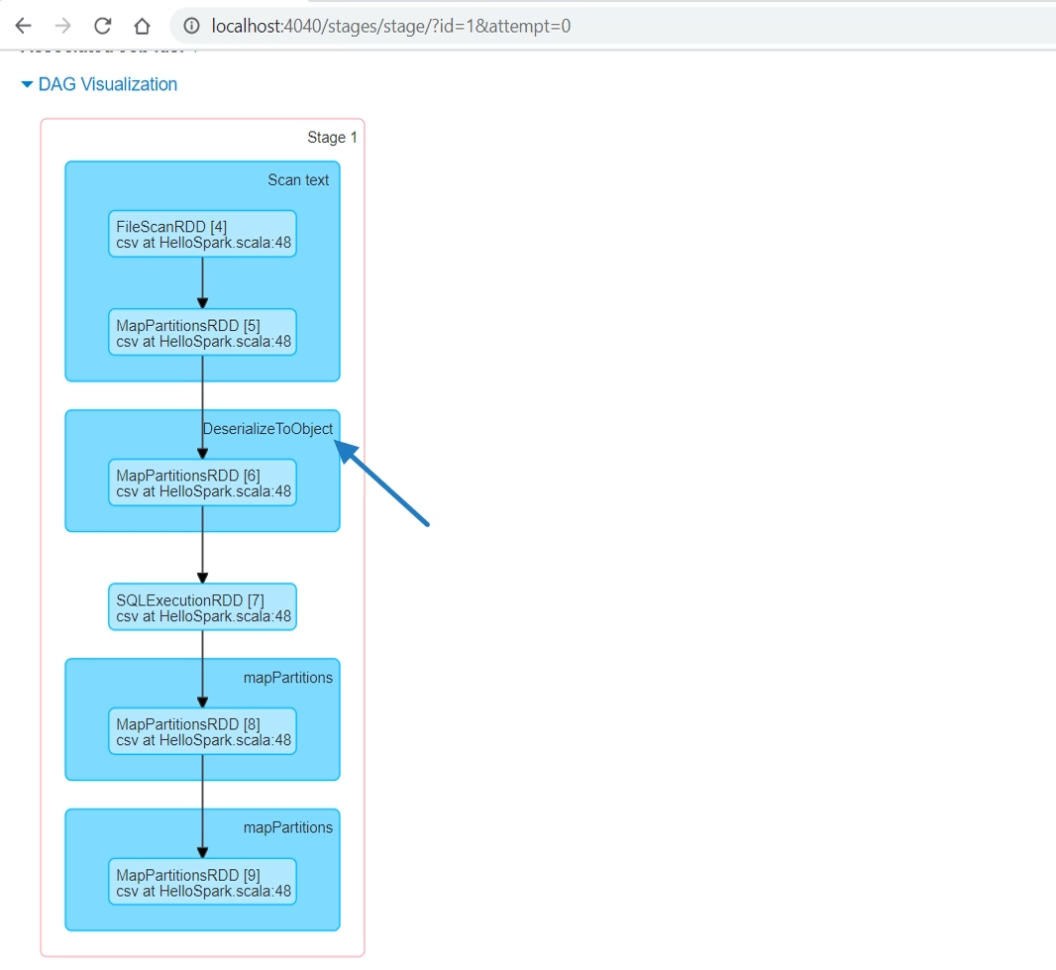

Both are caused by the spark dot read and the CSV method with these two options. Make Sense? Now I am going to uncomment everything else. Great! Now before we jump over the Spark UI, let me explain a few things. So, the spark is going to look at your code and break it into smaller sections separated by an action. I have two actions. Reading a file and collecting the results. Now each section becomes at least one Spark Job. Reading a file and inferring schema are two internal actions.

val surveyRawDF = spark.read // Job 0 – Internal Action

.option("header", "true") // Job 1 – Internal Action

.option("inferSchema", "true") // Job 1 – Internal Action

.csv(dataFile)

val partitionedSurveyDF = surveyRawDF.repartition(2)

val countDF = partitionedSurveyDF.where("Age < 40")

.select("Age", "Gender", "Country", "state")

.groupBy("Country")

.count()

logger.info(countDF.collect().mkString("->"))

So, we saw two jobs for this part of the code. However, collecting the results is a simple action, so I am going to get one job for this section of the code. And this job should cover everything from here to the collect(). So all these transformations, including repartition, select, where, groupBy, and count. All of this are planned as a single job. triggered by the collect action. Now let's drill down to the Spark Job. Spark will create a DAG for each job and break it into stages separated by a shuffle operation.

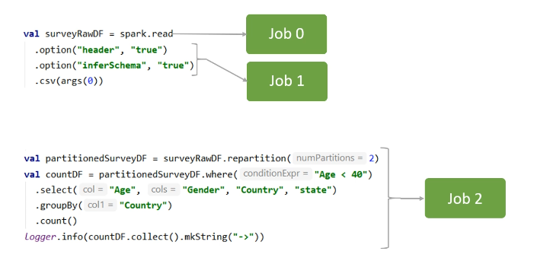

So, here is my DAG for the collect() job. We start from reading the previous DataFrame, then repartition it, filter, select, groupBy, and finally count it. Do you know which of these will cause a shuffle? Repartition and groupBy.

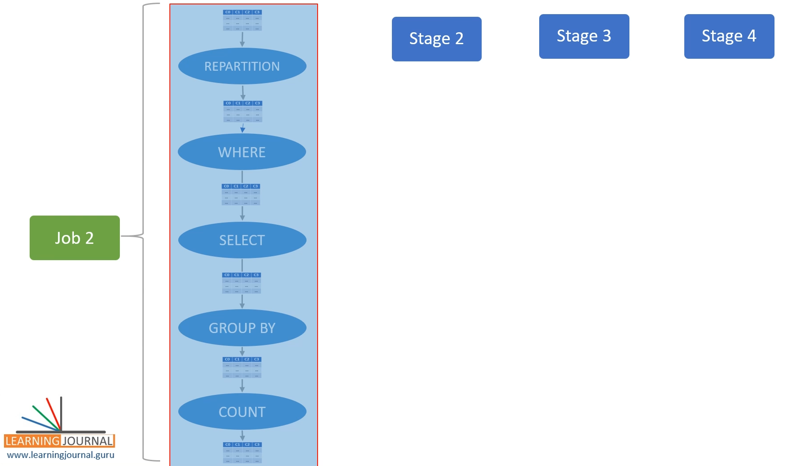

So Spark is going to break this job into three stages. This first stage will read the earlier DataFrame, make two partitions, and write them to an internal buffer called the exchange. The next stage is going to execute in parallel. Why? Because now we have two partitions. Each parallel stage task is going to read one partition from the exchange and perform these narrow transformations. That's what we call Tasks.

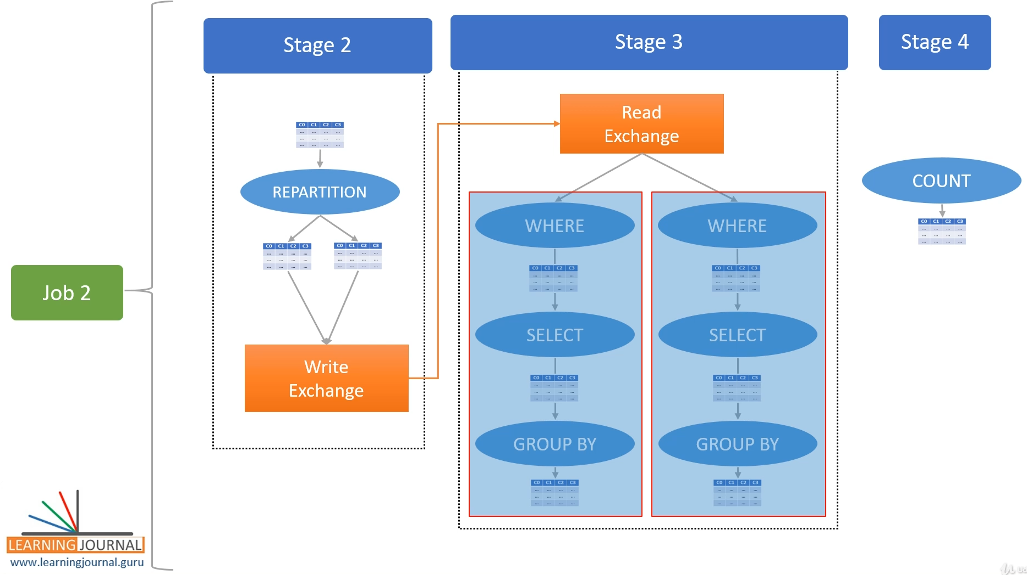

Now the second stage finishes at the groupBy writing the result to exchange. Why? Because we must shuffle/sort the groupBy results. The third stage will again start to read the result from the exchange. And this stage is also going to have two parallel tasks because we configured our session to have only two partitions for an internal shuffle. Finally, the collect runs at the driver to collect outcomes from both these tasks.

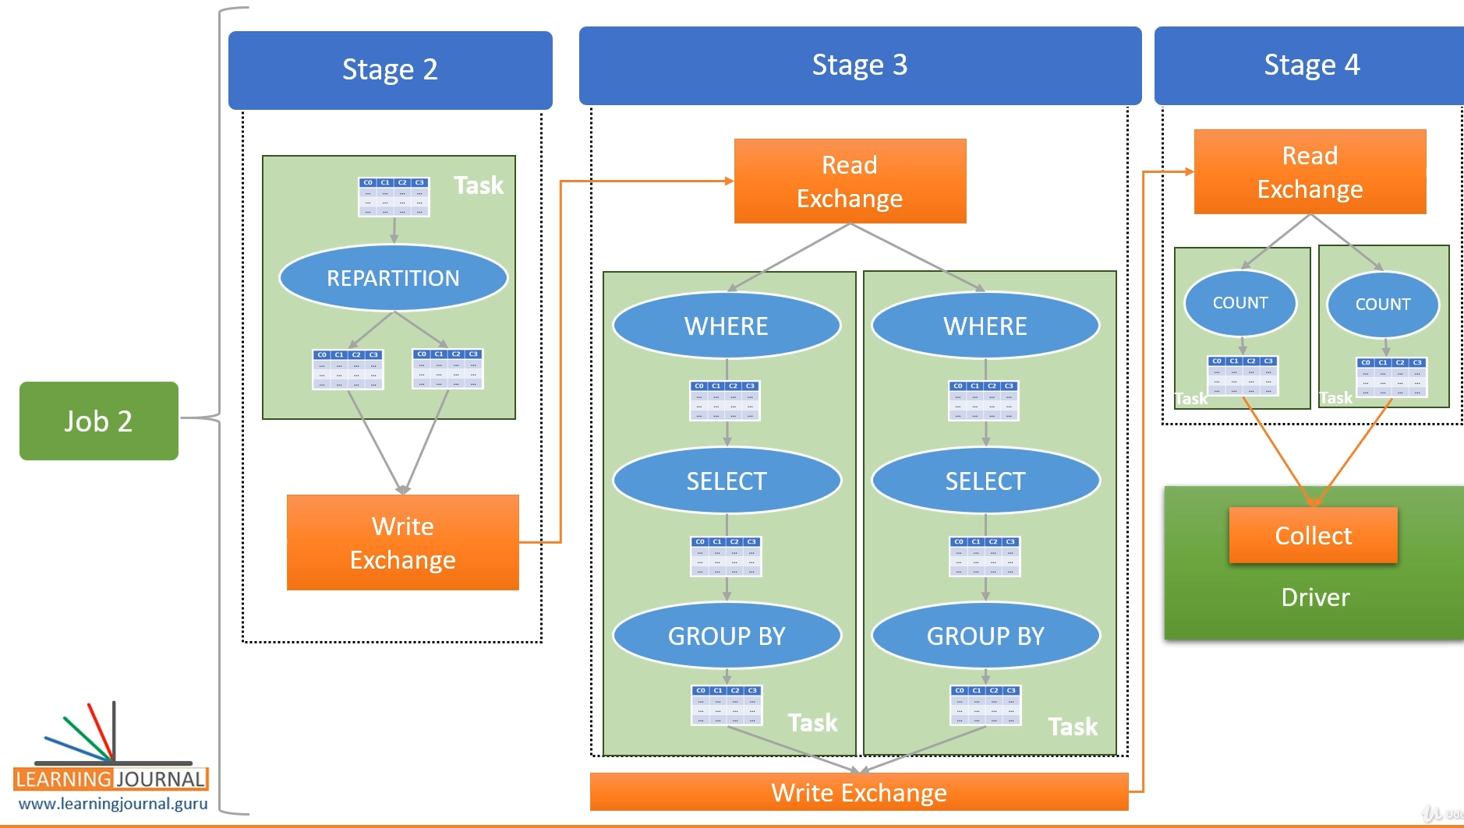

So, in summary, each action will result in a Job. Each wide-transformation will result in a separate stage. And every stage executes in parallel depending upon the number of DataFrame partitions. The first stage operated on a single partition DataFrame, so we do not have any parallel processing here. The next two stages worked on two partitions, so we have two parallel tasks. You can see all this in your Spark UI. Here it is. We have three jobs.

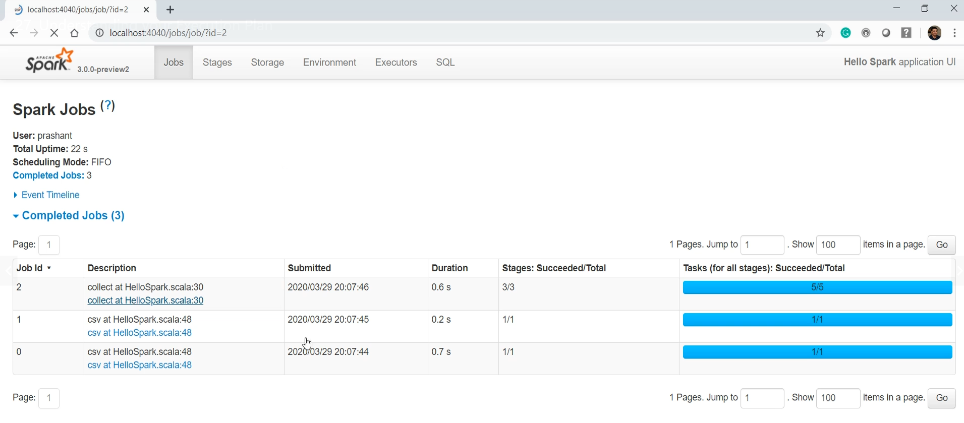

The first two jobs above are for CSV action. The last job is collect-action. If you look at the DAG for the whole job, you will see three stages.

|  |  |
| --- | --- |
| The first stage starts reading a DataFrame. | And finishes writing data to exchange caused by repartition. |
|  |  |

You can see it here. One task and a shuffle-write operation.

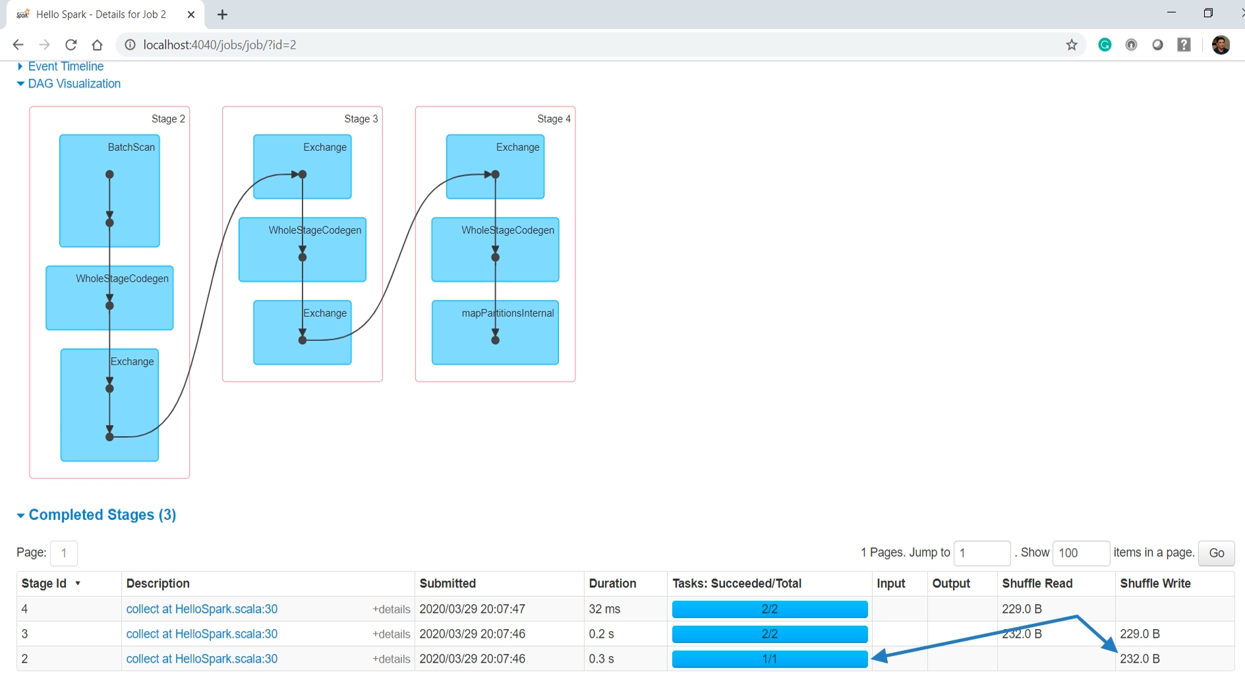

The next stage starts reading the data from the exchange.

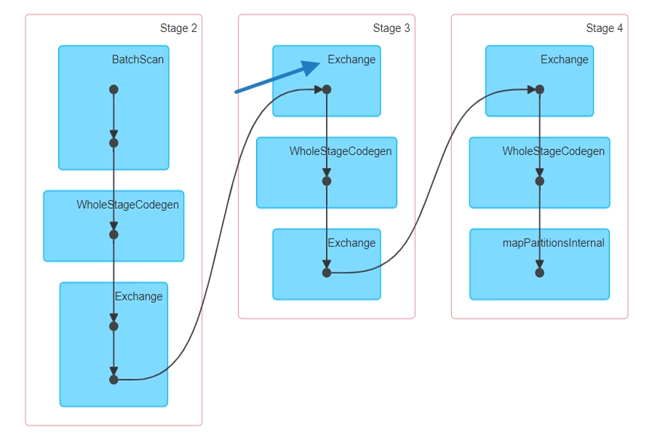

You can see it here again. Shuffle read and two tasks.

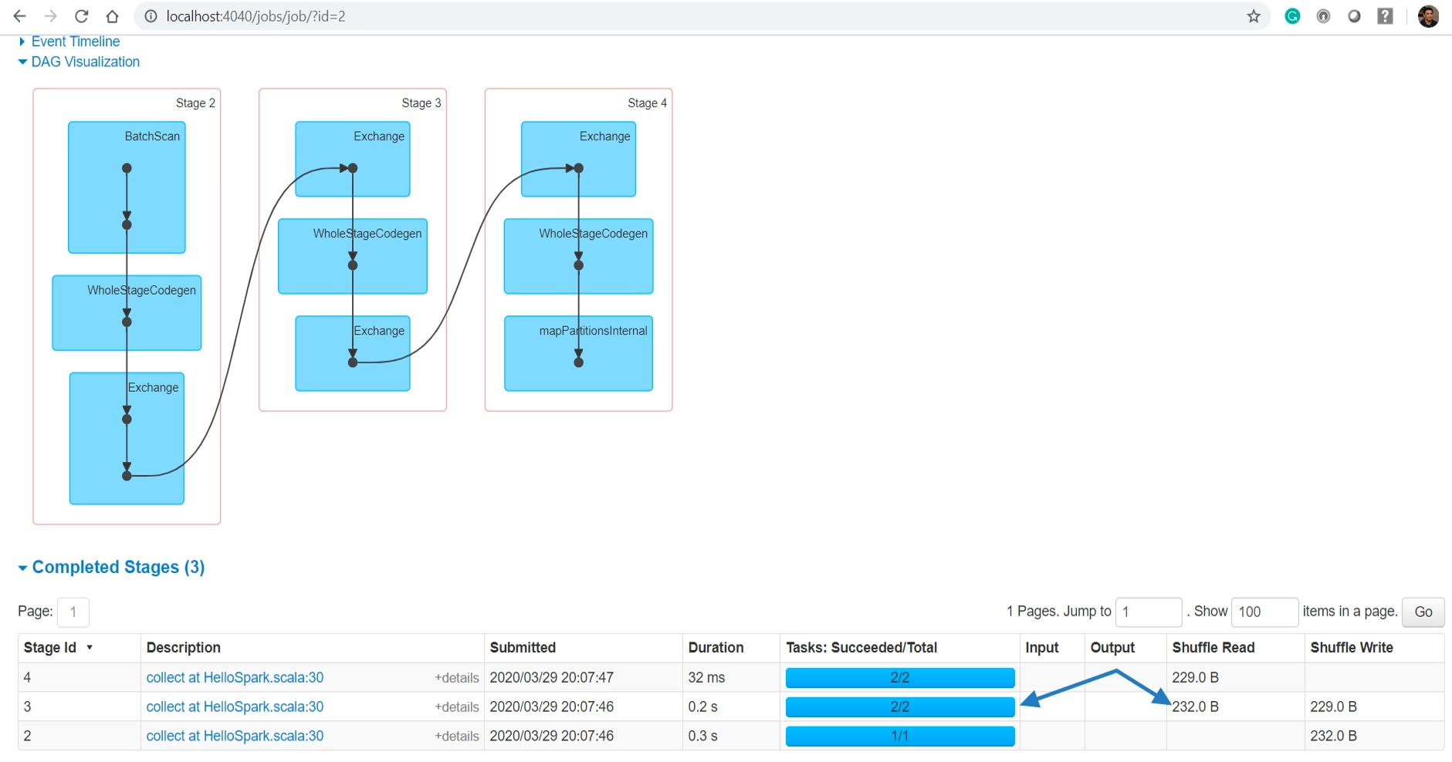

|  |  |
| --- | --- |
| So, this stage runs in parallel because we have two partitions for this stage. | The stage finishes writing data to exchange caused by the groupBy. |
|  |  |

You can see the write here.

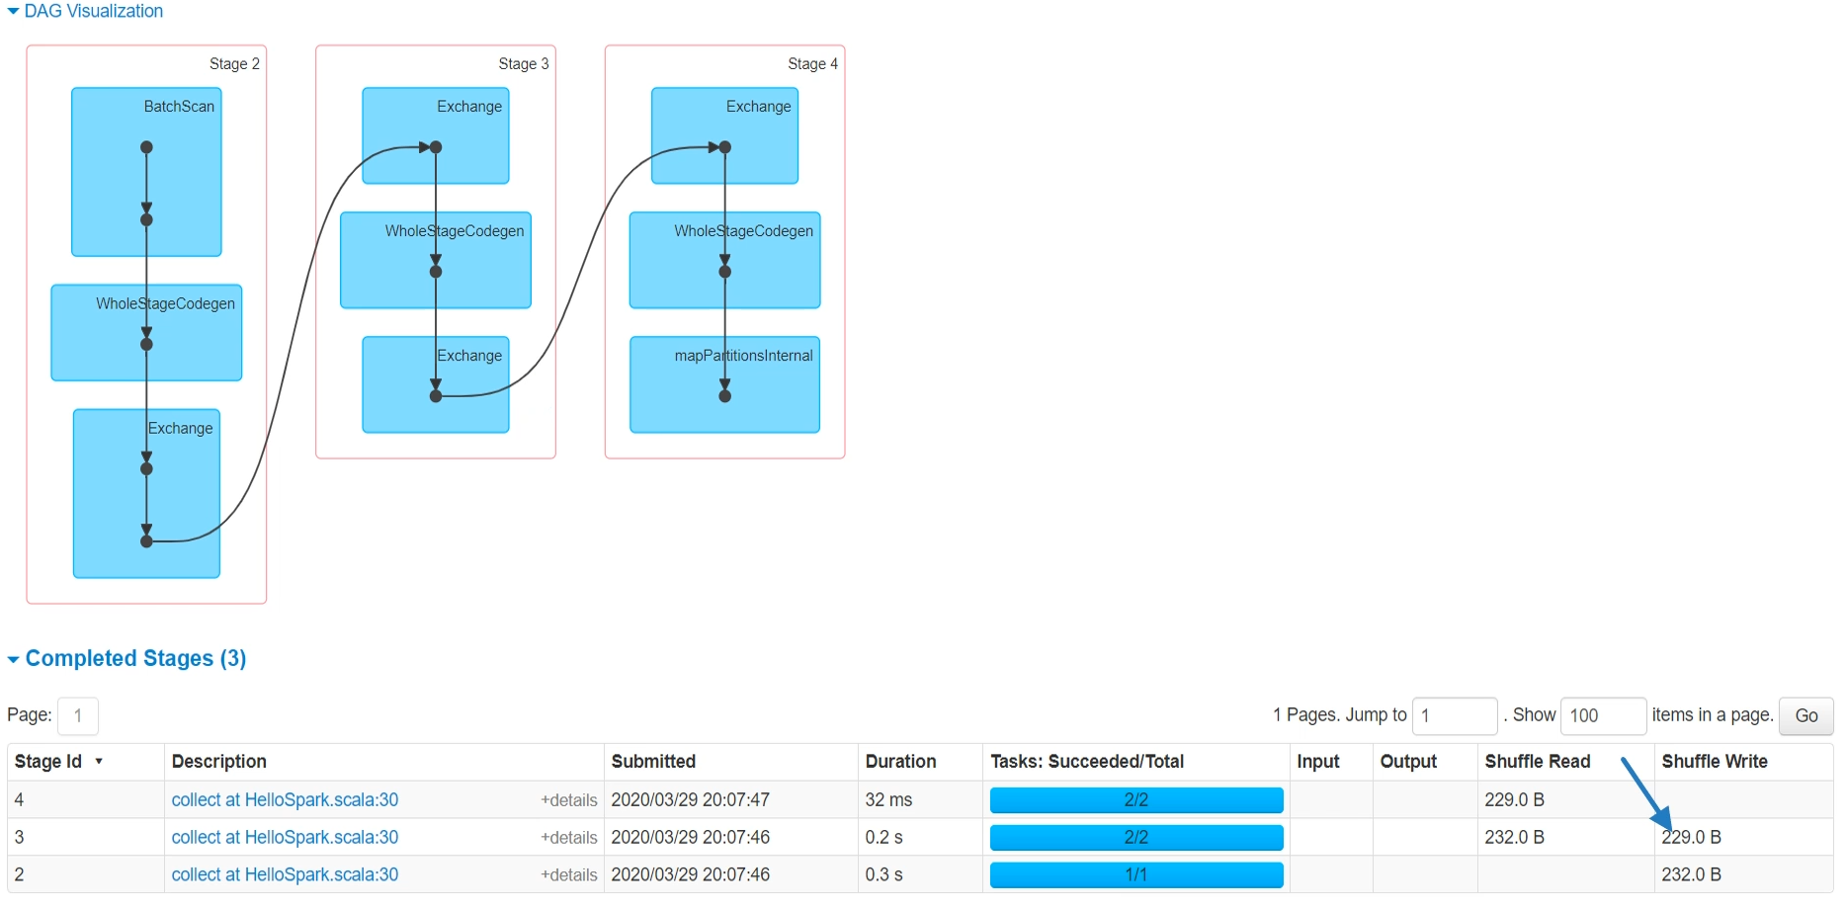

The last stage again reads from the exchange and executes two parallel tasks.

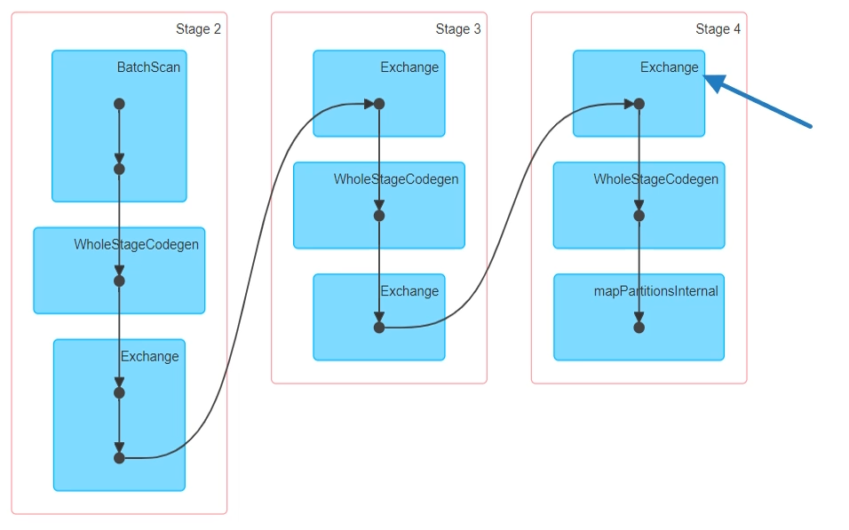

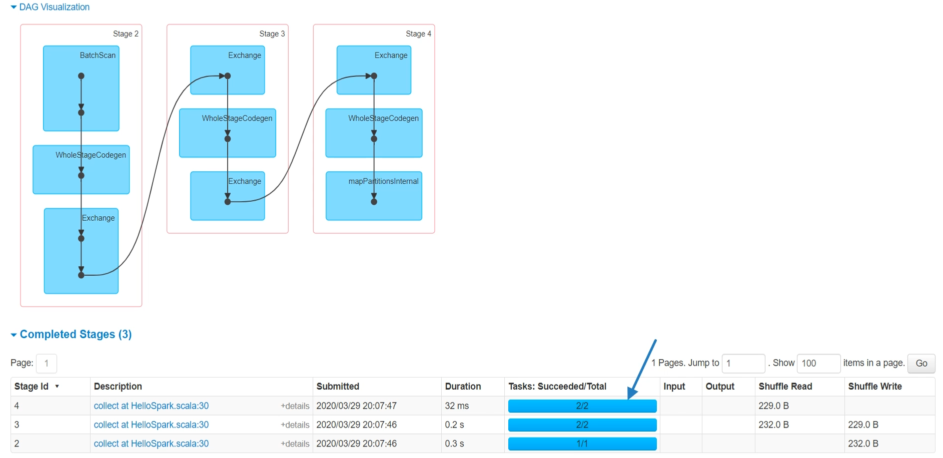

This DAG is for the whole job. If you want to drill down further into any of the stages, you can go to the stages tab or just click any of the stages here.

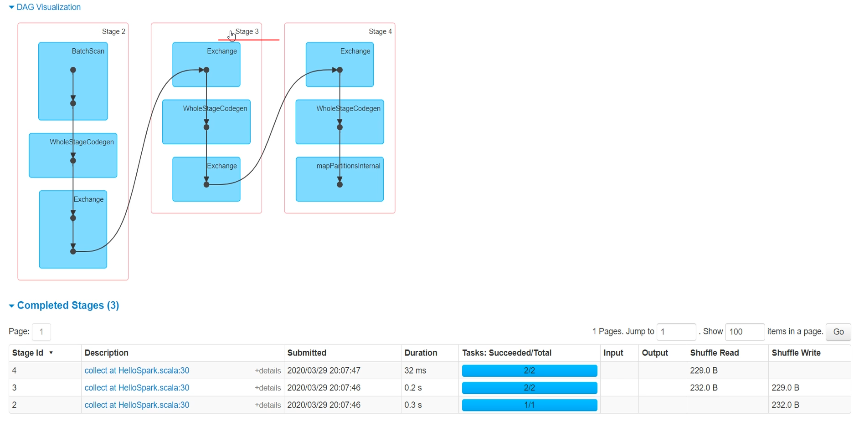

Both methods will take you to the same page.

### Unit Testing Spark Application

So far, in this section, we created a simple Spark Application. We are almost done with the example except for one last thing. Unit testing our application. And that's what we will learn in this video. So, let's start. Here is the example code, and we want to create Unit Test cases for this example. But what do you want to test here? I have two functions. The first one is to load the data file and create a DataFrame. So I can think of at least one test case such as this. Make sure that we are loading the data file correctly. So, we are going to read the data file and validate the number of records. We are going to do this in a minute. But we also have another critical function. This function is implementing some business rules and finally going to give us the count by the country. So, let me create one more test case here. I am going to read the data file, apply the transformations, and validate the results. Great! So now we have two unit test cases to implement. Let's do it. Let me create a new package here. Now we create a Test Class. I am going to use Scala FunSuite with BeforeAndAfterAll. Good. My unit test is also a spark program, and hence it is going to need a Spark Session. So, let me create a transient variable here and put a place-holder. I am going to initialize it later and use it across all my test cases. The next thing is to set up my SparkSession. So, I am going to override the beforeAll() method. The beforeAll method executes before all my unit test cases, and hence this one is the best place to set up my SparkSession. So, let me initialize the SparkSession. You already learned to create a new SparkSession.

package guru.learningjournal.spark.examples

import org.apache.spark.sql.SparkSession

import org.scalatest.{BeforeAndAfterAll, FunSuite}

import guru.learningjournal.spark.examples.HelloSpark.{*countByCountry*, *loadSurveyDF*}

import scala.collection.mutable

class HelloSparkTest extends FunSuite with BeforeAndAfterAll {

@transient var *spark*: SparkSession = _

override def beforeAll(): Unit = {

*spark* = SparkSession.builder()  
 .appName("HelloSparkTest")  
 .master("local[3]")  
 .getOrCreate()

}

override def afterAll(): Unit = {

spark.stop()

}

test("Data File Loading") {

val sampleDF = loadSurveyDF(*spark*,"data/sample.csv")  
 val rCount = sampleDF.count()  
 assert(rCount==9, " record count should be 9")  
 }  
  
 test("Count by Country"){

val sampleDF = loadSurveyDF(*spark*,"data/sample.csv" )  
 val countDF = countByCountry(sampleDF)  
 val countryMap = new mutable.HashMap[String, Long]  
 countDF.collect().foreach(r => countryMap.put(r.getString(0), r.getLong(1)))  
  
 assert(countryMap("United States") == 4, ":- Count for Unites States should be 6")  
 assert(countryMap("Canada") == 2, ":- Count for Canada should be 2")  
 assert(countryMap("United Kingdom") == 1, ":- Count for Unites Kingdom should be 1")  
 }

}

I am going to hardcode the required configurations here and avoid using the spark.conf. Why? Because all the configs in my spark.conf file may not make a good sense for unit testing. So it is good to hard code specific configs for unit testing or create a separate spark.conf file for your unit test cases. Great! We also have an afterAll() method, which is the best place for your cleanup. All I have is the spark session, which I want to stop. Now we are ready to implement our test cases. I am going to test two of my functions, so let me import it here. Great! Now we can create the first unit test case. Give a name to your test case. Call the function and get your DataFrame. We want to count the records. Assert it. That's all. We are done with the first test case. Let's do the next one. I am going to load the data file and then invoke my function. So now, I have a DataFrame that contains my outcome. It should be something like this. But I am not sure about the order of these records, so it is difficult to validate it directly with the DataFrame. However, validation could be an easy thing if I convert this DataFrame to a Key/Value map. Let me do it. I am going to create a mutable HashMap. I need a String key and a Long value. Now, I will collect the DataFrame, and for each record, I am going to put it on the map. Great! Now the assertion is straightforward. United States is four, Canada equal to 2, and the UK has got 1 record. Done. You want to run it? Let's do it. Good! You can also run your test cases using sbt command line.

### Debugging Spark Driver and Executor

Spark is a distributed framework, and we learned that a Spark application executes as a Driver and a bunch of executors. So the next obvious question is how we can debug these distributed components. In this video, I am going to help you understand debugging a Spark application. So, let's start. Spark is a complex system, and you already learned the following things about a Spark application. Your application code is compiled down to a low-level Spark API calls. These API calls are arranged in a bunch of Jobs. These Jobs are again broken down into stages. These stages are then executed by the executors as a task. All tasks of the same stage are performed in parallel. And that's how we get parallel processing. And the number of the parallel task will depend upon the number of partitions of the required DataFrame. Now the next important question is this. What can you debug? And what you cannot debug? Let's look at the example to understand it.

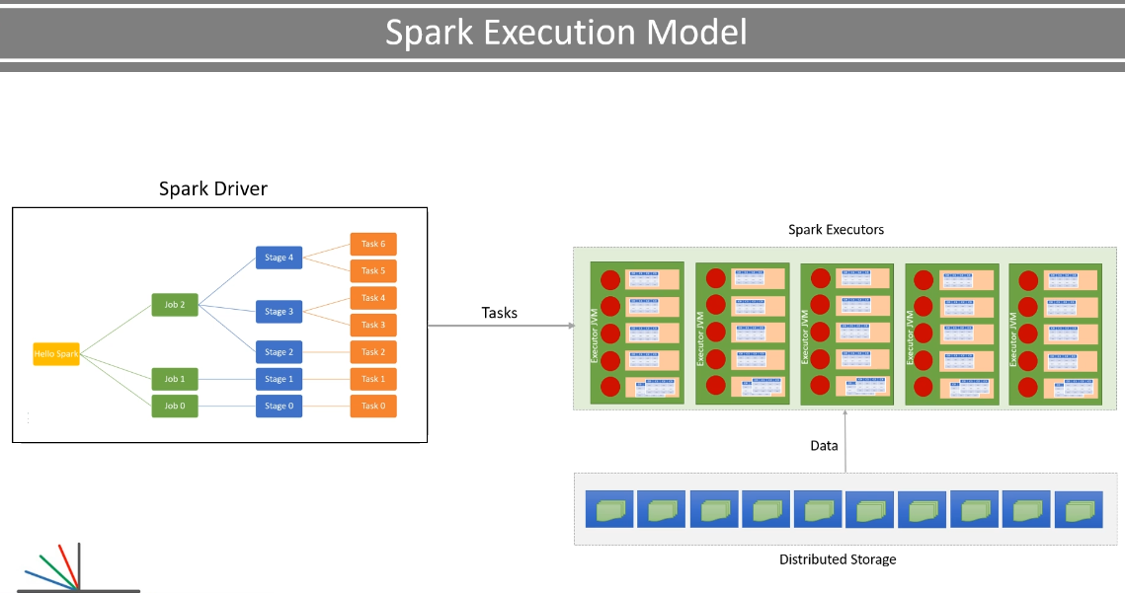

You can place a breakpoint at any place in this code and debug it. However, all the code that we have written so far is going to be used by the driver. So all your debug breakpoints will remain at the driver level. Let me show you. I am placing a breakpoint here. At the select transformation. Let me start debugging.

I am running this program in local mode with three threads. So my driver should be running in the main thread, and executors should be running in the other two threads. Now I got my breakpoint. Where am I? In the main thread. You can press F8 and step over to the next line. But you still remain in the main thread. no matter which line you go, you will stay in the driver thread. Even if you press F7 and step into the Spark APIs, you are still going to remain in the driver thread. And Why is this happening? Can't we reach to an executor thread? Let me explain.

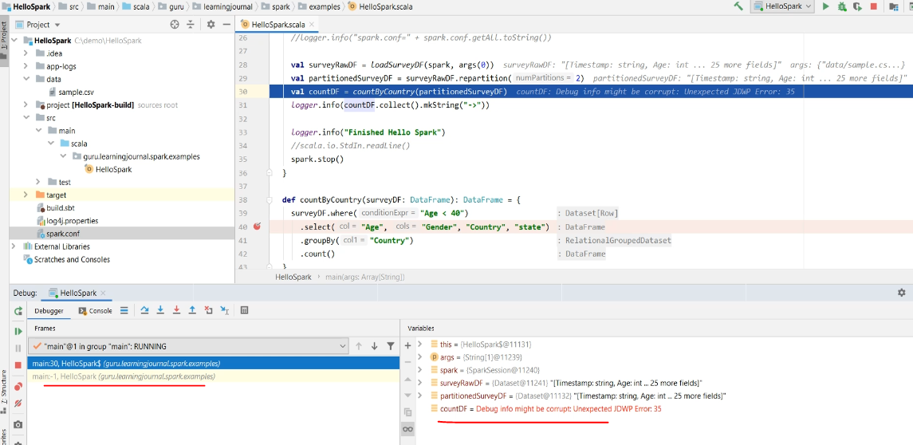

So we have two questions? Why everything seems to be happening in the driver thread? And how do we reach the executor thread?

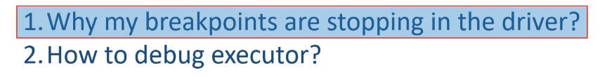

Everything seems to be happening at the driver because it is actually happening at the driver. We are using some high level transformations such as select(), where(), groupBy(), and count(). All these functions are used by the driver to generate some code. And the generated code is passed to the executors. What does it mean? It means that the executors are going to execute the generated code, which you cannot debug. So, we are not able to reach to the executor threads. We remain at the driver. In fact, we do not even need to debug the generated code because that thing is already tested by the Spark. And any issue in the generated code is a bug in Spark. So, do not worry about debugging the Spark. We care about our code. Now the next question. How do we reach the executor thread? So, you may want to debug the executor threads when your executors are running your code instead of running the generated code. Is it possible? Yes. We haven't learned all the transformations yet. However, we have some flexible transformations such as map(), flatMap(), and forEach().



These transformations do not generate code for the executors. They allow you to pass a lambda function and straightaway handover the lambda to the executors. Then the executors are going to execute your Lambda function. The lambda function is your code, and you want to debug it. You can do it. Let me show you. I am going to add a forEach method to the final DataFrame. The forEach method takes a lambda, and the lambda body is sent to the executor. Let me place a log method in the body. Great! So now, this lambda body will run at the executor. Now you can place a breakpoint here. Let me put one more breakpoint. So, the first breakpoint should stop at the driver, and the second breakpoint should stop at the executor thread. Let me start the debugging. Great! So we reached the first break, and you can see that we stopped in the main thread. Now press F9, and it should stop at the next breakpoint. Here it is. Now, we stopped at the executor task. You can press F9 again, and it will stop again to log the next record. Press F9 once more, and it stays for the third and the last record.

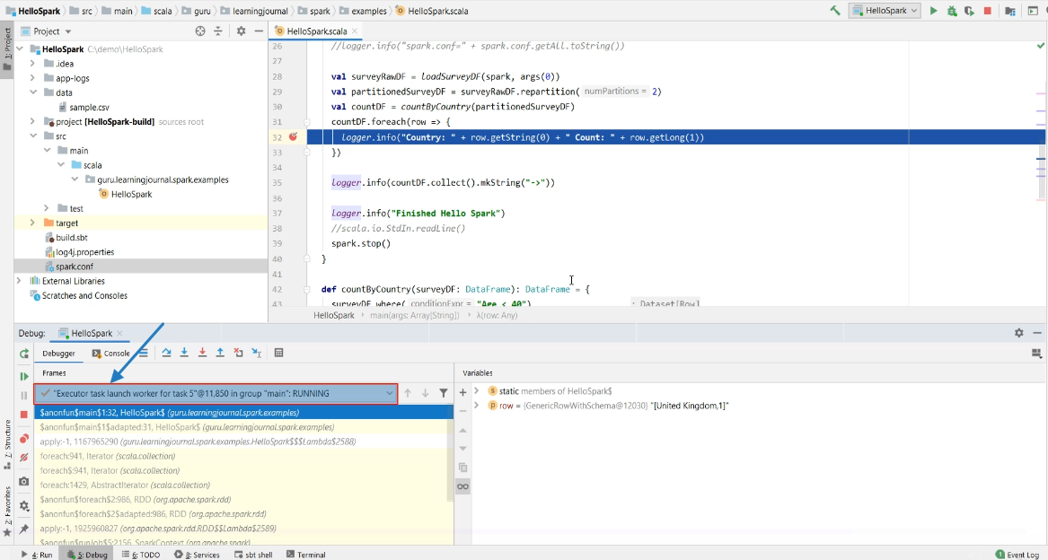

Let me finish it. Great! So the point is straight. You can debug the driver code, and you can also debug the executor code. However, you cannot and should not be debugging the generated code. In this example, we configured log4j to collect the application log in a log file. Here it is.

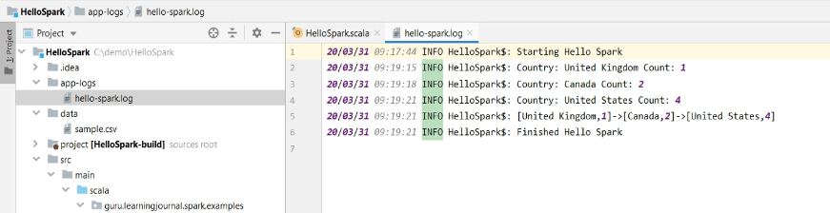

However, let's go back to the code and look at your log-entries. This log entry is created by the executor. But all other log entries are created by the driver.

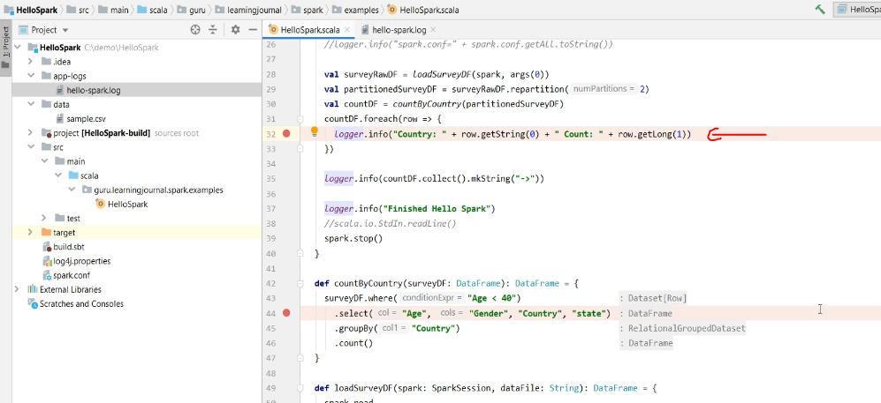

Why? Because this code is executed by the executor and hence the log entry is also produced by the executor. However, all other lines are run by the driver, and therefore all other log entries are provided by the driver. But all the entries came in the same log file. This is absolutely fine for the local environment. However, when you are running your application on a cluster, then you may want to keep it separate. Keeping driver and executor logs apart might help you investigate problems or to understand the behavior of your application on the cluster. In the next lecture, I will execute this example on a cluster and help you learn to collect your application log in a cluster environment.

### Spark Application Logs in a Cluster

We learned to debug a Spark application on a local machine. However, once your application goes running on a cluster, you cannot debug it. Debugging a live running distributed application that is working on a massive volume of data is not even practically possible. So how do you deal when your application is misbehaving on the cluster. Yes! You are absolutely correct. The application log is your best friend for investigating production problems.

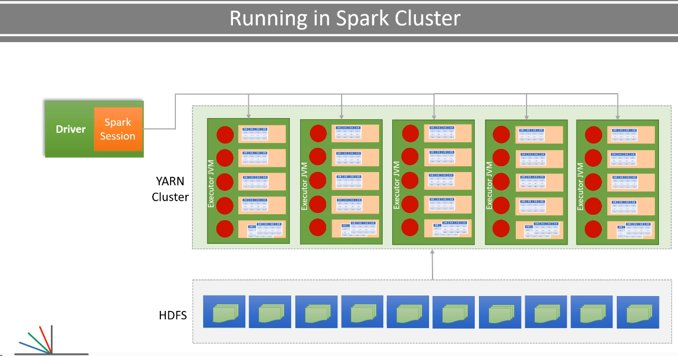

In this lecture, I am going to package and execute our example on a Spark cluster and help you learn how to access your application logs on a cluster. So, let's start. We have already taken care of configuring and creating application logs in our example. Look at your log4j configuration file. We configured it to send the log entries to the console as well as to a log file. And these two things together gives you good coverage. Let me show you.

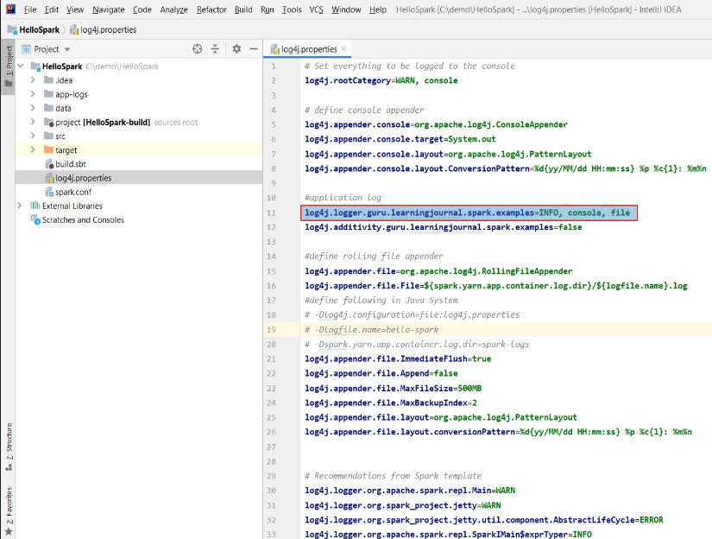

I have a Hortonworks Hadoop Sandbox Cluster, which is running on my local machine in Docker container. We can consider it as an on-premise Spark cluster, and the sandbox is good enough for learning how to work with on a real cluster. You do not need to set up the sandbox yourself, and the demo should be enough to learn things. However, if you want to set up the sandbox and repeat it yourself, you can follow the documentation here. And here. But remember. You will need a lot of resources to set up this thing. It requires approximately 30Gigs of download, 16GB RAM, and 4 CPU cores on your machine. If you do not have these resources, nothing to worry about. I am going to give you a detailed demo.

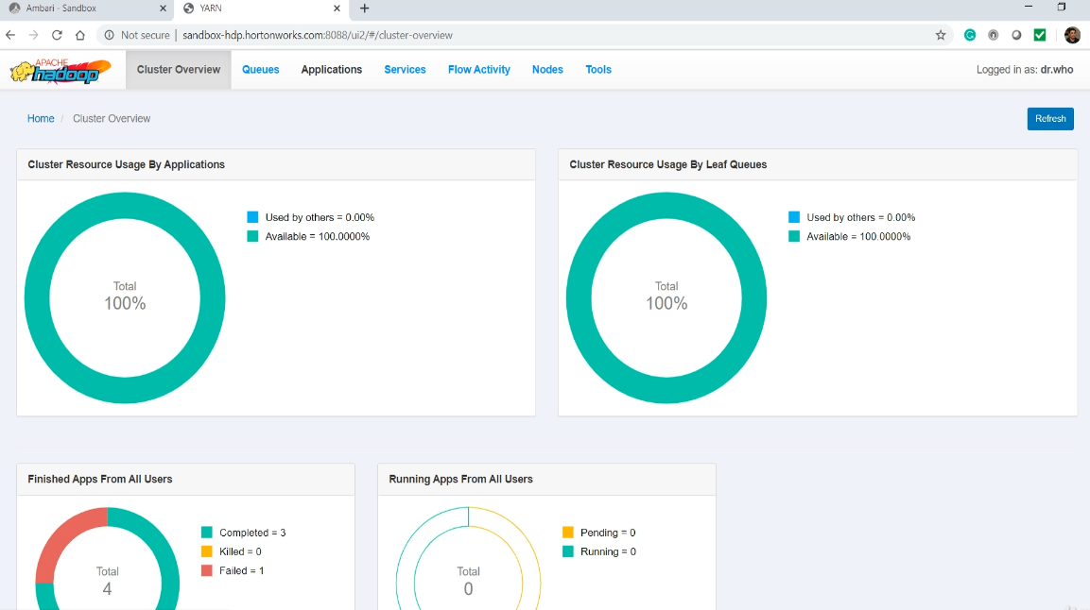

Let's start. I am logged in to my Hadoop sandbox cluster. Let me start spark-shell and check if things are working. Great! So I have Spark 2.3.1 in this cluster, which is built with Scala 2.11.8. Are you wondering about this long version number? Nothing to worry, this is the Hortonworks Hadoop version and the build number which they suffixed here.

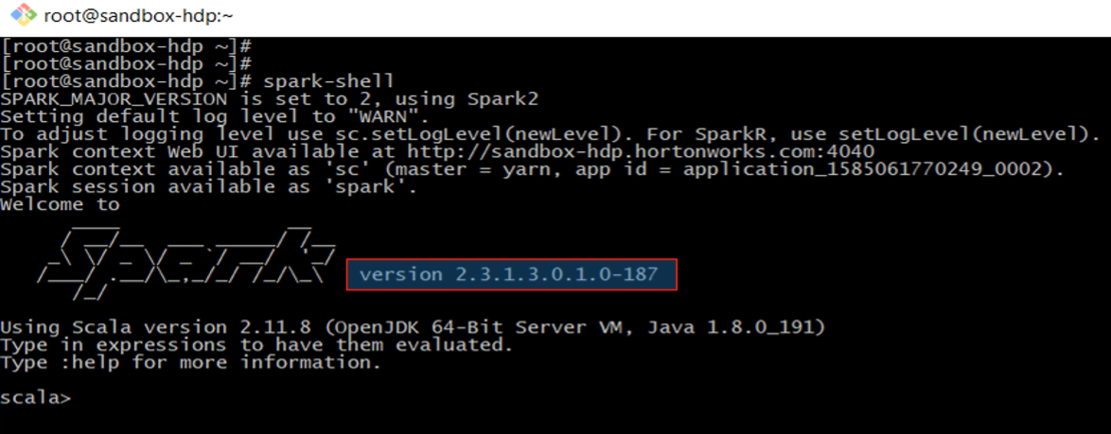

You can ignore this part, and your Spark version is 2.3.1. I am planning to execute my example on this cluster. So, I need to change the Spark and Scala version to match it with the cluster versions. Let me do it. However, this change is going to create one error.

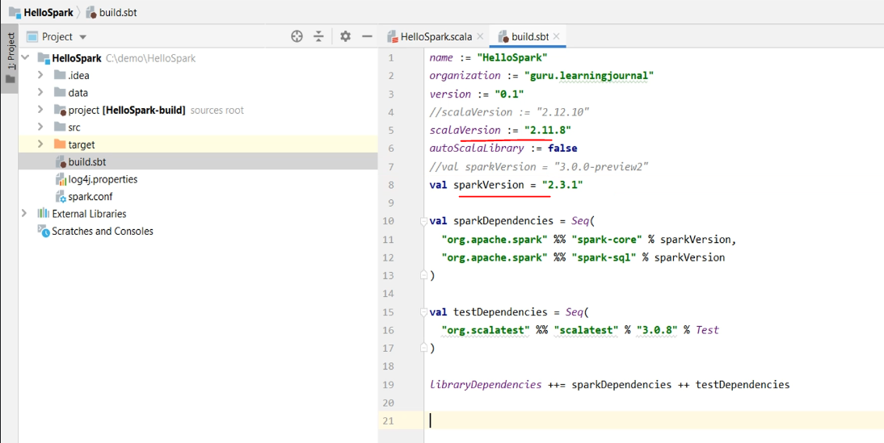

Let me show you. Remember this? I told you in the earlier video. Now we are using Scala 2.11. So we need to comment on this line and uncomment these two lines. Now you can build the project using the sbt package command. That's it. Done.

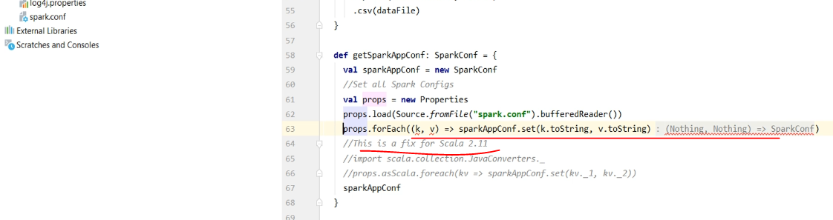

If you look at the target directory, you will see a jar file, and that's your Spark application jar compiled for the Scala 2.11.

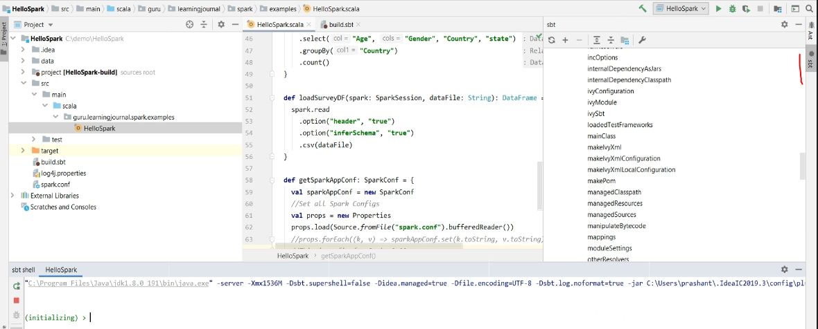

I copied this jar as well as few other things in a separate directory. We need all these things to correctly submit our application to the cluster. You need the jar file, and that's obvious, right? We also need the sample data because I am going to demo this using the same sample data file. We also need the spark conf as well as the log4j configuration file. These two files are necessary because we must send these files to the driver as well as they should also reach to the executor nodes.

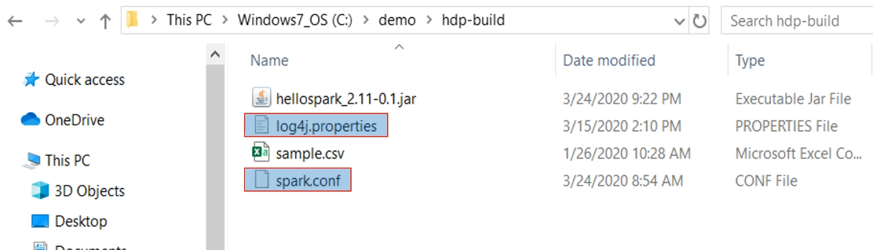

I will show you how to do it. But before that, we need to ship these files to one of the Spark cluster nodes. So, let me copy it to the Custer. I am running gitbash on my local machine, and I changed my current directory to the directory where I have all my artifacts. Now I can SCP all these files to the cluster node.

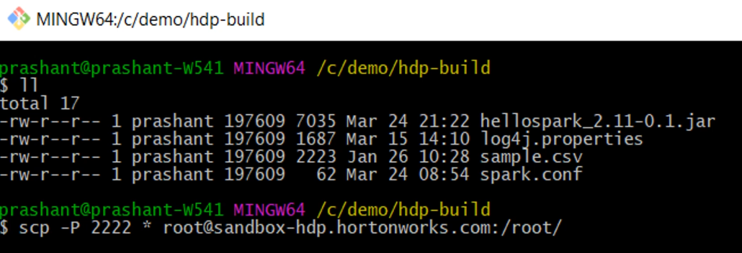

Great! Let me ssh to the cluster node. Now, I want to create a data directory in the HDFS. Here is the command. I am creating my data directory in the user-root directory because I will be running my application using the root user.

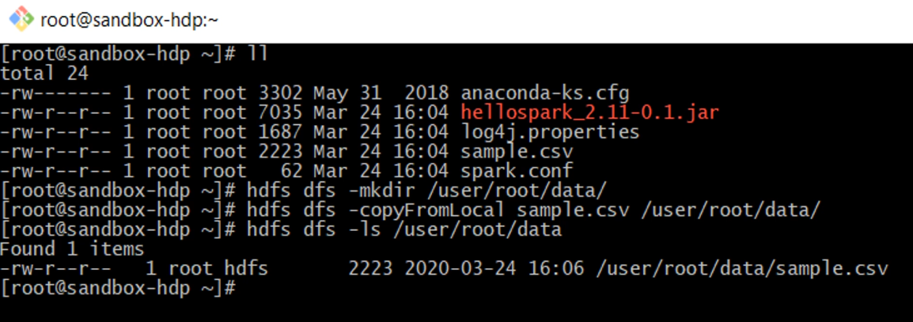

However, in real-life situations, you may have a different data directory, and you will be submitting your application using a non-root user. But in all this, you need to make sure that the user has got access permissions for the data directory. If the permissions are taken care of, rest all should be fine. Now we are going to use the spark-submit command to run our application in the cluster. Here is the command. I have got a lot of things here.

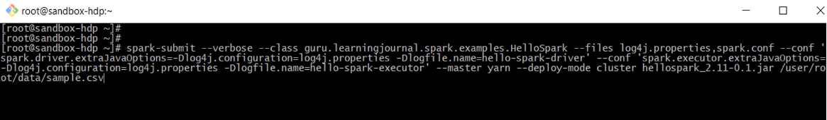

Let me explain it to you. You already know spark-submit. That's the main tool. Then I am giving a lot of options here.

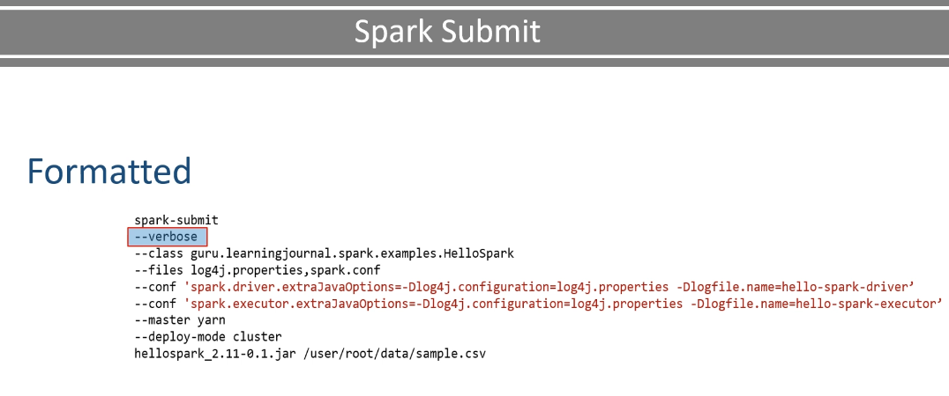

The first option is verbose. This option is not mandatory, but I am giving it here to get more detailed output from the spark-submit. This option is super valuable when you want to debug your spark-submit command and make sure things are working as expected. I will show you some details around it. The next option is the application class name. You already know that, right? The next one is the file option. I want these two files to get copied in the working directory of my driver as well as inside the executor containers. So the files option will make sure that these files are available to the driver as well as the executors. Now the next option is a custom configuration. I prefer to keep Spark Session configurations in my spark.conf files. However, some configurations are not used by the Spark Session, and they are needed even before the Spark could create a driver or executor JVM. So, these JAVA options should be passed via spark-submit, and hence I am using --conf option. So the first one is the driver JVM option, and the second one is for the executor JVM option. And what are we setting in the JVM? Two things. Log4J configuration file and the log file name. And you can see that I am giving a different log file name for the driver and a separate one for the executor.

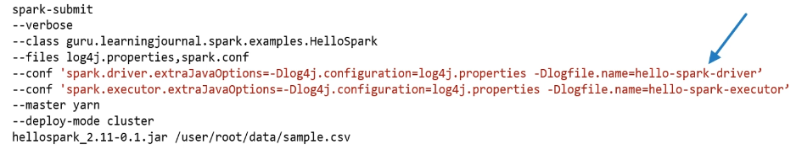

Rest is simple, and you already learned it, right? The master option is to set the cluster-manager. I am giving this option from the command line, and I have removed this option from the spark.conf file. The deploy-mode is a cluster. So, everything is going to run in my YARN cluster, including my driver and all my executors. You already learned about the deployment modes. The last one is my Spark Application Jar and the command line argument. I am passing the absolute path here. This URL is, by default, assumed to be an HDFS location in a YARN cluster. So, your data file must be present at this location, and the user submitting this Spark Job should have the access permissions for the file.

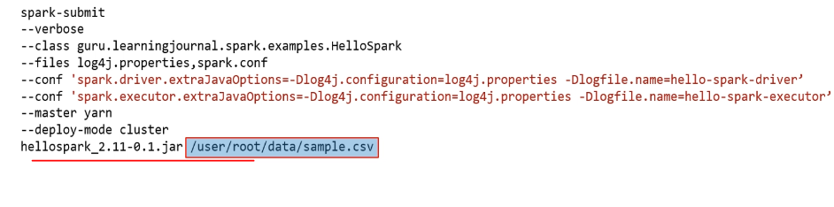

Let's run it. The Spark Submit is running in verbose mode, so it is going to spit out a lot of information. Let's look at the first message. So, your spark-submit is using spark-defaults.conf file and adding all these default configuration properties in a list that are going to go in your Spark Session. You already learned that in the earlier video.

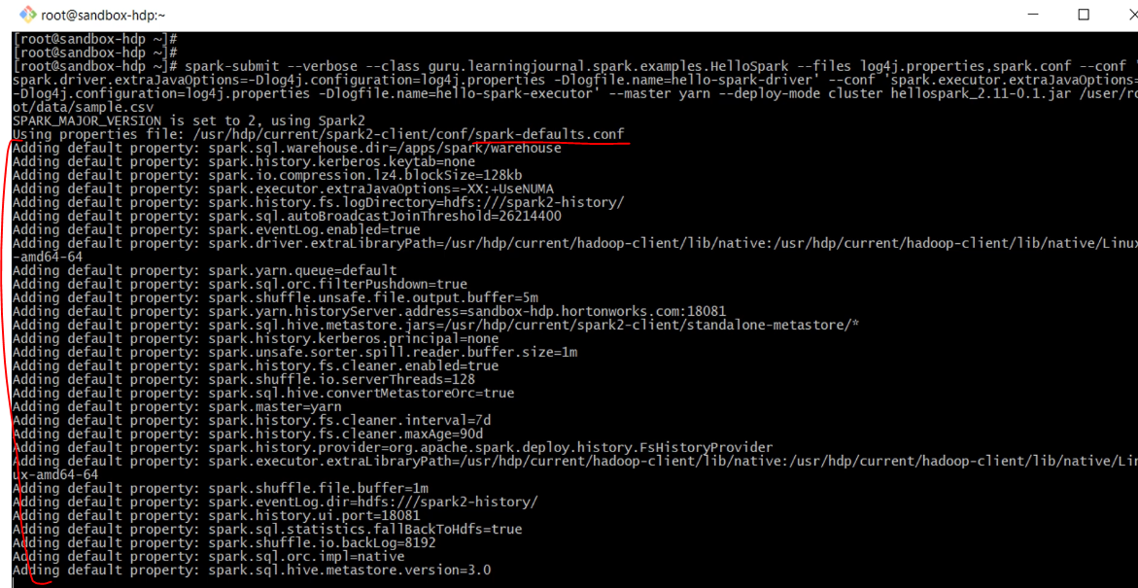

Then it shows you the combined list of all configurations used, including those specified through the --conf and those which are coming from the spark-defaults.

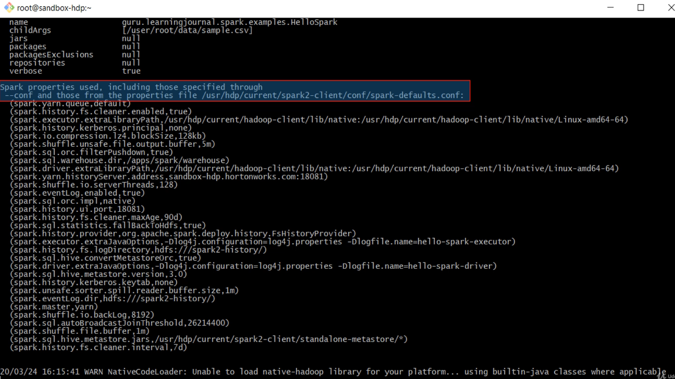

It also shows that your log4j.properties file, as well as your spark.conf file, is being uploaded to a directory. This is the working directory for your application. And the directory name is the application ID for your application. Here it is. Submitted application, some random number, and four. This is your application ID, and the working directory name for your driver and executors are the same as the application. See the two red highlights

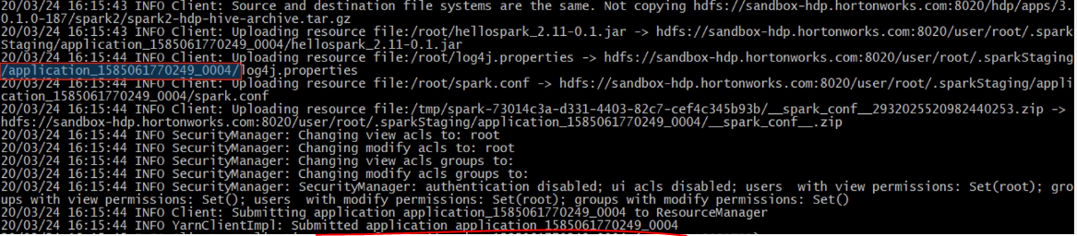

Finally, your application is accepted by the YARN cluster. Here is your Spark UI tracking URL. You can use this URL to monitor your application while it is running. However, you can use Spark History Server also. All you need is to know your application ID. That's all.

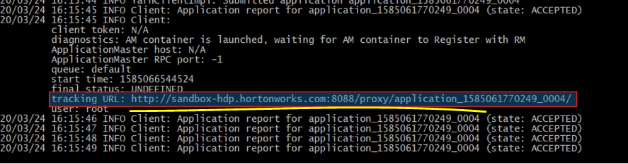

So your application is now running, and it finished. What is next? Now you want to look at your application logs. The most convenient method for looking at your application logs in a YARN cluster is using the YARN logs command. Copy your application ID. And use it in the yarn logs command.

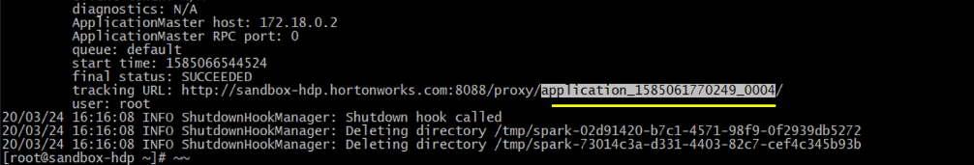

Here is the command.

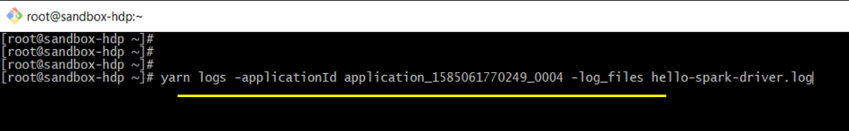

So, I want to see the log files for the given application, but I just want the hello-spark-driver.log file. This command prints the file content to the console. Similarly, you can get your executor logs. Here is the command. Simple, isn't it?

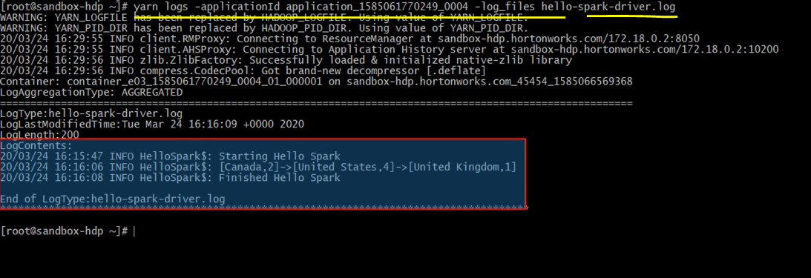

But to make this thing simple, you need to get prepared from the beginning. I mean, you must configure your log4j configurations correctly and log enough messages from your code.

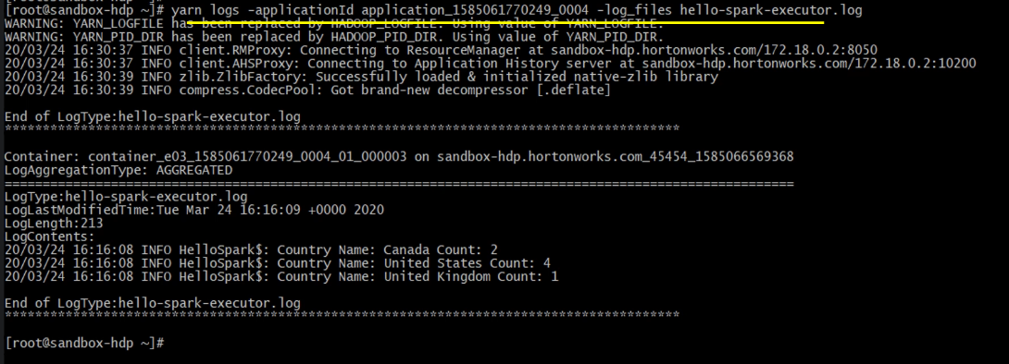

What is next? You can also access these log files using YARN resource manager UI. Let me show you. So, here is my Ambari dashboard. I hope you know a little about Ambari. Ambari is a web interface used for Hadoop Cluster Administration and monitoring purposes. Go to YARN Resource Manager UI.

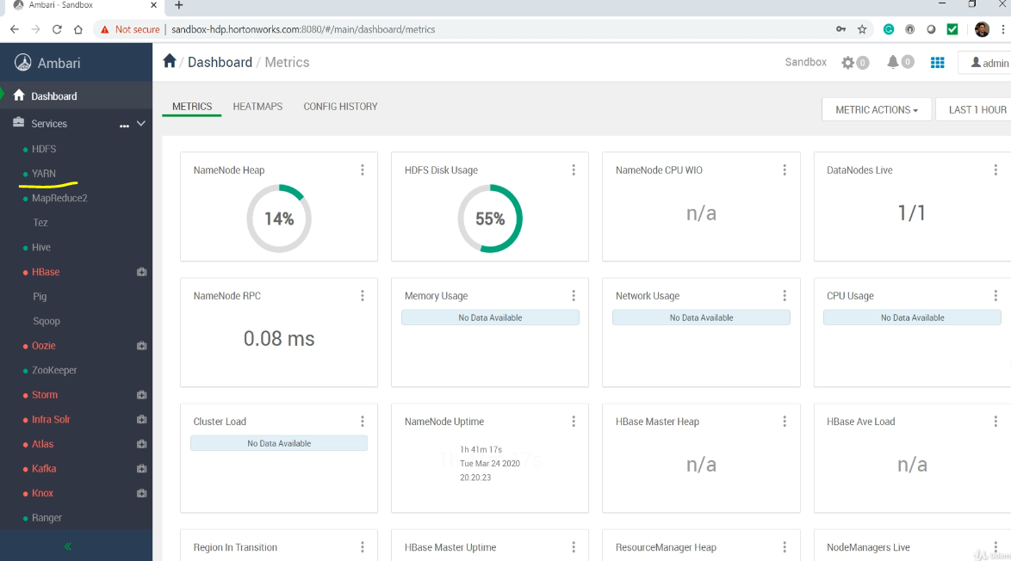

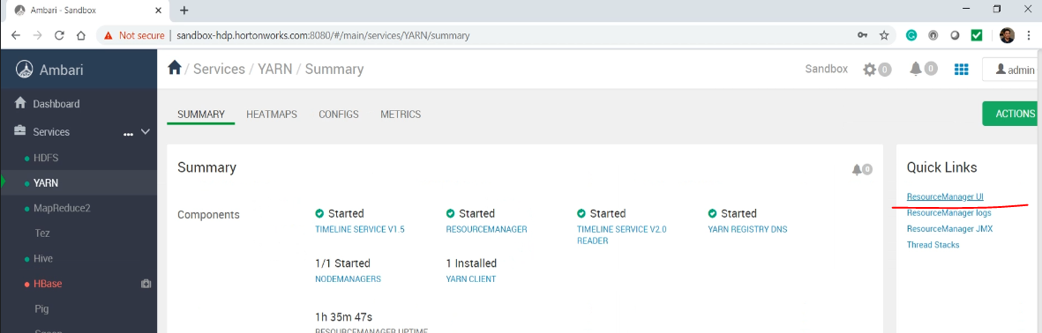

Look for the list of applications.

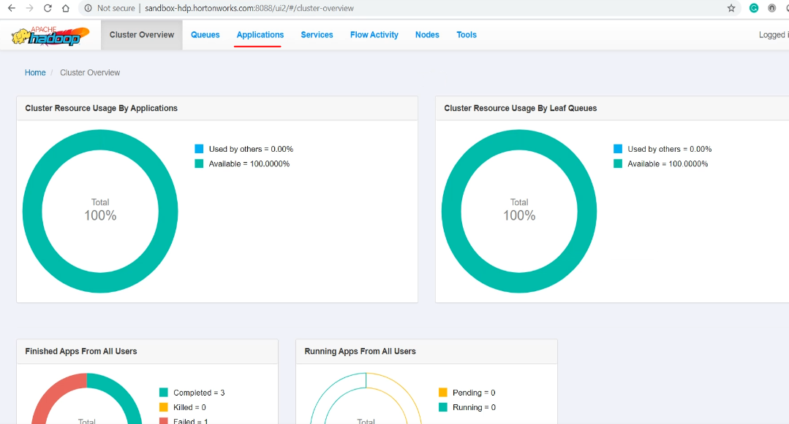

Click on your application id, and it should take you to the next screen.

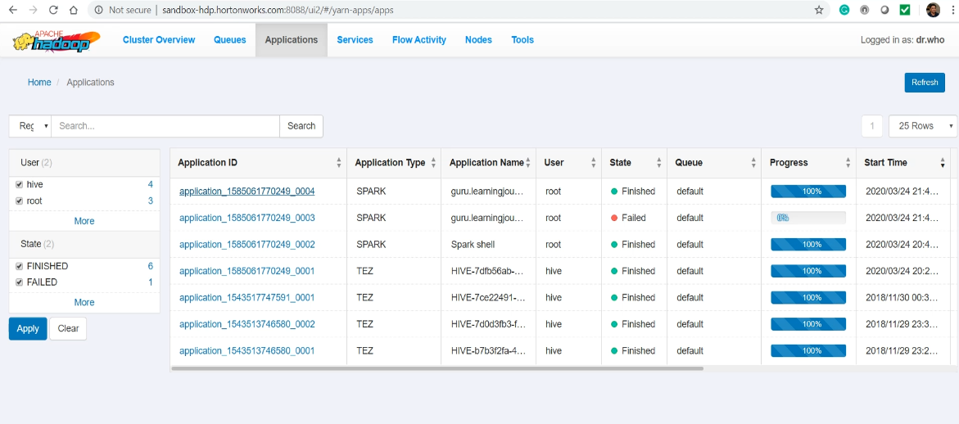

I am interested in logs.

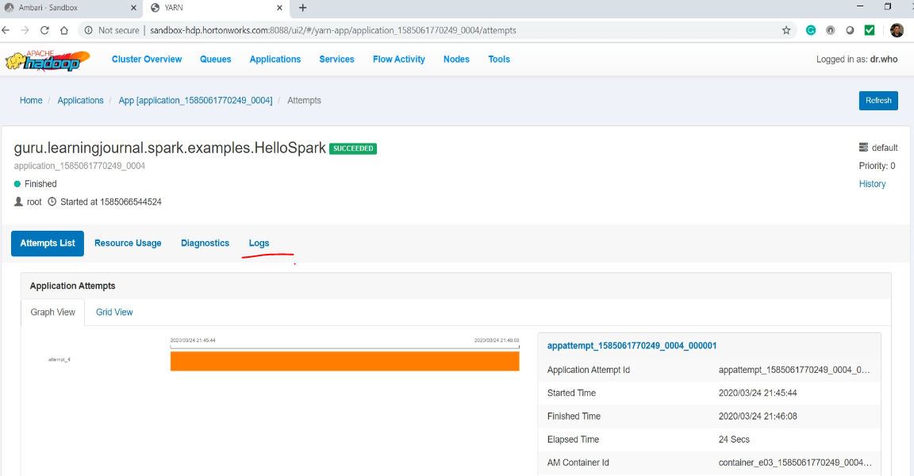

Select the attempt number. If your application didn't fail in-between and it was not automatically restarted by YARN, then you should have only one attempt. Now you can look at the list of containers. So, my application ran in three YARN containers. The first container was used by the driver.

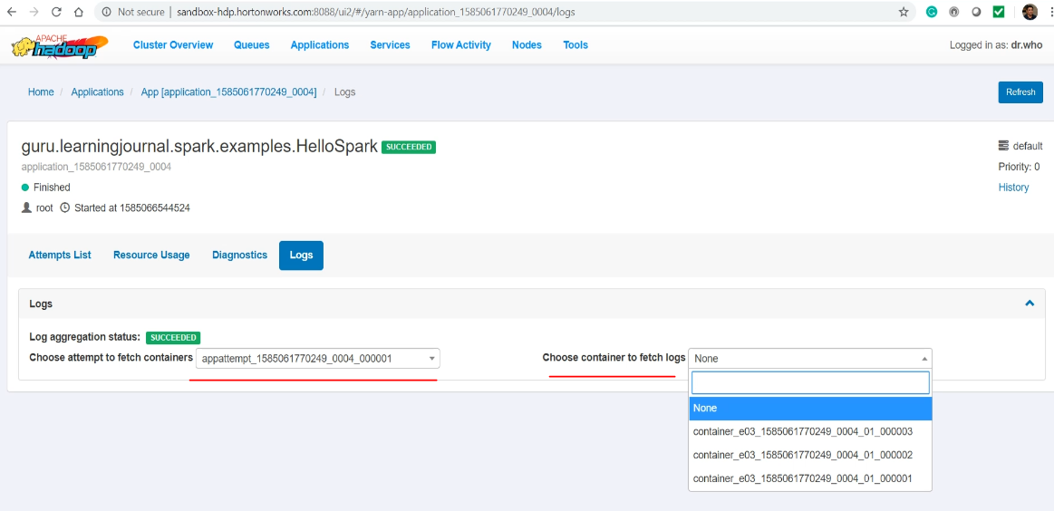

Now select the log file name. That's all. You got your driver log. Similarly, you can select other containers. I have two more containers, and they were used by the executors.

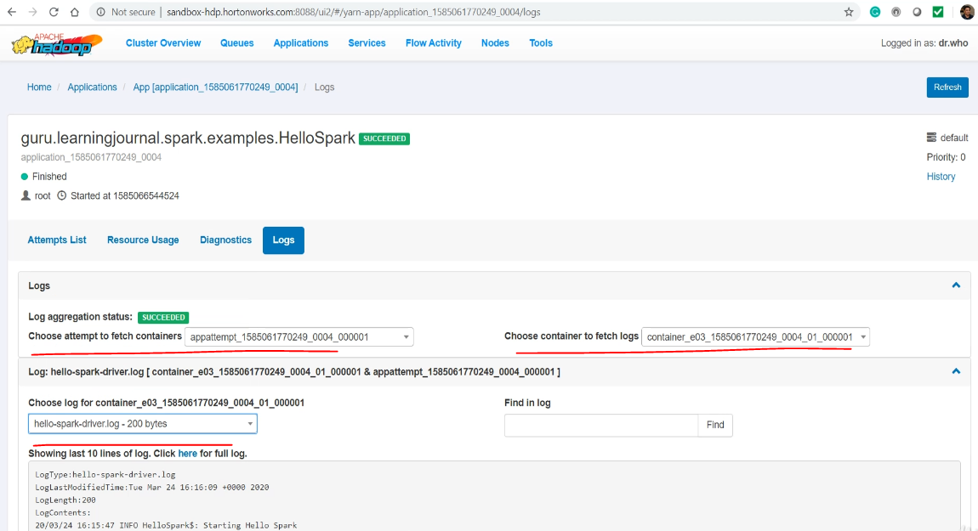

Let me select the second container. And then we look for the file name. Nothing is there. So it seems like the second executor didn't get any row for processing. Well, that's not good, but let me move on to the next container. Here it is. So this guy has got all three records.

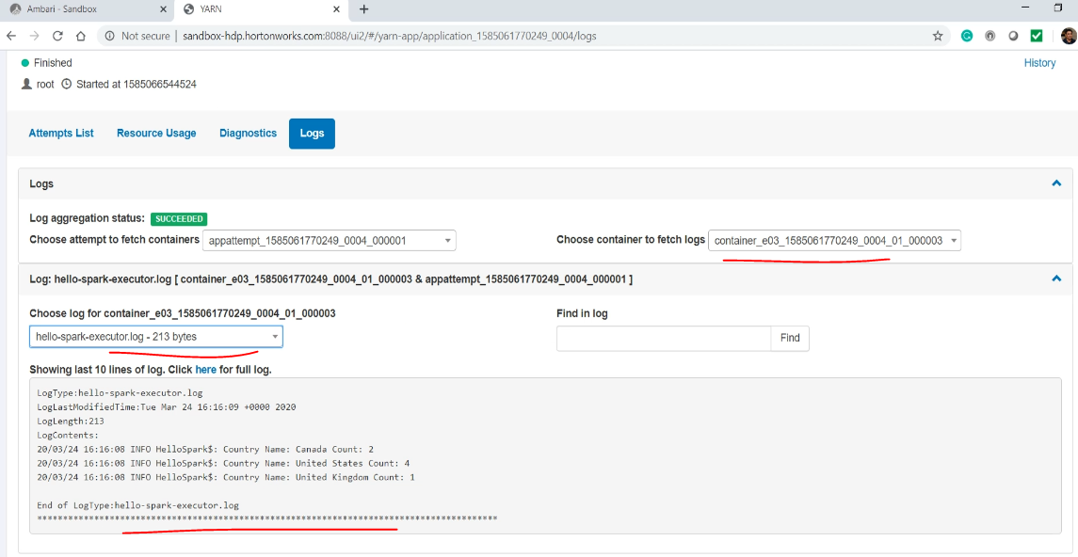

Great! So you learned to access your log file. You can also find a link to the Spark History Server UI.

Here it is.

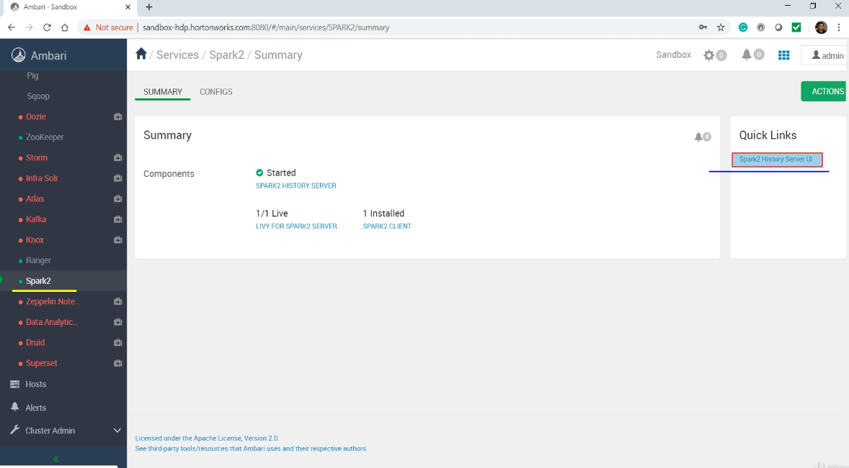

You can access your Application details using the Spark UI.

### Rounding Off Summary

So far, in this course, I tried to help you build a solid foundation on Apache Spark and Developer experience. In this video, I am going to quickly recap everything that we learned so far. This recap is going to help you consolidate your learning and help you consume the rest of the course more effectively. So, let's start. You learned about the notion of a data lake and five main components of the data lake. You also learned about the role of Apache Spark in the data lake. Then I explained the Spark ecosystem and talked about the three layers of Apache Spark. You also learned about installing Apache Spark on your local machine and use it from command line REPL. Then I helped you to setup and configure your IDE for spark development. You also learned about some other development environments, such as Databricks Notebook and Zeppelin Notebook.

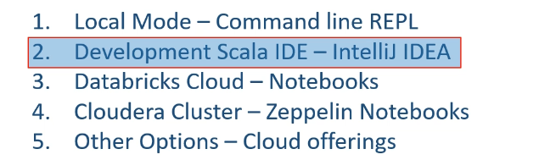

I gave you a full demo for configuring and using all these environments, and I am assuming that you learned to use them. All of this was covered in the first two sections as your Spark getting started. Then we started going a little deeper into the Spark Architecture. You learned two methods of executing your Spark application. Interactive client method for exploration And a backed job running in the data lake for production scenarios

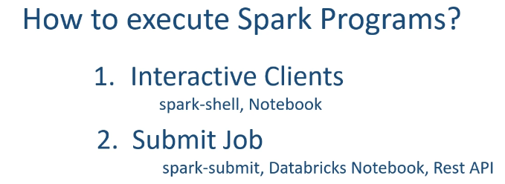

Then we learned about the notion of driver and executor. The idea of the driver and the executor is one of the most fundamental concepts of Spark architecture. And I hope you got this clear.

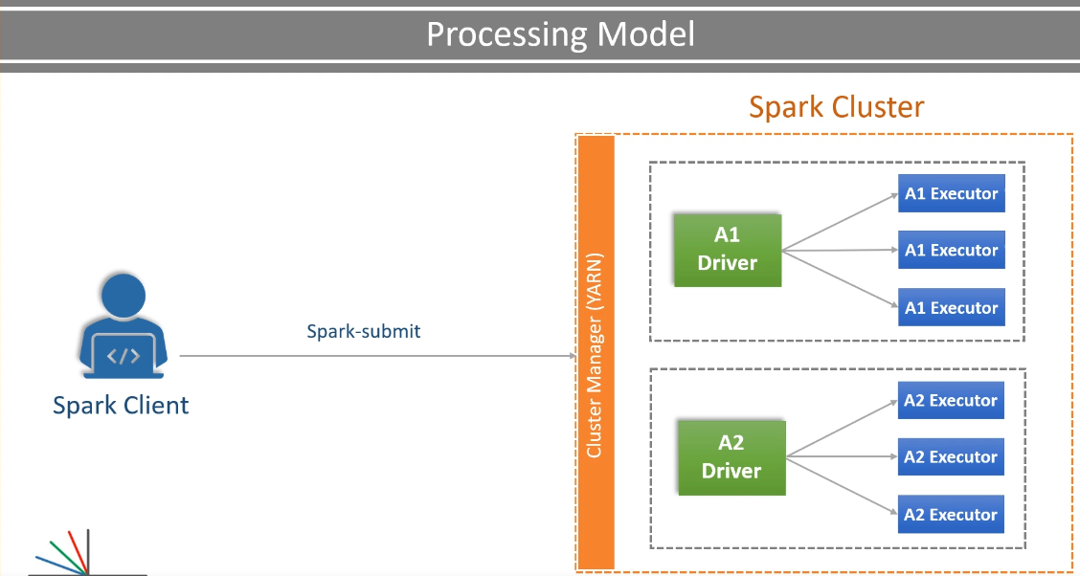

The next important concept was to learn about the Cluster Managers and the Deployment modes.

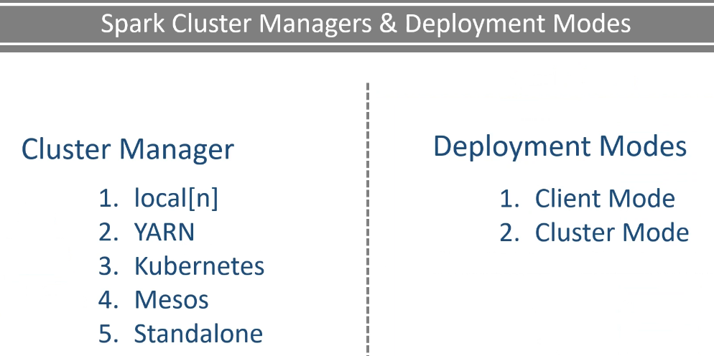

And I hope you got the main idea behind the cluster mode and the client mode. It is all about your driver's location. We didn't stop there but also learned about the combination of Cluster Manager and Cluster Modes. I talked about when to use which combination, and I also gave you a demo for all meaningful combinations.

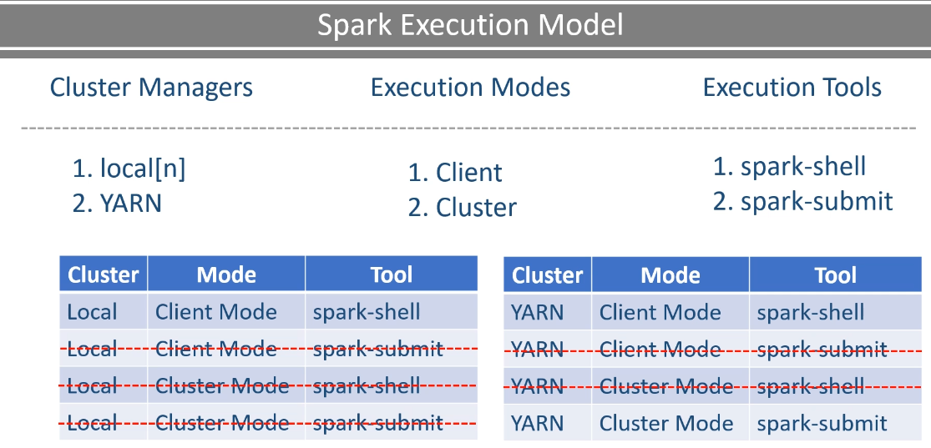

That's where we ended the section three and entered into the current section of this course. The main agenda of this section was to deep dive further into Spark Application architecture and also learned a few critical things to make your life easy as a Spark developer. So we learned the following items to help you get a pleasant and comfortable experience as Spark developer.

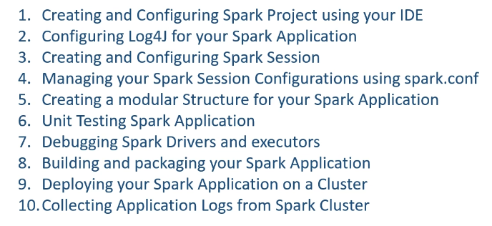

Creating and Configuring Spark Project using your IDE Configuring Log4J for your Spark Application Creating and Configuring Spark Session Managing your Spark Session Configurations using spark.conf Creating a modular Structure for your Spark Application Unit Testing Spark Application Debugging Spark Drivers and executors Building and packaging your Spark Application Deploying your Spark Application on a Cluster Collecting Application Logs from the Cluster Along with these developer experience topics, we also learned the following Spark Architecture topics. We extended the concept of driver and executor, and you also learned about the Spark Session I also talked about how your Spark Session Configs are propagated to the Spark Session

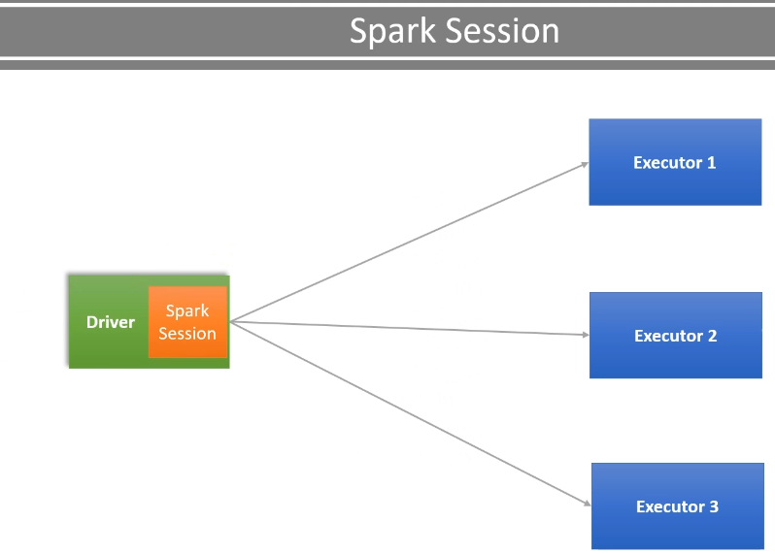

Then I spoke about the notion of distributed data structure using the Spark Data Frames and partitions.

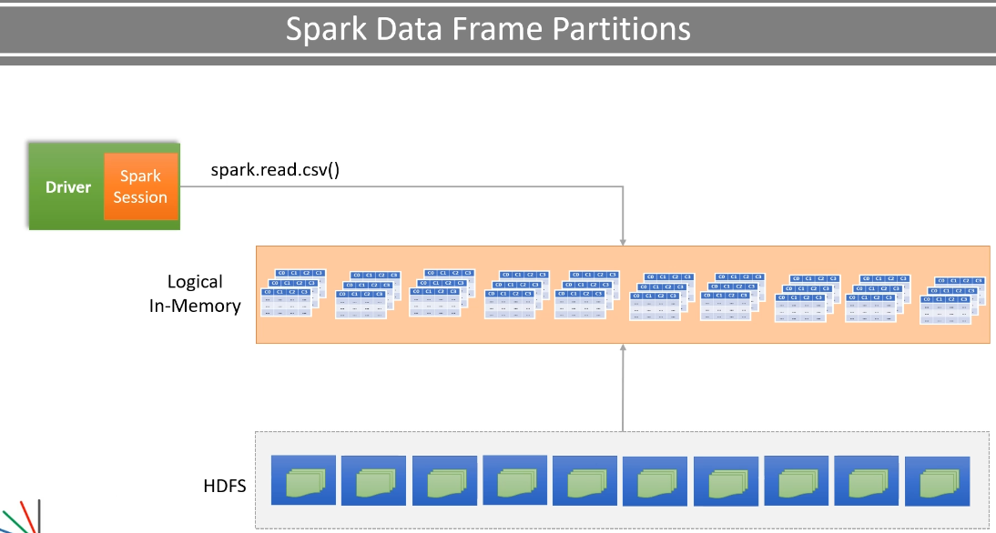

We finally mapped the idea of partitions to the concept of executors.

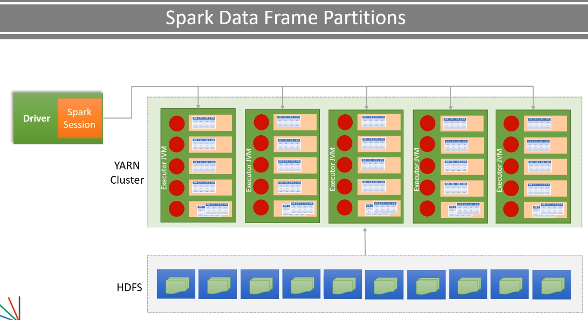

I also talked about the Spark Transformations, Actions, Wide, and narrow Transformations.

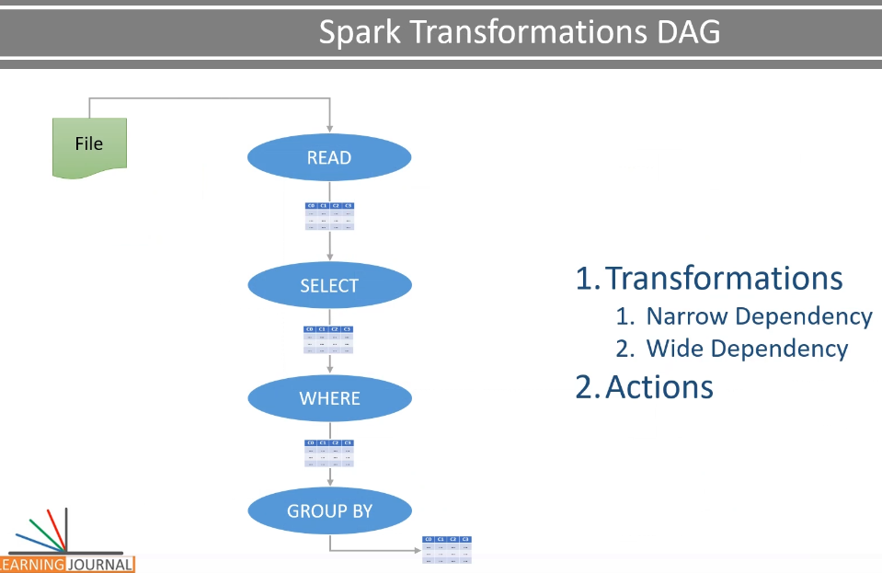

You learned the idea behind the shuffle/sort and partition data exchange.

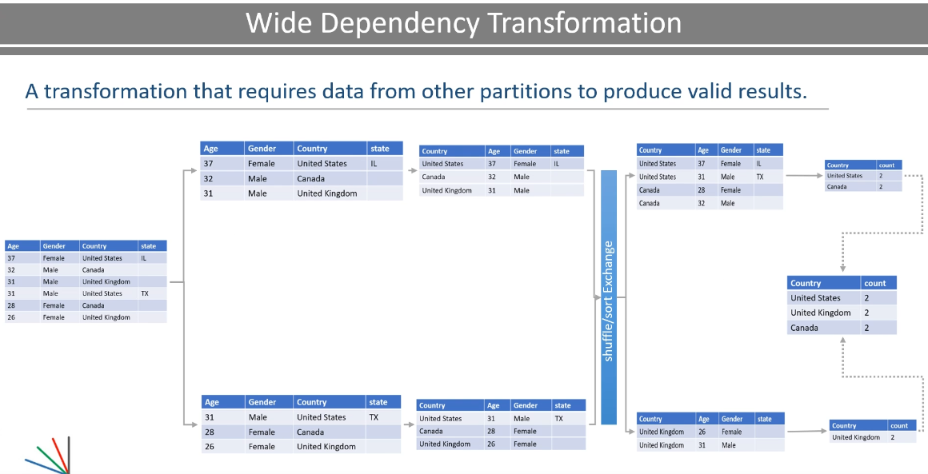

Then you also learned how your Spark code is compiled, and it is internally arranged into a DAG of Jobs, Stages, and Tasks.

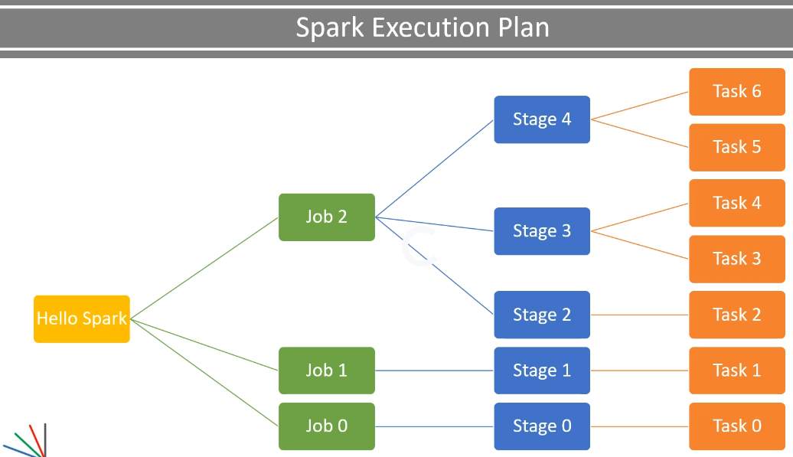

I explained that each action results in at least one job, and then these jobs are broken down into stages for each shuffle. These stages are executed as parallel tasks depending upon the number of partitions and availability of executor core.

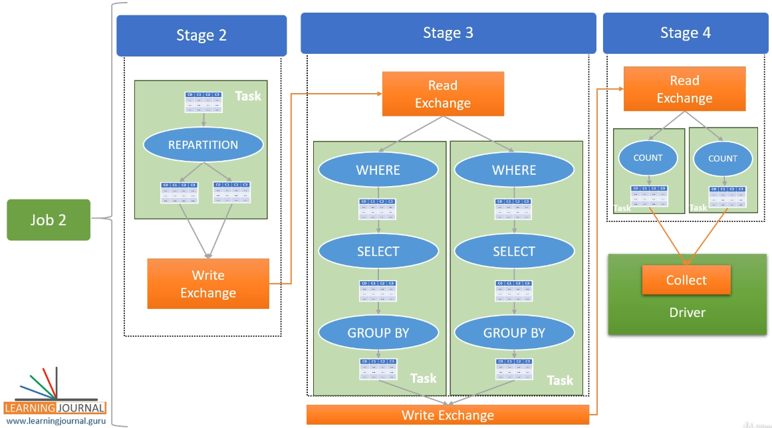

I mean, even if you have 100 partitions for a stage but you have only 10 executor cores. In such cases, the spark can run a maximum of 10 parallel tasks, and the rest of the tasks are queued, waiting for free executor core. Great! I hope you learned all these ideas clearly, and now you are ready to directly jump into Spark APIs. I mean, Spark transformations and actions. In the next section, we will learn a bunch of Spark Transformations, actions, and how to use them to solve your data crunching problems.

## Spark Structured API – Foundation

I am going to give you a high-level overview of the Spark data processing APIs, and we will elaborate them further in the rest of the section.

|  |  |
| --- | --- |
| So, let's start. Apache Spark started with the goal of simplifying and improving the Hadoop Map/Reduce programming model.  To achieve this goal, Spark came up with the idea of RDD - Resilient Distributed Dataset. The notion of RDD was revolutionary, and it created the core foundation of Apache Spark. However, Spark didn't stop at the RDD and came up with a higher level of APIs such as Dataset APIs and DataFrame APIs. To simplify our life, they also came up with the  SQL layer and a catalyst optimizer. So, all these Spark data processing tools can be visually arranged as the following figure.  So what does it mean? Simple! The RDD is at the core. |  |

You can use RDD APIs to develop your applications. However, it is the most challenging tool to learn and use. They offer you some additional flexibility, but they lack all the optimization brought to you by the catalyst optimizer. I will give you some more details about RDD in a separate video and help you get a reasonable understanding of the RDDs.

|  |  |
| --- | --- |
| However, the Spark community is not recommending to use RDD APIs unless you need a custom partitioner and want to manage how your data gets partitioned. The next one is the catalyst optimizer. So we write code using Spark SQL, DataFrame APIs, and Dataset APIs. This code is then submitted to Spark for execution. You learned some of it in the earlier section, right? However, the code passes through the Catalyst Optimizer, which decides how it should be executed and lays out an execution plan. |  |

I already talked about the execution plan in the earlier lecture. However, I will elaborate it further in this section and help you understand some optimizations applied by the Catalyst Optimizer. Finally, the Spark SQL, DataFrame APIs, and Dataset APIs are your preferred choices. I recommend you to prefer them in left to right order. I mean, Spark SQL is the most convenient option to use. So, you should prefer using it wherever applicable.

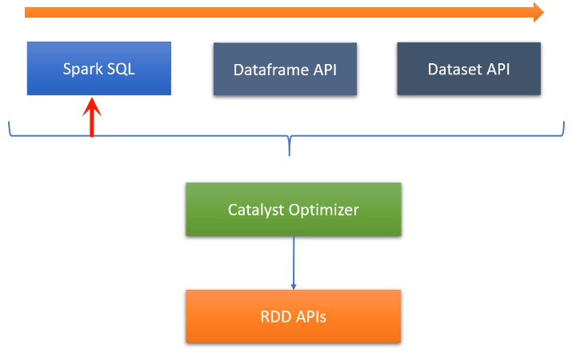

I will cover implementing Spark SQL in a separate video. The Spark SQL is excellent, and it can do a lot of the work for you. However, a single SQL expression or even a SQL script with a series of SQLs may not be helpful in many scenarios. You do not get some necessary facilities like debugging, implementing application logs, unit testing, and other obvious capabilities that a programming language brings on the table. So you will be using Spark SQL to catch some low hanging fruits. However, a sophisticated data pipeline is going to push you to use DataFrame APIs and rely more on your favorite programming language such as Scala. And that's where the DataFrame APIs are your obvious choice. Most of this course is focusing on DataFrame APIs, and I will cover enough details about them.

The last one is the Dataset API. The Dataset APIs are the language-native APIs in Scala and Java. What do I mean by language native? Well, that is simple. These APIs are strongly typed objects in your JVM based language such as Scala. And they are not at all available in dynamically typed languages such as Python. So, if you are using dataset API in Scala, they can give you a compile-time type-safety. I often see learners getting confused with Dataset and DataFrame and failing to understand the difference between them. I will cover it with an appropriate example. However, you can takeout a single liner difference at this stage.

DataFrame API works on a generic typed row/column, and the actual data types are assigned at runtime. So they do not offer compile-time type-safety. The Dataset API works on language-specific row/column types that are bound at the compile time. So, they offer you a compile-time type-safety. You will get more clarity when we create an example for both the APIs and show you the difference.

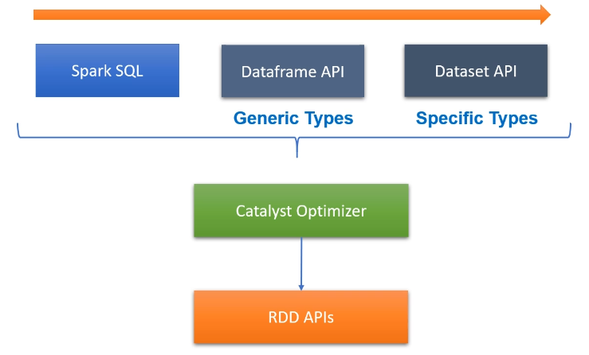

We are going to use Scala. And the DataFrame and Dataset APIs interoperate in Scala using Scala Implicits. So in real life, almost every programmer is going to use the mix of these APIs, and that's perfectly fine. Great! I hope you now have a high-level picture of the different types of APIs. In the rest of the section, I am going to elaborate on following things. We will be creating an example to help you understand the Spark RDD APIs.

|  |  |
| --- | --- |
|  | Then I will help you understand the difference between DataFrame and Dataset. The next thing is to create a Dataset API example. You have already seen DataFrame API example so we will skip that in this section. And move on to the Spark SQL example. The SQL example will enable you to use Spark SQL in your Spark applications. This section is going to help you navigate through the overall Spark API toolset. However, rest of the course is focused on using DataFrame and Dataset APIs. |

### Spark RDD API

Lets talk about Spark RDDs and also create an example to help you understand them better. So, let's start. The term RDD stands for the Resilient Distributed Dataset. What does it mean?

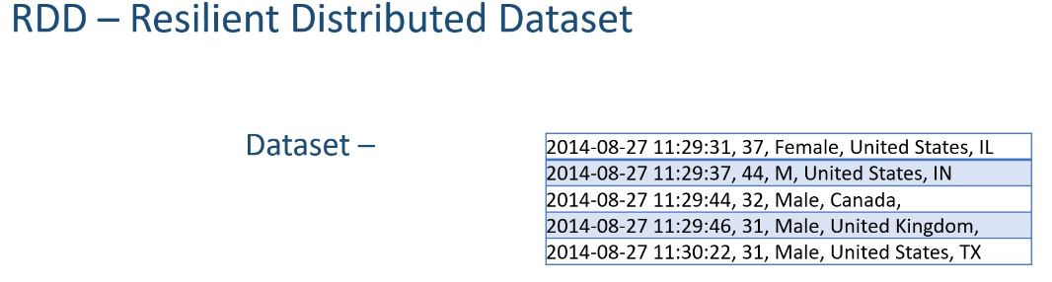

Let me explain. An RDD is a dataset. That means they are nothing but a data structure to hold your data records. They are similar to DataFrames because DataFrames are also built on top of the RDDs. However, unlike DataFrames, RDD records are just language-native objects, and they do not have a row/column structure and a schema. So in simple words, RDD is just like a Scala, Java, or a Python collection. You can create an RDD reading your data from a file. However, RDD is internally broken down into partitions to form a distributed collection.

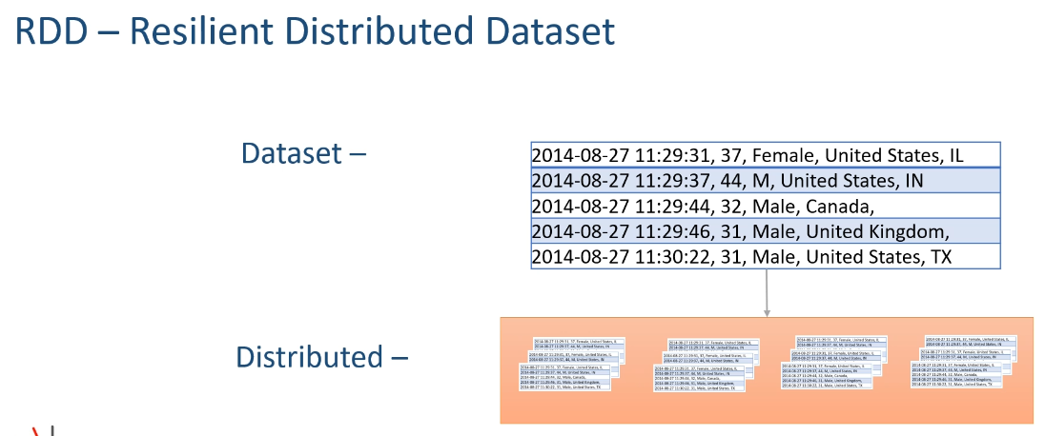

Same as DataFrames, they are partitioned and spread across the executor cores so they can be processed in parallel. RDDs are resilient. That means they are fault-tolerant. How? RDDs are fault-tolerant because they also store information about how they are created.

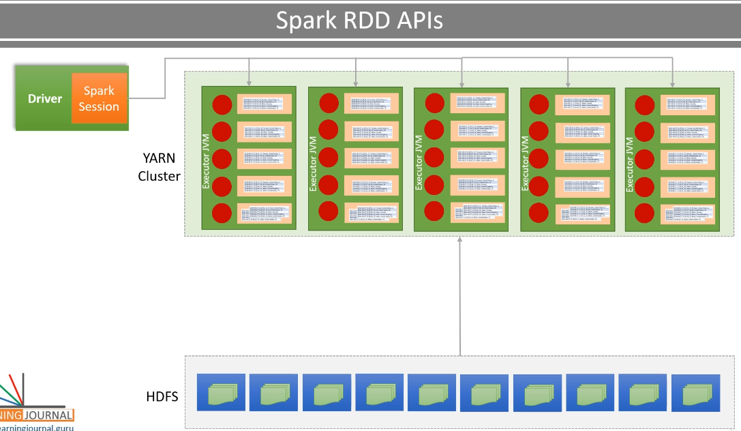

What does it mean? Let's assume an RDD partition is assigned to an executor core for processing it. In some time, the executor fails or crashes. That's a fault, and you could lose your RDD partition, right? However, the driver will notice the failure and assign the same RDD partition to another executor core. The new executor core will reload the RDD partition and start the processing.

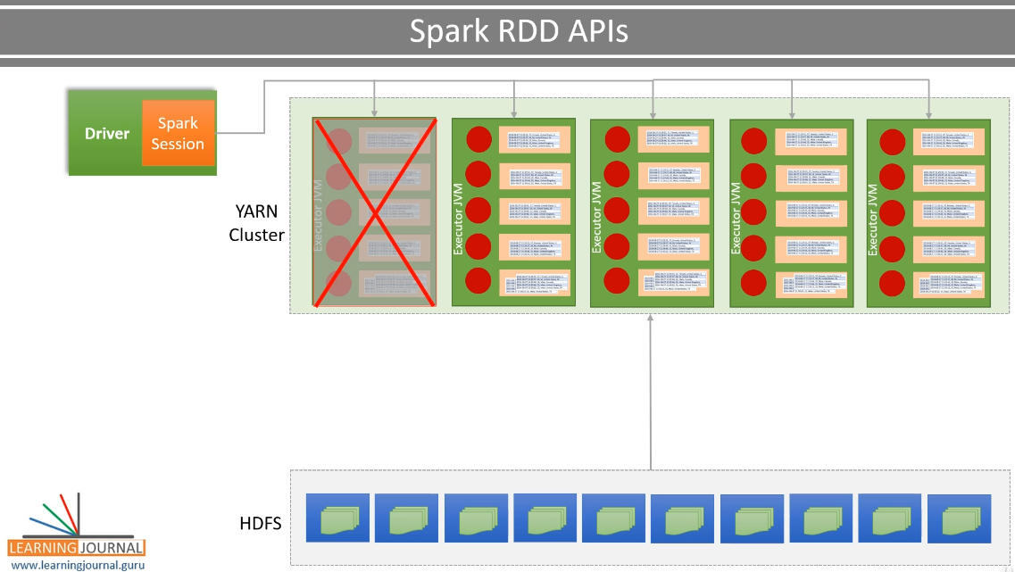

And this can be done easily because each RDD partition comes with the information about how to create it and how to process it. And that's why we call them resilient. That means an RDD partition can be recreated and reprocessed anywhere in the cluster. Great! Now you have an answer to the following question. What is an RDD? Right? They are similar to DataFrames, but they lack a row/column structure and the schema. Now let's create an example to see how things work. The first thing is to learn to create an RDD. I have this HelloRDD project. I created this project, copying a few things from the earlier example. I have the same sample.csv data file here. However, I have removed the header row from this file to keep it simple. We have the same log4J.properties file. I haven't changed anything in this file. I am not using spark.conf file in this example for keeping it simple. I also have built.sbt file. I also have built.sbt file. I have changed the project name and removed the spark-SQL dependency. RDD is part of the Spark Core API, so you do not need anything else to work with the RDD APIs. I removed the test dependency also because I am not going to implement a test case for this example.

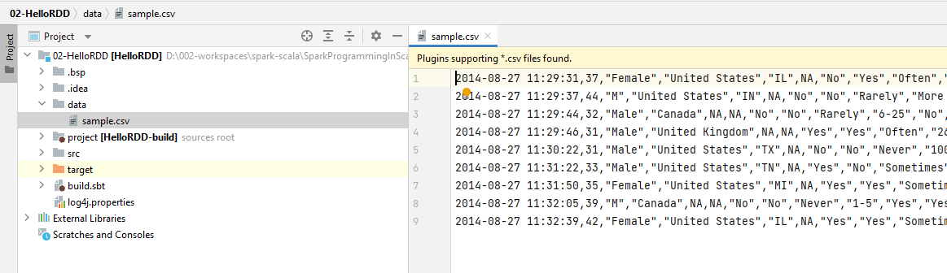

Now let's create a Scala Object. Make it serializable and also add a main() method. Create a transient logger. Check for the command line argument. I am going to pass the data file name as a program argument. I also have these JVM options, as we learned in the earlier lectures. So far, everything is almost the same as we already learned. Now we are ready to play with the RDD APIs. What do we want to do? We want to read the data file and create an RDD. Do you remember the steps that we followed to read a data file and create a DataFrame? Let me refresh it here. Create a SparkConf object Create a Spark Session using your SparkConf Use the spark session to read the data file Here is the code for the same. And this code is written using the modern Spark APIs. We want to use the traditional Spark RDD APIs, which are a little different. Let me show you.

The first step is the same. I am creating a new SparkConf object. Then I am setting some basic configurations.

The next step is different. The DataFrame APIs are based on SparkSession. However, the RDD APIs were based on SparkContext. So if you want to use the RDD API, then you need a SparkContext. Let me create it. You can create a SparkContext and pass on your SparkConf. That's all. Now all the RDD APIs are available through the SparkContext.

Now the third step is to read a data file. Let's do it. We start with the SparkContext and read a text file. This method returns an RDD, and each record in the RDD is a line of text from the data file. We are reading a text file here. However, the SparkContext comes with a bunch of methods to read a binary file, sequence file, Hadoop file, and object file. So basically, the data reader APIs in RDD were raw and fundamental. They didn't allow you to work with commonly used files such as CSV, JSON, parquet, and Avro. However, the RDD APIs were extensible to read any kind of file format. But nothing was available out of the box.

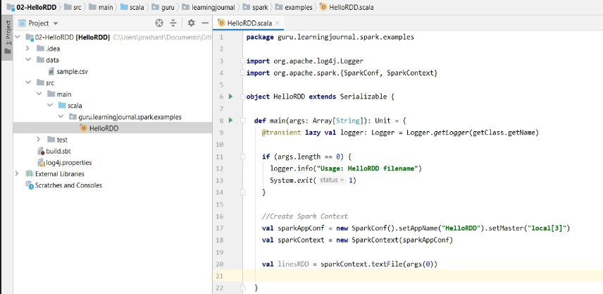

The DataFrame API comes with a DataFrame Reader interface and out of the box support for a bunch of file formats. Great! So now you got the answer to your question. How to create an RDD? The next question is this. How to process an RDD? RDDs implemented the notion of Transformations and Actions. You already learned them for DataFrames, right? The idea of Transformations and Actions are the same for the RDDs. However, RDDs offered only basic transformations such as map(), reduce(), filter(), foreach() etc.

package guru.learningjournal.spark.examples

import org.apache.log4j.Logger

import org.apache.spark.{SparkConf, SparkContext}

object HelloRDD extends Serializable {

def main(args: Array[String]): Unit = {

@transient lazy val logger: Logger = Logger.getLogger(getClass.getName)

if (args.length == 0) {

logger.info("Usage: HelloRDD filename")

System.exit(1)

}

//Create Spark Context

val sparkAppConf = new SparkConf().setAppName("HelloRDD").setMaster("local[3]")

val sparkContext = new SparkContext(sparkAppConf)

//Read your CSV file

val linesRDD = sparkContext.textFile(args(0),2)

val partitionedRDD = linesRDD.repartition( 2 )

val colsRDD = partitionedRDD.map( line => line.split(",").map(_.trim))

//Collect the result

logger.info(countRDD.collect().mkString(","))

//Stop the Spark context

//scala.io.StdIn.readLine()

sparkContext.stop()

}

}

Most of the RDD transformations were designed to accept a lambda function and simply apply your custom code to the RDD. So basically, the RDD API leaves all the responsibility in the developer's hand. You need to take care of giving a structure to your data, implement your operations, create an optimized data structure, compress your objects, and a lot of other things. So the developers are expected to reinvent the wheel. The DataFrame APIs improved the situation by offering some commonly used SQL like operations such as select(), where(), groupBy(), etc. Now let's apply some transformations on this RDD to get a feel of the complexity. Let me repartition this RDD. Simple! Right? Now I want to process my data records. However, my records are loaded as a line of text. That's what the textFile() method creates. I don't have a schema or a row/column structure. So the first thing is to give a structure to my data record. Let me write the code, and then I will explain it. Great! So what I am doing. I am using the map() transformation.

The map() transformation takes a lambda function and calls it in a loop for each line. So in each iteration, I will get a line, and I want to process the line. The processing is simple. I am doing two things. Split the line using the comma and trim it from both the sides to remove the blank spaces. Simple! The result is an array of strings. The input was a line of text, and the output is an array of text. So I got a new RDD of Array where I separated each column. Make Sense? So now, I have a row-column structure. But I also need a schema. I mean, I want to give a name and a data type to each column. So let's create a case class.

package guru.learningjournal.spark.examples

import org.apache.log4j.Logger

import org.apache.spark.{SparkConf, SparkContext}

object HelloRDD extends Serializable {

def main(args: Array[String]): Unit = {

@transient lazy val logger: Logger = Logger.getLogger(getClass.getName)

if (args.length == 0) {

logger.info("Usage: HelloRDD filename")

System.exit(1)

}

//Create Spark Context

val sparkAppConf = new SparkConf().setAppName("HelloRDD").setMaster("local[3]")

val sparkContext = new SparkContext(sparkAppConf)

//Read your CSV file

val linesRDD = sparkContext.textFile(args(0),2)

//Give it a Structure and select only 4 columns

case class SurveyRecord(Age: Int, Gender: String, Country: String, state: String)

val colsRDD = linesRDD.map(line => line.split(",").map(_.trim) )

val selectRDD = colsRDD.map( cols => SurveyRecord(cols(1).toInt, cols(2), cols(3), cols(4))

val filteredRDD = colsRDD.filter(r => r.Age < 40)

//Stop the Spark context

//scala.io.StdIn.readLine()

sparkContext.stop()

}

}

I am creating only four fields because I need only four. Now let's process the colsRDD. I will again use the map() method to process each row. So, I am going to create a SurveyRecord object taking only four columns. The result is another RDD of SurveyRecord. Great! So I managed to attach a schema to my RDD and also implemented the select() operation because I selected only four columns. What else? Let me apply a filter. So, I am filtering all the records where the age is less than forty. Now I want to group this record by country and count it. So, the first step is to create a key-value pair. The country becomes the key, and the value is a hardcoded value one. So I got a key/Value RDD. The next step is to use the reduceByKey() method and sum up the hardcoded value one. The result is another key/Value RDD where the key is the country, and the value is the sum of all the values for the country. And that's the count. You can collect the result and push it to your log file.

package guru.learningjournal.spark.examples

import org.apache.log4j.Logger

import org.apache.spark.{SparkConf, SparkContext}

object HelloRDD extends Serializable {

def main(args: Array[String]): Unit = {

@transient lazy val logger: Logger = Logger.*getLogger*(getClass.getName)

if (args.length == 0) {

logger.info("Usage: HelloRDD filename")

System.*exit*(1)

}

*//Create Spark Context*

val sparkAppConf = new SparkConf().setAppName("HelloRDD").setMaster("local[3]")

val sparkContext = new SparkContext(sparkAppConf)

*//Read your CSV file*

val linesRDD = sparkContext.textFile(args(0),2)

*//Give it a Structure and select only 4 columns*

case class SurveyRecord(Age: Int, Gender: String, Country: String, state: String)

val colsRDD = linesRDD.map(line => {

val cols = line.split(",").map(_.trim)

*SurveyRecord*(cols(1).toInt, cols(2), cols(3), cols(4))

})

*//Apply Filter*

val filteredRDD = colsRDD.filter(r => r.Age < 40)

*//Manually implement the GroupBy*

val kvRDD = filteredRDD.map( r => (r.Country, 1) )

val countRDD = kvRDD.reduceByKey( (v1, v2) => v1 + v2 )

*//Collect the result*

logger.info(countRDD.collect().mkString(","))

*//Stop the Spark context*

*//scala.io.StdIn.readLine()*

sparkContext.stop()

}

}

We are done. However, the groupBy implementation on an RDD is not so obvious and might not make sense at first. And that was the challenge we faced using the RDD APIs. We needed to hand-code everything, including regular operations such as grouping and aggregating. The Spark Engine had no clue about the data structure inside the RDD. Neither Spark could look inside your lambda functions. And these two things limited Spark to create an optimized execution plan. Great! That's all about the RDDs. I am not going further into RDDs because they are kind of raw and outdated APIs for Spark Developers. You are not likely to use them. They give you a lot of flexibility, but you may not even find a compelling reason to use them.

### DataSet vs DataFrame

|  |  |
| --- | --- |
|  | Lets talk about the Spark Datasets. So, let's start. The Spark Dataset APIs are a bridge between Spark DataFrame APIs and the RDD APIs. Let's go back into history to understand this. Apache Spark started with the notion of RDDs and offered RDD APIs as transformations and actions.  However, Spark soon realized that the RDD APIs are too fundamental, and the developers needed something more developer-friendly. This thought leads to the creation of Spark DataFrame APIs, which were introduced in Spark 1.3. Dataframe offered more developer-friendly transformation, and you have already seen some of them in the earlier lectures.  Before Spark 1.3, we lived with the RDDs, and DataFrame was added in Spark 1.3. So, DataFrame came even before we thought about the Dataset. DataFrames were great. They are still the best method to work with Spark. |

However, we have an open question. What are Datasets, and why they came into existence when we already had RDD and DataFrame? Let me explain. Dataframe lacked some of the critical capabilities of the RDDs. RDDs were strongly typed and offered compile-time type safety. Whereas DataFrames used generics, and the types were bound at the runtime. RDDs offered fundamental transformations like map() and filter() that accepts a lambda function. These transformations gave a lot of power to the developers. You can create a function to do anything that you want and pass it to the methods like map(). And the map() method will apply your function to each RDD record. DataFrame lacked this capability. They couldn't offer functions such as map() and filter(). So the Spark developers felt like losing power and flexibility. To overcome these two problems, Spark offered a DataFrame.RDD() function. This function allowed you to convert a data frame to an RDD. So, you can start with a DataFrame and converted it to RDD when we wanted to use map() or other RDD transformations. Simple! Isn't it?

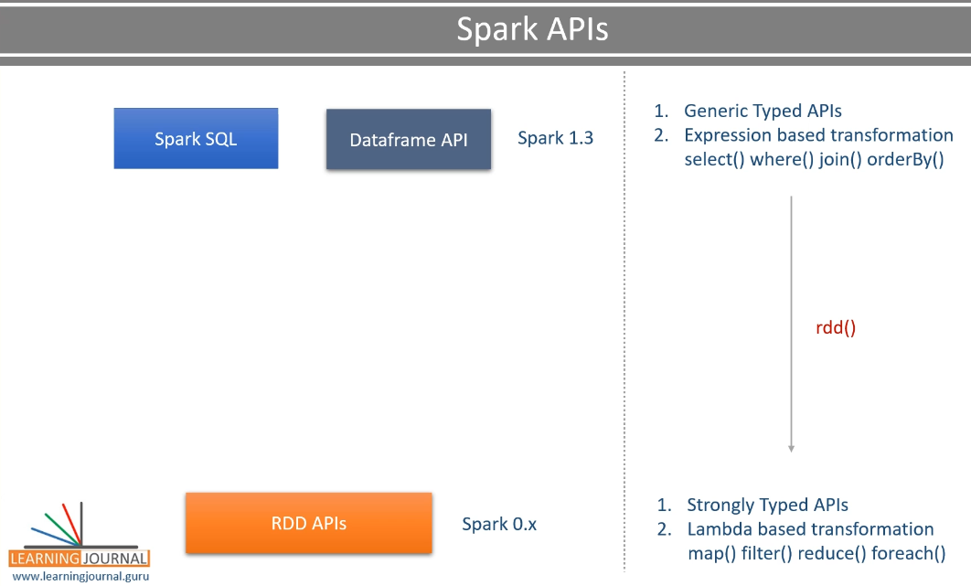

So the power and flexibility were given back by converting DataFrame into RDD and using RDD transformation. All looks good. However, we still discovered two more problems. The Spark couldn't offer seamless back and forth conversion between DataFrame and RDD. The second problem came out of the new developments in the Spark project for performance improvements. Spark creators started implementing a bunch of performance optimization techniques, and they named it Spark Tungsten Project. The tungsten project was a massive revamp of the Spark execution engine. They also developed Catalyst Optimizer.

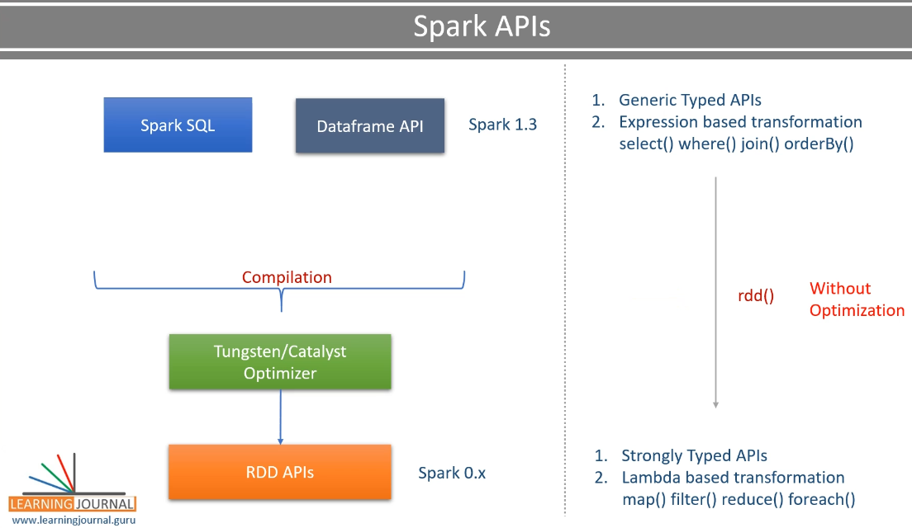

However, all these optimizations benefited DataFrames and RDDs were left behind.   So what does it mean? That means if you convert a Dataframe to an RDD, then you lose all these optimization benefits. So we needed a better solution. That's where we got Dataset APIs, which were introduced in Spark 1.6. Dataset offered all the power that comes from the RDD, such as type safety and lambda accepting transformations. And they allowed seamless back and forth conversion between DataFrame and Dataset. So, you can convert a DataFrame to Dataset and vice versa anywhere in your code, and you can do it as many times as you want.

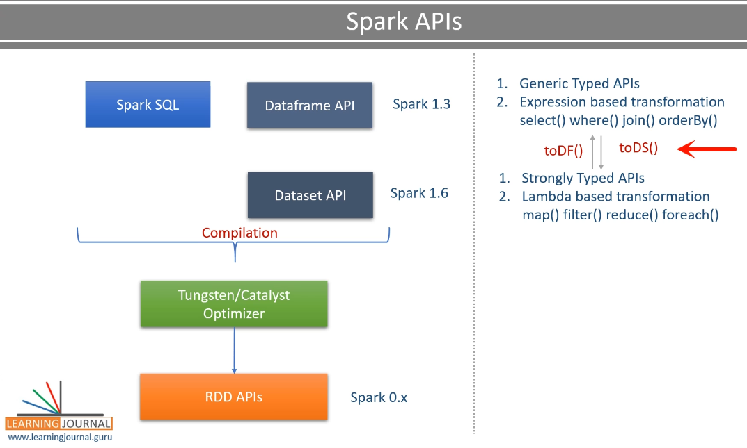

And the best part. You still don't lose most of the optimizations, such as Catalyst Optimizer and Tungsten Optimization. The notion of Dataset became successful. However, the dataset and data frame were still two different sets of APIs and possibly two separate code bases. So the Spark creators decided to combine them. The combined API set was released in Spark 2.0. And this new set is now known as the Spark Structured API. Does it mean one of them is gone and no longer exists? Well, the answer is a Yes and No, Both. Let me explain. The answer is yes because now the DataFrame is just an alias for the Dataset of a Row. So basically, the DataFrame does not exist in a real sense.

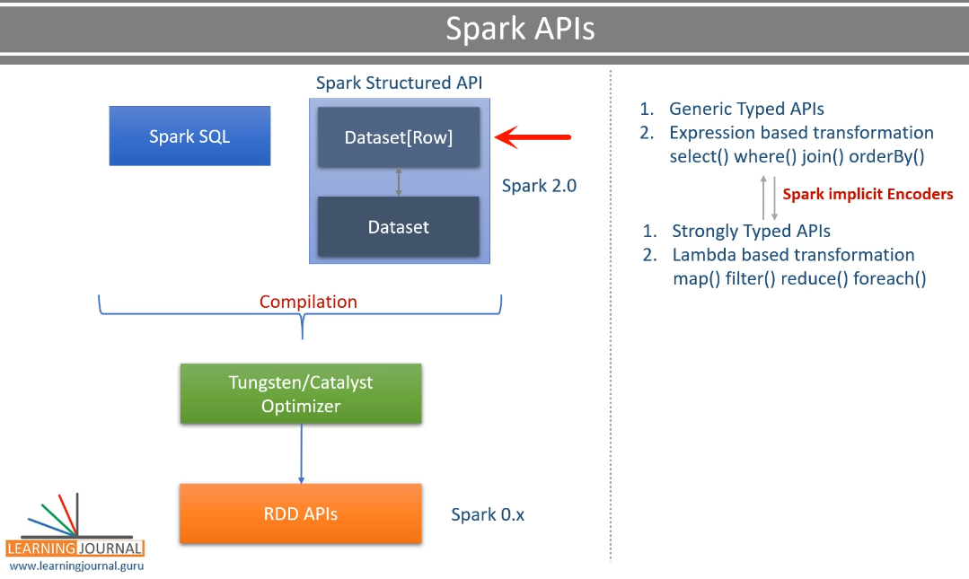

The thing that we call a DataFrame is just a Dataset of Row. A Row is a generic object which allows you to attach schema at the runtime. So basically, it is the Dataset that exists, and the DataFrame is just an alias. If you replace the generic Row with a specific object, it becomes a Dataset. If you attach back a generic Row, it becomes a DataFrame. So they both exist, but the line between these two is blurred by spark-implicit conversion. So the point is straight. We have only one API set, and we call it the Spark Structured API. The Structured API comes with two faces. DataFrame and Dataset And the Spark implicit conversion will keep switching these faces as and when needed.

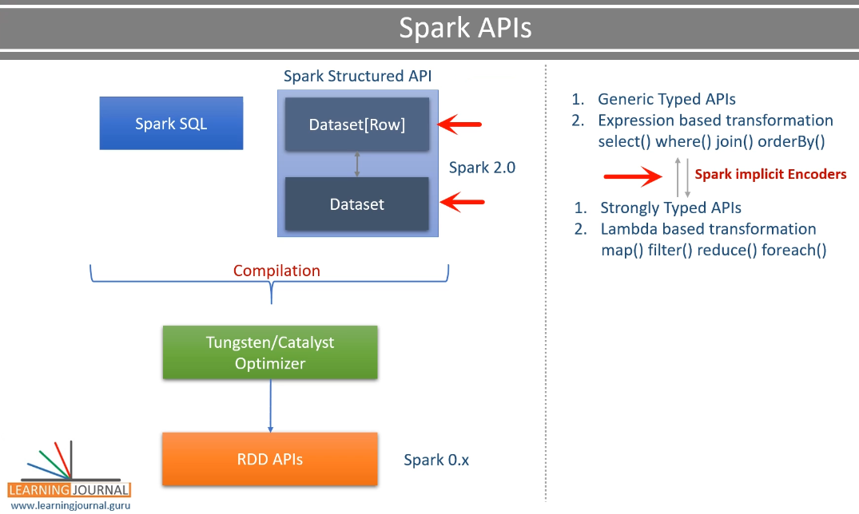

And that's a good sign for Spark developers because they do not need to worry about two faces. Think of it as a single API - Spark Structured API. That's all.   However, lets see dataset in action, lets create a small example.

### Working with Spark Dataset

Lets create an example and help you understand working with Spark Dataset. So, let's start. I created a new HelloDataset project and copied things from the earlier example. I have this build.sbt file and the log4j.properties file. You already learned about it. I also have the same sample.csv file, which comes with a header row. I also created this Scala Object and the main method.

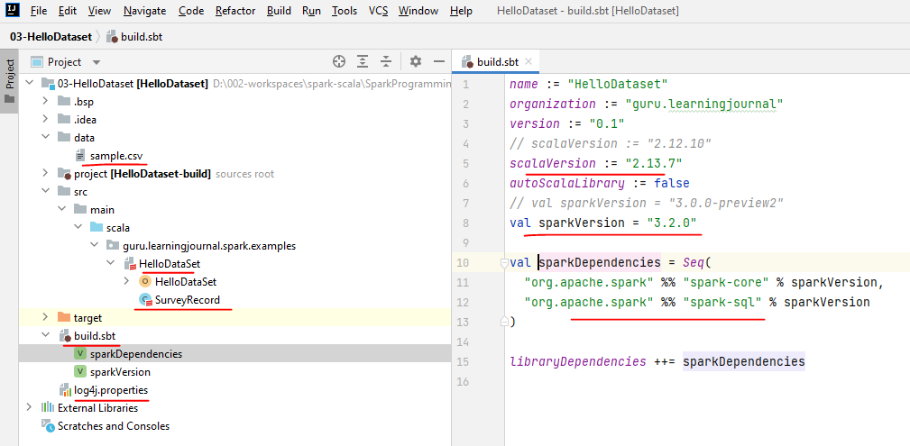

I am taking the data file name/location as a program argument. Now we are ready to create a spark session, read the data file, and process it.

**sample.csv**

"Timestamp","Age","Gender","Country","state","self_employed","family_history","treatment","work_interfere","no_employees","remote_work","tech_company","benefits","care_options","wellness_program","seek_help","anonymity","leave","mental_health_consequence","phys_health_consequence","coworkers","supervisor","mental_health_interview","phys_health_interview","mental_vs_physical","obs_consequence","comments"

2014-08-27 11:29:31,37,"Female","United States","IL",NA,"No","Yes","Often","6-25","No","Yes","Yes","Not sure","No","Yes","Yes","Somewhat easy","No","No","Some of them","Yes","No","Maybe","Yes","No",NA

2014-08-27 11:29:37,44,"M","United States","IN",NA,"No","No","Rarely","More than 1000","No","No","Don't know","No","Don't know","Don't know","Don't know","Don't know","Maybe","No","No","No","No","No","Don't know","No",NA

Right? So, let me create the SparkSession. Done. You already learned that. Now I am going to read the CSV file. We are using Spark DataFrameReader API to read the CSV file. This method gives us a DataFrame. Well, this is a Dataset example, right? You might be expecting to read the CSV file as a Dataset.

**HelloDataset.scala**

package guru.learningjournal.spark.examples

import org.apache.log4j.Logger

import org.apache.spark.sql.{Dataset, Row, SparkSession}

case class SurveyRecord(Age: Int, Gender: String, Country: String, state: String)

object HelloDataSet extends Serializable {

@transient lazy val *logger*: Logger = Logger.getLogger(getClass.getName)

def main(args: Array[String]): Unit = {

if (args.length == 0) {

*logger*.error("Usage: HelloDataSet filename")

System.*exit*(1)

}

//Create Spark Session

val spark = SparkSession.builder()

.appName("Hello DataSet")

.master("local[3]")

.getOrCreate()

import spark.implicits._

//Read your CSV file

val rawDF:Dataset[Row] = spark.read

.option("header", "true")

.option("inferSchema", "true")

.csv(args(0))

}

Why I am reading it as DataFrame. The answer is straightforward. A DataFrame is a Dataset of Row. You can define the type here, and it still remains the same. So, we do not have a separate API to read a data file as Dataset. So if I want to read the data from a data source, I must be using DataFrame API. No other option. However, in this example, I wanted to use compile-time safety using the Dataset API. So, let me create a specific type. I am creating a case class for SurveyRecord with four fields. Now I want to convert my DataFrame to a Dataset[SurveyRecord]. You are getting the point. My initial DataFrame is a Dataset[Row], but I want to convert it to Dataset[SurveyRecord]. What is the difference? The Row is a generic Type. However, SurveyRecord is a specific type. So the point is this. DataFrame is a generic type Dataset. But I need to achieve compile-time type safety, which cannot come unless I am using a specific type Dataset. Now let me convert it.

package guru.learningjournal.spark.examples

import org.apache.log4j.Logger

import org.apache.spark.sql.{Dataset, Row, SparkSession}

case class SurveyRecord(Age: Int, Gender: String, Country: String, state: String)

object HelloDataSet extends Serializable {

@transient lazy val *logger*: Logger = Logger.*getLogger*(getClass.getName)

def main(args: Array[String]): Unit = {

if (args.length == 0) {

*logger*.error("Usage: HelloDataSet filename")

System.*exit*(1)

}

// Create Spark Session

val spark = SparkSession.*builder*()

.appName("Hello DataSet")

.master("local[3]")

.getOrCreate()

import spark.implicits._

// Read your CSV file

val rawDF:Dataset[Row] = spark.read

.option("header", "true")

.option("inferSchema", "true")

.csv(args(0))

// Type Safe Data Set

val surveyDS:Dataset[SurveyRecord] =

rawDF.select("Age", "Gender", "Country", "state").as[SurveyRecord]

// Uncomment if you want to investigate SparkUI

// scala.io.StdIn.readLine()

spark.stop()

}

}

I will select only four columns from the DataFrame and cast is as SurveyRecord. However, this conversion is managed by the Spark Implicits. So, you must import the spark-implicit. Great! So I am reading data as a DataFrame, and then I am casting it to Dataset. Now I am ready to use the compile-time safe transformations. Let me do a filter operation. I am filtering for Age < 40. This filter operation is compile-time safe. How? Try changing the field name. You will see an error, right? Because the field name does not exist. How is it different from the DataFrame filter? Here is the DataFrame filter operation. You can try changing the field name once again. No Error. However, this code will fail at the runtime because the filed name does not exist.

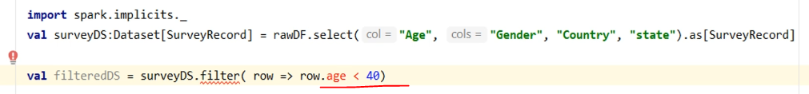

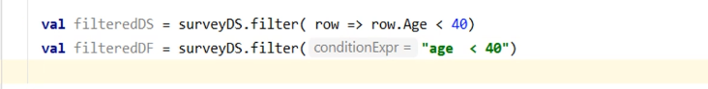

And this is what I mean when I said that the Spark has now got only one set of API. We call it Structured APIs. And it comes with two faces. You can use type-safe API like this.

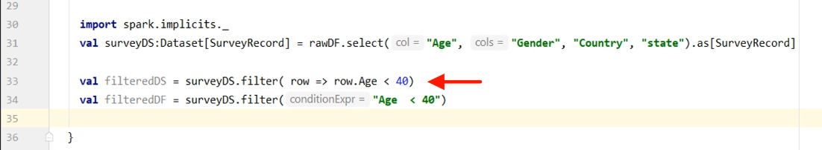

Or you can use the runtime binding like this.

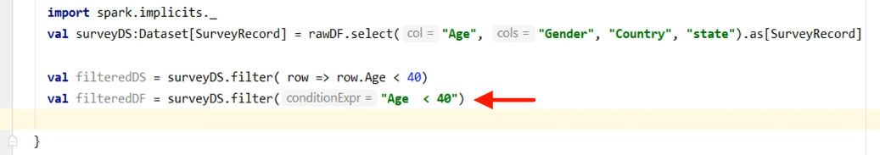

However, if you want to use the type-safe transformations, then you must create a case class and cast your DataFrame.

case class SurveyRecord(Age: Int, Gender: String, Country: String, state: String)

import spark.implicits._

// Read your CSV file

val rawDF:Dataset[Row] = spark.read

.option("header", "true")

.option("inferSchema", "true")

.csv(args(0))

// Type Safe Data Set

val surveyDS:Dataset[SurveyRecord] =

rawDF.select("Age", "Gender", "Country", "state").as[SurveyRecord]

Great! Similarly, you have two versions of the GroupBy() method.

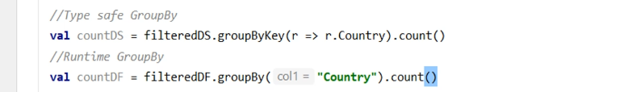

It is up to you which one do you want to use. However, the recommendation is to favor the DataFrame APIs. I mean, compile-time safety is good-to-have, and it helps you to cut down some developer mistakes. However, it comes at a cost. Let me explain.

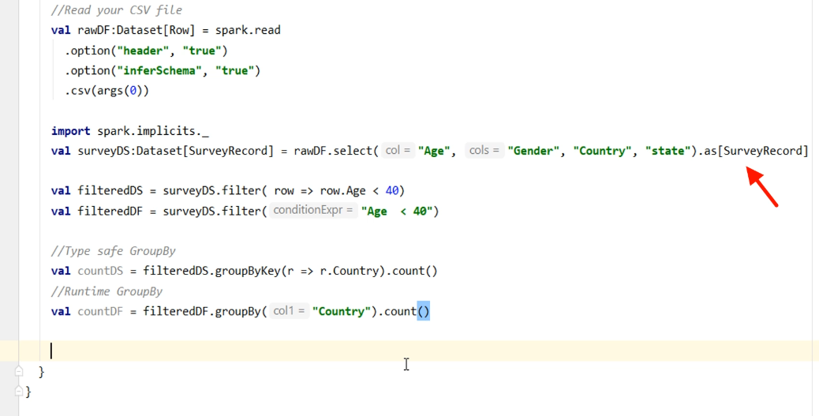

Spark must do some extra work to convert the Row format to the specific object format. It could be negligible, but you still have some overhead. The next overhead is for the serialization. The serialization is not a new concept for distributed computing systems. Serialization is a Â process by which a typed object is encoded into a binary presentation. Spark DataFrame Row object serialization is managed by Spark using Tungsten binary format.

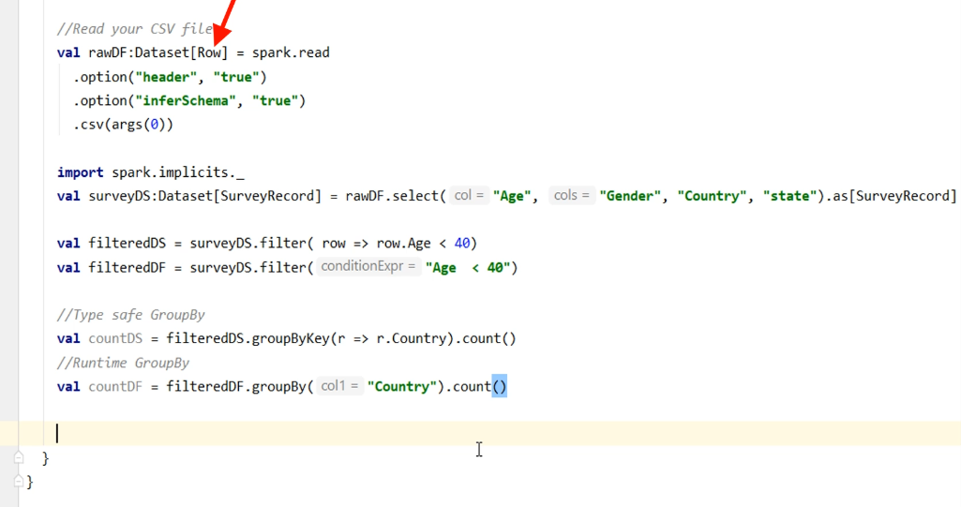

Whereas your custom objects serialization is handled by built-in Java serializers.

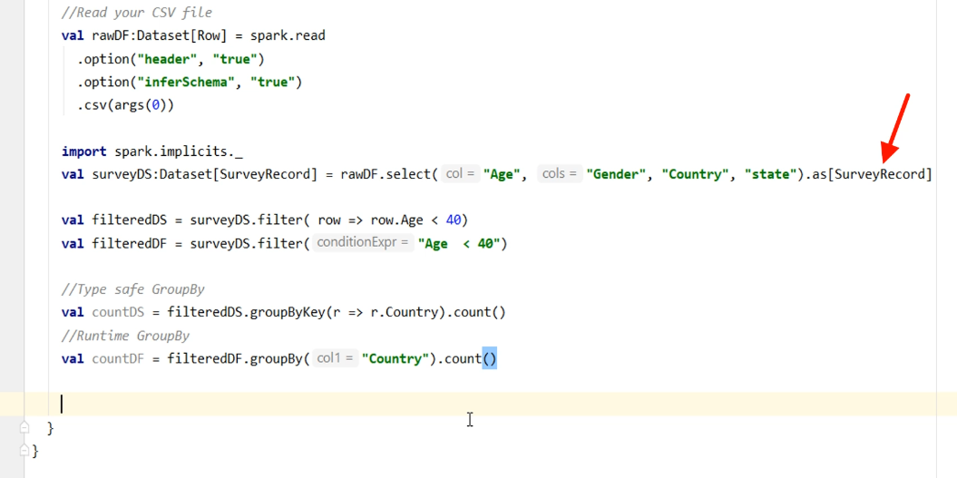

Spark Tungsten encoders are much faster and more efficient than Java's built-in mechanism. So you are going to miss the tungsten encoders when you are using specific types.

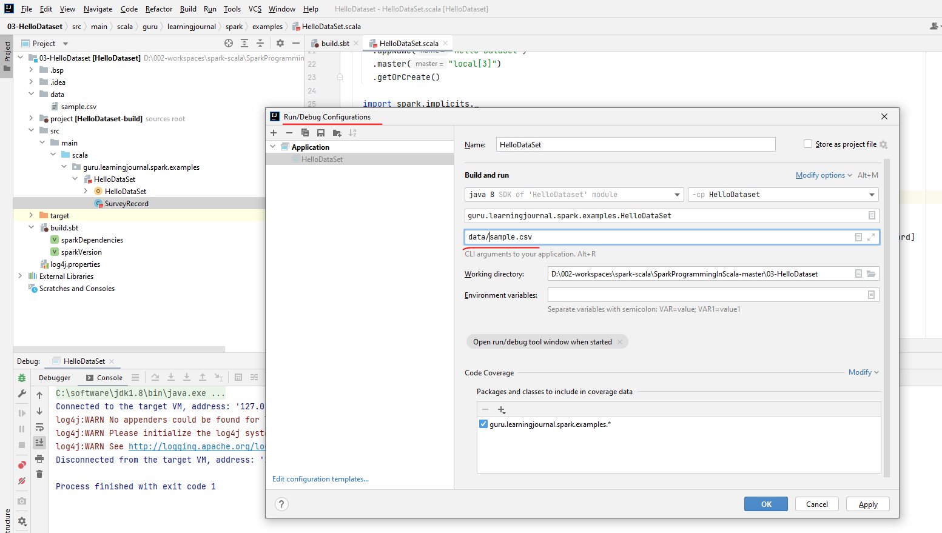

Ran successfully

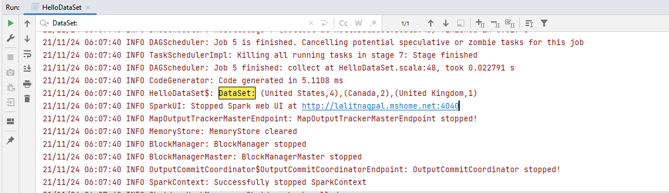

### Working with Spark SQL

You already learned to use Spark RDD, Dataset, and DataFrame APIs in your application. However, the most convenient method to use Spark is via Spark SQL. In this lecture, I am going to create a Spark SQL example. This example will help you understand How to use Spark SQL inside your Scala-based application. So, let's start. I have created this new example HelloSparkSQL. Most of the things are the same as our earlier examples. I have this same CSV sample data, log4j.properties, and the build.sbt file content is also the same. Same as the earlier example, we have a Scala object with the main() method. I am creating a new SparkSession and loading the data file into a Spark DataFrame.

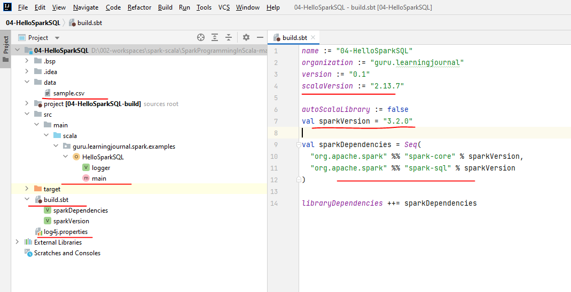

We have done a similar thing in the earlier example. Now we are ready to process the data. You learned to use DataFrame APIs, and you have also seen the Dataset API alternative in the earlier videos. In this video, we want to use the SQL expression for doing the same thing. However, you can execute SQL expression only on a table or view. Spark allows you to register your DataFrame as a View. Let me do it.

package guru.learningjournal.spark.examples

import org.apache.log4j.Logger

import org.apache.spark.sql.SparkSession

object HelloSparkSQL extends Serializable {

@transient lazy val *logger*: Logger = Logger.*getLogger*(getClass.getName)

def main(args: Array[String]): Unit = {

if (args.length == 0) {

*logger*.error("Usage: HelloSparkSQL filename")

System.*exit*(1)

}

val spark = SparkSession.builder()

.appName("Hello Spark SQL")

.master("local[3]")

.getOrCreate()

val surveyDF = spark.read

.option("header", "true")

.option("inferSchema", "true")

.csv(args(0))

surveyDF.createOrReplaceTempView("survey_tbl")

val countDF =

spark.sql("select Country, count(1) as count from survey_tbl where Age<40 group by Country")

logger.info(countDF.collect().mkString("->"))

//scala.io.StdIn.readLine()

spark.stop()

}

}

We start with the DataFrame and createOrReplaceTempView. Supply the view name. That's all. You are done. Now you have a view, and you can execute your SQL expressions against this view. Let's do that as well. We start with the SparkSession and use the SQL method. The SQL() method takes your Spark SQL expression and returns a DataFrame.



Amazing. Isn't it? All that we did in the earlier examples using multiple lines is done using a single SQL expression. If you know SQL, this approach could be easy to learn and the fastest method to meet your requirements. And the best part, Spark SQL, is as performant as the DataFrames. So, using SQL, you are not going to pay any additional performance cost.

### Spark SQL Engine and Catalyst Optimizer

|  |  |
| --- | --- |
|  | We learned to use RDDs, Datasets, DataFrames, and SQL in Apache Spark. These are the four approaches to process data in Apache Spark. We do not recommend using RDDs and encourage you to prefer SQL, DataFrames, and Datasets. And we have a compelling reason for this recommendation.  All these three APIs are internally powered by something known as the Spark SQL engine.  The Spark SQL engine is a powerful compiler that optimizes your code and also generates efficient Java Bytecode. The overall effort of the Spark SQL engine can be broken down into four phases.  The first phase is Analysis. In this phase, the Spark SQL engine will read your code and generate an Abstract Syntax Tree for your SQL or the DataFrame queries.  In this phase, your code is analyzed, and the column names, table, or view names, SQL functions are resolved. You might get a runtime error shown as an analysis error at this stage when your names don't resolve. |

The second phase is the logical optimization. In this phase, the SQL engine will apply rule-based optimization and construct a set of multiple execution plans. Then the catalyst optimizer will use cost-based optimization to assign a cost to each plan. The logical optimization includes standard SQL optimization techniques such as predicate pushdown, projection pruning, boolean expression simplification, and constant folding.

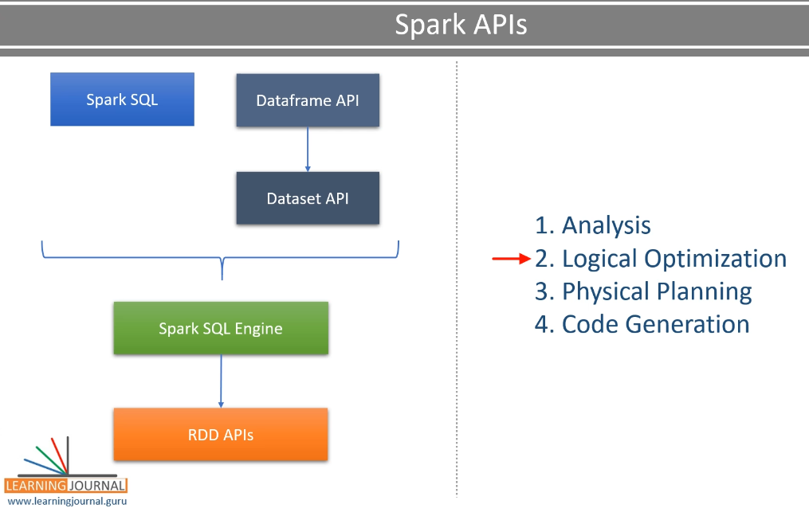

The next phase is the physical planning the SQL engine picks the most effective logical plan and generates a physical plan. The physical plan is nothing but a set of RDD operations, which determines how the plan is going to execute on the Spark cluster. Finally, the last phase is whole-stage-code-generation. This phase involves generating efficient Java bytecode to run on each machine. This phase was introduced in Spark 2.0 as part of the Project Tungsten. The Project Tungsten was initiated to apply ideas from modern compilers and MPP databases and make Spark run more efficiently. Great! So a lot of things happen inside the Spark engine. However, as a Sark programmer, all we do is to stick to the DataFrame APIs and Spark SQL. That's all. And you will get all these optimization benefits.

### Summary

|  |  |
| --- | --- |
|  | Lets summarize what we have learned. The following diagram is the main takeaway of this section. The figure gives you an overview of what is available to you and how they are arranged in the overall toolset.  The recommendation is to use Spark SQL as and when possible. However, you will also need to use DataFrame and Dataset to solve your data crunching problems. I briefly covered the RDD APIs and created an example so you can get some sense of it. However, you are going to avoid using RDDs. Then we tried to understand the difference between DataFrame APIs and the Dataset APIs. I am going to elaborate further on these two things for the rest of the course.  Finally, we learned to apply SQL over the DataFrames. I am assuming that you already know SQL, and this course is not about SQL. However, you already learned the basics of applying the SQL over the DataFrames.  Then I talked about the Spark SQL engine and the catalyst optimizer. The optimization automatically works under the hood, and you don't have much to do there. However, it is good to know how things work. |